Dear Enquirer,

**L’Arche Edinburgh Support and Care Coordinator (Registered Manager)**

Thank you for your interest in the Support and Care Coordinator (Registered Manager) role with L’Arche Edinburgh.

This pack includes:

1. **Copy of the advert and information on application process**
2. **Job description and Person Specification**
3. **Information on L’Arche Edinburgh including Identity and Mission statement**

**Please submit your CV and a covering letter** by **02nd of June at 9.00am** to [edinburgh.hr@larche.org.uk](mailto:edinburgh.hr@larche.org.uk)

I look forward to hearing from you.

With regards



**Kirsty MacCrimmon**

Community Leader

**Do you believe in a world where all belong?**

**Support and Care Coordinator (Registered Manager)**

**L’Arche Edinburgh**

**Salary £36,643 to £38,286**

**Do you have a passion for ensuring people with learning disabilities live fulfilled lives? Do you want to help lead a community that values people for who they are *and* what they can do?**

**L’Arche Edinburgh** is a community of more than 80 people with and without learning disabilities. It is a place of belonging where people with learning disabilities can live independent, yet connected lives. We’re looking for someone to join us as our Support and Care Coordinator, a post which requires registration with the Care Inspectorate and Scottish Social Services Council (SSSC). Our services, which support 16 people with learning disabilities, are dual registered under the categories of Care at Home and Housing Support.

You will lead a small supportive team of 3 Support and Care Leaders, working across 4 localities in the Leith and Restalrig areas of Edinburgh. Together you will ensure that we provide and develop high quality person-centred care supporting the practical, social and spiritual needs of those who call L’Arche home. You will be joining us at an exciting time as we’re looking to increase choice for the people we support and explore ways that we can grow as a Community.

L’Arche Edinburgh is an ecumenical Christian community which welcomes people of all faiths and none. We are part of a global network of communities where people with and without learning disabilities live and share in life together, working for a world where we all belong.

Knowledge and experience in care or supported housing is a key requirement for this role, but we’re also looking for someone with an enthusiasm for our values and the ability to inspire others. You might be looking to step up as a manager or to use your management experience in a different way. If you are interested in being part of a mutually supportive and lively community, then we want to hear from you!

**Please submit your CV and a covering letter by 02nd of June at 9.00am to** [**edinburgh.hr@larche.org.uk**](mailto:edinburgh.hr@larche.org.uk)

**Finding out more about L’Arche**

L’Arche is more easily experienced than explained. If you are shortlisted, you will be invited to visit a Community house, either in person or virtually, as part of your interview.

Kirsty MacCrimmon, Community Leader, would be very happy to talk informally with you to answer any questions and give you a feel for what being a Support and Care Coordinator in L’Arche is like. Kirsty is available on 07387 106307 or [Kirsty.MacCrimmon@larche.org.uk](mailto:Kirsty.MacCrimmon@larche.org.uk). You can find out more about L’Arche Edinburgh at [www.larche-edinburgh.org.uk](http://www.larche-edinburgh.org.uk) and L’Arche in the UK at [www.larche.org.uk](http://www.larche.org.uk)

**\*\*\* PLEASE NOTE THAT WE ARE UNABLE TO SPONSOR VISAS FOR THIS POST. Your application will be disregarded if you do not have the right to work in the UK.**

**Support and Care Coordinator (Registered Manager) Job Description**

Reports to: Community Leader.

Location: L’Arche Edinburgh office in Leith

Hours: Full time 37.5 hours per week. There will be some evening and weekend

commitments locally and some events which require travel and overnight stays

Salary: £36,643 to £38,286.

**Overall Objectives:**

To be responsible for the day-to-day operation and management of high quality, person-centred care and support service to adults with learning disabilities across 4 locations.

To support the Community Leader in creating community in accordance with the Identity and Mission of L’Arche.

**Main Duties**

1. ***Management and Leadership***

* Line manage Support and Care Leaders, and Support and Care Administrator, providing regular supervision and appraisal to ensure that excellent standards of care are maintained across the service.
* Oversee rota planning to ensure support levels are met, with effective staff deployment.
* Participate in staff recruitment, selection, induction and training.
* Lead in relation to staff performance and conduct issues.
* Lead in communicating a vision of service provision based on SSSC Codes of Practice, Health and Social Care Standards and L’Arche values and Code of Conduct.
* Work closely and supportively with the Community Leader, Assistants’ Coordinator (HR Manager) and other senior leaders.

1. ***Quality Assurance***

* Lead on quality assurance and service improvement consultations and action plans, providing regular reports as required.
* Implement and improve L’Arche systems, policies, procedures and reporting mechanisms.
* Contribute to the strategic plan ensuring quality input is received from people with learning disabilities.
* Keep up to date with innovations and developments within the sector, and advise the Community Leader on implications and necessary action.

1. ***Regulatory and legal***

* Ensure compliance with all service related legal requirements, including regulatory bodies such as the Care Inspectorate and Scottish Social Service Council.
* Lead as Registered Manager on issues relating to Adult Protection and Capacity.
* Oversee Health and Safety and Fire Safety ensuring internal and external compliance with all legal and regulatory requirements, delegating checks where appropriate.

1. ***Property***

* Oversee all property maintenance and improvements, ensuring high standards and quality within budget, delegating where appropriate.
* Lead on all issues relating to Houses of Multiple Occupancy (HMO) compliance.
* Ensure compliance in procedures and use of Motability vehicles.

1. ***Creating Community***

* Support the Community Leader in sustaining and developing L’Arche Edinburgh’s identity as a Community of people with and without learning disabilities, sharing life together.
* Support the Support and Care Leaders, Deputies and assistants in their role of creating community including encouraging continued expression of L’Arche values.
* Attend community events whenever possible.

1. ***Financial management***
   * Participate in the budget-setting process with the Community Leader, to ensure that each part of the service has a realistic, achievable budget.
   * Monitor monthly income and expenditure figures and take action to rectify inefficiencies or any deficits which emerge, in consultation with the Community Leader.
   * Negotiate with social work to ensure that appropriate levels of funding are in place for each person using our service.
   * Ensure robust management of the personal finances of people with learning disabilities using the service.
2. ***Service Development***

* Lead on developing our services to respond to emerging needs and demands.
* Lead on referrals to our services from care managers and individuals and their families.
* Participate in the development of major new projects in conjunction with the Community Leader.

1. ***Meetings, Training and Formation***

* Chair the monthly Support and Care Leader’s meeting, and lead on support and care issues in the monthly Leaders and Deputies Meeting.
* Chair or attend other relevant meetings, including service review meetings for people with learning disabilities.
* Attend formation and training courses relevant to this role as agreed with the Community Leader.
* Attend any L’Arche UK meetings relevant to this role as requested by the Community Leader, including occasional residential events (e.g. Good Practice Forum for Registered Managers)
* Deliver training and formation where appropriate, including the L’Arche in the UK Induction programme.

1. ***General***

* Coordinate and take part in both Tiers of the out of office hours On Call contact and respond appropriately to emergencies (the second Tier manages ASP Alerts and provides back up support to Tier 1 when required).
* To be available to respond and provide support in an emergency.
* Build and maintain links with staff in partner agencies, attending events and meetings as agreed with the Community Leader.
* Perform any other reasonable duties commensurate with the post, which may be required from time to time by the Community Leader.

**Support and Care Coordinator (Registered Manager) – Person Specification**

|  |  |  |  |
| --- | --- | --- | --- |
|  | Requirement : Essential (E) Desirable (D) | **E** | **D** |
| 1 | SVQ Social services and Healthcare SCQF Level 7, HNC Social Services, or equivalent, and PDA Health & Social Care Supervision award. Consideration also given to applicants with substantial, relevant experience (10 years+) without these qualifications. | **X** |  |
| 2 | SVQ Social Services & Healthcare SCQF Level 9 and SVQ Care Services Leadership & Management SCQF Level 10 qualification or equivalent OR capacity and commitment required to achieve both within SSSC registration timescales. |  | **X** |
| 3 | Understanding of the values, practice and identity and mission of L’Arche. | **X** |  |
| 5 | Knowledge of current support and care legislation and good practice, including of adult protection and capacity issues. | **X** |  |
| 6 | Knowledge of current issues and trends affecting the support of people with learning disabilities. | **X** |  |
| 7 | Knowledge of Care Inspectorate and SSSC. | **X** |  |
| 8 | Minimum of 2 years management experience in social care including supervisory experience. | **X** |  |
| 9 | Experience of working in social care sector, preferably in the disability field. | **X** |  |
| 10 | Experience of leading and working with teams to provide a high quality support and care to people with learning disabilities. | **X** |  |
| 11 | Experience of negotiation, developing support packages in working in partnership with commissioning and funding bodies. |  | **X** |
| 12 | Experience of budget management. |  | **X** |
|  | **Core competencies** |  |  |
| 13 | Ability to take ownership and responsibility: keep up to date with SSSC and other statutory requirements, and best practice in the sector | **X** |  |
| 14 | Ability to plan and make decisions, analyse problems and develop strategic approaches to enable solutions | **X** |  |
| 15 | Ability to work effectively with others, build positive relationships with colleagues, with excellent organisational skills, ability to prioritise and delegate. | **X** |  |
| 16 | Ability to communicate effectively: excellent written and verbal communication skills including the ability to communicate with people with learning disabilities. | **X** |  |
| 17 | Ability to be service user focused: to think and act in person centred ways. | **X** |  |
| 18 | Ability to manage change and to be able to deal with pressure. | **X** |  |
|  | **Job related competencies** |  |  |
| 19 | Ability to lead others, be able to motivate employees and volunteers, and convey authority. | **X** |  |
| 20 | Ability to manage performance and develop others, to assess, give feedback, manage conflict and make evaluative judgements about the performance of staff and volunteers. | **X** |  |
| 21 | Ability to meet the requirements of the Care Inspectorate for Registered Manager. | **X** |  |
| 22 | Competent administrator, IT literate in Microsoft 365. | **X** |  |

|  |  |  |  |
| --- | --- | --- | --- |
| 23 | Supportive and enthusiastic about working with an organisation which is both a high quality service provider and an ecumenical Christian community open to people of all faiths or none. | **X** |  |
| 24 | Approachable and encouraging manner when talking to people with learning disabilities and employees. | **X** |  |
| 25 | Emotional intelligence, including the personal qualities of compassion, courage, integrity and humility; ability to acknowledge personal limits, a commitment to Accompaniment (L’Arche internal mentoring) and a willingness to ask for help. | **X** |  |
| 26 | A clear PVG disclosure criminal record check. | **X** |  |
| 27 | To be based in the L’Arche Edinburgh office, and in the 4 service locations regularly | **X** |  |

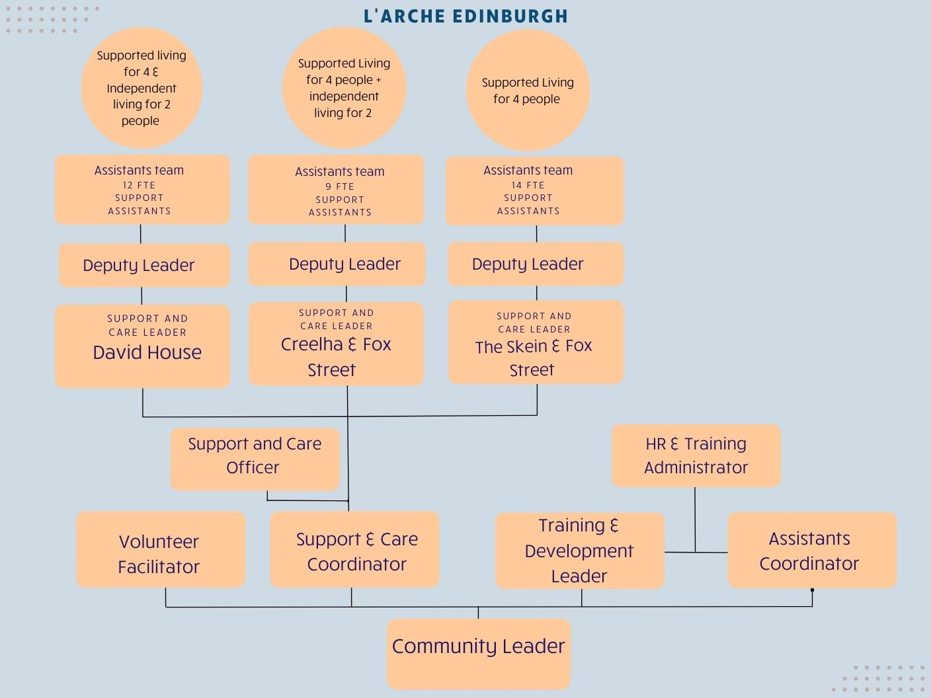

**L’Arche: What we do**

We believe that people with learning disabilities have much to teach us and contribute to the world. During the last fifty years, we have learnt that one of the best ways to enable this is by creating Communities with a culture of shared lives between people with and without learning disabilities, from which we can work together to build a more human society.

At L’Arche we celebrate people with learning disabilities and build circles of support around them. We go beyond supporting people's basic needs to attend to their emotional and spiritual lives, too. It is this focus on building relationships and cultivating a sense of belonging that makes us different from other service providers.

L’Arche Communities hold in balance four elements: service, community, spirituality & outreach. Experience has shown us that each element has an important role to play and needs to be present - not only for a Community to be healthy - but in order to make us better at each of the other elements.

L’Arche Communities around the world share this common philosophy and approach while reflecting and celebrating the ethnic, cultural and religious composition of the areas in which they exist

**Community life**

At the heart of L’Arche is the support we provide to people with learning disabilities. As well as providing high quality housing and supported living, we also work with individuals to access employment and voluntary opportunities. In addition, many of our Communities provide day support services. Furthermore, we assist people to access relevant healthcare and, where appropriate, receive therapeutic services. We work hard to ensure that the needs of individuals with learning disabilities are met holistically, and that people are supported to live fully integrated and empowered lives within the wider communities in which they live.

We have a long history of working with social services and social work departments, health authorities, primary care trusts, registration and regulatory authorities, housing associations and others, to provide high quality support that is recognised as being truly responsive to people with learning disabilities.

**L’Arche Edinburgh: Background information**

L’Arche Edinburgh is an intentional Community of more than 80 people with and without learning disabilities. It is one of ten communities that form L’Arche in the UK and belongs to an International Federation of 153 communities in 38 countries.

L’Arche Edinburgh opened its first house in 1991. It has grown since then and has a network of houses and flats. The community is made up of adults with learning disabilities, more than forty employed assistants, Community Support Group members and many other friends and volunteers.

Our employed assistants are drawn from two sources. Most are local people employed on standard contracts, whom we term “live-out assistants”. But what makes us different is that up to a third of our assistants live in our houses alongside the people with disabilities to whom they provide support. They receive board, lodging and expenses. This experience of living in community is a source of huge richness.

Our services are registered with the Care Inspectorate under their dual category of Care at home and Housing Support.

***Shared Households:***

* *The Skein and Fox Street:*  home to four people with learning disabilities today and supported by a team of 14 assistants, some of whom live in the house. This was our first house, opened in 1991
* *Creelha and Fox Street:*  home to four people with disabilities, supported by 9 assistants, some of whom live in the house
* *David House:* a house for four people with more complex support needs. 12 assistants support David House, some of whom live in the house

***Community and spiritual life***

L’Arche Edinburgh is an inclusive, ecumenical Christian Community which welcomes people of all faiths and none. The Community has a rich and vibrant community life. Whole Community Gatherings are held regularly, and there are many parties, outings, celebrations and meals to bring together large and small groups. The major feasts such as Christmas and Easter are celebrated together, and there are other opportunities for engaging in a spiritual life, reflection, and quiet time for those who wish to participate.

**L’Arche Identity and Mission Statement**

**Identity:**

* We are people with and without learning disabilities, sharing life in communities belonging to an International Federation.
* Mutual relationships and trust in God are at the heart of our journey together.
* We celebrate the unique value of every person and recognise our need of one another.

**Mission:**

* Make known the gifts of people with learning disabilities, revealed through mutually transforming relationships
* Foster an environment in community that responds to the changing needs of our members whilst being faithful to the core values of our founding story
* Engage in our diverse cultures, working together towards a more human society

**We value:**

* **Treating people with dignity and respect:** We value every person and celebrate who they are.   We do not just tolerate diversity, but actively embrace it in our communities. A key way we demonstrate dignity and respect is by being fully present to each other when we are together and listening deeply to one another.
* **Friendliness and welcome:** We are deeply committed to building friendships together, which calls us to live life with a joyful and grateful spirit. A key way we demonstrate friendliness and welcome is by offering meaningful invitation and welcome to newcomers and also to each other on a daily basis.
* **Empathy:** We are committed to understanding and sharing the feelings of one another.  We prioritise the qualities of compassion, caring, and kindness to nurture empathy. A key way we demonstrate empathy is through the quality of the shared life we build together.
* **Integrity:** We strive to have integrity in everything we do and in every relationship we build, seeking to be authentic and honest, trustworthy and open because to build meaningful relationships we need to reveal who we are. A key way we demonstrate integrity is through our willingness to be both vulnerable and courageous.
* **Commitment to community building:** We choose to share life together rather than merely work together. Sharing life means we create mutual relationships with one another and also share responsibility for the life and wellbeing of the community as a whole, practicing forgiveness and celebration and creating a place of belonging that is open to all who share our mission and values. A key way we demonstrate our commitment to community building is through our nurturing of our shared spirituality expressed through the community traditions and practices that shape our daily life together.
* **Openness to reflection, learning and growth:** We are personally committed to growth and development in the dimensions of L’Arche identity and mission and also support the growth of the whole community by nurturing the gifts of each person, creating a learning culture together and being attentive to our personal and communal spiritual life.  A key way we demonstrate our commitment to learning is the frequency and quality of our personal and group reflective practices and processes.
* **Commitment to the vision and mission of L’Arche:** We actively engage in all dimensions of L’Arche mission and practice both personally and communally.  A key way we demonstrate our commitment is our visibility as people with and without learning disabilities together engaged in our local neighbourhoods and the wider world in order to shape a more human society.

