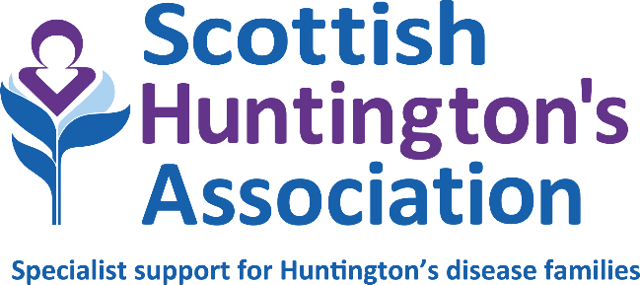

JOB DESCRIPTION

Job title: Huntington’s Disease Specialist
Accountable to: Deputy CEO & Head of Services and SHA Board of Trustees
Report to: Senior Huntington’s Disease Specialist – Lothian Service

Role summary
As a member of the Scottish Huntington’s Association multidisciplinary team, you will facilitate quality care for those impacted by Huntington’s disease and their families through assessment, planning, coordination, implementation and signposting to appropriate professionals/agencies. You will work with the Senior HD Specialist and your Team Leader to develop and enhance the service.

You will adopt a hybrid-working model based between the Lothian Office and home working. Please note at present the team are temporarily home-based until new office space is secured. Operational areas include the direct provision of services to families, promotion of self-help amongst families and increasing awareness about Huntington’s disease (HD).

You must be a full member of a professional body (relevant to qualification) and be able to work within the scope of your registration guidelines.

Main duties and responsibilities
- To provide support to individuals and families affected by Huntington’s disease through a psychosocial approach.

- To facilitate and support regular peer support opportunities for individuals impacted by Huntington’s disease and their family members. These include carers’ groups and symptomatic support groups.

- To provide advice on positive management of Huntington’s disease to individuals, families and relevant health and social care professionals and agencies.

- To liaise with other professionals to help individuals access the services to which they are entitled e.g. advocacy, respite, welfare rights community and health services.

Education and training
- To facilitate training at a local level and participation in national training events.

- To promote awareness about the needs and challenges facing individuals, families and care providers through the provision of education and information.

- To participate in the production of educational literature about Huntington’s disease.

- To maintain professional awareness about current trends and practices through appropriate training courses, study days and workshops.

Research and development
- To initiate and/or participate in research projects related to Huntington’s disease.

- To support individuals who are participating in current drug trials or new treatments.

- To become involved in the strategic planning and development of appropriate health and social services.

- To assist with new developments relevant to the Specialist Service function.

- To undertake surveys and audits as necessary to your own work and that of the Specialist Service.

Policy/service development
- To adhere to all company policies appropriate to own role. May at times be required to be responsible for policy development, propose changes in practice and contribute to the development of communication protocols.
Management and leadership
- To assist the management and development of the project working with the Senior
HD Specialist, Team Leader or Head of Services.

- To share leadership and contribute views to regular staff meetings and projects.

- To organise, manage and plan own caseload and diary.

- To be fully accountable for own professional actions and to work autonomously.

- To undertake responsibility for production of all reports concerning your work and activities of the Specialist Service.

Administration
- To ensure the maintenance of full and accurate, confidential client records and reliable notes concerning the work of the Specialist Service within your area

The duties and responsibilities of the post will be undertaken in accordance with the policies procedures and practices of Scottish Huntington’s Association.

May 2023

Notes:
1. This job description reflects the main tasks and responsibilities to be fulfilled by the post holder at this present time. However, Scottish Huntington’s Association reserves the right to alter or amend the content of this job description to reflect changes to the job, or services provided, while maintaining the overall character and level of responsibility for the post.
2. Notwithstanding any information or statement described within this job description, all duties must be carried out in a way that promotes equality of opportunity, dignity and respect for all individuals and is consistent with the Scottish Huntington’s Association stated policy on equal opportunities.
3. The successful candidate will be subject to membership to the Protecting Vulnerable Groups Scheme (PVG). Having previous convictions will not automatically disbar you from working at Scottish Huntington’s Association (with the exception of offences against children or other vulnerable groups) and every case is considered on an individual basis.
4. The duties and responsibilities of this post must be undertaken in accordance with the policies of Scottish Huntington’s Association.

PERSON SPECIFICATION

 | Essential / Desirable | Identified by
Qualifications  Degree level qualification in Nursing, Occupational Therapy, Social Work or other related health/social care profession  Current, full membership to your professional body | E  E | Application  Application
Professional Experience:  Clinical and Interpersonal  Ability to carry out complex specialist assessment, followed by appropriate and timely actions.  Client care  Ability to assess, develop and implement programs of care with a multidisciplinary and inclusive approach.  Planning and organisation  Working as an autonomous practitioner, the HD Specialist must be able to manage own caseload whilst at all times being accountable for own professional actions.  Education and training  Experience of facilitation of learning for small groups delivered to both paid and non paid carers and the wider multidisciplinary care team  Basic understanding of how adults learn  Ability to provide appropriate resources to service users  Previous experience in the production of literature for publication  Research and development  Ability to manage and undertake audits as necessary  Staff / Student Support  Ability to provide support to all colleagues in your team and any students, as agreed with the line manager, in compliance with good practice and professional standards  Knowledge of GDPR and Confidentiality  Have experience of applying GDPR and client confidentiality in all areas of practice, and in accordance with SHA policies  IT proficiency  Experience in a range of programs (eg. Microsoft Office 365 Suite - including Word, PowerPoint etc. Client Management Databases, and other relevant software packages) | E  E  E  D  D  E  E  E | Application / Interview  Interview  Interview  Application / Interview  Application / Interview  Application / Interview  Interview  Application / Interview
Attributes and competencies:  Managing relationships/team working  Builds and maintains effective relationships with a range of people. Works cooperatively with others, and enjoys being part of a team.  Planning and organising  Will think ahead in order to establish an efficient and appropriate course of action for self and others, taking into account all relevant issues.  Analytical thinking  Can critically evaluate information and address limitations or errors. Has a good understanding of motives and behaviors.  Resilience  Maximises personal effectiveness by managing emotions in the face of pressure and complex client situations. Demonstrates an approach to work that is characterised by commitment, motivation, and energy.  Developing others  Recognises and fosters the development potential in others.  Flexibility  Adapts and works effectively with a variety of individuals, groups and situations, often having to change and reprioritize workload and approaches to support. | E  E  D  E  D  E | Interview  Interview  Interview  Application / Interview  Interview  Interview

