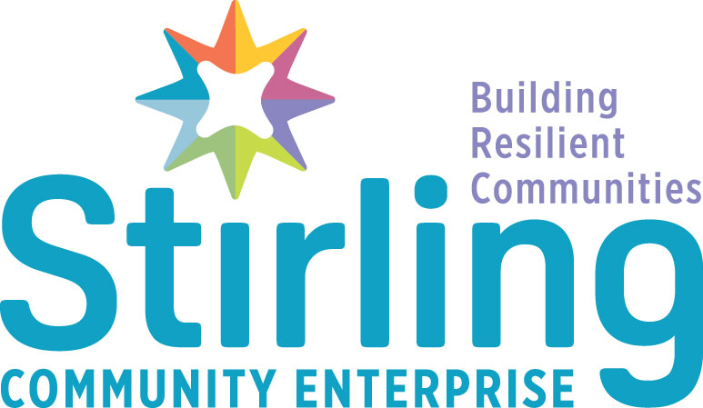

Job Description and Person Specification
Community Resilience Officer

About the Role

This is a 3-year fixed term contract funded by The Robertson Trust as part of our Resilient Futures Pathways Project.

You will coordinate and facilitate the support of individuals and families identified as at risk of involvement with statutory services. Working in partnership with Police Scotland, The NHS, Local Authority Housing, Social Work, Education and Third Sector organisations, you will act as a singular point of contact to case manage planned wrap around support that will help individuals or families progress towards a positive future.

This may include working with individuals currently in, or on the periphery of the justice system, at risk of homelessness or in temporary accommodation, individuals with problematic substance use, individuals with mental or physical health support needs, young people not engaging in education or individuals who are either long term unemployed or economically inactive.

About You

As an experienced professional you will have a good working knowledge of the barriers faced by disadvantaged groups and the services wrapped around them. You should have a sound understanding of employability, training and education sectors, with a background in either justice social work, housing, health or education services. You will have the ability to manage complex caseloads, coordinate and support multiple partner organisations and ensure that the support is appropriate, holistic and person centered.

You will be focused, well organised and detail orientated. As a strong communicator you will have the ability to think innovatively, solve problems and keep calm under pressure. You will be passionate about changing lives and an advocate for developing fairer, sustainable and resilient communities.

Job Description
This job description may be amended from time to time dependent on job requirements and Service provision.
Section B
Organisational relationship and employee responsibility
This section describes the reporting relationships of the job within the immediate organisation and if appropriate has detail of the organisation a tier above and below the job. Also described is responsibility for employees, (if any).

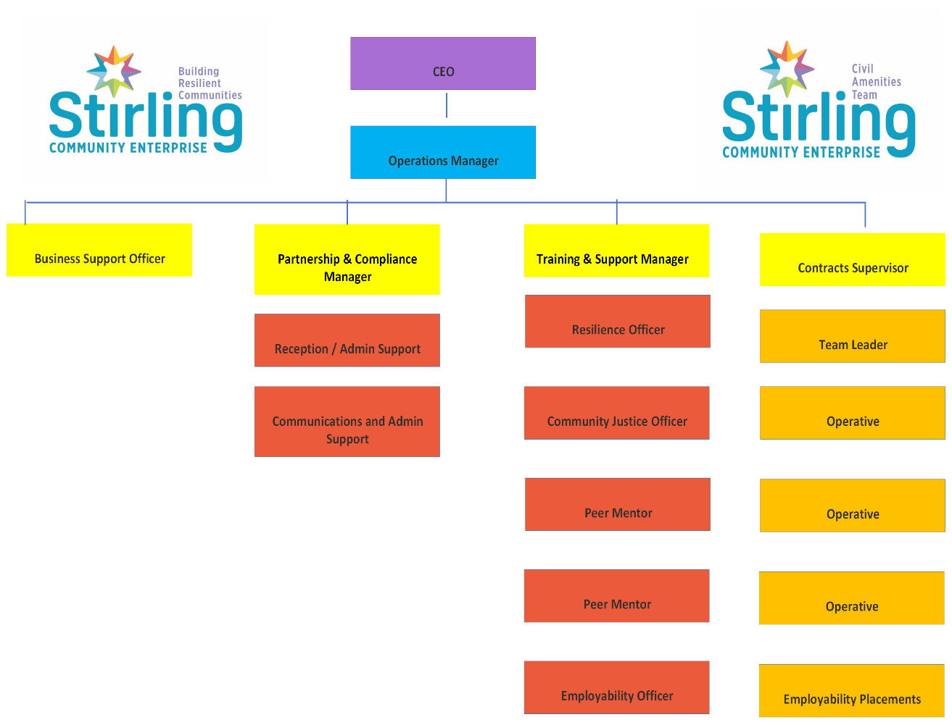

Principal purpose and objectives
This section lists the main (headline) responsibilities / accountabilities of the job.

The principal purpose and aim of this role is to coordinate support for individuals and families identified as at risk of involvement with statutory services. Working in partnership with Police Scotland, The NHS, Local Authority Housing, Social Work, Education and Third Sector organisations, you will act as a singular point of contact to case manage planned wrap around support that will help individuals or families progress towards a positive future and out of poverty.

This may include working with individuals currently in, or on the periphery of the justice system, at risk of homelessness or in temporary accommodation, individuals with problematic substance use, individuals with mental or physical health support needs, young people not engaging in education or individuals who are either long term unemployed or economically inactive.

The Resilience Officer will use SCE’s range of training, education and employability services as a vehicle to access areas of support that will improve life skills, promote resilience, improve financial awareness, enhance employment prospects, create more life options and reduce poverty.

In collaboration with key partners, the post holder will facilitate regular case management meetings where a collective approach will be used to identify, agree and develop appropriate interventions. The Resilience Officer will support, measure and report on these interventions based upon SCE outcome(s)framework and reporting mechanisms.

In addition to coordinating and measuring wrap around services, the Resilience Officer will support the delivery of bespoke training and education interventions, both in person and through a wider network of partner agencies that support people away from a chaotic lifestyle and towards a safer, healthier, and more productive lives.

The post holder will liaise with key statutory organisations on an outreach basis to target individuals at risk of becoming homeless, becoming involved in, or on the periphery of the justice system or young people at risk of becoming NEET.

Challenge perceptions and support new innovative practices to ensure no one is left behind.

This position is a core part of our organisation’s continued strategic and operational vision to provide high quality employability and wrap around support that helps increase life chances for the people and communities we support.

Main duties and responsibilities
This section provides detail of the main responsibilities / accountabilities. Individual tasks may be included. Note, these are illustrative only and are not exhaustive.
The post holder will be responsible for:

- Building rapport and establishing trust with clients who can at times have very challenging background. This might include individuals currently in the justice system or identified as at risk of involvement within it, people with alcohol or drug issues, individuals with chaotic lives, school pupils identified as NEET, and those experiencing homelessness.

- Undertaking individual assessments to identify specific need and develop an appropriate plan of support with associated person-centered interventions.

- Liaise and coordinate support from external agencies contributing to the action plan.

- Liaise and coordinate regular partner case management meetings and reviews.

- Attend external agency meetings, reviews and statutory appointments as an advocate for clients.

- Ensure individuals are supported and protected to achieve the goals identified within their specific actions plan. This may include 1-1 support or engaging partners to deliver tailored wrap around support to achieve sustainable, positive change.

- To be responsible for the management and co-ordination of a caseload of clients.

- Provide 1-1 support and guidance for individuals who have been released from custody or are subject to statutory court orders and those who are not being case managed by justice staff and have a history of offending that may be preventing them from securing employment or accessing a positive destination.

- Provide 1-1 support and guidance for individuals who require support in the areas of housing, health, addiction, low income and personal development that may be preventing them from securing employment or accessing a positive destination.

- Meet with clients within the SCE HUB and outreach support in the local community, including home visits.

- Provide tailored employability support including creation of disclosure letters, create and update CVs, create cover letters, job search, access additional advice services, access additional training opportunities

- Facilitate, develop and implement groupwork programmes for individuals as part of a broader employability pipeline.

- Support and promote warm, caring, and nurturing relationships and environments in which everyone feels secure, respected and valued.

- Establish and maintain positive and purposeful working relationships with a range of statutory and non-statutory agencies, as well as the general public as a representative of Stirling Community Enterprise.

- Establish strong professional relationships with the local community and services to identify individuals who may benefit from the service.

- Link with the wider SCE Team and external provision, including Health and Wellbeing support to meet the requirements of the individual.

- Ensure administrative systems such as client forms, databases and contact files are kept fully up to date and secure, in line with data protection legislation and our confidentiality policy.

- Maintain all relevant records to meet company, funding, accrediting body, audit and other requirements, including SQA and SDS.

- The post holder will work to standards and procedures, demonstrating confidentiality, initiative, commitment, and flexibility and manage competing priorities.

- Work on own initiative and as an effective team member.

- Regularly monitor objectives and report against performance targets set by the Training and Support Team Manager.

- To undertake appropriate training as identified by the service and participate in staff development opportunities, training and PRD.

- Keep abreast of national and local initiatives and requirements

- Any other duties that may be considered appropriate for this post.

Responsibility for physical assets, data and finance
This section details responsibility for physical assets, e.g., vehicles, buildings, stock control
/ Procurement, data, e.g. computers, record keeping, finance e.g. budget holding / monitoring / cash handling.
- Maintain all relevant records to meet company, funding, accrediting body, audit and other requirements, including, Scottish Qualifications Authority, Skills Development Scotland and Robertson Trust.
- Keyholder for the SCE building.

Communications skills
This section notes examples of the individuals or organisations with whom the post holder will come into regular contact and explains the nature of the communication and level of skill required by the postholder.
This role requires a high level of communication skills including verbal, written and digital literacy. It also requires the ability to develop partnership working with the following contacts.

Internal: SCE Training and Support Team, Senior Management Team, and other SCE staff and partners within the HUB. Providing support and guidance to individuals from the local community who may come from challenging social backgrounds.
External: Including but not limited to - Stirling Council, Community Planning Partners, Forth Valley College, Skills Development Scotland, Scottish Qualification Authority, Scottish Prison Services, Police Scotland, Local employers, Forth Valley Developing Young Work Force Team, Stirling Voluntary Enterprise, Community Groups, Department of Work and Pensions (DWP), Robertson Trust and related organisations.

Planning, collaboration and analysis
This section details the level of problem solving, analysis, creativity, forward planning/scheduling required.
- Excellent partnership, negotiation, and confident decision-making skills.
- Able to develop strong interpersonal relationships, build trust and develop role as an advocate for individual(s)
- Ability to work in partnership/engage with other services to manage and address risk/needs and support individuals reintegration into the community following periods of imprisonment.
- Ability to work as a team member while still delivering individual outcomes.

- Can effectively coordinate the individual work of multiple organisations to contribute positively to a multi-agency approach.

- Practice the principles of confidentiality, equal opportunities and non-discriminatory practice at all times.

Person Specification
Knowledge and skills
This section details the knowledge and skills including any qualifications, specific training or experience required.

Essential criteria:
- Significant experience of working as an effective team member
- Understanding of the employability, justice, social work, housing, health and or education systems.
- Understanding of the complex nature of underlying issues that can have an impact on offending behavior, non-engagement in education, risk of homelessness or long term unemployment.
- An understanding of the issues faced by people impacted by trauma, poverty and adverse childhood experiences
- Evidence of a proven track record of working with people impacted by trauma and experiencing multiple barriers, including anti social behavior, alcohol and drugs, mental health and homelessness.
- Ability to balance multiple priorities.
- Ability to build and sustain relationships in a professional context.

- Ability to communicate politely, articulately, and confidently both verbally and in writing with a wide range of people from the most senior person in an organisation to individuals from challenging social backgrounds.

- Adept in developing support programmes and materials with excellent project management, evaluation, and reporting skills.

- Solutions focused with good organisational, administration and problem-solving skills.

- Flexibility to undertake a variety of specialised tasks and a desire to learn and develop skills beyond those which he/she initially brings to the post.

Desired criteria:
- Experience of working and developing relationships with local employability, training and support providers.
- SQA Assessor/Internal Verifier
- An understanding of homelessness and accommodation processes.
- An understanding of the court system.

Summary of main terms and conditions

Type of contract | Full Time, Permanent.
Grade and salary | £29,258 - £33,258  New entrants will normally commence on the first spinal point (dependant on qualification and experience).  Salary spinal point increment is applicable every 2 years until the top of the scale is reached.  Inflationary increases are also applicable each April.
Hours of work | Full-time hours 35 hours per week.  We also offer flexible working opportunities.
Office location | Drip Road, Stirling FK8 1RW
Pension scheme | All employees are automatically enrolled in the Peoples Pension scheme.  Contributions are made by both the employee (4%) and employer (3%).
Annual leave | Leave entitlements start at 29 days per annum and increase in line with length of service.  In addition to this, we also have 7 fixed public holidays when our offices close.
Business travel | Mileage rates are £0.45 per mile up to 10,000 miles and  £0.25 per mile thereafter in a rolling year from 1 April to 31 March.  Public transport for business will be reimbursed through expenses.
Other benefits | - Staff development and training provision  - Cycle to work scheme  - Occupational health services  - Employee Assistance Programme

