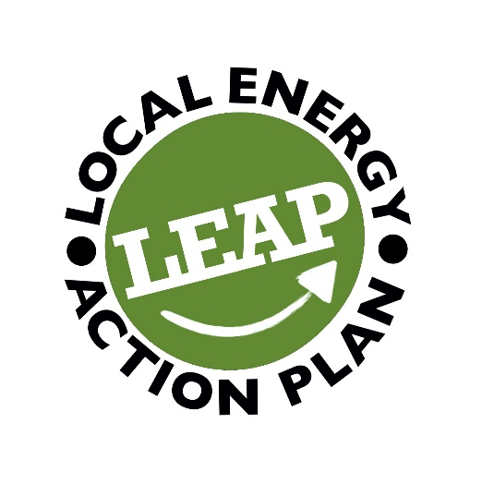
SHARED TRANSPORT COORDINATOR
12 Months Contract, 16 Hours per week, £26,754 pro-rata
Local Energy Action Plan (LEAP) is a Renfrewshire-based environmental charity. We are committed to highlighting the social, environmental and financial benefits for communities of shared transport and facilitating lower levels of car ownership and encourage travel by public transport, walking and cycling.
Since 2012, we have operated LEAP Car Club to provide low carbon emission vehicles for hire for as little as an hour or as long as required. We currently have five vehicles in Linwood and Lochwinnoch – three electric cars and two hybrid cars.
We are also about to launch a shared E-Bike pilot in Linwood in partnership with Linstone Housing Association. The pilot, involving five E-Bikes and 2 cargo bikes, has been primarily been funded by the Energy Saving Trust.
LEAP is seeking a Shared Transport Coordinator to spearhead our E-Bike pilot and assist in delivery of zero-emission Car Clubs in Linwood and Lochwinnoch.
The purpose of the role is to engage with communities in Linwood, with particular emphasis on Linstone Housing Tenants, and Lochwinnoch to build E-bike usage and increase Car Club membership and usage.
Key Duties and Responsibilities
- Lead on delivery of E-Bike pilot to meet Energy Saving Trust and Smarter Choices Smarter Places funding outcomes.
- Drive new member signups to increase the number of users of the E-Bikes and Car Club.
- Effectively communicate the benefits of shared transport and zero-emission vehicles to a new audience.
- Demonstrate bike and car booking, pickup and charging to new members
- Work with maintenance partners to ensure bikes are properly maintained.
- Manage regular cleaning of Car Club vehicles.
- Support basic operations of LEAP Car Club as required.
- Oversee and deliver marketing and communications – online and print.
- Manage inbound enquiries, phone, email, messenger, via drop-in, face to face.
- Work in partnership with Linstone Housing Association, Local Authorities and other key stakeholders.
- Maintain regular contact with Line Manager and other Contractors
- Organise, attend and deliver outreach events where possible, including holding focus groups
- Be an enthusiastic advocate for the value/benefits of making behaviour and structural changes to reduce the amount of CO2 released from daily activities, particularly through transport/travel
Team Structure
The Shared Transport Coordinator will report to the Project Manager.
Contract Period
The contract is for a period of 12 months with the potential to extend.
Essential Requirements
- Confidence in communicating and ability to clearly articulate information
- Ability to communicate to people from a variety of socio-economic backgrounds
- Self-motivation and tenacity, ability to motivate others
- Consistent and thorough approach to work with an eye for detail
- Flexible and able to work occasional weekends
- Holder of a clean driver’s licence for at least two years (or no more than 6pts)
- Required to complete Disclosure Scotland check
Desirable Requirements
- Experience in community engagement
- Experience in motivating individuals to change their behaviours
- Community Engagement qualifications
- Experience of developing and working with databases and/or excel spreadsheets
- Knowledge of Adobe InDesign or similar
- Interest in/experience of shared transport and sustainability
- Good understanding of how energy is consumed in the home & through transport
- Understanding of the Third Sector
- Familiar with local area
- Access to laptop/computer, and car
- Available to commence work immediately
Application Form
Application Closing Date: 5th July
We encourage early applications as we may close recruitment if the right candidate emerges.
Interview Date: Week Commencing 10th July

