Job Description

Title | Volunteer Coordinator
Line Manager | Head of Wellbeing Services
Line Manages | No line management. Will supervise volunteers
Salary | £24,305
Location | Hybrid (work from home and 2-3 days per week in our main office the Calman Centre, 75 Shelley Road, Glasgow).
Contract | Six months (then rolling monthly, with potential to become permanent)
Hours | 35 hours per week (some evening and weekend work)
Annual Leave | 35 days annual leave (including bank holidays)

About Cancer Support Scotland

Cancer Support Scotland has been the wellbeing champion for those affected by cancer for over 40 years – not only for those diagnosed, but their loved ones and carers too.

We deliver high-quality counselling, complementary therapy and stress management services to promote mental and physical wellbeing and to enable those affected by cancer to continue to live the most active life possible in their community.

All the services we provide are free of charge to help reduce health inequalities, and in the last year we have been able to offer 3,350 appointments. However, demand for our services is rising and we rely heavily on fundraising, donations, and legacies to continue our work in supporting people at this critical time.

As the charity was originally started as a support group, we still pride ourselves on offering a drop-in centre for anyone affected by cancer, with free tea, coffee, cakes and Wi-Fi. This provides a group setting for those affected by cancer to come together, defeat loneliness and remain resilient, while encouraging individuals to champion their experiences to help others.

Our Values

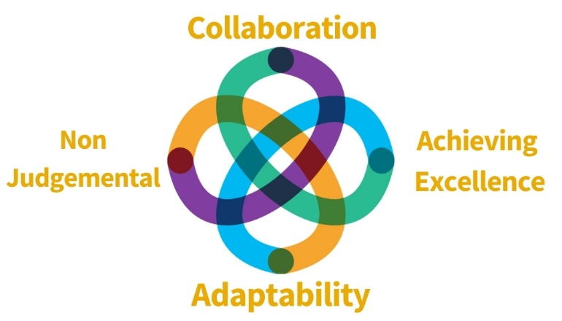

Founded by former Chief Medical Officer and Oncologist, Professor Sir Kenneth Calman, we remain a strong values-based organisation.

We will put people affected by cancer at the heart of what we do. Take care of the wellbeing of those affected by cancer. Treat everyone with kindness and respect and ensure professionalism and excellence.

The Post:

We are looking for a committed and highly organised individual who will join our team as Volunteer Coordinator. This individual will be primarily responsible for all volunteer recruitment, induction, ongoing support, activities, along with the design and dissemination of volunteer newsletters and policies. This individual will be key in supporting our service volunteers across the country. The successful candidate will also take on some HR administrative duties.

Cancer Support Scotland places a strong value on supporting people and taking a non-judgemental approach to our work. We therefore expect our Volunteer Coordinator to provide a fantastic experience for our volunteers and team based on respect.

Key Responsibilities

Volunteer recruitment, training and support

- To match volunteers with suitable volunteering opportunities in line with organisational priorities: fundraising, services, admin, gardeners, etc
- To coordinate, develop and deliver appropriate recruitment and training for new Volunteers, Induction etc as well and the processing of Volunteers when leaving.
- To develop and maintain links with local and national volunteer recruitment agencies
- To monitor and review volunteering across the organisation to ensure volunteers receive enough support including support calls and ongoing training needs
- To work in partnership with colleagues in Fundraising, Wellbeing Services and Operations to ensure volunteers are provided with regular review meetings and ongoing support to fulfil their goals.
- To attend relevant events, such as volunteer fairs and community events to promote volunteer opportunities within the Charity.
- To source high quality case studies and adverts for volunteering
- Organise the recruitment, screening, PVG checks and annual review of all volunteers (as well as relevant staff)
- Produce regular volunteer communication and newsletters ensuring all Volunteers are informed of events across the organisation, as well as coordinating volunteer social gatherings and Reward & Recognition schemes for all

Service Volunteers

- To provide ongoing support and review meetings for service volunteers, encourage their personal development and if appropriate, direction towards relevant and additional support
- Liaising with the Administrator and other relevant staff to ensure volunteers are fully supported to deliver their volunteering effectively
- Support staff by coordinating any student placements, such as screening, recruitment and general induction

Volunteer Management
- To develop good practice policies and procedure in volunteer management and ensure staff are fully trained in their practices
- To work with staff to develop new volunteering opportunities
- To support the development of a volunteer strategy in partnership
- Production of monthly and quarterly Volunteer statistics for the Leadership Team

HR Administration

- Oversee the use of existing HR tools for managing elements such as staff hours, holidays, and expenses
- Linking in with our external HR advisors on any issues which require attention
- Assist on recruitment and oversee induction processes
- Continue on our development as a Disability Confident employer
- Lead in other areas to ensure a friendly and positive workplace environment, ensuring staff are supported in their roles

General Responsibilities
- To ensure day to day operations such as income monitoring, evaluating and reporting are carried out to a high standard
- To ensure all records within database are kept up to date and consistent
- Working to all KPI’s set by line Manager and be accountable for these
- To liaise with relevant staff and outside agencies as required
- To attend internal and external meetings as required
- To operate within the policies and procedures set out by the organisation
- Any other duties that are required and relevant to this role
- To provide support to volunteers and assist with training, as required

Personal Specification
 | Essential (E) / Desirable (D) | Assessment Method
Qualifications | - Minimum of 2 years’ experience of managing/ supporting volunteers (E)  - Evidence of continuing personal development (E)  - Has a driver’s licence (D) | - Application
Experience | - Experience of recruiting, training and supporting volunteers (E)  - Experience of using online content management systems and customer relationship management systems (E)  - Experience of meeting and measuring key performance indicators. (D)  - Experience of working effectively in a team and leading on own initiative (E)  - Experience of responding to people with sensitive and complex needs (E)  - Experience of supporting volunteers who deliver services (E)  - Sound knowledge of relevant policy and procedures for volunteering roles (E)  - Experience of supporting staff through HR processes and mechanisms (D) | - Application  - Interview
Skills | - Excellent organisations skills, including ability to manage multiple tasks and projects (E)  - Excellent written and communication skills (E)  - Ability to work on own initiative and to meet deadlines (E)  - Attention to detail and to seek the highest standards (E)  - Ability to problem solve and find creative solutions (D) | - Application  - Interview

Benefits include:

- 35 Days Annual Leave increasing 1 day after year of service (to 40days)
- Flexible working options
- Modern workplace environment with friendly staff and a great base of volunteers
- Access to learning and development opportunities
- Competitive salary with incremental progression
- Access to pension scheme

Requirements of this role are:

- PVG Check (Paid for by Cancer Support Scotland)
- Two Professional references
- Adhere to all of Cancer Support Scotland’s guidance, policies and procedures
- This role is for a six-month contract, with a hope for the position to continue beyond this point subject to performance and results

This job profile is not exhaustive. The duties of the post holder may be reviewed from time to time and the employee may be called upon to work in other locations our out of hours by Cancer Support Scotland.

How to apply
You can apply with a tailored covering letter and C.V to: recruitment@cancersupportscotland.org

Applications will be reviewed and interviews conducted on a rolling basis with a view to hiring as soon as the right candidate is found.

