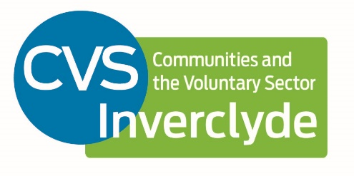

I-Promise Coaching and Modelling Practitioner – Health & Social Care

Location: The role is currently based within Greenock; however, the job location may move within the Inverclyde Council area. Some work outside of the Inverclyde area should be expected.

Reports to: CVS Inverclyde Management Team and IPromise Programme Manager, Inverclyde HSCP

Salary: £26,000 - £30,000 depending on experience

Term: Post funded until end of May 2024 with the possibility of extension, subject to future funding.

Hours: 35 hrs per week, normally all within 9-5 Monday-Friday, applications for reduced hours or flexible working are welcomed. Some evening and weekend work may be required.

Role
The post-holder will support the implementation of Inverclyde’s I-Promise Partnership and play have a key role in modelling for the wider organisations across the third, public sector and wider stakeholders.

Core Duties & Responsibilities
- Lead for coaching and mentoring of teams within the I-Promise partnership
- Link between the development work and modelling practice and implementation
- Lead for feedback on practical implementation of I-Promise
- Lead on the established Practitioners Forum and continued implementation of the Mind of My Own app.
- Involved in all levels of consultation and participation the third sector’s relationships with Inverclyde Health and Social Care Partnership & other relevant partners
- Ensure that the third sector are informed about the I-Promise Partnership and receive regular updates on opportunities for development and collaboration.
- Use the knowledge & understanding that CVS Inverclyde has about communities and third sector organisations to contribute to the I-Promise Partnership
- Represent the third sector on relevant health and social care partnerships and ensure that representation is effective.
- Work with Inverclyde HSCP and the I-Promise team to drive improved collaboration and the redesign of services to meet the needs of Inverclyde’s people.
- Provide operational support to third sector organisations as appropriate.

Generic Staff Responsibilities
- To promote membership of CVS Inverclyde to the third sector in Inverclyde
- To work as part of the I-Promise and CVSI teams, involving additional duties as and when required to support colleagues
- To practice & promote an equitable, accessible and non-discriminatory approach to work at all times
- To represent the I-Promise team and CVSI in relevant networks and partnerships and promote CVSI’s role, work and priorities.

Person Specification

Qualifications

Degree educated or with equivalent experience | Essential
HND level or above in a health / care related topic or equivalent experience | Essential
Driving Licence and own vehicle | Desirable

Experience / Knowledge

Understanding of the context of Health and Social Care Integration | Essential
Strong understanding of the Independent Care Review and Children’s Rights | Desirable
Experience of building collaboration and partnerships | Essential
Experience of managing people to achieve success | Essential
Strong understanding of the third sector | Essential
Organisational development expertise of relevance to the third sector | Desirable

Competencies

Strategic Awareness | Level 3
Quality and Change | Level 3
Effective Decisions | Level 3
Communication & Leadership | Level 3
Partnership Working | Level 3
Continuous & Professional Development | Level 3
Knowledge & Skills | Level 3
Delivering a Quality Service | Level 3
Taking Responsibility | Level 3

