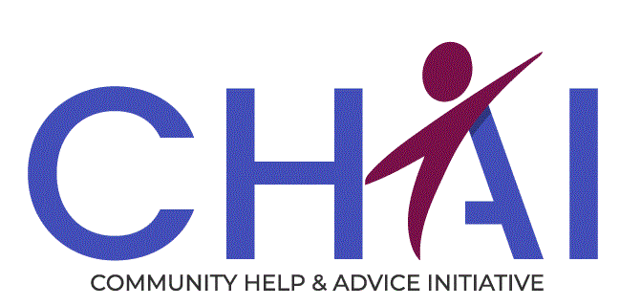
Job Advert

Position: Case Support Worker - Addiction Support
Location: Edinburgh
Salary Range: £23,253
Position Type: Permanent, Full time 35.75 hrs per week
Closing Date: 3rd of July 2023

Do you want to help alleviate poverty and improve the lives of people affected by addiction.

Within the UK there is over £19bn a year in unclaimed welfare benefits, and in Edinburgh an estimated 80,000 are living in relative poverty.

Are you:
- Passionate and committed to making a meaningful difference for individuals affected by addiction.
- Able to assist the Welfare Right & Housing Adviser in supporting people.
- Able to grow trusting relationships in a formal setting.
- Understanding of people’s journeys and the challenges they have had in their lives, and how poverty and addiction can have an impact on them.

As a Case Support Worker in CHAI You will :
- Provide high quality practical support focused on welfare rights and housing to people with addictions.
- Provide support within a range of setting from Recovery Hubs and local community venues.
- Conduct meetings with clients either in person, on the telephone or virtually.
- Facilitate better outcomes for people which will help improve their financial situation and their mental and physical health.
We offer the following:
- Extensive training programme
- Flexible working
- Access to Simply Health benefit plan
- 32 days annual leave (inclusive of public holidays)
- Enrolment to NOW Pension Scheme
- Supportive work environment
- Opportunities to improve services and make a difference

Applying
Please send your CV and a covering letter detailing why you are interested in the post and how your knowledge, skills, experience and personal qualities will fulfil the job description and person specification to:
Email : recruitment@chaiedinburgh.org.uk
Job Description
Job Title: Case Support Worker - Addiction Support
Location : Edinburgh
Reporting to: Service Manager
Position Type: 35.75 hours per week (Fulltime–permanent)
Salary Range: £23,253 (Full time), Part time pro rata depending on hours)

Job Purpose
To Assist Welfare Rights & Housing Advisers in their duties of Providing high quality advice and representation to individuals affected by addiction on income maximisation, welfare benefits, housing and money, in line with the Scottish National Standards for Information and Advice Providers.
The Support will be provided within a range of settings from Recovery Hubs and local community venues.
By joining our team, you will be helping alleviate poverty and improve individuals, families and children’s lives and ensure our Vision is fulfilled, in that no one in our communities endures hardship.
Role and Responsibilities
Support
- Support Advisers in their duties of providing high quality accurate advice, information and representation in line with the Scottish National Standards for Information and Advice Providers.
- Build positive trusting relationships with individuals affected by addiction.
- Provide practical support to service users on budgeting.
- Support people to access bank accounts.
- Support people to access and maintain welfare benefits.
- Conduct meeting with people either in person, telephone or virtual.
- Maintain accurate records and fully utilise the Advice Pro recording system.
- Assist Advisers with ongoing advice casework.
- Communicate effectively with third parties on behalf of people we support.
- Signpost people to relevant specialist support services were appropriate.
- Maintain accurate computer records in line with CHAI procedures and ensure all client mandates are in line with Data protection legislation.
Service Development
- Support the development of services within their various locations, through maintaining positive relationships with our partner organisations; health care professionals, community link workers, social workers, and support workers.
- Promote the service and represent CHAI to other agencies.

Personal Development
- Actively participate in all training sessions provided.
- Keep accurate individual training records.
Organisational
- Adhere to the policies and procedures of CHAI.
- Actively participate in Team and Organisational meetings
- Participate in the development of CHAI services .
- Feedback on the review of organisational policies and procedures.
- Promote and represent CHAI services positively.
- Perform other reasonable related duties as required.
We offer the following
- Flexible working
- Access to Simply Health benefit plan
- 32 days annual leave (inclusive of public holidays)
- Enrolment to NOW Pension Scheme
- Extensive training programme
- Supportive work environment
- Opportunities to improve services and make a difference

CHAI (Community Help & Advice Initiative
28 Westfield Avenue Edinburgh EH11 2QH
Tel: 0131 442 2100
Fax: 0131 443 5891
Email: chai@chaiedinburgh.org.uk
Web: www.chaiedinburgh.org.uk

Person Specification
Case Support Worker
Essential | Desirable
Qualification
- Wiling to work towards SVQ 3 in Social Care | - SVQ level 3 in social care
Knowledge, Skills & Experience
- Experience of developing trusting relationships in a formal setting.  - Ability to work independently and use own initiative and work collectively as part of a team.  - Experience of working with vulnerable groups.  - Ability to prioritise workload.  - Excellent communication and networking skills.  - Ability to follow policies, procedures and processes.  - Excellent literacy and numeracy skills, and the ability to write clear and comprehensive case notes.  - High level of computer literacy.  - Understanding of the welfare benefits system.  - Ability to research problems and find solutions.  - Ability to interact positively with colleagues and networks across a range of levels. | - Experience of providing high quality support to people .  - Experience of working within a social care environment.  - Awareness of legislation in safeguarding , health & safety and data protection.  - Advocacy skills.  - Knowledge of using a case management system e.g. AdvicePro.  - Good knowledge of support agencies in Edinburgh.  - Understanding of trauma informed practice.
Personal Qualities
- Passionate and committed to making a meaningful difference for individuals, families and children.
- Understanding of peoples journeys and the challenges they have had in their lives, and how poverty can have an impact on them.
- Demonstrate commitment to a person centred approach.
- Pro-active approach to identifying client needs and accommodating them.
- Flexible approach to the working environment.
- Ability to work under pressure.
- Ability to keep knowledge and skills up to date and be motivated to do so.
Other
Will be required to obtain a Protection of Vulnerable Groups Scheme Record Disclosure

