

APPLICATION PACK
Learning Manager

APPLICATION PACK

Head of Area Support and
Community Improvement

Supporting

Training

Recruiting





Improving outcomes for children and young people

Contents


Introduction from the National Convener……………………………………………..3
About us……………………………………………………………………………………….……….4
Our values……………………………………………………………………………………………..5
Completing your application………………………………………………………………….6
Application & Equality monitoring form link and instruction …………………7
Job Description………………………………………………………………………………………9
Person Specification……………………………………………………………………………..12


INTRODUCTION FROM THE NATIONAL CONVENER


Dear applicant

Thank you for expressing an interest in working with Children’s Hearings Scotland.

As an organisation that works within the Children’s Hearings System, we are passionate about making a positive contribution to improving the outcomes of Scotland’s children and young people.

Our vision is of a Children’s Hearings System where everyone works together, making sure that all children and young people are loved, cared for and protected and that their views are heard, respected and valued. In the coming year, we will be rolling out a range of projects that will see us transform the way we work helping us to achieve our vision – it is a truly exciting time to join Children’s Hearings Scotland.

It is an enormous privilege to lead this organisation and we are committed to shaping a modern twenty-first century Children’s Hearings System that meets the needs of Scotland’s children and young people.

Good luck with your application.



Elliot Jackson
National Convener/Chief Executive

ABOUT US

Children’s Hearings Scotland recruits, trains and supports around 2,500 skilled volunteer Panel Members who sit on children’s hearings and make decisions with and for vulnerable children and young people across Scotland.

Our organisation is also responsible for supporting a network of 22 volunteer led Area Support Teams. Our Area Support Teams are made up of around 400 people who support Panel Members at a local level.

Children’s Hearings Scotland is undergoing an exciting period of reform designed to deliver a step change in improving the outcomes for infants, children and young people who need us most.
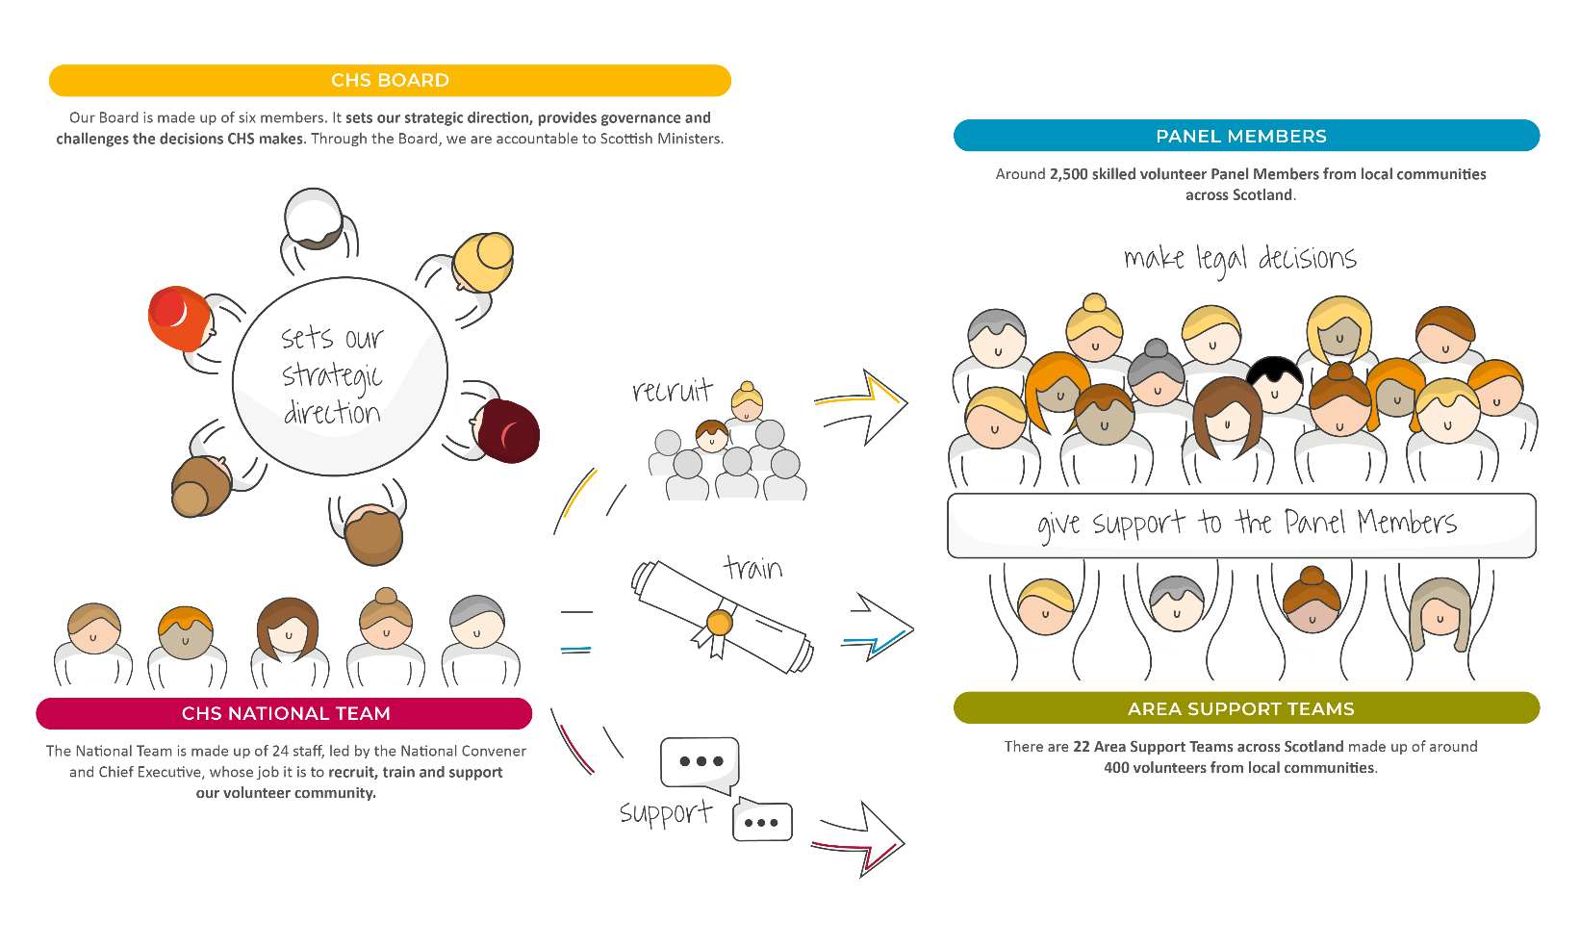

OUR VISION

Our vision is of a Children’s Hearings System where everyone works together, making sure that all children and young people are loved, cared for and protected and their views are heard, respected and valued.

OUR VALUES

Our values sit alongside are vision and mission and are threaded throughout everything we do.
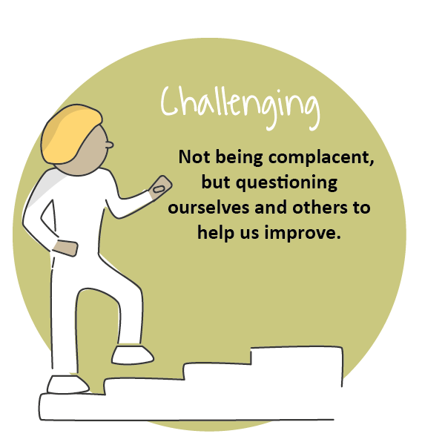
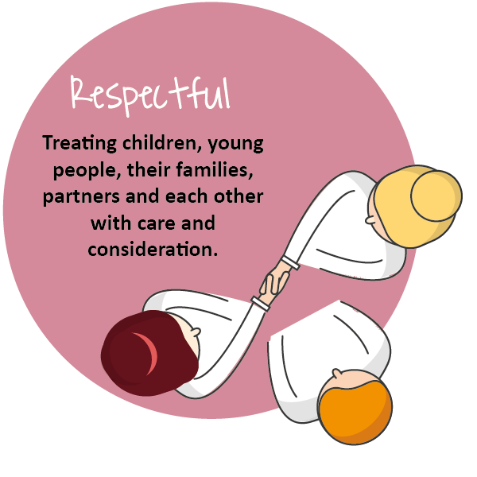
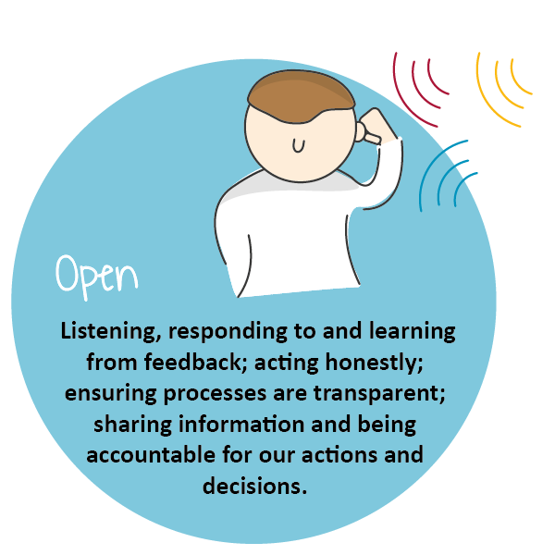
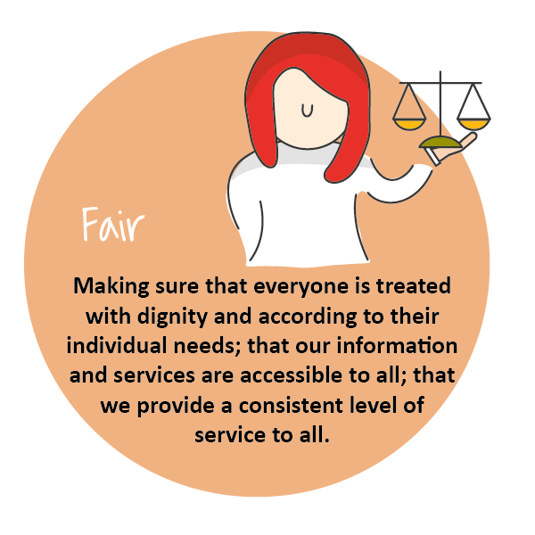
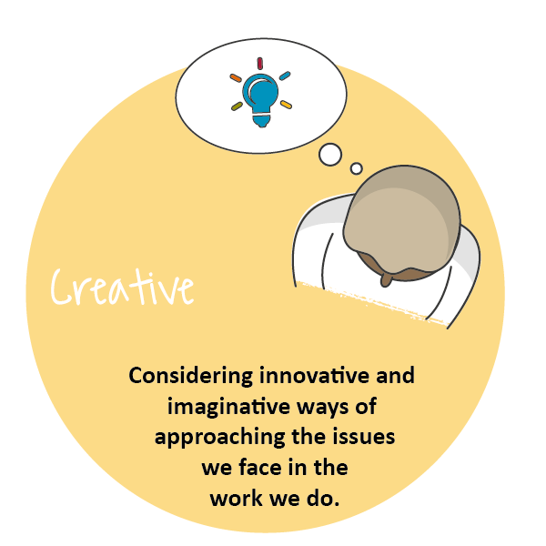
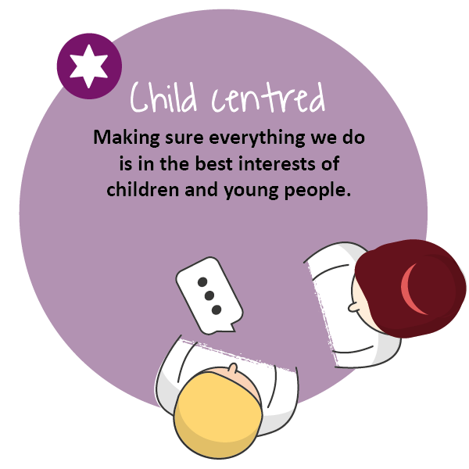

COMPLETING YOUR APPLICATION

Thank you for your interest in joining our team at Children’s Hearings Scotland (also known as CHS).

This application form has been designed to ensure compliance with legislation and best practice. The processing of all information will be in accordance with the requirement of the Data Protection Act 2018. The information you provide on your application form will only be used as part of the selection procedure and for any subsequent employment administration if your application is successful.

For further details on how your information will be handled please refer to our privacy statement. If any part of the form is unclear, please contact us via: jobs@chs.gov.scot

We are striving to be an equal opportunities employer with a diverse workforce which is representative of the population we serve. We are committed to embedding a culture of equality and diversity into our organisation and ensuring that all job applicants and employees are treated fairly, without discrimination because of age, disability, gender reassignment, marriage or civil partnership status, pregnancy and maternity, race, religion or belief, sex, sexual orientation or any other factor.

At the end of the application form you will find our Equal Opportunities Monitoring Survey which is intended to assist CHS in maintaining equal opportunities best practice and in identifying equality barriers for job applicants. We would be grateful if you would complete it.

Employees of CHS are required to adhere to a detailed our Staff Code of Conduct. Key principles in this are that staff:
- Act in the best interests of CHS
- Are Honest
- Are Selfless
- Have Integrity and Respect.

Prior to employment, all applicants will undergo pre-employment background checks in line with the Scottish Government’s Baseline Personnel Security Standards. We may contact previous employers, educational providers, fraud prevention bodies, local authorities and government agencies as part of this process. We may also use background screening companies.

Please complete the form as fully as you can. If you would prefer to submit your application in handwritten or alternative format, please contact our Jobs Mailbox, so that arrangements can be made.

Please email your completed application form to: jobs@chs.gov.scot no later than the closing date of . Applications received after this time will not be considered.

Guidance on filling in the online application form
The form has been designed to help both the applicants and our resourcing team process applications quickly, efficiently, and on a variety of devices. This application can be accessed on any device.
The application sections are detailed below. We would advise you to read over them and have your information prepared on separate document you can cut and paste from (such as your CV and a covering letter) as once you start the application, you will not be able to save it and return to complete it at a later stage. CHS does not accept CV’s, please ensure you include all relevant information on this form.

Section 1
- Personal Information: Please note that only your surname is required in full. Give only the initials of your first name(s).

Section 2
- Education and Training: This section asks about your education and job related training. Please give us enough details to assess your attainments in relation to the post for which you are applying. Continue on a separate sheet if necessary. We need a minimum 3 years’ job related/education history.

Section 3 – 7
- Work Experience: This section asks about your work experience with a separate section for each relevant role. We have supplied space for your post recent post as well as four previous roles.. Again, please give as much detail as you feel gives us an accurate picture, both about the type of work you are/were doing and the responsibilities you have/had. Please start with the most recent, supplying exact dates where possible.

Section 8
- Supplementary Information: Please detail any further experience or information relevant to the post for which you are applying, considering the information you have been given about the post, for example the job description, person specification etc. Try to ensure you are clear about how you meet the essential criteria listed.

Section 9
- General Information: You are asked to tell us if you are relate d to any member of CHS’ staff or Board. This is to ensure compliance with CHS’ Code of Conduct Policy. You are asked to tell us if you are currently eligible for employment in the UK. This is so that we can ensure compliance with the Immigration Act 2014, Asylum and Immigration Act 1996 and Immigration, Asylum and Nationality Act 2006 which requires organisations to ensure individuals, to whom they are offering employment, have permission to work in the UK – please visit: https://www.gov.uk/check-uk-visa if you are unsure of your status. If you are invited to interview you will be required to produce such evidence.
- CHS works with vulnerable persons under the age of 18 and we are required by The Protection of Vulnerable Groups (Scotland) Act 2007 to ensure that all of the staff we employ are suitable to work with persons under 18 or with their data. CHS is also an exempted body for the purposes of the Rehabilitation of Offenders Act 1974 (Exceptions) Order 1975. CHS is required to take into account, prior to offering employment, any information of any spent and unspent convictions that may be relevant to the post for which you are applying. No unconditional offer of employment will be made until a satisfactory Protecting Vulnerable Groups (PVG) clearance has been received.
- If you are the successful candidate for the post you will be asked to complete a pre-employment health questionnaire. This questionnaire will be screened by CHS’ Occupational Health Provider, who may ask you to attend for consultation. Formal offers of employment will be made once CHS’ Occupational Health Provider has assessed the individual as “Fit to work” and where appropriate any reasonable adjustments have been implemented.

Section 10
- References: We request three professional references. References will only be taken up if you are short listed. Please indicate if you do not wish your referee(s) to be contacted at this stage, however, please note that no unconditional offer of employment will be made until satisfactory references have been received.

Section 11
- Declaration: You are asked to declare the information you provided is true to the best of your knowledge. If you have any questions or concerns please contact us at lobs.chs.gov.scot

Section 12
- Equality Monitoring: The information in this survey will be used for monitoring purposes only. Your responses are voluntary but the more information you supply, the more effective our monitoring of responses will be.

- This information will only be viewed by the CHS Resourcing Team and is not connected to your application form and will not be used to identify you. It will not be seen by anyone involved in interviewing or shortlisting and will be stored securely in line with the principles of the Data Protection Act 2018. Monitoring will help to improve our recruitment processes and enable us to be as inclusive an employer as possible.

- Please select the most applicable option in the questions and complete the open boxes where relevant. We would be grateful if you would fill in this survey

APPLICATION FORM

https://forms.office.com/e/i5r5HkBNUT

JOB DESCRIPTION

Reports to: | Director of Positive Outcomes
Direct Reports | National Training Lead (2 FTE)* 1 x FTE is a Future role
JD Last Updated | April 2023
Role Last Evaluated | April 2023

OVERVIEW OF ROLE
Reporting to the Director of Positive Outcomes, the role holder will be responsible for the implementation of a modern and refreshed 5 year Learning and Development strategy. The role holder will focus on building on the foundation work that has already been done, to further develop and evolve CHS’s Learning culture and Learning Academy brand in order to ensure the delivery of strategic priorities.

The role holder will explore innovative and effective delivery mechanisms for learning that enables higher rates of flexible participation across the CHS community to drive forward maximum participation and engagement across Tribunal members fostering a culture of learning across the organisation.

The role holder will be responsible for delivering a comprehensive national curriculum to ensure quality training to the Tribunal Member community taking full account of current and future assessed internal and external needs to support the right skills, knowledge and behaviors across the Tribunal Member community.

The role holder will play a crucial role in evaluating the uptake, impact and relevance of the learning strategy and delivery mechanisms to ensure enhanced performance and a culture of continuous improvement.

MANAGEMENT ACCOUNTABILITIES
- Be a role model for effective and positive management which is results driven and future-oriented;
- Promote a culture of cohesive and responsive service provision through effective management of direct reports;
- Provide ongoing feedback, mentoring, advice and coaching to direct reports, supporting skills development, continuous improvement and increased competencies through an effective performance management framework;
- Lead the delivery of a comprehensive national curriculum across the Tribunal Member Community in order to ensure quality training, knowledge growth and upskilling in order to achieve the best interventions and outcomes for infants, children, young people and their families;
- Represent the organisation as delegated by the Director of Positive Outcomes.

OPERATIONAL MANAGEMENT ACCOUNTABILITIES
The role holder through their team(s) will have accountability for:
- Overseeing identification of learning needs across the Tribunal Member community, working with the National Training Lead(s) and other key functions and regions to understand our short and long-term capability and skills needs;
- Ensuring training delivery to Tribunal members encompasses the legal and regulatory framework within which they must operate;
- Ensuring a quality and engaging Induction/Onboarding process for all new recruits to ensure new starts are upskilled in the best way and tailored to individual learning styles;
- Delivery of efficient learning to provide the right knowledge and instil the right behaviours to the whole community;
- Ensuring the consistency of learning across the organisation;
- Providing continuous development to allow Tribunal panel members’ knowledge to stay current and relevant;
- Assessing the effectiveness of learning and provided with follow up or alternative development as required to fill any knowledge gaps allowing for effective feedback on both on training and learning needs;
- Ensuring the evaluation and impact measurement of learning interventions to demonstrate strategic value and return on investment.

CORE ACTIVITIES
- Ensuring a robust yet agile learning needs process is in place to identify what critical skills and capabilities are required to deliver our strategic priorities, development of CHS’s learning culture and demonstrate development commitment to our Tribunal Members;
- Engage, influence and work collaboratively with the National Training lead(s), the Quality Manager and wider regions/functions to ensure best practice and learning interventions are being shared, partnerships developed, and effective ways of working are implemented to drive the best return on investment for the organisation;
- Working with the Director of Positive Outcomes to lead and implement the Tribunal skills agenda, supporting on development and delivery of key learning initiatives;
- Undertake effective research, framing and scoping activities and identify the right learning solutions and programmes to build strong capabilities and skills within the Tribunal member community;
- Work closely with the National Training Lead(s) to build blended learning programmes and support engagement with the Learning Academy including promotion and evolution of the brand to relevant stakeholder groups;
- Work in collaboration with the Wellbeing Manager to support a culture of reflective learning and to offer additional development interventions as required to enable individual reflection and development of learning needs;
- Work in collaboration with the Digital team to ensure the Learning Strategy is fully aligned with the Digital Strategy to ensure seamless delivery and data-gathering through common and consistent channels and MI platforms;
- Identify and develop strong partners to support in the development and delivery of learning interventions, managing relationships, performance, and budgets closely;
- Keep up to date and research new learning and development technologies and trends, showcasing any that will deliver more effective ways of working or efficiencies for the organisation.

COMPETENCY FRAMEWORK/ PERSON SPECIFICATION

MANAGEMENT/PERSONAL EFFECTIVENESS COMPETENCIES

COMPETENCY AREA | KEY SKILLS
Managing change | - Good project/change management skills and able to guide others in the effective management of organisational change programmes and projects;  - Ability to sustain performance under conditions of rapid change;  - Supporting others through change and having the willingness and ability to enable changes to take place in the most productive way;  - Ability to use data / MI to manage team improvements.
Teamwork and Collaboration | - Effectively initiates dialogue across teams, levels, departments recognising that we have a shared responsibility to provide the best experience for our colleagues and wider stakeholders;  - Recognises the value of every contribution and area of expertise within the organisation. This includes building links and networks across teams (internally and externally);  - Creates a supportive team environment by listening and responding to others and creating opportunities for innovation and generation of ideas and actions.
Managing People | - Effectively manage, motivate and empower team(s);  - Build and maintain high performing team(s);  - Effectively promote a culture of employee engagement and empowerment;  - Able to deal with managing the performance of people and people issues effectively;  - Coach and mentor others;  - Drive positive outcomes through people.
Communication | - Excellent influencing and negotiation skills;  - Ability to communicate effectively in 1:1 and group settings;  - Excellent report writing skills, including an ability to prepare high level reports to Senior Management.
Personal Integrity | - Encourages and supports open two-way communication;  - Is motivated by values and getting on with the job;  - Shows resilience that enables the team to perform to the highest standards;

FUNCTIONAL/TECHNICAL COMPETENCIES

COMPETENCY AREA | KEY SKILLS
Computer literacy | - High level of proficiency with Microsoft office (Outlook, Word, Excel, and PowerPoint)  - Familiarity with Learning Management Systems (LMS) would be advantageous

TRACK RECORD/EXPERIENCE

Experience (typically 3 years+) of managing a Learning / OD Function
Track record (typically 3 years +) of effectively managing multi-disciplinary teams
Track record (typically 3 year +) of effectively developing and implementing a learning agenda/strategy, working with a broad range of stakeholder groups;
Track record (typically 3 year +) of being able to pivot strategy and respond to changing technologies to support continuous improvement and growth across an organisation
Experience (typically 3 years +) of delivering effective learning and development methods, technologies and training programmes involving engagement with complex stakeholder groups
Experience (typically 3 years +) of using management information to support business planning and improvement

EDUCATIONAL ATTAINMENT/ QUALIFICATIONS
Educated to degree level or equivalent in a related qualification

PROFESSIONAL BODY MEMBERSHIP
N/A

OTHER REQUIREMENTS FOR THE ROLE
Experience of E-Learning design and use of E-Learning platforms/packages would be advantageous;

Thank you for your interest in this position

