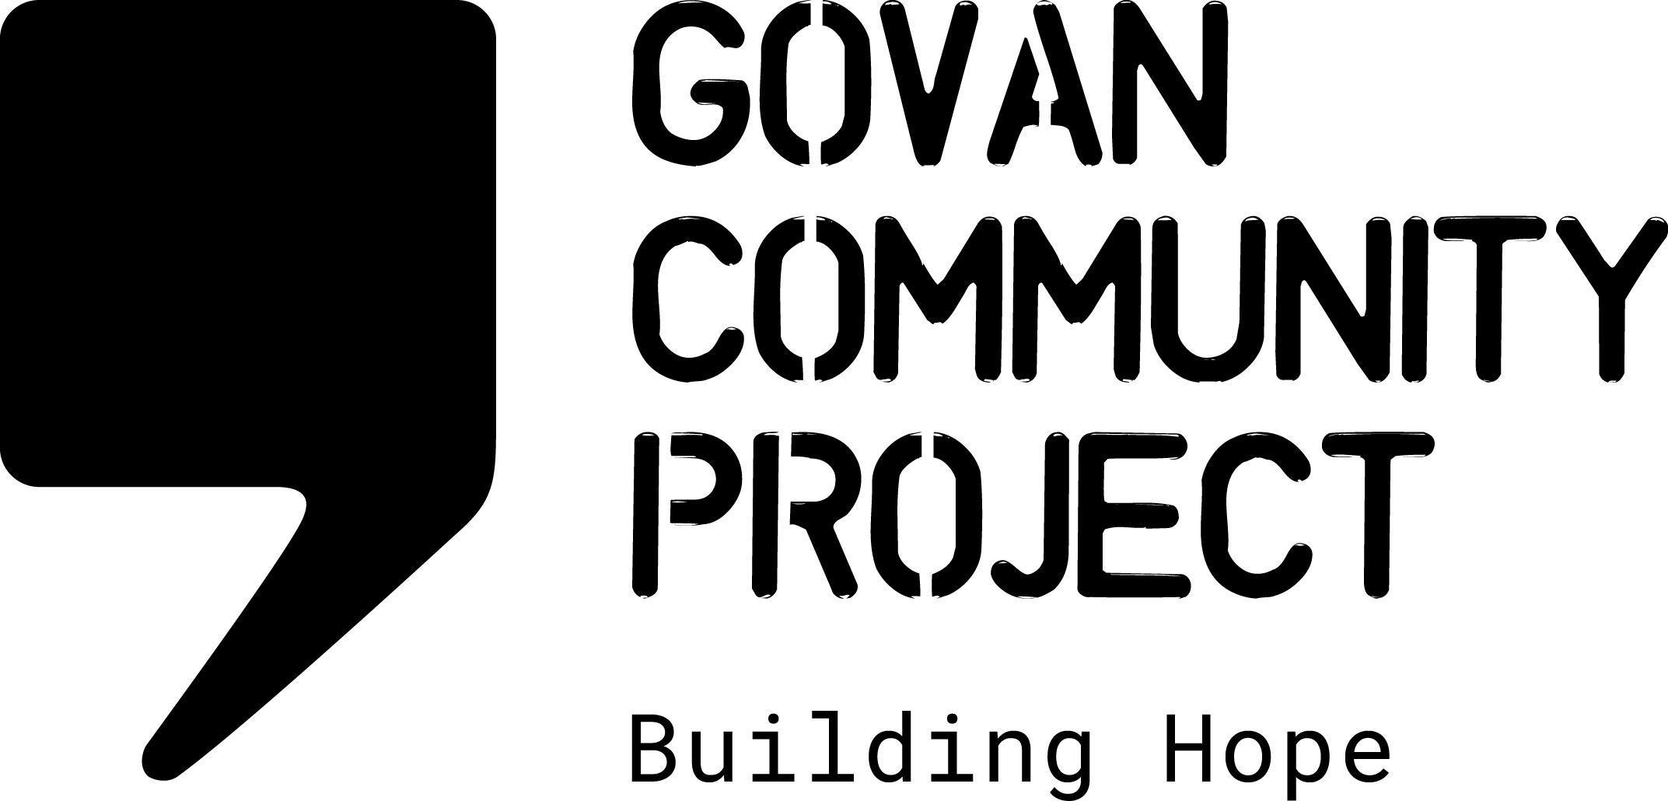
JOB DESCRIPTION

Job Title: | Group Coordinator
Location: | Govan , Glasgow
Hours Per Week: | 21 hours per week
Salary Scale: | £23,634 pro rata
Reporting To: | Communities Team Service Manager
Responsible For: | Volunteers & group participants

PROJECT OVERVIEW

GCP previously worked closely with the Scottish Government & COSLA supporting individuals with lived experience of the impact of No Recourse to Public Funds to coproduce the Scottish Government’s Ending Destitution Together Strategy.

The 3 year strategy is now in its final year of implementation and GCP will be working with the Scottish Government to support and develop an inclusive forum which will facilitate the involvement of experts by experience in informing evaluation of the impact/effectiveness of the strategy for those with lived experience.

OVERALL PURPOSE OF THE JOB

The Group Coordinator will work collaboratively with partners engaging with individuals experiencing the impact of NRPF to recruit group participants ensuring cross sectional representation from different communities impacted by NRPF.

The group coordinator will be responsible for coordinating training and support which will empower people with lived experience of NRPF to participate in focus groups and workshops with representatives from Scottish Government and COSLA/ The coordinator will be responsible for facilitating group meetings and ensuring practical and wellbeing support is in place to mitigate barriers to participation for group members.

MAIN DUTIES AND RESPONSIBILITIES

Engagement Activities

- Work with partners to recruit group participants with lived experience of NRPF and destitution, ensuring cross sectional representation
- Work with colleagues and partners in developing and delivering activities for the group.
- Identify personal development/support needs of group members
- Develop workshops for group members to support skills development/empowerment
- Provide regular 1:1 support for group members and coordinate regular group wellbeing support sessions.
- Develop a programme of engagement activities which provide a safe, nurturing and mutually enquiring space for focussed discussions on the implementation and effectiveness of Ending Destitution Together
- Support group members to represent the group’s work to the Ending Destitution Advisory Panel

Information & Communication

- Work collaboratively with GCP Comms Officer to develop accessible materials which support recruitment of group members
- Produce information/workshop materials which are accessible to participants inclusive communication needs
- Coordinate regular updates/information sharing sessions

Reporting, Monitoring and Evaluation

- Work with group members to identify the personal outcomes they wish to gain from participating in the project
- Gather quarterly individual feedback from group participants
- Organise evaluation focus groups with participants and stakeholders
- Provide bi-annual updates for the Advisory Panel
- To provide quarterly reports to Head of Charity
- Develop case studies and pictorial evidence of activities

Other Duties

- Work as part of the staff team to maintain and promote the values and ethos of Govan Community Project.
- Adhere to all organisational policies and procedures.
- Work with the staff team to contribute towards providing a safe, welcoming, clean and tidy environment for staff and visitors.
- Attend team meetings and contribute to strategic development.
- Perform any other tasks or duties deemed necessary.

Occasional Weekend or Evening Work may be necessary in this post

PERSONAL SPECIFICATION

Essential

- Knowledge and understanding of the current impact of destitution and NRPF in Scotland on the communities this effects
- Knowledge of the current policy landscape in Scotland and the UK in relation to immigration
- Experience of working with people who are experts through their experience
- Ability to listen, engage and empower individuals
- Excellent group facilitation skills, including working with groups using a trauma informed approach
- Experience of collaborating with a range of stakeholders
- Ability to present information in a clear and compelling way
- Experience of working with language/communication barriers in a group setting
- Knowledge and understanding of human rights & equalities and social justice issues
- Ability to work autonomously and as part of a team
- Excellent time management skills and the ability to adapt priorities across a range of tasks and responsibilities

Desirable

- Knowledge of the NRPF community in Scotland
- Lived experience of destitution through NRPF
- Experience working with interpreters
- Knowledge of support available to individuals in crisis
- A good spoken level of a relevant second language, e.g. Arabic or Farsi .

