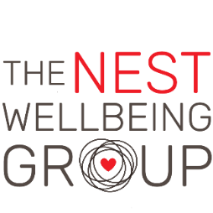

Recruitment Application Form
POSITION APPLIED FOR: Recovery Coordinator

1. Personal Details
First name (s): | Surname:
Contact tel no: | Email:
Home address:

2a. First Referee
Current or most recent employer
Full name: | Position:
Contact tel no: | Email:
Organisation & contact address:

2b. Second Referee
Full name: | Position:
Contact tel no: | Email:
Organisation & contact address:

3. Declaration
Please sign this declaration after you have completed all parts of the form.

I declare that to the best of my knowledge and belief all the information I have provided in this application form is complete and true. I understand that any false or misleading statement or any significant omission may disqualify me from employment and render me liable to dismissal.

I consent to the above data being held and processed for the sole purpose of recruitment and selection within The Nest Wellbeing Group and being retained for a period of 6-months should my application be unsuccessful. I also consent to references being taken from the referees detailed in section 2 above, in the event of me being offered the position applied for at The Nest Wellbeing Group. All data provided is treated in confidence and processed in accordance with the General Data Protection Regulation (GDPR).

Signed: Dated:

4. Special Requirements
Please list below any special requirements or reasonable adjustments if you are disabled that you may have if
you are invited to an interview.

This space is intentionally blank, so that the first/second page can be removed
when sifting applications.

5. Qualifications

From-To | Educational Institute  (School, college, university) | Qualification  (subject / level obtained)

6. MEMBERSHIP OF PROFESSIONAL BODIES
Name of professional body (please list any)

7. EMPLOYMENT HISTORY
Please list chronologically, starting with current or last employer

Employer’s name | Dates of employment:  From:  To: | Post held | Reason for Leaving

8. Voluntary work (300 words limit)
Please tell us about any relevant voluntary work you have done

9. Supporting Information
Please tell us about your skills and experience, demonstrating that you meet the competencies in the
person specification. Please set these out clearly against the essential and desirable criteria.
(1000 words limit)

10. What has attracted you to apply for this post? (500 words limit)

11. Is there anything else you want us to know in support of your application? (300 words limit)

Please complete this form electronically and return applications to
hello@thenestwellbeinggroup.co.uk
on the 14/07/23 (closing date).
(Late applications will not be considered)
Do not attach a CV with your application as this will not be considered.

