

APPLICATION PACK
Change Delivery Manager

APPLICATION PACK

Head of Area Support and
Community Improvement

Supporting

Training

Recruiting





Improving outcomes for children and young people

Contents


Introduction from the National Convener……………………………………………..3
About us……………………………………………………………………………………….……….4
Our values……………………………………………………………………………………………..5
Completing your application………………………………………………………………….6
Application & Equality monitoring form link and instruction …………………7
Job Description………………………………………………………………………………………9
Person Specification……………………………………………………………………………..12


INTRODUCTION FROM THE NATIONAL CONVENER


Dear applicant

Thank you for expressing an interest in working with Children’s Hearings Scotland.

As an organisation that works within the Children’s Hearings System, we are passionate about making a positive contribution to improving the outcomes of Scotland’s children and young people.

Our vision is of a Children’s Hearings System where everyone works together, making sure that all children and young people are loved, cared for and protected and that their views are heard, respected and valued. In the coming year, we will be rolling out a range of projects that will see us transform the way we work helping us to achieve our vision – it is a truly exciting time to join Children’s Hearings Scotland.

It is an enormous privilege to lead this organisation and we are committed to shaping a modern twenty-first century Children’s Hearings System that meets the needs of Scotland’s children and young people.

Good luck with your application.



Elliot Jackson
National Convener/Chief Executive

ABOUT US

Children’s Hearings Scotland recruits, trains and supports around 2,500 skilled volunteer Panel Members who sit on children’s hearings and make decisions with and for vulnerable children and young people across Scotland.

Our organisation is also responsible for supporting a network of 22 volunteer led Area Support Teams. Our Area Support Teams are made up of around 400 people who support Panel Members at a local level.

Children’s Hearings Scotland is undergoing an exciting period of reform designed to deliver a step change in improving the outcomes for infants, children and young people who need us most.
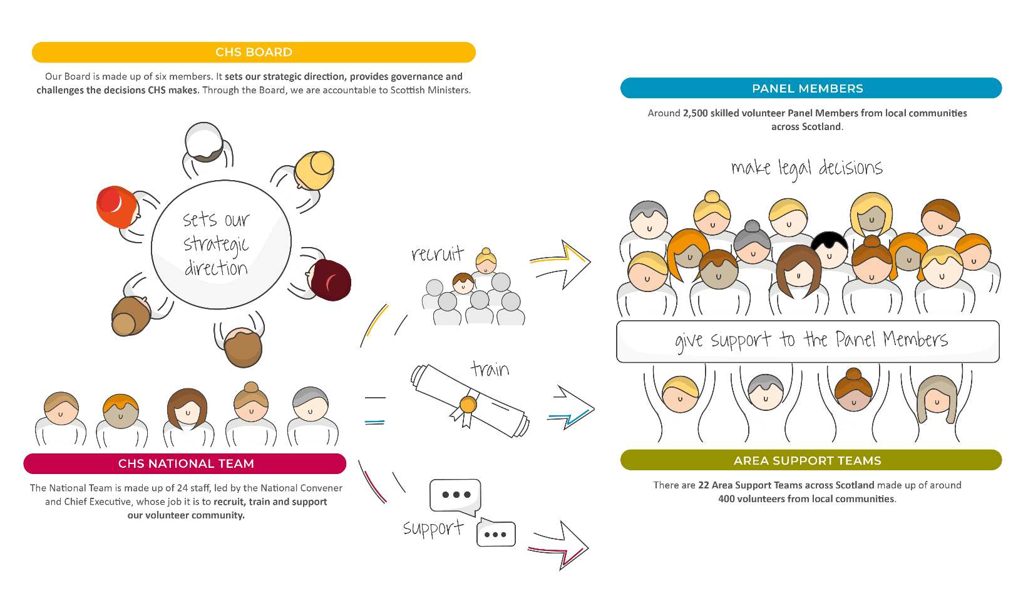

OUR VISION

Our vision is of a Children’s Hearings System where everyone works together, making sure that all children and young people are loved, cared for and protected and their views are heard, respected and valued.

OUR VALUES

Our values sit alongside are vision and mission and are threaded throughout everything we do.
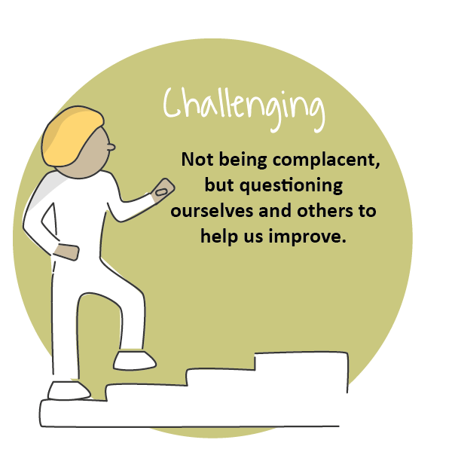
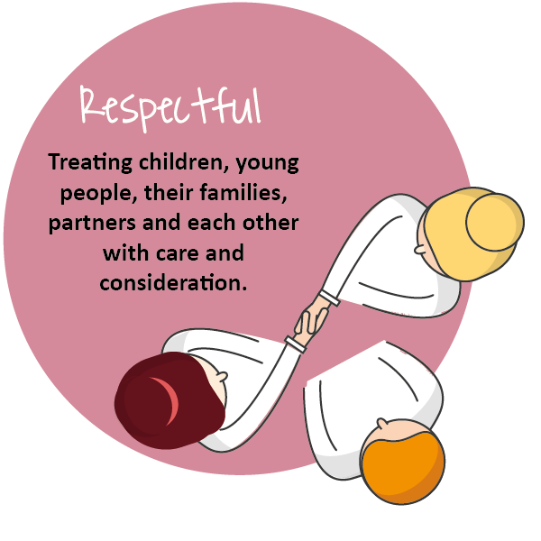
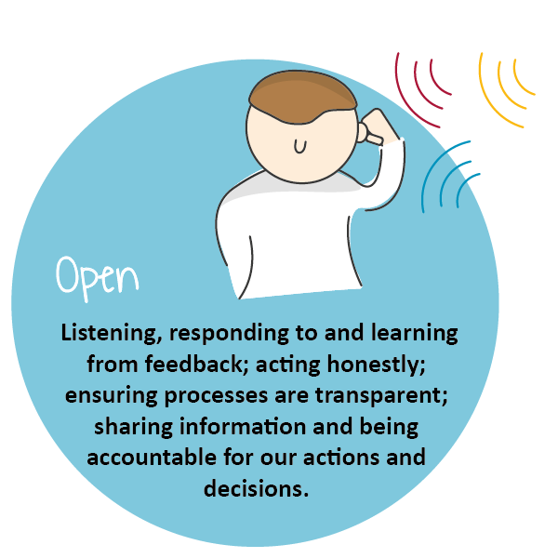
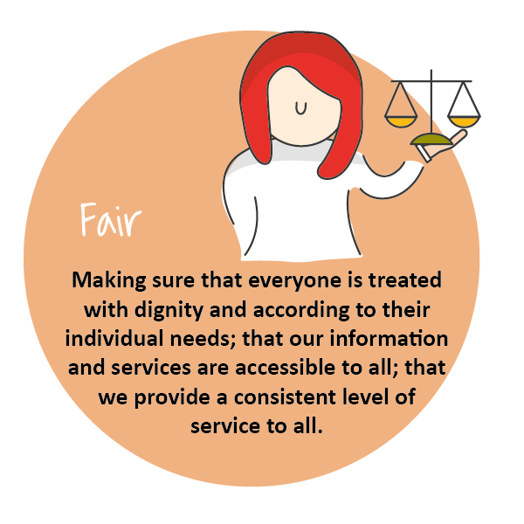
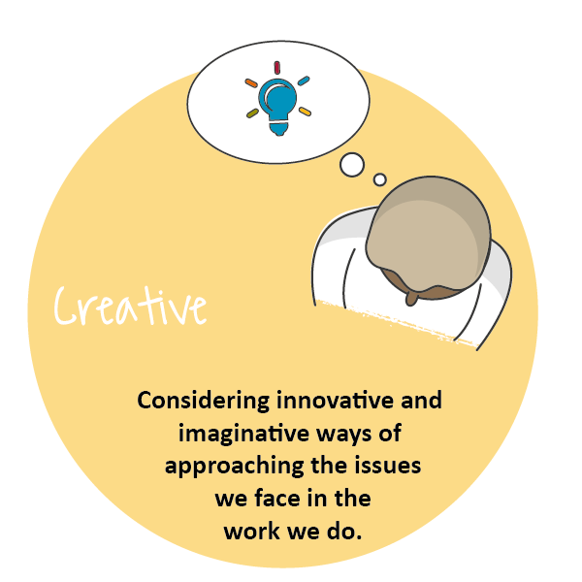
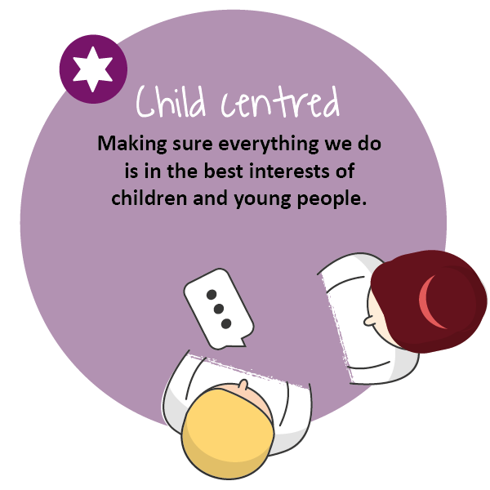

COMPLETING YOUR APPLICATION

Thank you for your interest in joining our team at Children’s Hearings Scotland (also known as CHS).

This application form has been designed to ensure compliance with legislation and best practice. The processing of all information will be in accordance with the requirement of the Data Protection Act 2018. The information you provide on your application form will only be used as part of the selection procedure and for any subsequent employment administration if your application is successful.

For further details on how your information will be handled please refer to our privacy statement. If any part of the form is unclear, please contact us via: jobs@chs.gov.scot

We are striving to be an equal opportunities employer with a diverse workforce which is representative of the population we serve. We are committed to embedding a culture of equality and diversity into our organisation and ensuring that all job applicants and employees are treated fairly, without discrimination because of age, disability, gender reassignment, marriage or civil partnership status, pregnancy and maternity, race, religion or belief, sex, sexual orientation or any other factor.

At the end of the application form you will find our Equal Opportunities Monitoring Survey which is intended to assist CHS in maintaining equal opportunities best practice and in identifying equality barriers for job applicants. We would be grateful if you would complete it.

Employees of CHS are required to adhere to a detailed our Staff Code of Conduct. Key principles in this are that staff:
- Act in the best interests of CHS
- Are Honest
- Are Selfless
- Have Integrity and Respect.

Prior to employment, all applicants will undergo pre-employment background checks in line with the Scottish Government’s Baseline Personnel Security Standards. We may contact previous employers, educational providers, fraud prevention bodies, local authorities and government agencies as part of this process. We may also use background screening companies.

Please complete the form as fully as you can. If you would prefer to submit your application in handwritten or alternative format, please contact our Jobs Mailbox, so that arrangements can be made.

Please email your completed application form to: jobs@chs.gov.scot no later than the closing date of . Applications received after this time will not be considered.

Guidance on filling in the online application form
The form has been designed to help both the applicants and our resourcing team process applications quickly, efficiently, and on a variety of devices. This application can be accessed on any device.
The application sections are detailed below. We would advise you to read over them and have your information prepared on separate document you can cut and paste from (such as your CV and a covering letter) as once you start the application, you will not be able to save it and return to complete it at a later stage. CHS does not accept CV’s, please ensure you include all relevant information on this form.

Section 1
- Personal Information: Please note that only your surname is required in full. Give only the initials of your first name(s).

Section 2
- Education and Training: This section asks about your education and job related training. Please give us enough details to assess your attainments in relation to the post for which you are applying. Continue on a separate sheet if necessary. We need a minimum 3 years’ job related/education history.

Section 3 – 7
- Work Experience: This section asks about your work experience with a separate section for each relevant role. We have supplied space for your post recent post as well as four previous roles.. Again, please give as much detail as you feel gives us an accurate picture, both about the type of work you are/were doing and the responsibilities you have/had. Please start with the most recent, supplying exact dates where possible.

Section 8
- Supplementary Information: Please detail any further experience or information relevant to the post for which you are applying, considering the information you have been given about the post, for example the job description, person specification etc. Try to ensure you are clear about how you meet the essential criteria listed.

Section 9
- General Information: You are asked to tell us if you are relate d to any member of CHS’ staff or Board. This is to ensure compliance with CHS’ Code of Conduct Policy. You are asked to tell us if you are currently eligible for employment in the UK. This is so that we can ensure compliance with the Immigration Act 2014, Asylum and Immigration Act 1996 and Immigration, Asylum and Nationality Act 2006 which requires organisations to ensure individuals, to whom they are offering employment, have permission to work in the UK – please visit: https://www.gov.uk/check-uk-visa if you are unsure of your status. If you are invited to interview you will be required to produce such evidence.
- CHS works with vulnerable persons under the age of 18 and we are required by The Protection of Vulnerable Groups (Scotland) Act 2007 to ensure that all of the staff we employ are suitable to work with persons under 18 or with their data. CHS is also an exempted body for the purposes of the Rehabilitation of Offenders Act 1974 (Exceptions) Order 1975. CHS is required to take into account, prior to offering employment, any information of any spent and unspent convictions that may be relevant to the post for which you are applying. No unconditional offer of employment will be made until a satisfactory Protecting Vulnerable Groups (PVG) clearance has been received.
- If you are the successful candidate for the post you will be asked to complete a pre-employment health questionnaire. This questionnaire will be screened by CHS’ Occupational Health Provider, who may ask you to attend for consultation. Formal offers of employment will be made once CHS’ Occupational Health Provider has assessed the individual as “Fit to work” and where appropriate any reasonable adjustments have been implemented.

Section 10
- References: We request three professional references. References will only be taken up if you are short listed. Please indicate if you do not wish your referee(s) to be contacted at this stage, however, please note that no unconditional offer of employment will be made until satisfactory references have been received.

Section 11
- Declaration: You are asked to declare the information you provided is true to the best of your knowledge. If you have any questions or concerns please contact us at jobs.chs.gov.scot

Section 12
- Equality Monitoring: The information in this survey will be used for monitoring purposes only. Your responses are voluntary but the more information you supply, the more effective our monitoring of responses will be.

- This information will only be viewed by the CHS Resourcing Team and is not connected to your application form and will not be used to identify you. It will not be seen by anyone involved in interviewing or shortlisting and will be stored securely in line with the principles of the Data Protection Act 2018. Monitoring will help to improve our recruitment processes and enable us to be as inclusive an employer as possible.

- Please select the most applicable option in the questions and complete the open boxes where relevant. We would be grateful if you would fill in this survey

APPLICATION FORM

https://forms.office.com/e/Xdk0yrQMpD

JOB DESCRIPTION

Reports to: | Senior Change Delivery Manager
Direct Reports | N/A
JD Last Updated | April 2023
Role Last Evaluated | April 2023

OVERVIEW OF ROLE
The role holder will share collective responsibility for delivering organisational change, through active engagement and collaboration with colleagues at all levels within the organisation and key stakeholders.

The role holder will develop and implement change management strategies and plans that maximise colleague adoption and usage of required changes. These responsibilities include plans and efforts to anticipate and minimise resistant behaviours from colleagues and stakeholders who are impacted by the changes.

The role holder will have specific responsibility for supporting the implementation and embedding of the new operating model for Children’s Hearings Scotland and the associated changes against a set of measurable organisational objectives/actions.

The role holder will work closely with the Programme Management Office to ensure change activities become embedded in the organisation’s measurement, evaluation and performance frameworks.

The role holder will support development of colleague communication and training strategies and other plans critical to the successful introduction of changes to organisation’s processes, systems and technology and will directly support the adoption of the improvement changes required to stabilise, strengthen and transform the CHS operating model.

The role holder will be expected to be an exemplar for the values of CHS including listening to and valuing the voice of children and young people, the contribution of Tribunal Members, and ensuring these are embedded within the change management process to deliver a respected, quality based, and sustainable tribunal system on behalf of the National Convenor.

MANAGEMENT ACCOUNTABILITIES
- Be a role model for effective and positive management which is results driven and future-oriented;
- Lead the delivery of change management strategies that are responsive to the wider organisational and wider stakeholder
- Delivering consistent guidance on the change management process to ensure that CHS National team and Tribunal Members are well supported in their role
- Maintaining and actively promoting an outcome-focus across the organisation and on specific change activities to ensure effective delivery of organisational objectives at pace.

OPERATIONAL MANAGEMENT ACCOUNTABILITIES
- Ensuring appropriate corporate plans are developed and maintained, and delivery monitored and reported on as required;
- Ensuring stakeholders are fully up to date with the information they require to carry out their roles;
- Ensuring there is an effective flow of relevant information between stakeholders in the organisation and that plans are put in place to resolve any operational issues;

CORE ACTIVITIES
- Apply a structured change management methodology, process and tools to support adoption of the changes required by a project or initiative
- Conduct impact analyses, assess change readiness and identify key stakeholders, ensuring the management of the stakeholder relationships in the context of organisational change
- Support the design, development, delivery and management of communications
- Provide input, document requirements and support the design and delivery of training programs to support change projects/initiatives
- Identify, analyse and prepare risk mitigation tactics
- Identify and manage anticipated and persistent resistance
- Consult and coach project teams across the wider organisation
- Create actionable deliverables for core change management plans, Communications Plan, and Training Plan
- Create actionable deliverables for any required "Extend" plans, such as a resistance management plan;
- Support and engage senior leaders in change management activities and provide coaching for the wider organisations people managers
- Define and measure success metrics and monitor change progress.

COMPETENCY FRAMEWORK/ PERSON SPECIFICATION

MANAGEMENT/PERSONAL EFFECTIVENESS COMPETENCIES

COMPETENCY AREA | KEY SKILLS
Managing change | - Good project/change management skills and able to guide others in the effective management of organisational change programmes and projects;  - Ability to sustain performance under conditions of rapid change;  - Supporting others through change and having the willingness and ability to enable changes to take place in the most productive way;  - A strong outcome / delivery focus and the creativity to adapt individual approach in changing circumstances;  - Ability to use data / MI to manage team improvements.
Teamwork and Collaboration | - Effectively initiates dialogue across teams, levels, departments recognising that we have a shared responsibility to provide the best experience for our colleagues and wider stakeholders;  - Recognises the value of every contribution and area of expertise within the organisation. This includes building links and networks across teams (internally and externally);  - Creates a supportive team environment by listening and responding to others and creating opportunities for innovation and generation of ideas and actions.
Communication | - Excellent influencing and negotiation skills;  - Ability to communicate effectively in 1:1 and group settings;  - Excellent report writing skills, including an ability to prepare high level reports to Senior Management.
Personal Integrity | - Encourages and supports open two-way communication;  - Is motivated by values and getting on with the job;  - Shows resilience that enables the team to perform to the highest standards;

FUNCTIONAL/TECHNICAL COMPETENCIES

COMPETENCY AREA | KEY SKILLS
Financial Management | - High level of ability to handle management reporting in relation to change, programme and project management
Computer literacy | - High level of proficiency with Microsoft office (Outlook, Word, Excel, and PowerPoint)  - Familiarity with project management Software

TRACK RECORD/EXPERIENCE

Strong level of experience in Change Management and delivering end-to-end Organisational Change;
Proficient with Process Improvement & Continuous Improvement;
Proven experience & knowledge of change management principles, methodologies and tools;
Experience in change management in big Organisational Transformation Projects;
Proven relationship and Stakeholder Management skills and ability to influence effectively at different organisational levels;
Track record of ability to navigate complex areas, remove blockages and articulate the change from different stakeholder perspectives perspective;
Experience in implementing change within a public sector background.

EDUCATIONAL ATTAINMENT/ QUALIFICATIONS
Educated to degree level or equivalent in a related qualification

Bachelor’s degree or similar level of qualification in organisational change, organisational development or relevant field.

PROFESSIONAL BODY MEMBERSHIP
Membership of one of the major professional bodies or equivalent

OTHER REQUIREMENTS FOR THE ROLE
None

Thank you for your interest in this position

