

APPLICATION PACK
Regional Tribunal Delivery Manager

APPLICATION PACK

Head of Area Support and
Community Improvement

Supporting

Training

Recruiting





Improving outcomes for children and young people

Contents


Introduction from the National Convener……………………………………………..3
About us……………………………………………………………………………………….……….4
Our values……………………………………………………………………………………………..5
Completing your application………………………………………………………………….6
Application & Equality monitoring form link and instruction …………………7
Job Description………………………………………………………………………………………9
Person Specification……………………………………………………………………………..12


INTRODUCTION FROM THE NATIONAL CONVENER


Dear applicant

Thank you for expressing an interest in working with Children’s Hearings Scotland.

As an organisation that works within the Children’s Hearings System, we are passionate about making a positive contribution to improving the outcomes of Scotland’s children and young people.

Our vision is of a Children’s Hearings System where everyone works together, making sure that all children and young people are loved, cared for and protected and that their views are heard, respected and valued. In the coming year, we will be rolling out a range of projects that will see us transform the way we work helping us to achieve our vision – it is a truly exciting time to join Children’s Hearings Scotland.

It is an enormous privilege to lead this organisation and we are committed to shaping a modern twenty-first century Children’s Hearings System that meets the needs of Scotland’s children and young people.

Good luck with your application.



Elliot Jackson
National Convener/Chief Executive

ABOUT US

Children’s Hearings Scotland recruits, trains and supports around 2,500 skilled volunteer Panel Members who sit on children’s hearings and make decisions with and for vulnerable children and young people across Scotland.

Our organisation is also responsible for supporting a network of 22 volunteer led Area Support Teams. Our Area Support Teams are made up of around 400 people who support Panel Members at a local level.

Children’s Hearings Scotland is undergoing an exciting period of reform designed to deliver a step change in improving the outcomes for infants, children and young people who need us most.
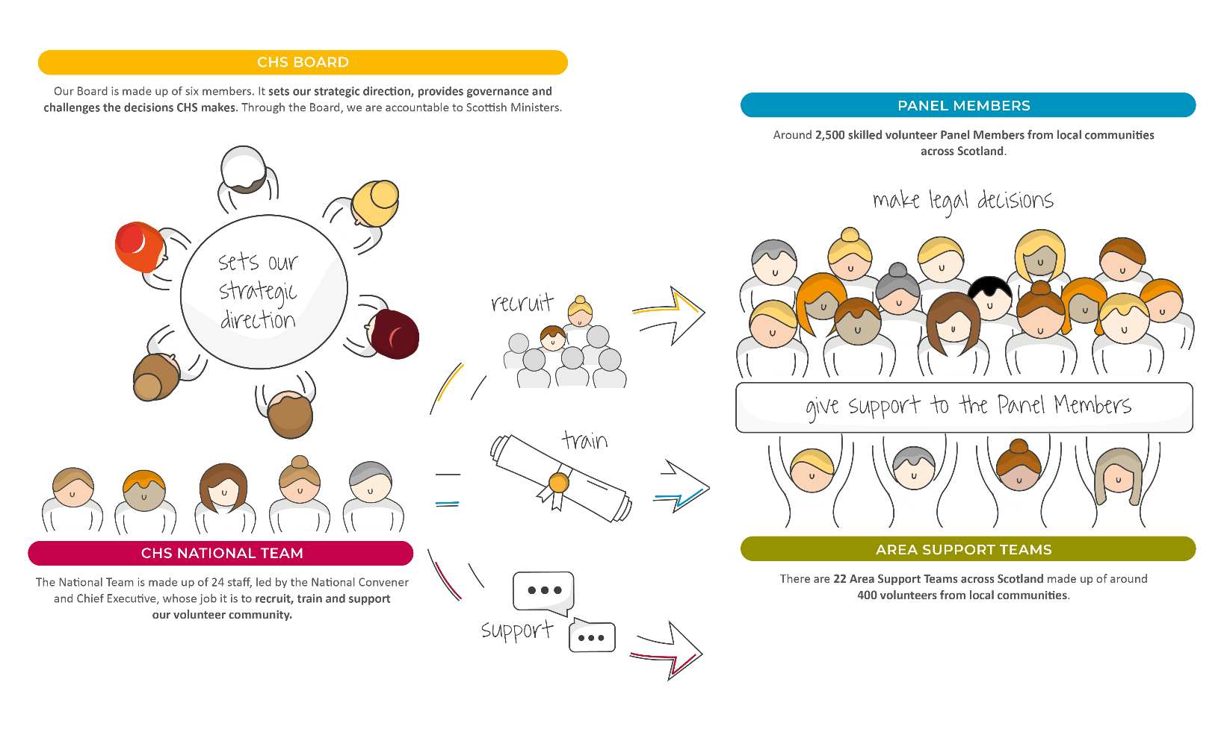

OUR VISION

Our vision is of a Children’s Hearings System where everyone works together, making sure that all children and young people are loved, cared for and protected and their views are heard, respected and valued.

OUR VALUES

Our values sit alongside are vision and mission and are threaded throughout everything we do.
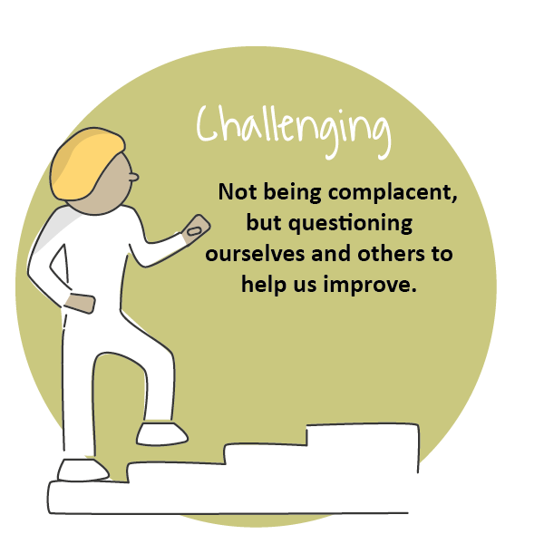
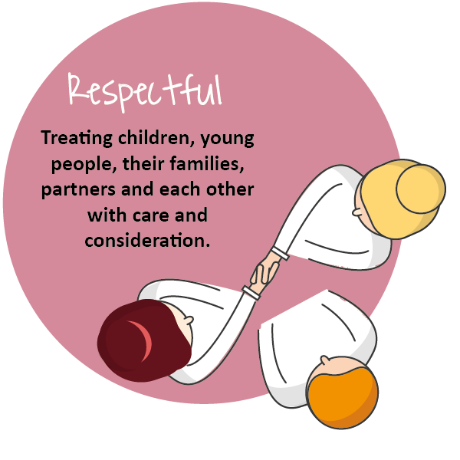
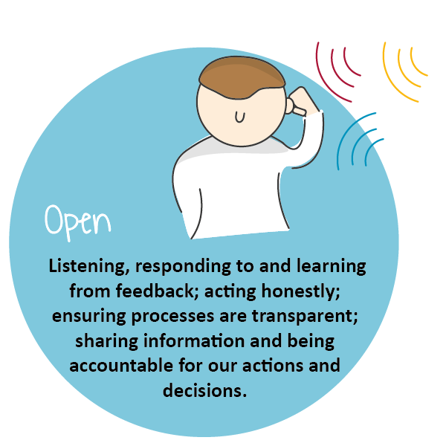
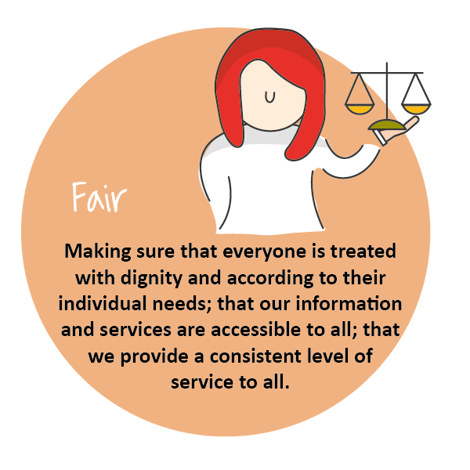

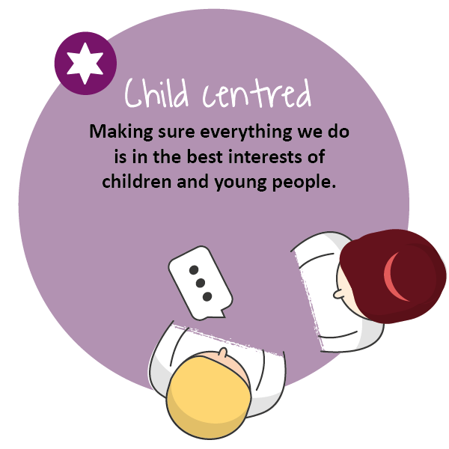

COMPLETING YOUR APPLICATION

Thank you for your interest in joining our team at Children’s Hearings Scotland (also known as CHS).

This application form has been designed to ensure compliance with legislation and best practice. The processing of all information will be in accordance with the requirement of the Data Protection Act 2018. The information you provide on your application form will only be used as part of the selection procedure and for any subsequent employment administration if your application is successful.

For further details on how your information will be handled please refer to our privacy statement. If any part of the form is unclear, please contact us via: jobs@chs.gov.scot.

We are striving to be an equal opportunities employer with a diverse workforce which is representative of the population we serve. We are committed to embedding a culture of equality and diversity into our organisation and ensuring that all job applicants and employees are treated fairly, without discrimination because of age, disability, gender reassignment, marriage or civil partnership status, pregnancy and maternity, race, religion or belief, sex, sexual orientation or any other factor.

At the end of the application form you will find our Equal Opportunities Monitoring Survey which is intended to assist CHS in maintaining equal opportunities best practice and in identifying equality barriers for job applicants. We would be grateful if you would complete it.

Employees of CHS are required to adhere to a detailed our Staff Code of Conduct. Key principles in this are that staff:
- Act in the best interests of CHS
- Are Honest
- Are Selfless
- Have Integrity and Respect.

Prior to employment, all applicants will undergo pre-employment background checks in line with the Scottish Government’s Baseline Personnel Security Standards. We may contact previous employers, educational providers, fraud prevention bodies, local authorities and government agencies as part of this process. We may also use background screening companies.

Please complete the form as fully as you can. If you would prefer to submit your application in handwritten or alternative format, please contact our Jobs Mailbox, so that arrangements can be made.

Please email your completed application form to: jobs@chs.gov.scot no later than the closing date of . Applications received after this time will not be considered.

Guidance on filling in the online application form
The form has been designed to help both the applicants and our resourcing team process applications quickly, efficiently, and on a variety of devices. This application can be accessed on any device.
The application sections are detailed below. We would advise you to read over them and have your information prepared on separate document you can cut and paste from (such as your CV and a covering letter) as once you start the application, you will not be able to save it and return to complete it at a later stage. CHS does not accept CV’s, please ensure you include all relevant information on this form.

Section 1
- Personal Information: Please note that only your surname is required in full. Give only the initials of your first name(s).

Section 2
- Education and Training: This section asks about your education and job related training. Please give us enough details to assess your attainments in relation to the post for which you are applying. Continue on a separate sheet if necessary. We need a minimum 3 years’ job related/education history.

Section 3 – 7
- Work Experience: This section asks about your work experience with a separate section for each relevant role. We have supplied space for your post recent post as well as four previous roles. Again, please give as much detail as you feel gives us an accurate picture, both about the type of work you are/were doing and the responsibilities you have/had. Please start with the most recent, supplying exact dates where possible.

Section 8
- Supplementary Information: Please detail any further experience or information relevant to the post for which you are applying, considering the information you have been given about the post, for example the job description, person specification etc. Try to ensure you are clear about how you meet the essential criteria listed.

Section 9
- General Information: You are asked to tell us if you are related to any member of CHS’ staff or Board. This is to ensure compliance with CHS’ Code of Conduct Policy. You are asked to tell us if you are currently eligible for employment in the UK. This is so that we can ensure compliance with the Immigration Act 2014, Asylum and Immigration Act 1996 and Immigration, Asylum and Nationality Act 2006 which requires organisations to ensure individuals, to whom they are offering employment, have permission to work in the UK – please visit: https://www.gov.uk/check-uk-visa if you are unsure of your status. If you are invited to interview you will be required to produce such evidence.
- CHS works with vulnerable persons under the age of 18 and we are required by The Protection of Vulnerable Groups (Scotland) Act 2007 to ensure that all of the staff we employ are suitable to work with persons under 18 or with their data. CHS is also an exempted body for the purposes of the Rehabilitation of Offenders Act 1974 (Exceptions) Order 1975. CHS is required to take into account, prior to offering employment, any information of any spent and unspent convictions that may be relevant to the post for which you are applying. No unconditional offer of employment will be made until a satisfactory Protecting Vulnerable Groups (PVG) clearance has been received.
- If you are the successful candidate for the post, you will be asked to complete a pre-employment health questionnaire. This questionnaire will be screened by CHS’ Occupational Health Provider, who may ask you to attend for consultation. Formal offers of employment will be made once CHS’ Occupational Health Provider has assessed the individual as “Fit to work” and where appropriate any reasonable adjustments have been implemented.

Section 10
- References: We request three professional references. References will only be taken up if you are short listed. Please indicate if you do not wish your referee(s) to be contacted at this stage, however, please note that no unconditional offer of employment will be made until satisfactory references have been received.

Section 11
- Declaration: You are asked to declare the information you provided is true to the best of your knowledge. If you have any questions or concerns please contact us at jobs@chs.gov.scot

Section 12
- Equality Monitoring: The information in this survey will be used for monitoring purposes only. Your responses are voluntary but the more information you supply, the more effective our monitoring of responses will be.

- This information will only be viewed by the CHS Resourcing Team and is not connected to your application form and will not be used to identify you. It will not be seen by anyone involved in interviewing or shortlisting and will be stored securely in line with the principles of the Data Protection Act 2018. Monitoring will help to improve our recruitment processes and enable us to be as inclusive an employer as possible.

- Please select the most applicable option in the questions and complete the open boxes where relevant. We would be grateful if you would fill in this survey.

APPLICATION FORM

https://forms.office.com/e/9rwq4xngnk

Regional Vacancies | Current CHS Area Support Teams
South East | Edinburgh  South East
North Strathclyde | East Renfrewshire  Renfrewshire  East Dunbartonshire  West Dunbartonshire  Argyll & Bute  Inverclyde
Tayside & Fife | Fife  Tayside
Grampian | Aberdeen City  Aberdeenshire  Shetland*  Orkney*

*TBC

JOB DESCRIPTION

Reports to: | Director of Tribunal Delivery
Direct Reports | Regional Partnership Co-Ordinator (1 FTE)  Wellbeing Co-Ordinator (1 FTE)  Volunteer roles (Various including Tribunal Panel Member) (No. will vary depending on size of Region)
JD Last Updated | March 2023
Role Last Evaluated | March 2023

OVERVIEW OF ROLE
This position is responsible for ensuring the smooth running of the designated region and contributes to organisational planning, reporting, policy and procedure implementation.

The core purpose of this role will be to provide, management and support to the regional team members to deliver the National Conveners statutory duties around the provision of Children’s Hearings across a dedicated region in Scotland. The role holder will be key to managing the relationship(s) between Tribunal Members who are volunteers and the organisation more broadly.

The role holder will share collective responsibility for delivering organisational objectives, through active engagement and collaboration with colleagues at all levels in the organisation;

The role holder will be expected to be an exemplar for the values of CHS including listening to and valuing the voice of children and young people, the contribution of volunteers, and ensuring a respected, quality based, and sustainable tribunal system is delivered on behalf of the National Convenor.

MANAGEMENT ACCOUNTABILITIES
- Be a role model for effective and positive management which is results driven and future-oriented;
- Promote a regional culture of cohesive and responsive service provision through effective management of direct reports and wider tribunal members;
- Provide ongoing feedback, mentoring, advice and coaching to direct reports, supporting skills development, continuous improvement and increased competencies through an effective performance management framework;
- Lead the delivery of services that are responsive to the regional community profile;
- Delivering a stakeholder engagement strategy at a regional level;
- Represent the organisation as delegated by the Director of Tribunal Delivery;
- Delivering consistent policy, practice, procedure and guidance to ensure that Tribunal Members are well supported in their role.

OPERATIONAL MANAGEMENT ACCOUNTABILITIES
- Ensuring appropriate corporate plans are developed and maintained, and delivery monitored and reported on as required;
- Providing effective management of direct reports ensuring they receive support and the development they require to carry out their roles;
- Effectively supporting volunteer Lead Tribunal Representative(s) in order to ensure Tribunal Members are supported to deliver hearings to the standards set out by CHS;
- Ensuring the wellbeing of Tribunal Members is being effectively supported through the Wellbeing Co-ordinator and other relevant mechanisms;
- Ensuring regional colleagues and Tribunal Members are fully up to date with the information they require to carry out their roles and any wider organisational issues;
- Ensuring there is an effective flow of relevant information between the region and key internal stakeholders in the organisation and that plans are put in place to resolve operational issues;
- Ensuring, and effectively contributing to the identification of people/organisations in their region with whom CHS want to have relationships and the effective building and maintenance of these relationships.

CORE ACTIVITIES
- Collaborate and work in conjunction with the Director of Tribunal Delivery in developing and implementing region specific plans, ensuring CHS strategic objectives are well understood and executed by regional colleagues;
- Monitor and review KPIs to ensure CHS strategic objectives are met within the region;
- Meeting with regional paid colleagues and Tribunal Group Leads on a one to one and team basis to review performance and progress toward any set objectives;
- Analyse and respond to business information to design and implement operational improvements and respond to improvement opportunities;
- Prepare accurate and timely reports for the Director of Tribunal Delivery on key performance and productivity trends within the region;
- Leading and championing change required in the region in line with wider CHS strategic objectives;
- Communicating key messages regarding the organisation accurately and consistently to the correct stakeholders;
- Co-ordinating the team members to identify and address issues affecting the operations in their region;
- Supporting the Regional Partnership Co-ordinator by meeting with key external stakeholders in their activities to maintain good relationships and resolve any operational issues identified as required;
- Coordinating Tribunal Member recruitment/retention activities and planning in collaboration with the People & Culture department;
- To resolve any concerns raised from the Tribunal Member Community.

COMPETENCY FRAMEWORK/ PERSON SPECIFICATION

MANAGEMENT/PERSONAL EFFECTIVENESS COMPETENCIES

COMPETENCY AREA | KEY SKILLS
Managing change | - Good project/change management skills and able to guide others in the effective management of organisational change programmes and projects;  - Ability to sustain performance under conditions of rapid change;  - Supporting others through change and having the willingness and ability to enable changes to take place in the most productive way;  - Ability to use data / MI to manage team improvements.
Teamwork and Collaboration | - Effectively initiates dialogue across teams, levels, departments recognising that we have a shared responsibility to provide the best experience for our colleagues and wider stakeholders;  - Recognises the value of every contribution and area of expertise within the organisation. This includes building links and networks across teams (internally and externally);  - Creates a supportive team environment by listening and responding to others and creating opportunities for innovation and generation of ideas and actions.
Managing People | - Effectively manage, motivate and empower team(s);  - Build and maintain high performing team(s);  - Effectively promote a culture of employee engagement and empowerment;  - Able to deal with managing the performance of people and people issues effectively;  - Coach and mentor others;  - Drive positive outcomes through people.
Communication | - Excellent influencing and negotiation skills;  - Ability to communicate effectively in 1:1 and group settings;  - Excellent report writing skills, including an ability to prepare high level reports to Senior management.
Personal Integrity | - Encourages and supports open two-way communication;  - Is motivated by values and getting on with the job;  - Shows resilience that enables the team to perform to the highest standards;

FUNCTIONAL/TECHNICAL COMPETENCIES

COMPETENCY AREA | KEY SKILLS
Financial Management | - Small budgetary responsibility
Computer literacy | - Able to effectively use computerised office applications including Microsoft Excel or equivalent spreadsheet software, Microsoft Word and Outlook.

TRACK RECORD/EXPERIENCE

Track record (typically 3 years +) of effectively managing medium/large and complex teams
Significant experience at management level of managing multi-disciplinary services across geographically diverse locations
Around 3+ years relevant experience in stakeholder liaison/influencing activities
3+ years’ experience of managing and developing a team(s)
Experience of using management information to support business planning and improvement
Track record of successfully managing volunteers
Ability to work under pressure, prioritise and to handle varied workloads
Ability to develop and manage colleague performance/coaching
Excellent judgement and decision making skills
Strong written and verbal communication skills
Proficiency in Microsoft Office, with CRM systems and project management tools

EDUCATIONAL ATTAINMENT/ QUALIFICATIONS
Educated to degree level or equivalent in a relevant qualification
Educated Scottish Credit and Qualifications Framework Level 9 (ordinary degree) or equivalent
Evidence of professional development in management skills

PROFESSIONAL BODY MEMBERSHIP
N/A

OTHER REQUIREMENTS FOR THE ROLE
None

Thank you for your interest in this position

