Job Description

Title | Head of Fundraising and Communications
Line Manager | Chief Executive Officer
Line Manages | Staff and volunteers within the Fundraising and Communications Team
Salary | £40,108.95 (Band 6.1)
Location | Hybrid (work from home and 2-3 days per week in our main office the Calman Centre, 75 Shelley Road, Glasgow).
Contract | Permanent
Hours | 35 hours per week
Annual Leave | 35 days annual leave (including banking holidays)
Notice Period | 8 weeks

About Cancer Support Scotland

Cancer Support Scotland has been the wellbeing champion for those affected by cancer for over 40 years – not only for those diagnosed, but their loved ones and carers too.

We deliver high-quality counselling, complementary therapy and stress management services to promote mental and physical wellbeing and to enable those affected by cancer to continue to live the most active life possible in their community.

All the services we provide are free of charge to help reduce health inequalities, and in the last year we have been able to offer more than 3,350 appointments. However, demand for our services is rising and we rely heavily on fundraising, donations, and legacies to continue our work in supporting people at this critical time.

As the charity was originally started as a support group, we still pride ourselves on offering a drop-in centre for anyone affected by cancer, with free tea, coffee, cakes and Wi-Fi. This provides a group setting for those affected by cancer to come together, defeat loneliness and remain resilient, while encouraging individuals to champion their experiences to help others.

Our Values

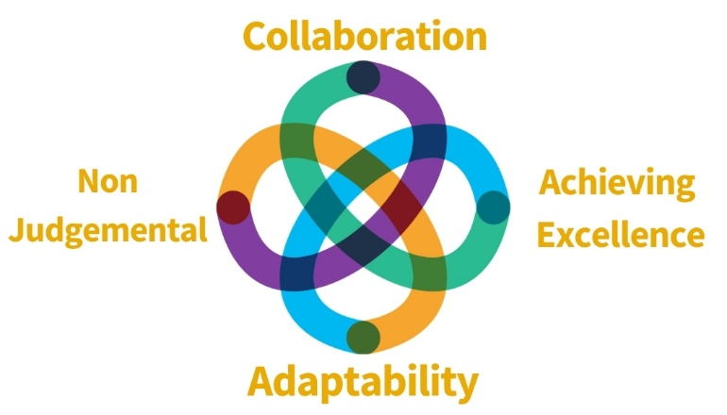

Founded by former Chief Medical Officer and Oncologist, Professor Sir Kenneth Calman, we remain a strong values-based organisation.

We will put people affected by cancer at the heart of what we do. Take care of the wellbeing of those affected by cancer. Treat everyone with kindness and respect and ensure professionalism and excellence.

The Post:

The Head of Fundraising & Communications forms part of the Charity’s senior leadership team, responsible for the development and delivery of the charity’s strategy. The post holder will be a strategic thinker and hands-on practitioner who will maximise fundraising income by developing, executing, and managing fundraising across identified income streams to ensure long term and sustainable income growth.

The role will provide excellent leadership, direction and support for Cancer Support Scotland’s financial objectives. As well as leading on embedding a relational fundraising approach and ensuring high quality donor stewardship, the role will also have strategic oversight Cancer Support Scotland’s communication output and income generation with the expectation for growth each financial year.
Key Responsibilities:

Fundraising

- Lead, inspire and develop all members of the fundraising and communications team, including our amazing volunteers.
- Lead the continuing development, implementation and monitoring of our fundraising and communication strategy.
- Establish a range of new income streams, with an emphasis on corporate, major donors, digital technologies, and looking at how to provide income through our service skills sets.
- Analysing and reporting on all KPI and income targets – including our pipeline – adjusting the fundraising and communications programme considering results and experience gained to maximise new opportunities or to mitigate programme underperformance.
- Manage monitoring and control mechanisms for performance management; including monthly, quarterly and annual analysis against agreed objectives.
- Ensure a comprehensive and integrated ‘donor’ journey (including our membership) is in place.
- To embed a culture of fundraising across the whole organisation.
- To ensure day to day operations such as income monitoring, evaluating, and reporting are carried out to a high standard.
- Lead the development of fundraising budget and work to achieve or exceed the fundraising target.
- To liaise with relevant staff and outside agencies as required.
- To be a hands on, both able to delegate and to take on direct roles in the successful delivery of our events calendar and growth of key income streams.

Leadership Team
- Lead, motivate and inspire your team to exceed agreed financial targets and KPI’s across existing income streams to excel.
- To personally lead on the development of corporate and major gift fundraising. To continually research, cultivate and develop strong relationships with these prospects, facilitating discussions and negotiations with high level individuals and organisational contacts.
- Work closely with the CEO and other members of the Leadership Team and participant as an integral member of the senior manager with the charity.
- To build a team that is ambitious, innovative and professional.
- To provide positive, resilient, dynamic and flexible leadership.
- To demonstrate a strong commitment to collaboration, creativity, accountability for objectives and modelling our values and core competencies.
- Ensure fundraising is in line with all current fundraising regulatory standards, data protection, and VAT and Gift Aid legalisation.
- Be an active participant within the leadership team ensuring forward planning and effective day to day management of the charity including business planning, financial forecasting and strategic decision making.
- Work with the management team to provide Cancer Support Scotland with quarterly reports on performance against agreed targets.
- Provide updates for the Board of Trustees where appropriate.
- Work with the CEO to provide accurate and up to date information towards the Charity’s risk management system, ensuring appropriate governance in accordance with the Fundraising Regulator and Trust guidelines.
- Strengthen the awareness and perception of Cancer Support Scotland
- Any other relevant duties as may be required by the CEO.

Personal Specification

 | Essential (E) / Desirable (D) | Assessment Method
Qualifications | - Minimum of 5 years’ experience of fundraising with a proven track record of income generation from a range of sources (E)  - Minimum of 2 years’ experience of managing a fundraising team (E)  - Evidence of continuous professional development (E)  - Membership of the IOF (D) | - Application
Experience | - Experience of delivering income targets of c£400-£1m (D)  - Experience of working across community, events, corporate, trusts & foundations and individual giving fundraising (E)  - Experience of working with best practice within fundraising, charity fundraising legislation and codes of practice (E)  - Experience in being able to set clear direction, inspire, coach, motivate and develop a team of experienced and new staff (E)  - Experience of using fundraising related Customer Relationship Management Systems (we use Donorfy) – (E)  - Experience of setting, meeting and measuring key performance indicators. (D) | - Application  - Interview
Skills | - Exceptional written, oral, social media and communication skills (E)  - Demonstratable networking skills (E)  - Effective management skills (E)  - Ability to develop strong partnerships (E)  - Ability to problem solve and find creative solutions (E)  - Attention to detail and to seek the highest standards (E)  - Ability to budget, forecast, interpret and act appropriately on latest financial and statistical information (E)  - Track record of having exceptional organisational skills to manage competing priorities and own workload. (E)  - Skilled at operating at senior management level (D)  - Skills in project planning, management techniques and their successful application to fundraising and communication opportunities (D) | - Application  - Interview

Benefits include:

- 35 Days Annual Leave increasing 1 day after year of service (to 40days)
- Flexible working options
- Modern workplace environment with friendly staff and a great base of volunteers
- Access to learning and development opportunities
- Competitive salary with incremental progression
- Access to pension scheme

Requirements of this role are:

- PVG Check (Paid for by Cancer Support Scotland)
- Two Professional references
- Adhere to all of Cancer Support Scotland’s guidance, policies and procedures

This job profile is not exhaustive. The duties of the post holder may be reviewed from time to time and the employee may be called upon to work in other locations our out of hours by Cancer Support Scotland.

How to apply
You can apply with a tailored covering letter and C.V to: recruitment@cancersupportscotland.org. Applications will be reviewed and interviews conducted on a rolling basis with a view to hiring as soon as the right candidate is found.

Organisational chart
