

APPLICATION PACK
Project Coordinator

APPLICATION PACK

Head of Area Support and
Community Improvement

Supporting

Training

Recruiting





Improving outcomes for children and young people

Contents


Introduction from the National Convener……………………………………………..3
About us……………………………………………………………………………………….……….4
Our values……………………………………………………………………………………………..5
Completing your application………………………………………………………………….6
Application & Equality monitoring form link and instruction …………………7
Job Description………………………………………………………………………………………9
Person Specification……………………………………………………………………………..12


INTRODUCTION FROM THE NATIONAL CONVENER


Dear applicant

Thank you for expressing an interest in working with Children’s Hearings Scotland.

As an organisation that works within the Children’s Hearings System, we are passionate about making a positive contribution to improving the outcomes of Scotland’s children and young people.

Our vision is of a Children’s Hearings System where everyone works together, making sure that all children and young people are loved, cared for and protected and that their views are heard, respected and valued. In the coming year, we will be rolling out a range of projects that will see us transform the way we work helping us to achieve our vision – it is a truly exciting time to join Children’s Hearings Scotland.

It is an enormous privilege to lead this organisation and we are committed to shaping a modern twenty-first century Children’s Hearings System that meets the needs of Scotland’s children and young people.

Good luck with your application.



Elliot Jackson
National Convener/Chief Executive

ABOUT US

Children’s Hearings Scotland recruits, trains and supports around 2,500 skilled volunteer Panel Members who sit on children’s hearings and make decisions with and for vulnerable children and young people across Scotland.

Our organisation is also responsible for supporting a network of 22 volunteer led Area Support Teams. Our Area Support Teams are made up of around 400 people who support Panel Members at a local level.

Children’s Hearings Scotland is undergoing an exciting period of reform designed to deliver a step change in improving the outcomes for infants, children and young people who need us most.
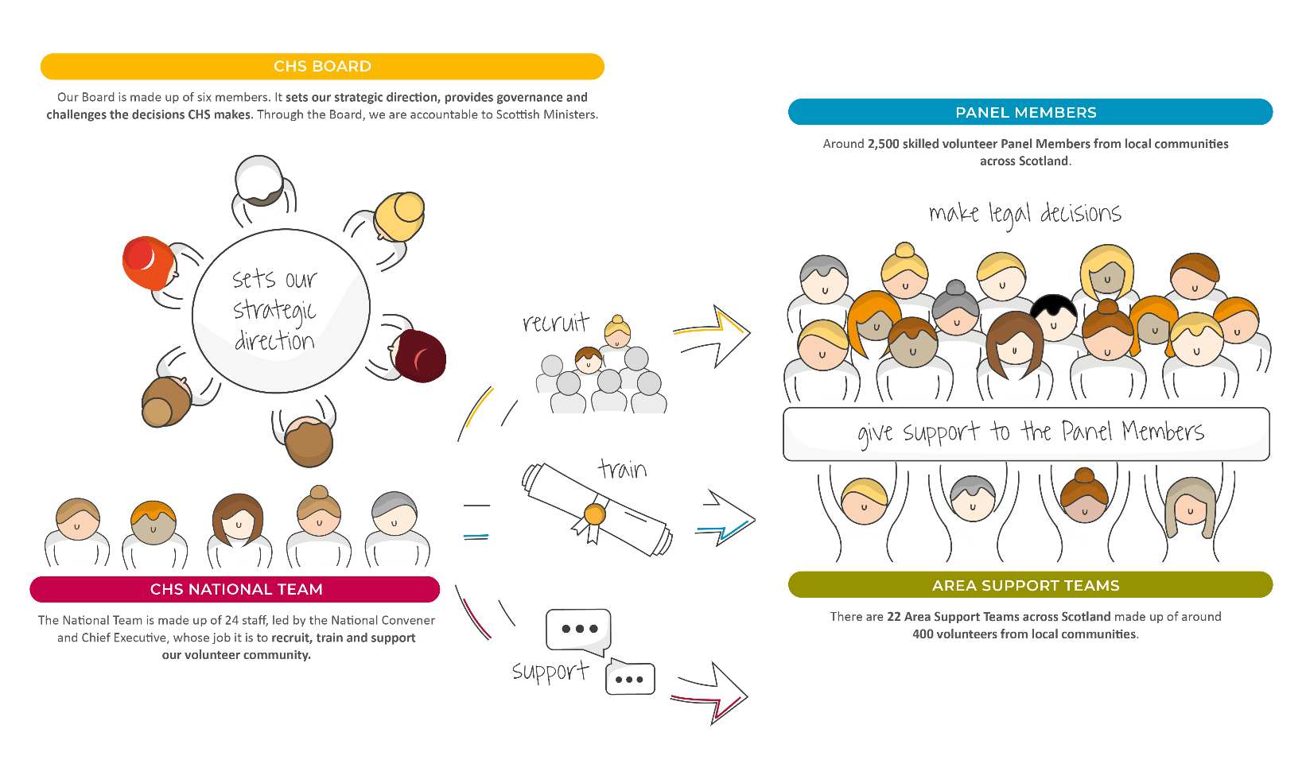

OUR VISION

Our vision is of a Children’s Hearings System where everyone works together, making sure that all children and young people are loved, cared for and protected and their views are heard, respected and valued.

OUR VALUES

Our values sit alongside are vision and mission and are threaded throughout everything we do.
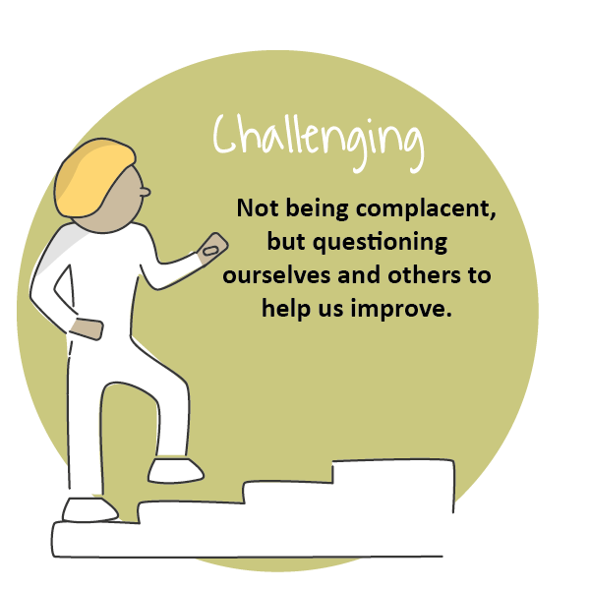
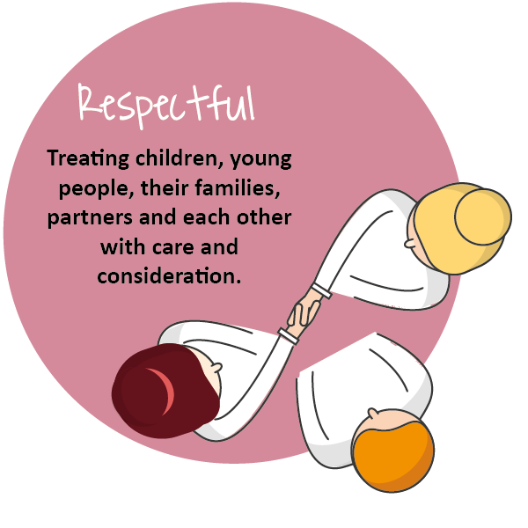
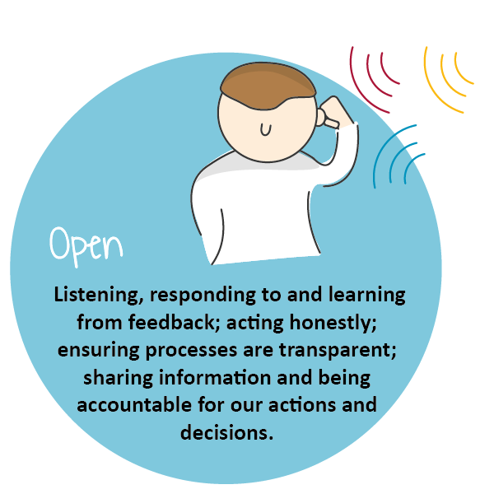
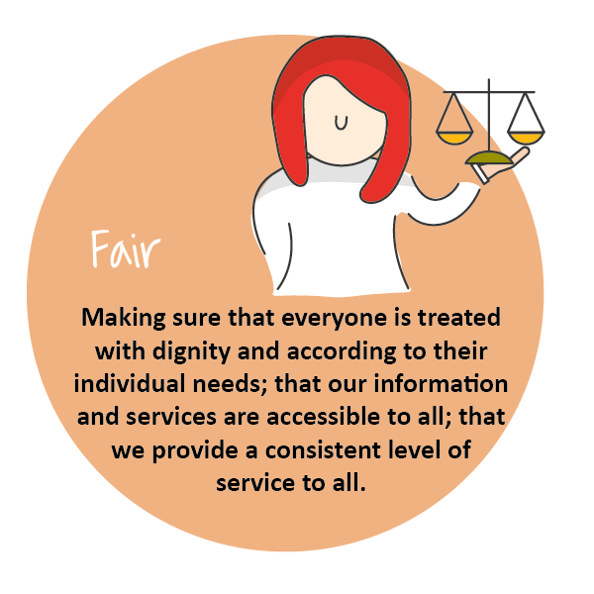
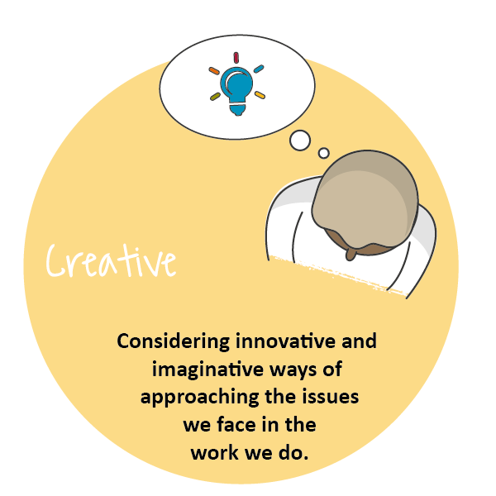
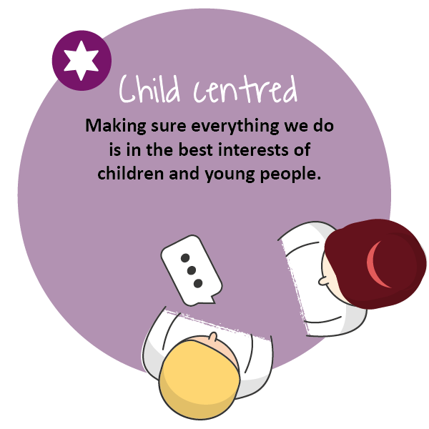

COMPLETING YOUR APPLICATION

Thank you for your interest in joining our team at Children’s Hearings Scotland (also known as CHS).

This application form has been designed to ensure compliance with legislation and best practice. The processing of all information will be in accordance with the requirement of the Data Protection Act 2018. The information you provide on your application form will only be used as part of the selection procedure and for any subsequent employment administration if your application is successful.

For further details on how your information will be handled please refer to our privacy statement. If any part of the form is unclear, please contact us via: jobs@chs.gov.scot

We are striving to be an equal opportunities employer with a diverse workforce which is representative of the population we serve. We are committed to embedding a culture of equality and diversity into our organisation and ensuring that all job applicants and employees are treated fairly, without discrimination because of age, disability, gender reassignment, marriage or civil partnership status, pregnancy and maternity, race, religion or belief, sex, sexual orientation or any other factor.

At the end of the application form you will find our Equal Opportunities Monitoring Survey which is intended to assist CHS in maintaining equal opportunities best practice and in identifying equality barriers for job applicants. We would be grateful if you would complete it.

Employees of CHS are required to adhere to a detailed our Staff Code of Conduct. Key principles in this are that staff:
- Act in the best interests of CHS
- Are Honest
- Are Selfless
- Have Integrity and Respect.

Prior to employment, all applicants will undergo pre-employment background checks in line with the Scottish Government’s Baseline Personnel Security Standards. We may contact previous employers, educational providers, fraud prevention bodies, local authorities and government agencies as part of this process. We may also use background screening companies.

Please complete the form as fully as you can. If you would prefer to submit your application in handwritten or alternative format, please contact our Jobs Mailbox at jobs@chs.gov.scot , so that arrangements can be made.

Guidance on filling in the online application form
The form has been designed to help both the applicants and our resourcing team process applications quickly, efficiently, and on a variety of devices. This application can be accessed on any device.
The application sections are detailed below. We would advise you to read over them and have your information prepared on separate document you can cut and paste from (such as your CV and a covering letter) as once you start the application, you will not be able to save it and return to complete it at a later stage. CHS does not accept CV’s, please ensure you include all relevant information on this form.

Section 1
- Personal Information: Please note that only your surname is required in full. Give only the initials of your first name(s).

Section 2
- Education and Training: This section asks about your education and job related training. Please give us enough details to assess your attainments in relation to the post for which you are applying. Continue on a separate sheet if necessary. We need a minimum 3 years’ job related/education history.

Section 3 – 7
- Work Experience: This section asks about your work experience with a separate section for each relevant role. We have supplied space for your post recent post as well as four previous roles.. Again, please give as much detail as you feel gives us an accurate picture, both about the type of work you are/were doing and the responsibilities you have/had. Please start with the most recent, supplying exact dates where possible.

Section 8
- Supplementary Information: Please detail any further experience or information relevant to the post for which you are applying, considering the information you have been given about the post, for example the job description, person specification etc. Try to ensure you are clear about how you meet the essential criteria listed.

Section 9
- General Information: You are asked to tell us if you are relate d to any member of CHS’ staff or Board. This is to ensure compliance with CHS’ Code of Conduct Policy. You are asked to tell us if you are currently eligible for employment in the UK. This is so that we can ensure compliance with the Immigration Act 2014, Asylum and Immigration Act 1996 and Immigration, Asylum and Nationality Act 2006 which requires organisations to ensure individuals, to whom they are offering employment, have permission to work in the UK – please visit: https://www.gov.uk/check-uk-visa if you are unsure of your status. If you are invited to interview you will be required to produce such evidence.
- CHS works with vulnerable persons under the age of 18 and we are required by The Protection of Vulnerable Groups (Scotland) Act 2007 to ensure that all of the staff we employ are suitable to work with persons under 18 or with their data. CHS is also an exempted body for the purposes of the Rehabilitation of Offenders Act 1974 (Exceptions) Order 1975. CHS is required to take into account, prior to offering employment, any information of any spent and unspent convictions that may be relevant to the post for which you are applying. No unconditional offer of employment will be made until a satisfactory Protecting Vulnerable Groups (PVG) clearance has been received.
- If you are the successful candidate for the post you will be asked to complete a pre-employment health questionnaire. This questionnaire will be screened by CHS’ Occupational Health Provider, who may ask you to attend for consultation. Formal offers of employment will be made once CHS’ Occupational Health Provider has assessed the individual as “Fit to work” and where appropriate any reasonable adjustments have been implemented.

Section 10
- References: We request three professional references. References will only be taken up if you are short listed. Please indicate if you do not wish your referee(s) to be contacted at this stage, however, please note that no unconditional offer of employment will be made until satisfactory references have been received.

Section 11
- Declaration: You are asked to declare the information you provided is true to the best of your knowledge. If you have any questions or concerns please contact us at lobs.chs.gov.scot

Section 12
- Equality Monitoring: The information in this survey will be used for monitoring purposes only. Your responses are voluntary but the more information you supply, the more effective our monitoring of responses will be.

- This information will only be viewed by the CHS Resourcing Team and is not connected to your application form and will not be used to identify you. It will not be seen by anyone involved in interviewing or shortlisting and will be stored securely in line with the principles of the Data Protection Act 2018. Monitoring will help to improve our recruitment processes and enable us to be as inclusive an employer as possible.

- Please select the most applicable option in the questions and complete the open boxes where relevant. We would be grateful if you would fill in this survey

APPLICATION FORM

https://forms.office.com/e/FJejNYFnu5

JOB DESCRIPTION

Reports to: | Programme Management Office (PMO) Manager
Direct Reports | N/A
JD Last Updated | June 2023
Role Last Evaluated

OVERVIEW OF ROLE
The post holder will contribute to the administration, planning, coordination and reporting within Children’s
Hearings Scotland’s (CHS) Projects and Programmes of work. This will enable the delivery of key projects sitting
within the CHS Programme Management Office (PMO) supporting the key objectives and outcomes planned within the organisation’s annual business and corporate parenting plan

The post holder will also work closely with the Business Operations and Governance Manager to support the administration of reporting to support governance and improvement across the organisation.

OPERATIONAL ACCOUNTABILITIES
Within the CHS PMO- liaising with managers and staff across CHS, key stakeholders and partners, including SCRA, the CHS Learning Academy and our CHS community volunteer colleagues. Providing support and guidance to project teams, on the CHS PMO toolkit and processes. And being a main point of contact for the use and updating of our digital Programme Management tool, ZOHO Projects.

The post holder will primarily support the PMO Manager with the administration and delivery of the Programme Management Office (PMO), but will also be expected to support other work streams within the organisation when key priorities require. One of these priorities would be the administration of reporting function across both the PMO and Core Operations sides of the organisation by supporting the Business Operations and Governance Manager.

CORE ACTIVITIES
- Support the PMO manager with the input and embedding of the Programme Management tool, ZOHO Projects, and the individual support and admin for key projects within this digital tool.
- Act as the lead data base administrator to support project deliverables.
- Support the PMO manager and project teams to develop and enhance project plans and a variety of progress reports.
- Attending and supporting project leads on project meetings, including the creation and delivery of agreed agendas and outcomes; followed by clear and concise meeting minutes and actions.
- Escalating issues or risks at project level to the PMO manager, taking advice on proactive suggestions on how to mitigate or minimise risk or negative impact on project deliverables.
- Providing sound guidance and advice to project leads, on the CHS PMO processes and how to utilise various project framework delivery methods.
- High level auditing of project documentation and processes.
- Support on the administration of regular reporting functions across the organisation within and beyond the CHS PMO. Liaising across National Team colleagues to gather data to support CHS Business performance reporting.

COMPETENCY FRAMEWORK/ PERSON SPECIFICATION

PERSONAL EFFECTIVENESS COMPETENCIES

COMPETENCY AREA | KEY SKILLS
Teamwork and Collaboration | - Effectively initiates dialogue across teams, levels, departments recognising that we have a shared responsibility to provide the best experience for our colleagues and wider stakeholders;  - Recognises the value of every contribution and area of expertise within the organisation. This includes building links and networks across teams (internally and externally);  - Creates a supportive team environment by listening and responding to others and creating opportunities for innovation and generation of ideas and actions.
Communication | - Good written and verbal communication skills;  - Ability to communicate effectively in 1:1 and group settings;  - Ability to adjust communication skills to meet the needs of the recipient
Personal Integrity | - Encourages and supports open two-way communication;  - Is motivated by values and getting on with the job;  - Shows resilience that enables the team to perform to the highest standards;

FUNCTIONAL/TECHNICAL COMPETENCIES

COMPETENCY AREA | KEY SKILLS
Computer literacy | - Good level of proficiency with Microsoft office (Outlook, Word, Excel, and PowerPoint)  - Excellent IT skills and evidence of a dynamic adaption to new systems and multiple platforms for collaboration, data entry and communication.
Project Management | - Good organisational and co-ordination skills to support, inform and develop project plans and project decision making.  - Ability to prioritise and manage workload/time effectively.  - Excellent team working skills as part of a multi- disciplinary team and able to build effective working relationships with colleagues.  - Entry level knowledge of PRINCE 2 and or Agile project management methodologies

TRACK RECORD/EXPERIENCE

- Track record of producing coherent outputs and support to the planning and delivery of projects.
- Demonstrable experience of collating, analysing and summarising data to inform projects and decision-making.
- Professional experience acting as lead data base administrator to support project deliverables.
- Experience in supporting project meetings with agenda creation, accurate minute taking, and progressing as well as updating action logs.
- Experience of prioritising workload, delivering to targets and meeting tight deadlines.
- Extensive experience of report writing to key stakeholders.
- Experience of working with project risk registers and demonstrable understanding of risk escalation and mitigation processes.
- Experience of working with sensitive and confidential information.
- Experience of collecting data for improvement and evaluation purposes is desirable.
- Working in an Non-Departmental Public Body is desirable.
- Working in a national organisation is desirable.
- Experience of working for or with an organisation that delivers services through the engagement of volunteers is desirable.
- Experience of using ZOHO Projects is desirable
- Experience of using Project Management software is desirable

EDUCATIONAL ATTAINMENT/ QUALIFICATIONS
Qualified to HND level, of equivalent experience
Entry level qualification in project management (preferably Agile or PRINCE 2, but other methodologies and evidenced experience also recognised) is desirable

PROFESSIONAL BODY MEMBERSHIP
N/A

OTHER REQUIREMENTS FOR THE ROLE
None

Thank you for your interest in this position

