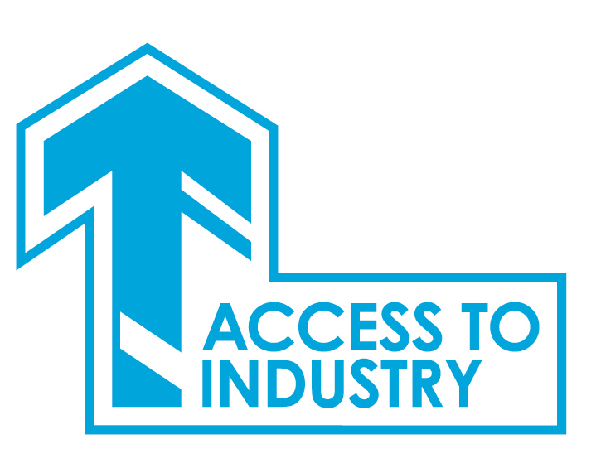

Access to Industry Application Pack

Post: Access to Industry Caseworker
Project: MELDAP

Enclosed in this pack is:
Job Description 2
Person Specification 4
About Access to Industry 5
How to Apply 6
Terms and Conditions of Employment 7
Recruitment Privacy Statement 8

Thank you for your interest in applying for a position with Access to Industry.

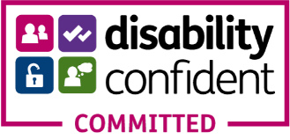

Job Description
Job Title | Caseworker | Accountable to | AI Management Team
Working Hours | 28-35 hours weekly | Location | Midlothian and East Lothian
Salary Scale | £25,480-£28,600*  (pro rata for part-time) | Length of Post | Permanent
Programme | MELDAP  (Mid and East Lothian Drug and Alcohol Partnership) | Project | Mid and East Recovery Project
*Placement on scale dependent on experience.

About the Role: An opportunity has arisen in Access to Industry for an enthusiastic self-starter who has a passion to support and progress people in recovery. Managing a caseload of clients in outreach across Midlothian and East Lothian, you will have the opportunity to develop meaningful activity for clients and work with colleagues and external partners.

Key responsibility areas will include:
Case Management: You will manage a caseload of clients. Your clients will have a history of substance use and you will engage them in education, training and employability activity that supports recovery. Clients may have many barriers to progression including previous offending, accommodation issues and in mental health wellbeing and your role will include developing their confidence, resilience and general wellbeing. You will manage a caseload of around 40-50 per annum across Mid and East Lothian, you will efficiently manage your time and caseload across this geography.

One-to-one Support: You will assess clients’ needs, devise action plans and work holistically with clients. Support will be flexible, from employability to welfare advice. You will work to progress clients into training programmes, employment, and education. One-to-one sessions take place in a place that is accessible, and safe, for the clients. You will have the support of AI’s wider services.

Skills-based Activity: You will motivate and support clients to achieve qualifications, delivered in outreach both individually and in small skills-based group settings across Midlothian and East Lothian. Clients will be able to progress into AI’s Community College offering accredited learning and you will lead on supporting delivery, with partners, in learning centres in Mid and East Lothian. You will have the opportunity to utilise or build your own skills in group activity delivery and will be supported to do this.

Targets: You will work towards stated project outcomes for learning delivery and collect required ‘evidencing’ to show outcomes in line with funder requirements.

Relationship Management: In addition to working with learning partners, you will develop and maintain links with referral and support agencies across Mid and East Lothian, including statutory services and voluntary organisations. This is to recruit clients and to benefit clients through access to wider services and signposting to specialist services.
Supervision: As part of developing clients’ digital skills, you will supervise and support our Peer Digital Champion who is in place and who works across East Lothian offering digital support to our clients of East Lothian. You may be responsible for volunteers recruited to support delivery.

AI Team: You will play a part in the wider team of AI through attendance at internal meetings and participation in shared services across the teams.

Administration: You will administer all aspects of the project from referrals, training, progression routes and employer engagement.

Quality Assurance & Management Systems: You will maintain excellent records and will maintain case management through use of the Management Information System, Helix. You will demonstrate clients’ progression through gathering relevant evidence required by funders.

Health and Safety & Property Management: You will ensure a healthy and safe environment and the protection and best use of property and equipment by implementing and observing AI policies and procedures.

Communications: You will be an effective communicator, working with external agencies, specialist providers and employers, and attending meetings on AI’s behalf. You will contribute to internal reporting procedures both through writing and verbally. You will market the project externally. You will always ensure client confidentiality.

Other Requirements: The post holder will be expected to manage their own caseload and work with minimum supervision partly in an outreach capacity.

Person Specification
Key Areas | Essential | Desirable
Qualifications and attainment | Qualified to degree level or relevant experience. | A relevant qualification in a subject such as Community Education, Careers Guidance, Social Policy, Social Care or Addiction.
Knowledge, Skills and Experience | Experience of client case management towards a goal.  Experience of holistic support that removes barriers to progression and puts in place steps that build personal resilience.  Skills in developing and supporting delivery of a programme of activity around learning, confidence building and/or wellbeing.  Experience of training/learning/group work delivery.  A knowledge of support and learning services in Midlothian and East Lothian.  Strong time management skills; ability to work on own initiative; and able to prioritise own workload; ability to work efficiently across a wide geographic area.  Skilled in achieving targets and gathering evidence to support these.  Confident using Microsoft Office suite and digital platforms.  Excellent written and verbal communication skills. | Experience of employability support.  Experience of working with clients in recovery including the impact of addiction on wellbeing.  Knowledge and understanding of a trauma-informed approach to service delivery.  Experience of working in an outreach setting.  Supervision skills having supported volunteers or staff members.
Additional Requirements | Empathetic and non-judgemental in your approach to working with individuals and groups, and an ability to easily build a positive rapport.  Patient, passionate and committed to delivering the best service possible.  A team player, you will be determined and flexible to achieve your own and your team’s goals.

About Access to Industry
MELDAP Recovery College
Access to Industry (AI) has been delivering an education, training, and employability service to unemployed people with complex health and social care needs across Midlothian and East Lothian since 2014, funded through MELDAP (Mid and East Lothian Drugs and Alcohol Partnership). Project funding is confirmed on an annual basis.

The project will engage with clients in a trauma informed way. Offering an outreach service enables the caseworker to meet with the client in their own town or village, reducing their need for travel or initial engagement within an unfamiliar space.

Assessment will be carried out with each client one-to-one, identifying key areas that are posing barriers to progression and creating an action plan that will form key milestones to be achieved during their time on the project.

Caseworkers will provide one-to-one support and skills-based activity. The project will link with the wider initiatives within AI, including our Community College. Groupwork is used as mechanism to maintain engagement while building skills and confidence. The project delivers this directly and also through third parties including Edinburgh College and external training providers.

Staff Development
Access to Industry supports individuals who can have complex needs that act as a barrier to progression. We are constantly reviewing the skills of our employees and developing these so we can best support our staff to meet the needs of our clients.

On joining Access to Industry, as part of your initial induction your training may include:

- Mental Health First Aid
- Motivational Interviewing
- ASIST – Applied Suicide Intervention Skills Training
- Living Life to the Full – training in course delivery
- Conflict resolution – de-escalation
- Train the Trainer

How to Apply
Access to Industry: Caseworker

Application is through a CV and a Supporting Statement.

- All applications should be marked ‘CONFIDENTIAL: Mid and East Caseworker’.

- CVs should include two referees one of whom should be your most recent employer. We will not contact referees prior to interview.

- The supporting statement should demonstrate your experience and how this matches with our requirements. This additional information should be confined to a maximum of two sides of A4 in minimum font size 11. Additional information over this limit will not be considered. Generic statements not contextualised for the post will be discarded.

- Closing date for applications is: Monday 14 August 2023 at 5pm

- Interviews will be held on: Thursday 24 August 2023

Applications should be sent to:
Email: admin@accesstoindustry.co.uk
Postal: Access to Industry, 156 Cowgate, Edinburgh EH1 1RP

Terms and Conditions of Employment
Access to Industry
Caseworker
Salary
Salary scale for this post is £25,480-£28,600 (pro rata). Starting salary offered will be dependent on experience.
AI operates an auto enrolment pension. AI contribution is 6%; employee contribution is 2%.
Annual leave
Entitlement is 25 days per annum (pro rata). Public holiday entitlement is 10 days per annum. Salary rises incrementally to 30 days per annum from 3 years of service, incremental at one day per year (pro rata where role is not full-time).

Working Hours
28-35 hours a week (35 hours = full time).

Equality and Diversity
Access to Industry work towards the three aims of The Equality Duty in order to:
- Eliminate unlawful direct or indirect discrimination, harassment and victimisation and other conduct prohibited by The Equality Act 2010;
- Advance equality of opportunity between people who share a protected characteristic as set out in the Equalities Act 2010 and those who do not; and
- Foster good relations between people who share a protected characteristic and those who do not.
Performance Review
A three-month probation review period will be in operation.

Appointment is subject to satisfactory references, PVG and right to work.

Recruitment Privacy Statement
How We Use Your Data for Recruitment

Background
This privacy policy covers how we Access to Industry collect, use, store and protect the data that is supplied to us by job applicants and agencies.

Our Commitment to Job applicants
We believe completely in equal opportunities and will treat all applicants fairly with no discrimination.

We never knowingly provide misleading information about the nature of the role. We would never charge a job seeker a fee for the purpose of finding them a role.

We are committed to managing your personal information securely and with respect in accordance with the General Data Protection requirements.

The information we collect may cover the following:
- Contact information (name address, phone number and email address);
- Information from CV or Application Form or Covering Letter (education, skills and qualifications);
- Health records (Night Worker assessment forms, Health questionnaires) where required as part of the role;
- Occupational health report (higher level screening required for role) with access to medical records consent being given by the applicant;
- Criminal convictions/offences/protecting vulnerable groups information from Disclosure Scotland where a requirement for the role;
- References from the named referees that the applicant provides and only with the applicant’s consent;
- Visa and proof of the right to work in the UK documents;
- Employment records (including job titles, work history, working hours, training records and professional memberships);
- Salary, annual leave, pension, and benefits information;
- Access to your DVLA portal.

We may also collect, store and use ‘special categories’ of more sensitive personal data which require a higher level of protection, such as information about your ethnicity, religions and beliefs, sexual orientation, and political opinions. Also, information about criminal convictions and offences.

Purpose of Collection
The purpose of collecting this information is to find suitable candidates to fulfil a specific role within our organisation, and to check that you are legally entitled to work in the UK.

To enable us to make recruitment decisions and assess suitability for particular work, we will process information about criminal convictions and offences (including alleged offences).
We will process this information to enter a contract with you, to comply with a legal obligation, for our legitimate interests and to exercise or perform employment law rights or obligations.

Any offer of work from us will be subject to a satisfactory criminal record check to allow us to perform our public task and comply with our statutory obligation.

Processing criminal conviction data requires the same safeguards as ‘special categories’ data.

How the information is held.
Most information is transmitted by email and is stored on our computers, and paper-based filing.

All this information can only be accessed by authorised staff within our organisation. Our staff are trained to understand the importance of keeping personal data secure. Our computers are safeguarded by anti-virus software and the regular changing of security passwords.

The information on candidates for specific roles will be held for six months in line with CIPD recommended best practice. After which paper files will be securely shredded and computer records deleted. Only if we have asked, and you have given your consent for the data to be held will this not apply.

Disclosure
We may disclose the information for the purpose of obtaining referees. Where additional information is required, the information may be obtained from Disclosure Scotland, your GP or an Occupational Health professional only after you have given your consent.

You have specific rights in connection with personal information: request access to your personal information; request correction of the personal information that we hold about you; request erasure of your personal information; object to processing of your personal information where we are relying on a legitimate interest; request the restriction of processing of your personal information; request the transfer of your personal information to another party and the right to withdraw consent.

Complaints
Privacy complaints are taken very seriously and if you believe that we have breached your privacy you should in the first instance write to the Finance Administrator, who has responsibility for Data Protection within our Organisation, stating the details of your complaint (finance@accesstoindustry.co.uk). We would ask that you provide us with as much detail as possible to allow a thorough investigation. Your complaint will be acknowledged within 24 hours, and we aim to resolve any complaint within five working days. However, depending on the complexity of the complaint and availability of external agencies it may on occasions take longer.

Should your complaint show that we have breached our duty of care we will report the breach to the Information Commissioner’s Office. If you are not satisfied by our response you may complain to the ICO.

