

APPLICATION PACK
Feedback and Complaints Officer

APPLICATION PACK

Head of Area Support and
Community Improvement

Supporting

Training

Recruiting





Improving outcomes for children and young people

Contents


Introduction from the National Convener……………………………………………..3
About us……………………………………………………………………………………….……….4
Our values……………………………………………………………………………………………..5
Completing your application………………………………………………………………….6
Application & Equality monitoring form link and instruction …………………7
Job Description………………………………………………………………………………………9
Person Specification……………………………………………………………………………..12


INTRODUCTION FROM THE NATIONAL CONVENER


Dear applicant

Thank you for expressing an interest in working with Children’s Hearings Scotland.

As an organisation that works within the Children’s Hearings System, we are passionate about making a positive contribution to improving the outcomes of Scotland’s children and young people.

Our vision is of a Children’s Hearings System where everyone works together, making sure that all children and young people are loved, cared for and protected and that their views are heard, respected and valued. In the coming year, we will be rolling out a range of projects that will see us transform the way we work helping us to achieve our vision – it is a truly exciting time to join Children’s Hearings Scotland.

It is an enormous privilege to lead this organisation and we are committed to shaping a modern twenty-first century Children’s Hearings System that meets the needs of Scotland’s children and young people.

Good luck with your application.

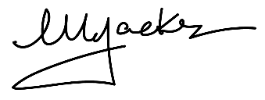

Elliot Jackson
National Convener/Chief Executive

ABOUT US

Children’s Hearings Scotland recruits, trains and supports around 2,500 skilled volunteer Panel Members who sit on children’s hearings and make decisions with and for vulnerable children and young people across Scotland.

Our organisation is also responsible for supporting a network of 22 volunteer led Area Support Teams. Our Area Support Teams are made up of around 400 people who support Panel Members at a local level.

Children’s Hearings Scotland is undergoing an exciting period of reform designed to deliver a step change in improving the outcomes for infants, children and young people who need us most.
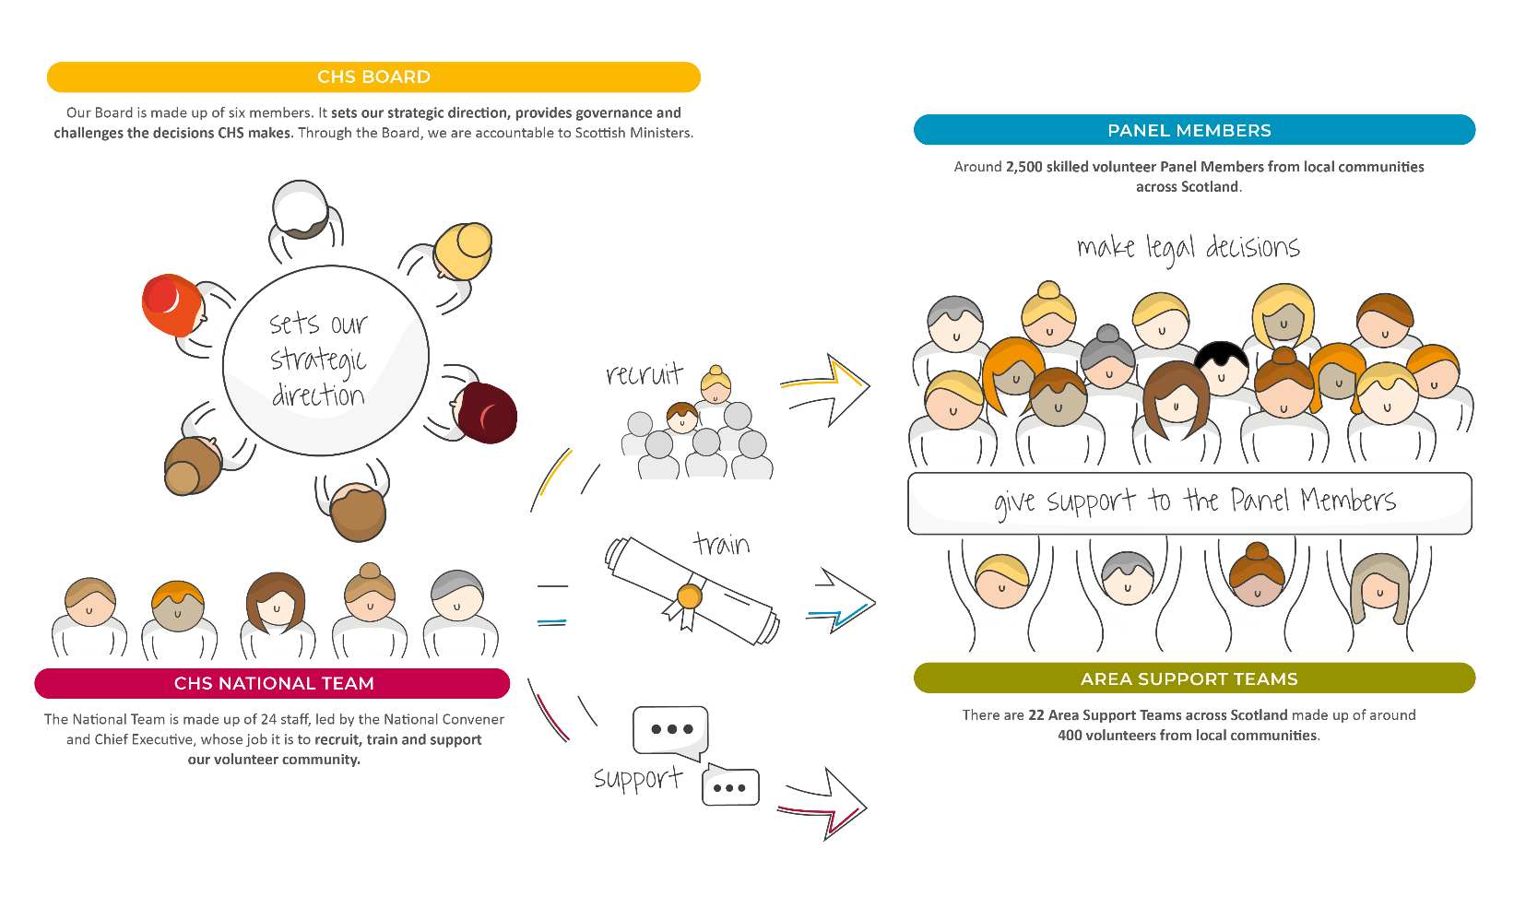

OUR VISION

Our vision is of a Children’s Hearings System where everyone works together, making sure that all children and young people are loved, cared for and protected and their views are heard, respected and valued.

OUR VALUES

Our values sit alongside are vision and mission and are threaded throughout everything we do.
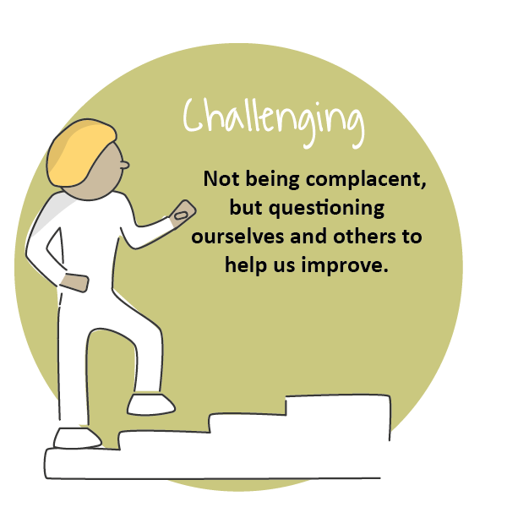
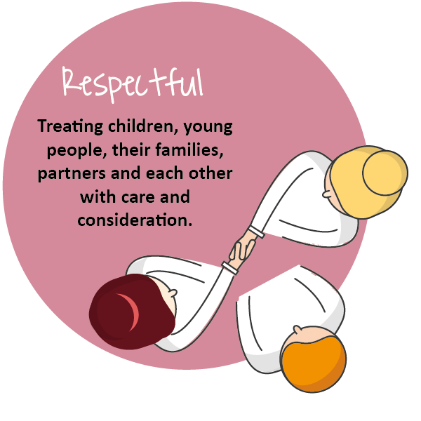
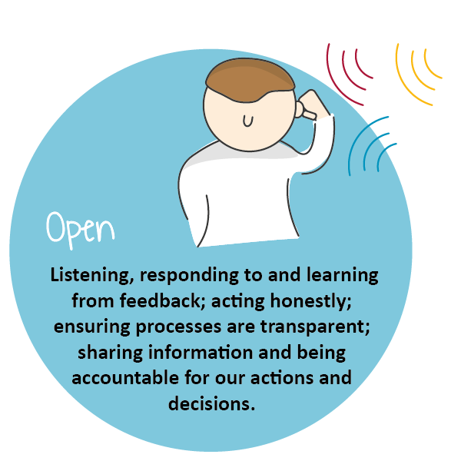
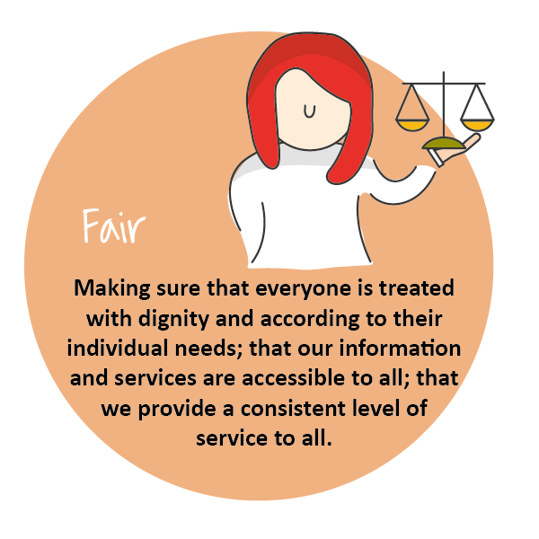
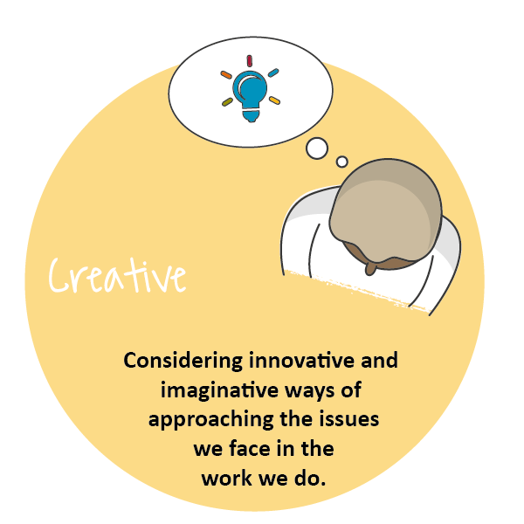
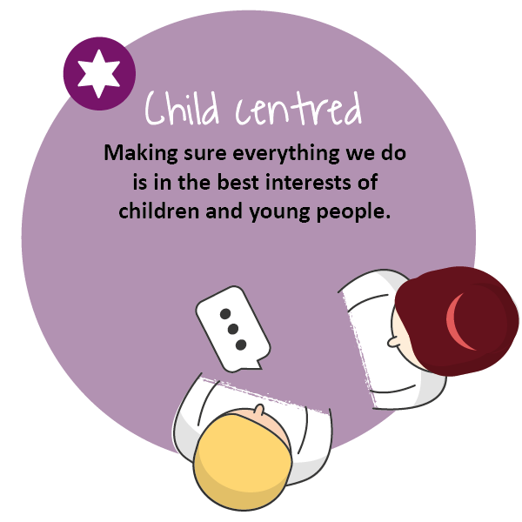

COMPLETING YOUR APPLICATION

Thank you for your interest in joining our team at Children’s Hearings Scotland (also known as CHS).

This application form has been designed to ensure compliance with legislation and best practice. The processing of all information will be in accordance with the requirement of the Data Protection Act 2018. The information you provide on your application form will only be used as part of the selection procedure and for any subsequent employment administration if your application is successful.

For further details on how your information will be handled please refer to our privacy statement. If any part of the form is unclear, please contact us via: jobs@chs.gov.scot.

We are striving to be an equal opportunities employer with a diverse workforce which is representative of the population we serve. We are committed to embedding a culture of equality and diversity into our organisation and ensuring that all job applicants and employees are treated fairly, without discrimination because of age, disability, gender reassignment, marriage or civil partnership status, pregnancy and maternity, race, religion or belief, sex, sexual orientation or any other factor.

At the end of the application form you will find our Equal Opportunities Monitoring Survey which is intended to assist CHS in maintaining equal opportunities best practice and in identifying equality barriers for job applicants. We would be grateful if you would complete it.

Employees of CHS are required to adhere to a detailed our Staff Code of Conduct. Key principles in this are that staff:
- Act in the best interests of CHS
- Are Honest
- Are Selfless
- Have Integrity and Respect.

Prior to employment, all applicants will undergo pre-employment background checks in line with the Scottish Government’s Baseline Personnel Security Standards. We may contact previous employers, educational providers, fraud prevention bodies, local authorities and government agencies as part of this process. We may also use background screening companies.

Please complete the form as fully as you can. If you would prefer to submit your application in handwritten or alternative format, please contact our Jobs Mailbox, so that arrangements can be made.

Please email your completed application form to: jobs@chs.gov.scot no later than the closing date of . Applications received after this time will not be considered.

Guidance on filling in the online application form
The form has been designed to help both the applicants and our resourcing team process applications quickly, efficiently, and on a variety of devices. This application can be accessed on any device.
The application sections are detailed below. We would advise you to read over them and have your information prepared on separate document you can cut and paste from (such as your CV and a covering letter) as once you start the application, you will not be able to save it and return to complete it at a later stage. CHS does not accept CV’s, please ensure you include all relevant information on this form.

Section 1
- Personal Information: Please note that only your surname is required in full. Give only the initials of your first name(s).

Section 2
- Education and Training: This section asks about your education and job related training. Please give us enough details to assess your attainments in relation to the post for which you are applying. Continue on a separate sheet if necessary. We need a minimum 3 years’ job related/education history.

Section 3 – 7
- Work Experience: This section asks about your work experience with a separate section for each relevant role. We have supplied space for your post recent post as well as four previous roles. Again, please give as much detail as you feel gives us an accurate picture, both about the type of work you are/were doing and the responsibilities you have/had. Please start with the most recent, supplying exact dates where possible.

Section 8
- Supplementary Information: Please detail any further experience or information relevant to the post for which you are applying, considering the information you have been given about the post, for example the job description, person specification etc. Try to ensure you are clear about how you meet the essential criteria listed.

Section 9
- General Information: You are asked to tell us if you are related to any member of CHS’ staff or Board. This is to ensure compliance with CHS’ Code of Conduct Policy. You are asked to tell us if you are currently eligible for employment in the UK. This is so that we can ensure compliance with the Immigration Act 2014, Asylum and Immigration Act 1996 and Immigration, Asylum and Nationality Act 2006 which requires organisations to ensure individuals, to whom they are offering employment, have permission to work in the UK – please visit: https://www.gov.uk/check-uk-visa if you are unsure of your status. If you are invited to interview you will be required to produce such evidence.
- CHS works with vulnerable persons under the age of 18 and we are required by The Protection of Vulnerable Groups (Scotland) Act 2007 to ensure that all of the staff we employ are suitable to work with persons under 18 or with their data. CHS is also an exempted body for the purposes of the Rehabilitation of Offenders Act 1974 (Exceptions) Order 1975. CHS is required to take into account, prior to offering employment, any information of any spent and unspent convictions that may be relevant to the post for which you are applying. No unconditional offer of employment will be made until a satisfactory Protecting Vulnerable Groups (PVG) clearance has been received.
- If you are the successful candidate for the post, you will be asked to complete a pre-employment health questionnaire. This questionnaire will be screened by CHS’ Occupational Health Provider, who may ask you to attend for consultation. Formal offers of employment will be made once CHS’ Occupational Health Provider has assessed the individual as “Fit to work” and where appropriate any reasonable adjustments have been implemented.

Section 10
- References: We request three professional references. References will only be taken up if you are short listed. Please indicate if you do not wish your referee(s) to be contacted at this stage, however, please note that no unconditional offer of employment will be made until satisfactory references have been received.

Section 11
- Declaration: You are asked to declare the information you provided is true to the best of your knowledge. If you have any questions or concerns please contact us at jobs@chs.gov.scot

Section 12
- Equality Monitoring: The information in this survey will be used for monitoring purposes only. Your responses are voluntary but the more information you supply, the more effective our monitoring of responses will be.

- This information will only be viewed by the CHS Resourcing Team and is not connected to your application form and will not be used to identify you. It will not be seen by anyone involved in interviewing or shortlisting and will be stored securely in line with the principles of the Data Protection Act 2018. Monitoring will help to improve our recruitment processes and enable us to be as inclusive an employer as possible.

- Please select the most applicable option in the questions and complete the open boxes where relevant. We would be grateful if you would fill in this survey.

APPLICATION FORM

https://forms.office.com/e/QnEGeRADLw

JOB DESCRIPTION

Reports to: | Complaints Management Officer
Direct Reports | N/A
JD Last Updated | July 2023
Role Last Evaluated | April 2023

OVERVIEW OF ROLE
The Feedback and Complaints Officer will work with the Complaints Management Officer by dealing with feedback and complaints (and) analysing themes and trends to provide insight and inform policy and practice improvements across Children’s Hearings Scotland (CHS).

The post holder will deal with feedback and complaints from children and families, other members of the public, the CHS volunteer community and other external organisations. They will also review and analyse feedback and complaints and seek new and innovative ways to encourage and obtain it.

The post holder will play a key role in developing and implementing our feedback and complaints so that they inform our practice and learning and they will also investigate complaints and achieve good outcomes in line with the SPSO Model Complaints Handling Procedure.

OPERATIONAL ACCOUNTABILITIES
The post holder will deal with complaints from children, family members, other members of the public, external bodies and partner agencies, along with internal complaints from within our volunteer community. They will also review and analyse feedback and seek new ways to encourage and obtain it.

The post holder will support the Complaints Management Officer in a number of key projects and strategic activities including developing a child friendly feedback and complaints policy for the organisation, as well as supporting changes to our volunteer organisational structure through the lens of feedback and complaints

The post holder will engage directly with complainants to gain a full understanding of the complaint and with our volunteer community and other partner agencies to obtain the additional facts and information required to undertake a high quality investigation and reach well informed decisions. They will also consider whether any additional support, development or learning may be required for someone who is the subject of a complaint.

The post older will support the Complaints Management Office in ensuring that all statutory and legal requirements are met and provides report and statistics about complaints handling. They will also keep records of complaints in line with requirements and maintain the complaints management system..

CORE ACTIVITIES
- Be the main point of contact for feedback and complaints
- Monitoring, updating and maintaining the systems in place to manage complaints and feedback effectively
- Investigating complaints made by members of the public about CHS, in some circumstances members of our staff, or our volunteer panel or Area Support Team members
- Investigating internal complaints raised by our volunteer community
- Maintain a laser focus on the accurate reporting and monitoring of complaints to ensure deadlines are adhered to and complaints intelligence/themes are readily available
- Supporting the Complaints Management Officer with analysis of themes and trends arising from complaints and feedback
- Provide advice and guidance about complaints to the volunteer community and others
- Support the development and delivery of information and training workshops for the volunteer community as required
- Assist with attendance at local Area Support Team meetings (in person or virtually) as requested to offer advice and guidance based on what we learn about both good and poor practice
- Develop excellent working relationships with the Practice and Policy team, the wider network of CHS colleagues, external organisations and the volunteer community
- Provide information to the Complaints Management Officer to inform statutory reporting requirements.
- Monitor complaints performance to provide assurance that statutory SPSO deadlines are being met.
- In the spirit of team working, support colleagues and the wider volunteer community when the need arises, particularly in times of pressure and demand.
- Proactively explore ways to continuously enhance the effectiveness of your role in order to support wider CHS outcomes and objectives, including identification of factors outside of the immediate team.
- Please note that some travel may be required as a requirement of this job, as well as occasionally working outside of CHS’s normal working hours

COMPETENCY FRAMEWORK/ PERSON SPECIFICATION

PERSONAL EFFECTIVENESS COMPETENCIES

COMPETENCY AREA | KEY SKILLS
Teamwork and Collaboration | - Effectively initiates constructive communication across teams, levels, departments recognising that we have a shared responsibility to provide the best experience for our colleagues and wider stakeholders;  - Recognises the value of every contribution and area of expertise within the organisation. This includes building links and networks across teams (internally and externally);  - Creates a supportive team environment by listening and responding to others and creating opportunities for innovation and generation of ideas and actions.
Communication | - Excellent written and verbal communication skills;  - Ability to communicate effectively in 1:1 and group settings;  - Ability to adjust communication skills to meet the needs of the recipient
Personal Integrity | - Encourages and supports open two-way communication;  - Is motivated by values and getting on with the job;  - Shows resilience that enables the team to perform to the highest standards;

FUNCTIONAL/TECHNICAL COMPETENCIES

COMPETENCY AREA | KEY SKILLS
Computer literacy | - Excellent level of proficiency with Microsoft Office (Outlook, Teams, Word, Excel, and PowerPoint), in particular highly competent at using excel to accurate record, theme and disseminate feedback and complaints intelligence.
Complaints handling | - Knowledge and understanding of the relevant standards and requirements of the Scottish Public Services Ombudsman for handling, responding to and reporting complaints in the public sector.  - Excellent analytical and problem solving skills with the ability to assimilate and process information and issue sound determinations for complaints  - Ability to positively engage, influence and network with key stakeholders including those holding senior and influential positions  - Demonstrable ability to communicate complex information to a range of audiences (including to senior management and Boards) both through written reports and presentations  - Ability to handle difficult/sensitive situations with tact and diplomacy

TRACK RECORD/EXPERIENCE

- Experience of dealing with feedback and complaints
- Experience of delivering to targets and strict deadlines
- Experience of handling confidential and sensitive information
- Experience of dealing with complaints within a public sector organisation is desirable
- Experience of dealing with complaints and feedback from members of the public is desirable
- Experience of building complaints and feedback into digital and management information systems is desirable
- Experience of working alongside paid staff and volunteers and a good understanding of the differences and challenges facing each group is desirable
- Evidence of relevant Continuous Professional Development.
- Understand the Children’s Hearings system and the needs of people with care experience

EDUCATIONAL ATTAINMENT/ QUALIFICATIONS
Degree level qualification is desirable

PROFESSIONAL BODY MEMBERSHIP
N/A

OTHER REQUIREMENTS FOR THE ROLE
None

Thank you for your interest in this position

