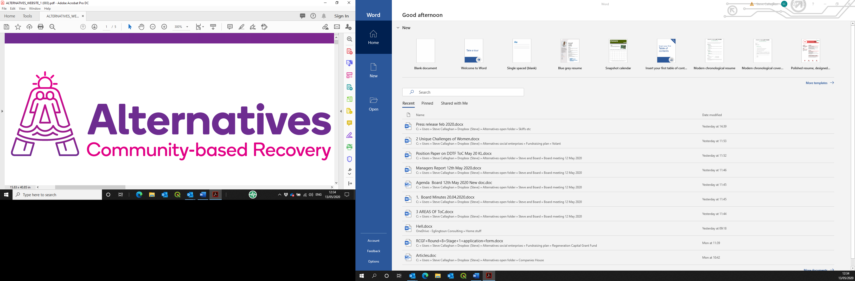

Post of Community Recovery Project Worker
Application pack



Contents
Introduction and background information 3
Applying for the post on offer 3
Alternatives West Dunbartonshire Community Drug Services (Alternatives) 3
History and achievements 3
Social enterprises 3
Job description 3
Person specification 5
Application form 6

Introduction and background information

Applying for the post on offer
Please read this pack in its entirety, then apply using the enclosed electronic form. This should be returned by 9.00a.m on 25th August 2023, by email to Mhairi@alternativeswd.org .
Please add your surname to the name of the file as you save it before sending.
LATE APPLICATIONS WILL NOT BE ACCEPTED.
Interviews will take place week commencing 4th September 2023

Alternatives West Dunbartonshire Community Drug Services (Alternatives)

History and achievements
Alternatives has been established since 1996 as a charitable company, with premises across West Dunbartonshire. Its operation base currently consists of:
- A main office in Quay Street, Dumbarton;
- A secondary office in Alexander Street, Clydebank;
- A 16-bed residential rehabilitation in Jean Armour Drive, Clydebank;
- 4 x 2-bedroom ‘scatter flats’ in Drumry, Clydebank;
- A catering operation within the Concord Community Centre and the Denny Tank Museum, Dumbarton
- 15 Acres of land for Horticulture and Wildlife development in Dumbarton

Alternatives’ core theme and purpose is to facilitate the personal journey from chaos to wholeness for individuals who have a substance dependency, by normalising a lifestyle without such a dependency.

Social enterprises
We run social enterprises as safe, therapeutic work placement opportunities, these are being developed within the operational structure through, to take in a horticulture operation, an upcycling/life skills operation and an expansion of the piloted catering operation. A heritage-based operation will also follow in due course.

Job description

To deliver the Foundation, Advanced and Move On phases of the Community Recovery Programme. This involves working with individuals and families affected by drug misuse, collaboration with partner organisations with specific focus on the delivery of our new innovative groupwork programme aimed at promoting positive alternatives to drug use and stability in the community.

PVG Scheme Membership is required for this post.
Alternatives operates an Equal Opportunities Policy.

Job title: Community Recovery Project Worker
Place of work: Safe As Houses Project, Clydebank
Employer: Alternatives West Dunbartonshire Community Drug Services (Alternatives)
Reporting to: Community Recovery Team Manager
Salary: £24,918.62 plus a contributory Pension of up to 6%.
Hours: 35hrs per week, Monday to Friday

Main Duties of the post:

- Under the direction of the Line Manager assist with the development and implementation of the structured Groupwork Programme and outdoor activities.
- To be directly involved in the initial assessment of drug using individuals and subsequent provision of groupwork and outdoor activities.
- To provide individual one to one support in assessment of need, development of Careplan and the provision of regular reviews of agreed Careplan.
- To support the ongoing development of our Social Enterprises
- To provide support to drug using individual in a non-judgemental manner within a harm reduction framework.
- To work jointly with all partner agencies towards meeting the needs of service users.
- To record work undertaken in a suitable form as designated by the Line Manager and to gather data and maintain data gathering systems.
- To actively promote the services provided by Alternatives in line with policy guidelines, protocol and service philosophy.
- To work as part of a team towards the aims of service users in line with agreed working practice and strategies.
- To undertake such training programmes as may assist this agency and personal development.
- To be willing to undertake evening/weekend work as directed.
- To participate in formal consultation and supervision of as required.
- To undertake the development, training and supervision of volunteers/sessional workers in the delivery of groupwork programmes.
- To undertake such other duties, appropriate to the grade, as may be delegated by the Project Manager.

Person specification
Specification | Essential | Desirable | How demonstrated
Qualifications | Relevant SVQ level 3 Qualification or equivalent | Clean driving licence | Certificates
Knowledge and Experience | Direct experience of working with families experiencing hardship  Knowledge of local resources such as college courses, leisure facilities and support agencies  A person-centred approach to working with people experiencing issues  An awareness of needs of people experiencing drug problems  Ability to recognise and report concerns about the well-being of children and vulnerable service users  Ability to work within appropriate legislation processes and procedures  Previous Groupwork experience | Previous experience of inter-agency working  Previous experience of presenting training inputs | Application form; detailed in interview and references
Competencies | Good quality written and verbal skills  Ability to work on own or as part of a team.  Ability to work irregular hours |  | Application form;  Competency based interview; references

Application form
A | Post details
Post Title |  | Community Recovery Project Worker
Employer |  | Alternatives West Dunbartonshire Community Drug Services

B | Personal details
Surname: |  | First name(s):Click or tap here to enter text. |  | Known as:Click or tap here to enter text.
Address and Postcode: |  | Click or tap here to enter text.
Telephone (home): |  | Click or tap here to enter text. | National Insurance No: |  | Click or tap here to enter text.
Telephone (mobile): |  | Click or tap here to enter text. | Email address: |  | Click or tap here to enter text.

C | Referees
(we will only contact if successful at interview) |  | First reference | Second reference
Name: |  | Click or tap here to enter text. | Click or tap here to enter text.
Role: |  | Click or tap here to enter text. | Click or tap here to enter text.
Organisation/personal: |  | Click or tap here to enter text. | Click or tap here to enter text.
Address: |  | Click or tap here to enter text. | Click or tap here to enter text.
Postcode: |  | Click or tap here to enter text. | Click or tap here to enter text.
Telephone: |  | Click or tap here to enter text. | Click or tap here to enter text.
Email address: |  | Click or tap here to enter text. | Click or tap here to enter text.

D | Additional information
Notice required by current employer: |  | Click or tap here to enter text.
Are you allowed to work in the UK? |  | Click or tap here to enter text.
What driving licence do you hold? |  | Click or tap here to enter text.
Penalty points current: |  | Click or tap here to enter text.

E | Education and Qualifications
Attainment |  | Results obtained | Year
Click or tap here to enter text. |  | Click or tap here to enter text. | Click or tap here to enter text.

F | Other training and experience
Description |  | When undertaken/achieved
Click or tap here to enter text. |  | Click or tap here to enter text.

G | Membership of professional bodies
Institution |  | Class of membership | From | To
Click or tap here to enter text. |  | Click or tap here to enter text. | Click or tap here to enter text. | Click or tap here to enter text.

H | Employment history
Employer (most recent first) |  | Role held | Description of duties | Timeframe
Click or tap here to enter text. |  | Click or tap here to enter text. | Click or tap here to enter text. | Click or tap here to enter text.

I | Health
If offered employment, this will be subject to a required medical questionnaire. Please state that you will be prepared to complete such a documentClick or tap here to enter text.

J | Supporting information
Please give enough information for us to assess your application against the person specification

K | Declaration
Alternatives posts are covered by the Rehabilitation of Offenders Act 1974.
Before an offer of appointment, an Enhanced Disclosure Scotland check will be carried out.

- I agree to an Enhanced Disclosure Scotland check being carried out.
- I certify that all of the information I have provided is accurate and truthful; I realise that supplying incorrect or untruthful information on the form may form grounds for summary dismissal without notice.
Signed: |  | Click or tap here to enter text. | Date: | Click or tap here to enter text.

