SERVICE ADMINISTRATOR
Reporting to: Business Manager
Responsible for: None
Hours of work: 36.25 within the hours of Monday to Friday 9am-5pm
Place of work: Office based post: The Almondbank Centre, Shiel Walk, Livingston, EH54 5EH
Salary: £21392 point 13 on SJC scale
Holidays: 39 days per annum (inclusive of 6 fixed public holidays)
JOB PURPOSE
Working within the Administration Team to provide administrative assistance to the organisation to ensure a comprehensive service delivery. The Administration Team consists of the Business Manager (1FTE), Business Administrator (0.8 FTE) and two Service Administrators (1.8 FTE including this post).
SUMMARY OF DUTIES
- To provide the initial response to telephone enquiries from clients and other organisations and advise and/or pass on relevant information to colleagues, enabling an effective service to be provided.

- Daily issue of standard letters to clients on behalf of project workers. Process outgoing mail daily via e mail and post.

- To undertake the input of all electronic client databases in use across the service.

- To process all referrals from twice weekly Addiction Care Partnership Meetings and add to client caseload list

- To update DAISY waiting times on a daily basis and assessments and discharge client files on a regular basis

- To contribute to the quarterly Alcohol and Drug Partnership and other reports as required

- Maintain and update the WLDAS website

- Make copies of client packs and information leaflets to ensure sufficient supplies are always available.

- Undertake annual archiving of case files.

- Support TSS Groupwork: make room bookings and ensure sufficient materials, folders and worksheets are available for attendees.

- To attend relevant meetings.

- To take minutes of meetings as required.

GENERAL RESPONSIBILITIES
- To comply fully with the organisations ethos, policies and procedures and relevant legislation.

- To undertake other duties in line with the job purpose.

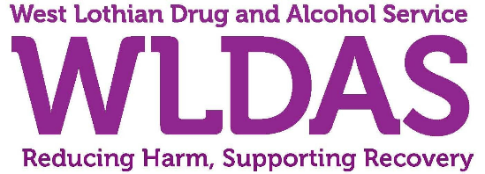
Post: Service Administrator
PERSON SPECIFICATION
In order to be shortlisted you must demonstrate you meet all the essential criteria and as much of the desirable as possible. When a large volume of applications are received for a vacancy and most applicants meet the essential criteria then the desirable criteria is used to produce the shortlist.

Criteria | Essential | Desirable | How assessed
Personal Traits | - A belief in social justice and making a positive difference to people's lives  - Ability to uphold WLDAS’ values  - Enthusiasm and dedication  - Team-working and people skills  - Communication skills: oral and written.  - Administrative and organisational skills.  - Pro-activity and flexibility |  | AI
Qualifications and Training | HNC/SVQIII in Secretarial Studies/Business Administration/another relevant subject or equivalent. |  | ACIR
Experience and Knowledge | Previous experience in an administrative role and ability to demonstrate:  - The ability to follow, develop and implement administrative processes  - Sound working knowledge of computer software packages including Word, Excel databases & spreadsheets, Outlook email. | Previous experience of working in health care or third sector environment | ACIR
Skills and/or Abilities | Effective organisational skills and ability to manage priorities  Effective oral and written communication skills  Effective time management in order to meet deadlines  Excellent keyboard skills  Attention to detail  Ability to work with limited supervision  Flexible to meet the needs of the service | Experience of minute taking | ACIR

Key – how assessed
A = Application form | I = Interview
C = Copies of certificates | R = References

