



Prevention Worker

01382 201291
info@wrasac.org.uk
support@wrasac.org.uk
www.wrasac.org.uk

Dear Applicant

Thank you for your interest in applying for a post with Women’s Rape and Sexual Abuse Centre. Please find enclosed the following documents: -

- Information about WRASAC
- Advice on completing your application form
- Job Description and Person Specification

Please do not send a curriculum vitae as this will not be considered.

Please note, all applications and relevant recruitment documents will be held confidentially and destroyed after 6 months, apart from documents relating to the successful applicant.

Your completed application should be submitted via email by sending it to recruitment@wrasac.org.uk.

Closing date is Friday 8th September 2023 at midnight

Interviews will be held Wednesday 20th September 2023

Please note this post is 21 hours per week on a 12 month rolling contract

We look forward to receiving your completed application form. Enquiries about this position are welcome by phoning or emailing recruitment@wrasac.org.uk.

Yours sincerely

Katie Hardy-Jensen
Manager

Sangobeg House, 4 Francis Street, Dundee, DD3 8HH
WRASAC Dundee & Angus is a company limited by guarantee, registered with OSCR and registered in Scotland as company number SC241372 and charity number SC009070.

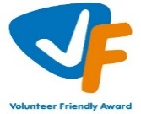



Information about WRASAC

The Women’s Rape and Sexual Abuse Centre – Dundee and Angus (WRASAC) has been supporting survivors of rape, sexual abuse and exploitation and raising awareness about the damaging effects of sexual violence since 1984. We are a registered charity and a company limited by guarantee.

WRASAC has a dynamic team of 34 staff members, 10 volunteers, 2 Students and 2 Sessional Workers. The organisation has an annual income of just over 1 million pounds per year.
We provide a range of services to survivors of sexual violence, abuse and exploitation including:
Women’s Support Service
The Women’s Support Service provides support to self-identifying women (over 18) who have experienced rape, sexual abuse and/or exploitation.
Support can include 1:1 session in the centre or on outreach, advocacy support and signposting to other organisations for support.
Dundee and Angus Young Survivors (DAYS)
We support all young people of any gender aged between 8 and 18 who live in Dundee or Angus and have experienced any type of sexual abuse.
We take a flexible approach to planning support to best meet the needs of the young person, this can be school, home, community or at our office.
1:1 Support - We offer emotional support to survivors. Each session is a safe and confidential space for survivors to process the trauma they have experienced at their own pace. We do this by using a range of therapeutic interventions and tools which are survivor centred.
Group work support - We various creative groups and peer support groups all of which aims to reduce isolation and extend social circles. The aim of these are to build survivors support networks and build survivors confidence, reducing isolation and feelings of blame and shame.
Family and Friends
We can also provide support to family, friends, partners and agency workers to help them understand the impact of sexual violence and cope with their feelings whilst supporting a survivor.

Vice Versa
Vice Versa provides support to adult women who have been involved, are currently involved or are at risk of being involved in Commercial Sexual Exploitation (CSE). The women we support generally experience multiple disadvantage which may include substance use, homelessness, physical and mental health issues, welfare issues and extensive historical and ongoing trauma.
The aim of the project is to provide women with safety and stabilisation support and with all issues that impact on their involvement in CSE. Support can include 1:1 session in the centre or on outreach, supporting to attend appointments and groups, advocacy support and signposting to other organisations or support. Support is led entirely by the women and their needs and priorities.
Justice Advocacy Service
Our Justice Advocacy Service provides support throughout the criminal justice process. We can support survivors with their decision to report the incident to the Police or not.

If they decide to report to the Police, we can go with survivors while they provide their statement and if they would prefer, we can get updates on the investigation from the Police on survivor’s behalf. If the case is reported to the Crown Office and Procurator Fiscal Service (COPFS), we can liaise with survivors assigned Victim Information and Advice Officer (VIA) and talk to them about special measures that can be put in place to make giving evidence as easy as possible.

Advocacy Workers can go into the court room with survivors (as an In Court Supporter) while they give evidence, and they can provide support around verdicts and sentencing. Advocacy workers can also provide post court support to survivors.

Dundee Womens Hub
WRASAC supported by partners across the Dundee area are responsible for the setting up, development and facilitation of Dundee Womens Hub (DWH).

The main aim of the DWH is to increase capacity and co-ordination of services to respond to the needs of the women experiencing substance use and multiple disadvantage. The hub will improve access to substance use and related services for women in Dundee with the overall goal of improving physical and emotional wellbeing for women who experience substance use and multiple disadvantages.

Prevention Work
We have a dedicated Prevention Worker who works in schools, colleges and youth settings in Dundee and Angus delivering the Rape Crisis Scotland Prevention Pack.
Gender Based Violence (GBV) Team
The GBV Team is made up of a Community Engagement Worker who focuses on increasing access to our service and raising awareness around our service and issues related to sexual violence.
Two Learning and Development Officers who are co-located between WRASAC and Dundee City Council who provide training and support and strategic direction in relation to GBV and Trauma across the VAWG network and council in Dundee
Training and Awareness Raising
Staff across our teams provide training sessions We provide WRASAC Information Session’s to staff from Dundee and Angus. We also provide training on a range of topics including understanding sexual violence and dealing with trauma. Additionally, we run community awareness raising events, like our Reclaim the Night March each year.

Vision, Values and Strategic Priorities

In 2017-18, after a long period of reviewing and consulting with staff, volunteers, trustees, survivors and partner agencies we developed our new Strategic Plan and updated our Vision, Mission Statement and Values.

Our Vision
For a world free from sexual violence, abuse and exploitation and a society in which everyone has equality, freedom and choices to live the lives they want and thrive.

Our Mission
To support survivors who have experienced any form of sexual violence, abuse or exploitation in their lives.
To promote equality and raise public awareness of the routes of sexual violence and its damaging and life-changing effects.

Our Values
We believe first and foremost that perpetrators of rape, sexual abuse and exploitation are responsible for their actions – not survivors.

We are a feminist organisation which means we recognise that all forms of rape, sexual abuse and exploitation are acts of violence, that disproportionately affects women and children, involving the abuse of power and control, are a breach of human rights and are fundamentally rooted in gender inequality.

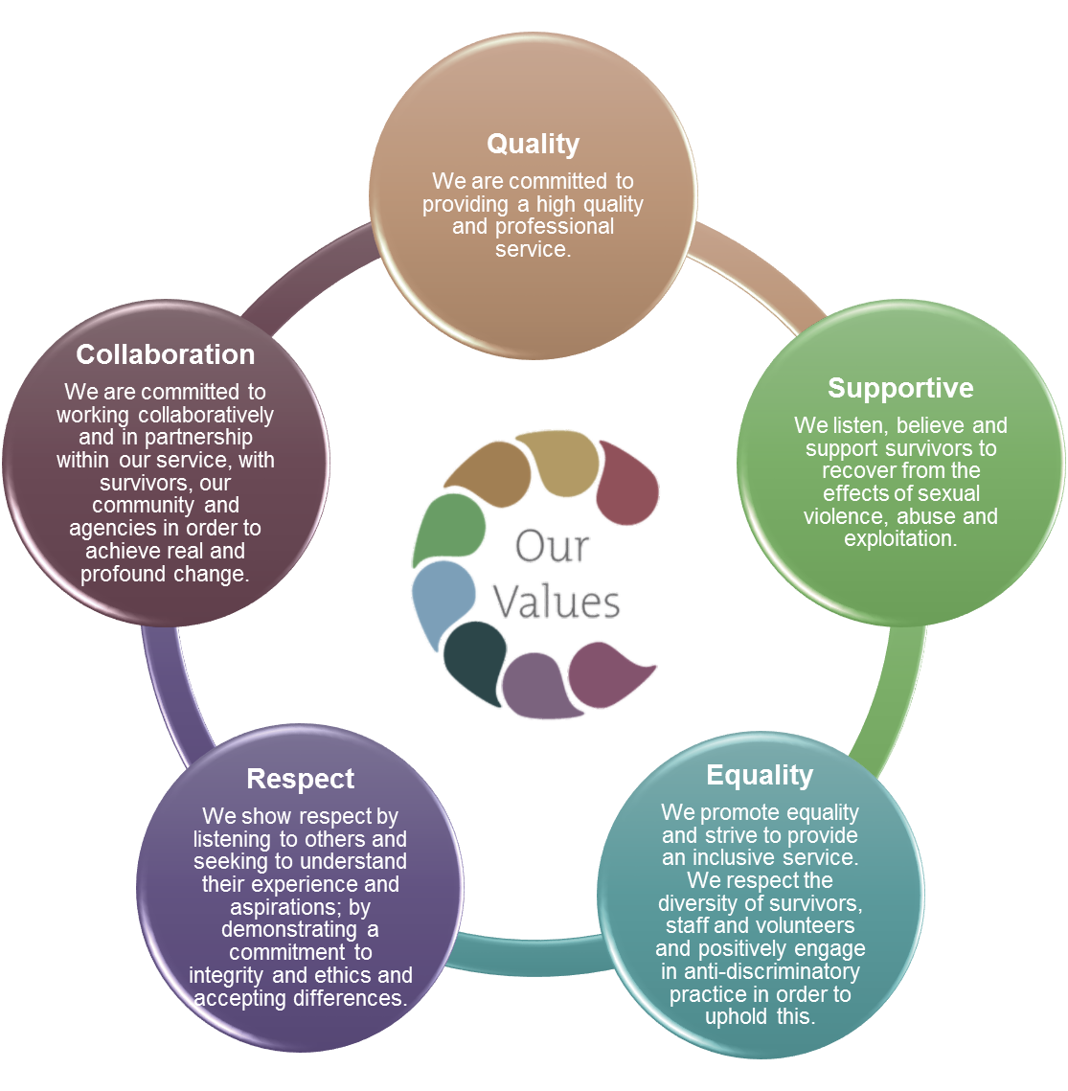

Our Strategic Priorities

ADVICE ON COMPLETING YOUR APPLICATION FORM

As part of WRASAC’s commitment to equal opportunities, candidates for each post are treated equally. Application forms are the only basis on which the first selection is made to decide whom to call for interview. Therefore, only information, which appears on the form (and continuation pages), can be considered. It is very important that your completed form contains both the information we want about your skills and experience and the information you want to give us. These advice notes are intended to help you to complete your form effectively.

1 Read all the information provided especially the job description and person specification. These outline the duties you would be expected to carry out in this post and lists the skills, knowledge and abilities that the short listing/interview panel will be looking for.

2 Section 4 asks you to note down your general experience and is the most important part of your application. This is your chance to explain why you are suitable for the job. It is not enough to say you have the experience – you must demonstrate experience and skills with specific examples. Relevant experience may be from your current or previous jobs or from out with formal employment.

3 We have lots of information about our service on our website www.wrasac.org.uk.

4 Do not send your CV in addition to or in place of a completed application form as it will not be considered by the short-listing panel.

5 A Protection of Vulnerable Groups and Non-Police Personnel Vetting is required as part of the job.

6 Completing the Equal Opportunities Monitoring Form is voluntary, but the information requested here is useful as it allows us to monitor the effectiveness of our policy of equal opportunities in employment.

7 All applicants must complete all parts of the application form.

8 Application forms must arrive on time, forms arriving late will not be considered.

9 References are normally taken up for the short-listed applicants before interview. If you do not wish one or all references to be taken up at that point please indicate on the relevant page. It is our policy not to make a job offer without taking up references.

National Sexual Violence Prevention Programme.
The national sexual violence prevention programme is funded by the Scottish Government to run workshops across Scotland on seven different topics adapted for four different age/stage groups.
This work is led by workers based in local Rape Crisis Centres and places an emphasis on young people’s participation and leadership.

Programmes are planned in partnership with schools and youth groups to best meet their needs.

The prevention programme promotes children’s rights to protection from violence and abuse.

Job Description & Person Specification

Sexual Violence Prevention Worker

JOB PURPOSE: The overall aim of this post is to deliver interventions to young people around healthy sexual relationships using the Rape Crisis Scotland sexual violence prevention pack, and to develop local strategic approaches to sexual violence prevention.

The main outcomes for this post are as follows:
- National and local strategic approaches to sexual violence prevention are more consistent and more effective.
- Strategic partnerships between rape crisis centres and local agencies are strengthened, promoting shared approaches to sexual violence and support for direct interventions by centres.
- Young people have increased knowledge and more positive attitudes towards sexual relationships, and less tolerance of violence.
- Young people have a greater role in shaping interventions in relation to sexual relationships.

Responsible to: Centre Manager

Salary: £17,408.38 rising to £18,740.00 after successful completion of probation

Hours: 21 hours per week

Location: Dundee & Angus

Holidays: 38 Days rising annually to a total of 42 days (pro rata)

Pension: Employer contribution at 6% to CIS pension fund.

MAIN DUTIES
Delivery of prevention education
Deliver educational programs in schools and other education and community settings using the Rape Crisis Scotland sexual violence prevention pack.

Develop partnerships with schools and other education and training providers to plan education programs and to support the development of policy and practice in relation to sexual violence, in accordance with existing priorities such as Curriculum for Excellence, Getting it Right for Every Child and child protection.

Deliver information sessions to school staff and parents/carers as required.

Strategic development

Liaise with statutory and voluntary sector agencies (such as local education authority, youth and children’s services) and participate in multi-agency partnerships to develop strategic approaches to sexual violence prevention.
Liaise with Rape Crisis Scotland to increase connections and consistency between local and national approaches to prevention sexual violence.
Participate in practitioners’ forums with network of Rape Crisis prevention workers
Seek and develop opportunities for young people to be involved in shaping prevention interventions.

Support

Respond sensitively to disclosures and facilitate young people’s access to support services as appropriate
Act on any child protection or wellbeing concerns identified during seminars according to the child protection policies and procedures. Where appropriate, participate in multi-agency initiatives to promote the young person’s safety and wellbeing.

Monitoring and Evaluation

Gather evaluation data from young people and link professionals using the materials in the Rape Crisis Scotland sexual violence prevention pack. Pass data to Rape Crisis Scotland to inform revision of materials and funding reports.

Contribute to any agreed evaluation procedures including external evaluations.

Equalities

Promote anti-discriminatory values and non-violence in all aspects of practice.

Accountability, supervision and professional development

Attend regular support and supervision with line manager.
Undertake training and development as required.
Adhere to center’s policies and procedures.

Team working and communication

Work as a team with other staff members
Attend regular team meetings and contribute to ongoing development within the organisation

OTHER DUTIES
This job description is a broad picture of the post at the date of preparation. It is not an exhaustive list of all possible duties and it is recognised that jobs change and evolve over time. Consequently, this is not a contractual document and the post holder will be required to carry out any other duties to the equivalent level that are necessary to fulfil the purpose of the job.

PERSON SPECIFICATION

CRITERIA | ESSENTIAL | DESIRABLE
Knowledge | Understanding of feminist analysis of violence  against women  Thorough knowledge of issues relating to sexual violence  Understanding of the impact of sexualisation of young people in the media and links with violence against women | Knowledge of approaches to sexual violence prevention  Knowledge of current legislation, policy and strategy relating to education and to the violence against women agenda
Skills and Abilities | Ability to engage with young people in a range of settings.  Ability to work effectively with a wide range of partners in voluntary and statutory agencies.  Good communication skills both written and oral  Ability to organise and prioritise your own workload and schedule.  Competence in use of IT, for example Word and Excel programs, email and internet and delivery of PowerPoint presentations
Experience | Experience of delivering workshops/groupwork to young people  Experience of responding to disclosures | Experience of developing educational materials or groupwork program  Experience of working with people affected by gender-based violence  Experience of evaluating interventions aimed at young people  Experience of working independently in an outreach capacity
Qualifications |  | Qualification in Social Care, Community Education, Youth Work or similar discipline
Other | Clean driving license, access to vehicle and able to travel to various locations in the local area.  Able to work flexibly and to undertake some evening and weekend work.  Commitment to anti-discriminatory practice

Women’s Rape and Sexual Abuse Centre Dundee

Post Applied For:

1. Personal Details

First Names: | Surname:
Address:  Post Code: | Contact information:  Mobile:  Email:

2. References
Please provide details of a minimum of two referees, one of which must be your most recent employer.

Name: Contact prior to interview: Y/N

Address:

Email address:
Telephone number:

Relationship to you:

Name: Contact prior to interview: Y/N

Address:

Email address:
Telephone number:

Relationship to you:
- Period of notice required by current employer?

- Are there any dates when you will be unavailable for interview?

- Are there any adjustments that WRASAC will need to make, should you be invited to interview? Please state what these are.

- Are there any restrictions to your residence in the UK, which might affect your right to take up employment? If Yes, please provide details

- If you are successful in your application will you require a work permit prior to taking up employment?

- Do you hold a full drivers licence?

- Do you currently have car insurance for business use?

- Are you related to any employee or board member of WRASAC Dundee and Angus? Yes / No If yes, please provide details:

- Are you or have you ever been a member of WRASAC Dundee and Angus Board of Directors? Yes / No If yes, please provide details:
- Where did you see this vacancy advertised

Data Protection Statement
The information that you provide on this form and that obtained from other relevant sources will be used to process your application for employment.

The personal information that you give us will also be used in a confidential manner to help us monitor our recruitment process. If you succeed in your application and take up employment with us, the information will be used in the administration of your employment with us and to provide you with information about us or third party via your payslip. We may also use the information if there is a complaint or legal challenge relevant to this recruitment process.

We may check the information collected, with third parties or with other information held by us. We may also use or pass to certain third parties information to prevent or detect crime, to protect public funds, or in other ways as permitted by law.

By signing the application form we will be assuming that you agree to the processing of sensitive personal data, (as described above), in accordance with our registration with the Data Protection Commissioner.

DECLARATION
I declare that to the best of my knowledge and belief the information given is correct and complete. I understand that WRASAC reserves the right to withdraw the offer of employment or to terminate employment already commenced if the information given to us is inaccurate or misleading in any way. Any job offer is conditional upon receipt of satisfactory references and, if required by WRASAC, any medical reports or disclosure check.

Signed
Date

WRASAC is an Equal Opportunities Employer
Women’s Rape and Sexual Abuse Centre
Dundee and Angus

Post Applied For:

Personal Details

First Names: | Surname:
Address:  Post Code: | Contact information:  Mobile:  Email:

References
Please provide details of a minimum of two referees, one of which must be your most recent employer.

Name: Contact prior to interview: Y/N

Address:

Email address:
Telephone number:

Relationship to you:

Name: Contact prior to interview: Y/N

Address:

Email address:
Telephone number:

Relationship to you:

Period of notice required by current employer?

Are there any dates when you will be unavailable for interview?

Are there any adjustments that WRASAC will need to make, should you be invited to interview? Please state what these are.

Are there any restrictions to your residence in the UK, which might affect your right to take up employment? If Yes, please provide details

If you are successful in your application will you require a work permit prior to taking up employment?

Do you hold a full drivers licence?

Do you currently have car insurance for business use?

Are you related to any employee or board member of WRASAC Dundee and Angus?
Yes / No If yes, please provide details:

Are you or have you ever been a member of WRASAC Dundee and Angus Board of Directors?
Yes / No If yes, please provide details:
Where did you see this vacancy advertised?

Data Protection Statement
The information that you provide on this form and that obtained from other relevant sources will be used to process your application for employment.

The personal information that you give us will also be used in a confidential manner to help us monitor our recruitment process. If you succeed in your application and take up employment with us, the information will be used in the administration of your employment with us and to provide you with information about us or third party via your payslip. We may also use the information if there is a complaint or legal challenge relevant to this recruitment process.

We may check the information collected, with third parties or with other information held by us. We may also use or pass to certain third parties information to prevent or detect crime, to protect public funds, or in other ways as permitted by law.

By signing the application form we will be assuming that you agree to the processing of sensitive personal data, (as described above), in accordance with our registration with the Data Protection Commissioner.

DECLARATION
I declare that to the best of my knowledge and belief the information given is correct and complete. I understand that WRASAC reserves the right to withdraw the offer of employment or to terminate employment already commenced if the information given to us is inaccurate or misleading in any way. Any job offer is conditional upon receipt of satisfactory references and, if required by WRASAC, any medical reports or disclosure check.

Signed
Date

WRASAC is an Equal Opportunities Employer

Applicant No: _________ (office use only)

- Work Experience – Starting with most recent employer
Please continue on additional sheets if necessary.

Post:
Address:
From: To:
Main Duties:

Reason for leaving:

Post:
Address:
From: To:
Main Duties:

Reason for leaving:

Employment Continued

Dates from to | Employers name and address | Post title, responsibilities, experience gained, key achievements | Reason for Leaving, Salary

- Membership of professional bodies

3. Educational, Technical & Professional Qualifications

Institute | Qualification gained | Date Achieved

- Skills, experience and knowledge (please refer to the person specification)

Your completed application should be submitted via email by sending it to recruitment@wrasac.org.uk

