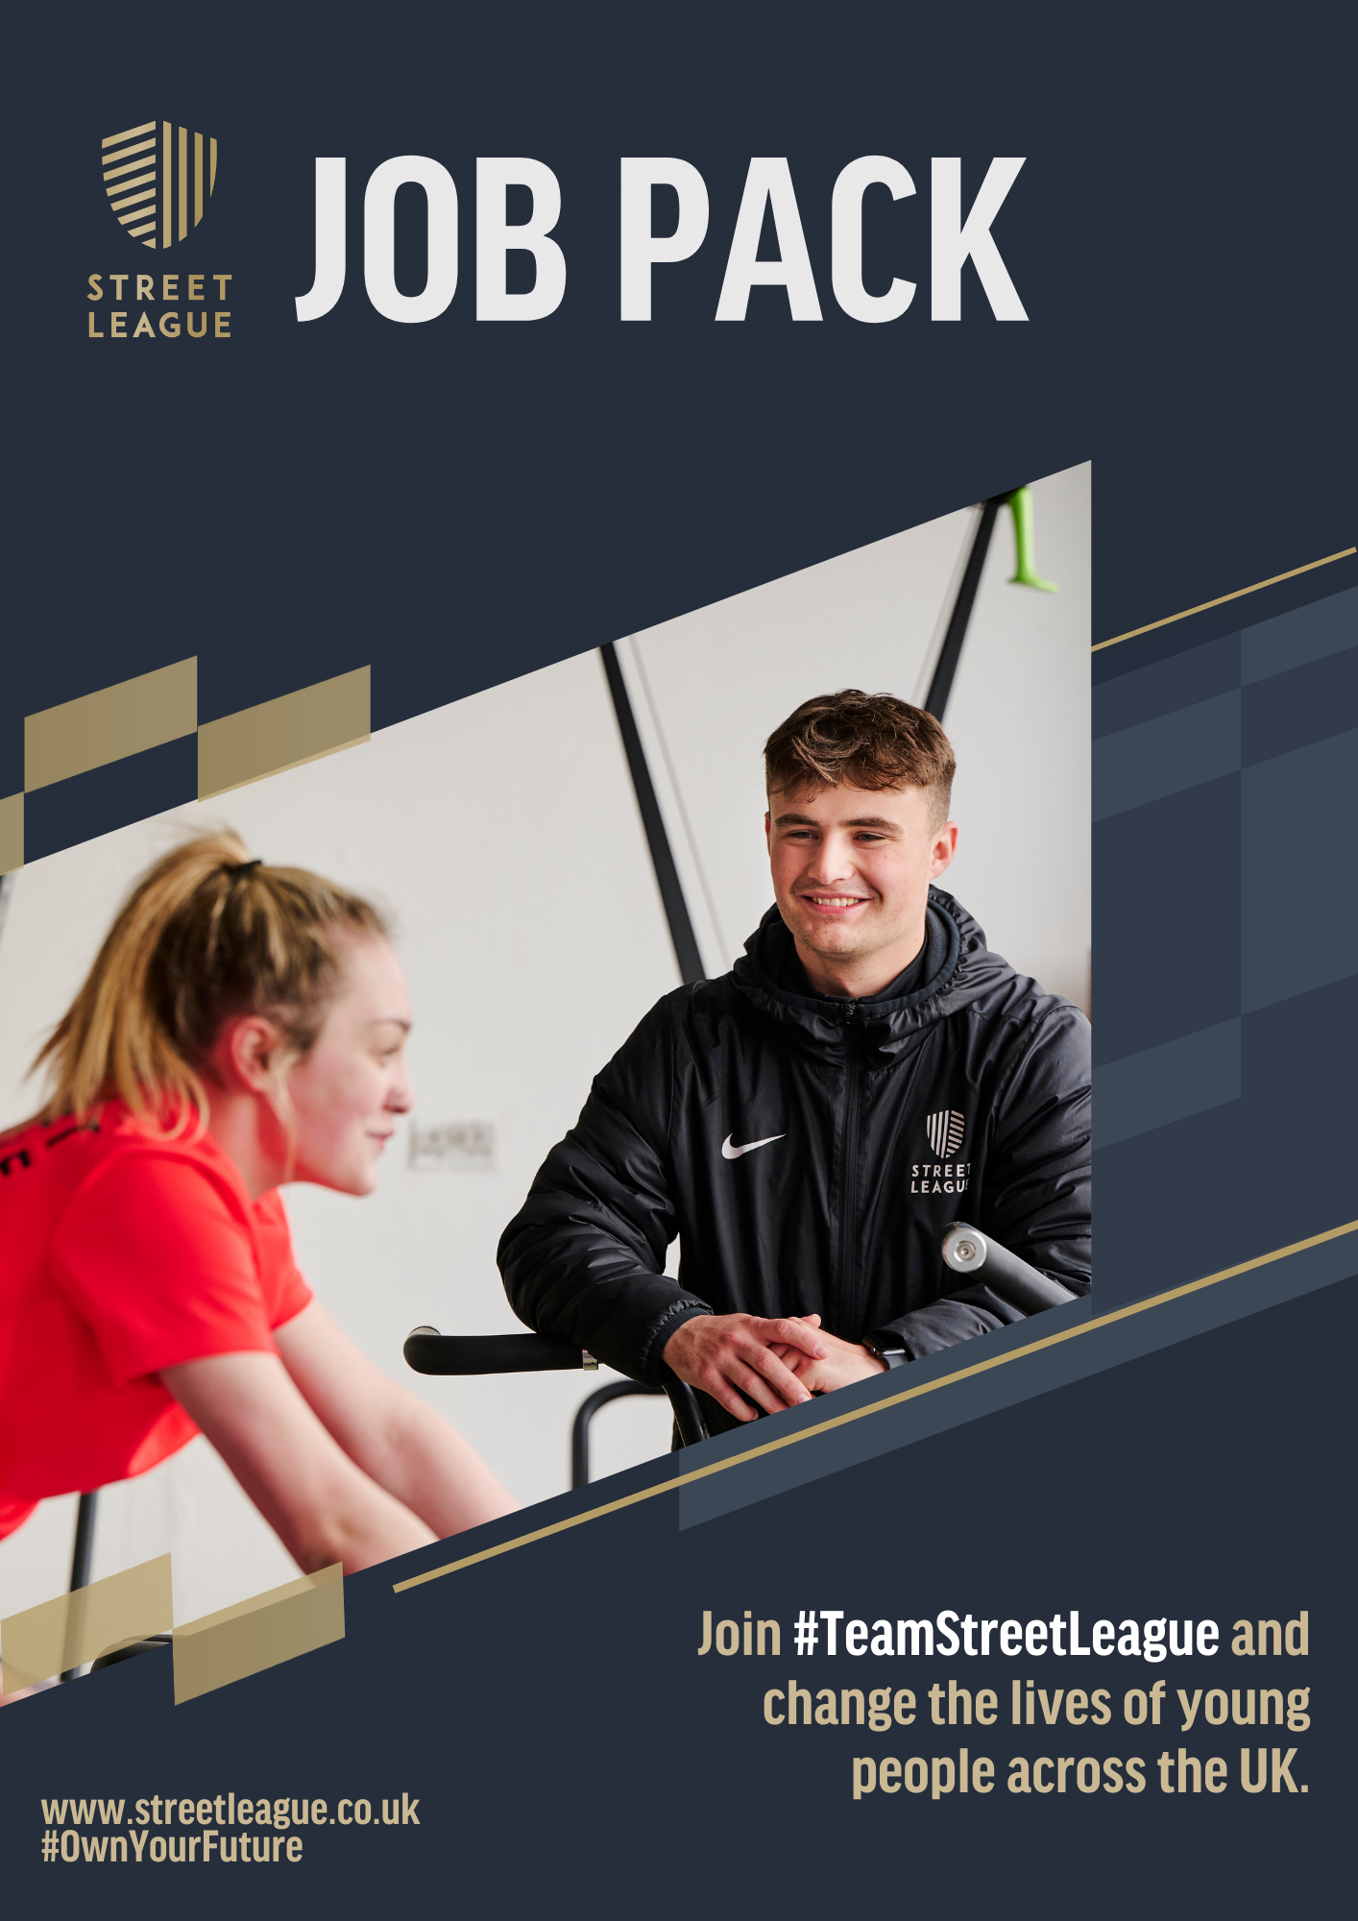

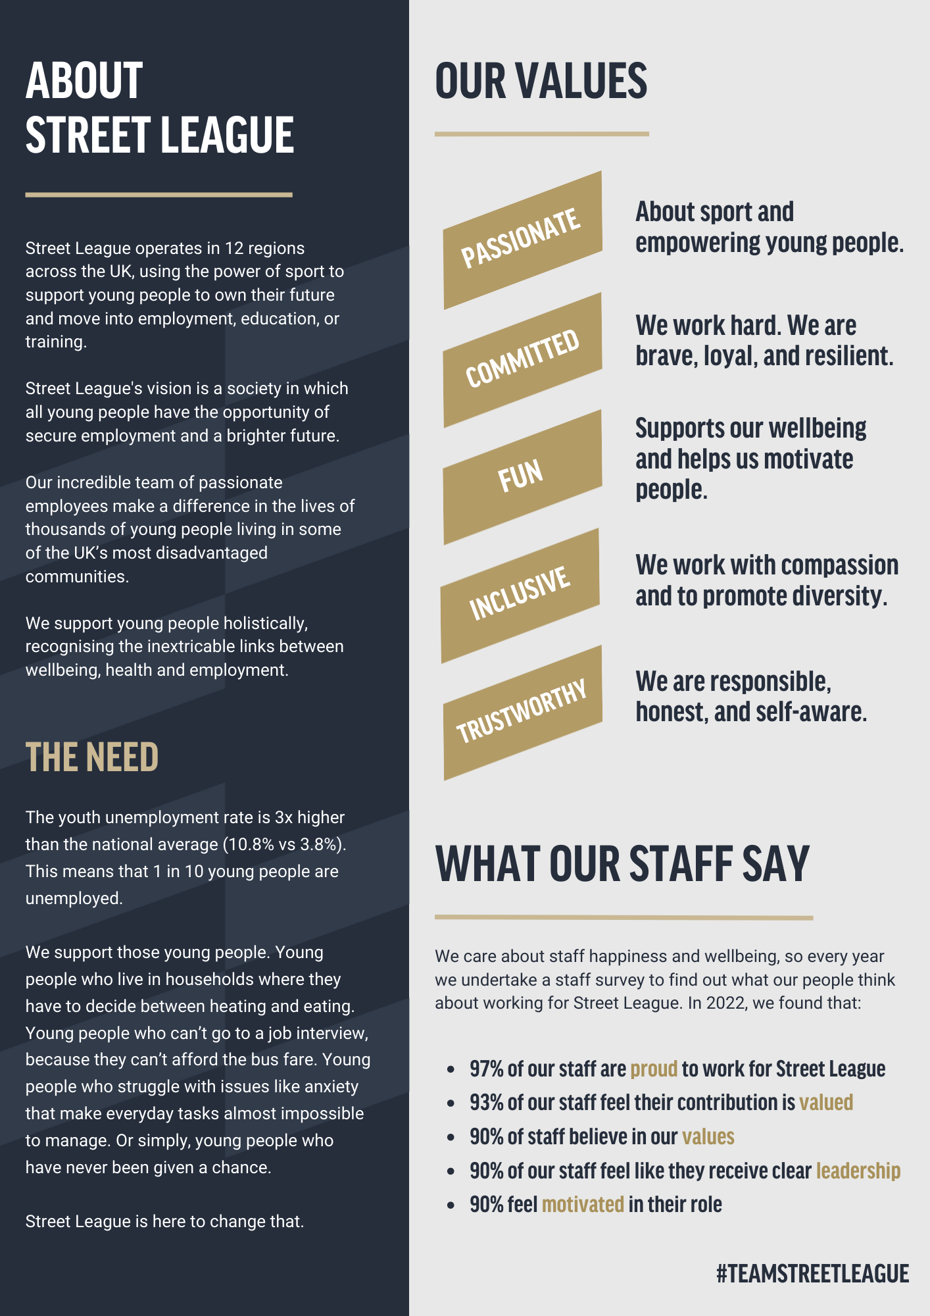
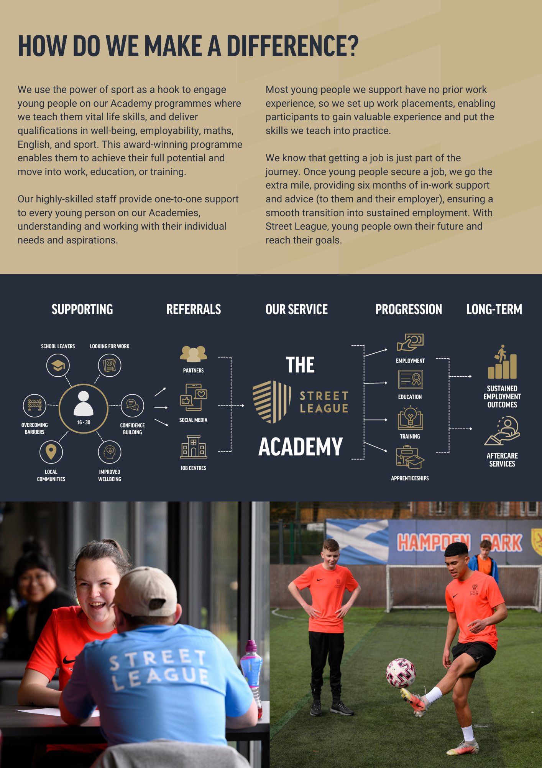

Job Description

POST TITLE - Progressions Coordinator
RESPONSIBLE TO - Operations Manager
SALARY - £24,150
LOCATION - Dundee
WORK PATTERN - 36.25 hours per week, Monday-Friday
CONTRACT - Fixed-Term until March 2024

Role Summary:

The Progressions Coordinator works in partnership with their delivery partner (Youth & Community Coach) in delivering and administering Street League’s core programmes in their specific local areas.

You will be responsible for:

- Securing employment, education and training opportunities for Street League participants and supporting them to progress. You will do this by locally securing and sharing job/training opportunities for young people.

- The delivery of Street League’s Academy, in which you will deliver group employability and personal development workshops and qualifications.

- Establishing and maintaining partnerships with referral agencies and develop further partnerships with employers or colleges in order to secure suitable opportunities for our participants.

- Monitoring and reporting are essential to this role.

Major Duties and Responsibilities:

Corporate Responsibilities:

- To undertake compliance with Street League’s policies and procedures and business plan.

- Full participation in team and wider staff meetings, support and supervision and personal/professional development.

- To actively promote and implement Street League’s Equal Opportunities policy within all aspects of the post.

- Undertake Safeguarding and Health and Safety duties, including risk assessments as required in line with Street League’s policy.

- Ensure compliance with Street League’s Data Protection Policy in the management, storage, and security of participant information.

- To undertake any other reasonably required duties as instructed by line manager or someone acting on their behalf, in addition to the role specific responsibilities detailed below.

Role Specific Responsibilities:

- Overall accountability for the preparation, administration and delivery of the Street League Academy and progression service.
- Delivery of a complete employability service including job searching strategies, interview techniques, job applications, etc. and delivering group employability and personal development workshops.
- Overall accountability for supporting participants.
- Overall accountability for soft skills analysis, overcoming barriers and assisting participants
to draw up action plans. Undertaking an appropriate initial assessment with each participant
using a variety of tools and methods that assist in identifying the needs of the participant.
- Overall accountability for meeting delivery team targets in relation to retention, outcomes, and sustainment.
- Evaluate and assess (formative and summative) the work of learners in relation to the qualification assessment criteria and provide timely constructive and helpful learner feedback so that learners develop the skills, knowledge, and behaviours to progress to their next steps.
- To network with external organisations such as colleges, job centres, careers centres, employers, community groups and other relevant organisations to source and secure employment, education and/or training opportunities for Street League participants. Also using social media and local media to raise awareness of Street League’s work, with support and training provided by our Communications team.
- To contribute to the development and implementation of Street League’s Practice Framework and to update, develop and share sessions or workshops that are relevant to Street League contracts and funding streams.
- Overall accountability for identifying work experience opportunities and
supporting participants within work experience, employment, education, or training by providing aftercare.

- Keeping up to date with labour market information, legislation, professional and academic developments.

Duties to Young People:
- To promote equal opportunities at all times in line with Street League’s Equal Opportunities, Equality and Diversity Policy.
- Responsibility and diligence around issues or incidents which may make activity non-inclusive for participants and carrying out the necessary procedures in identifying and dealing with any safeguarding or child protection, diversity, or health & safety issues.
- Shared responsibility for the appropriate referral or signposting of participants to agencies for specialist help who require additional support needs such as housing, addiction, etc.
- Responsibility for completing all necessary paperwork for each participant on academies including organising travel expenses, timesheets, training allowances where contractually appropriate.
- Joint responsibility with other members of the delivery team (Youth and Community Coach & Functional Skills Tutor) for the pastoral support and care of Street League’s young people including liaising with but not limited to support workers, key workers, social workers, DWP advisors.
- To provide First Aid cover for Street League Activity and ensure sessions are safe and enjoyable for all. First Aid training will be provided to all staff.
- Support Senior Staff to facilitate stakeholder visits to Academies and activity. Stakeholders include but are not limited to funders, politicians, ambassadors, and partner organisations.

Teamwork:

- Shared responsibility for inputting and maintaining M&E (monitoring and evaluation)
information by capturing daily attendance, personal development information, outcomes
and sustainment and to produce reports as required.

- To work closely with Coaching and Functional Skills staff in the delivery of Street Leagues core activity programmes.

- Shared responsibility in the recruitment, supervision, organisation and training of sessional coaches, volunteers, and apprentices.

- Shared responsibility for health and safety, ensuring that risk assessments are carried out on all venues in which Street League activity takes place and that health and safety procedures and policies are adhered to.

- A flexible approach to the working pattern will be required, as there may at times be a requirement to work outside the normal working week, however sufficient advance notice will be given and time back granted.

- Joint responsibility for the invigilation of Functional Skills examinations ensuring all awarding body and Street League procedures and policies are followed.

- Shared responsibility with Coaches for supporting young people to overcome barriers and assisting participants in achieving their individual learning plans.

- Represent and market Street League services within your region. This includes having a presence and building relationships with key stakeholders in local communities and schools. Relationship building and local networking with referral agencies and community partner projects on an ongoing basis.

- Using social media and local media to raise awareness of Street League’s work, with support and training provided by our marketing team.


Person Specification
Knowledge and Understanding | - A knowledge and understanding of the third sector and related agencies.  - A knowledge of voluntary and career pathways for Street League participants.  - A knowledge of suitable training and education programmes for Street League participants.  - An understanding of the barriers that face Street League’s client group and local authority and government response to these social challenges.  - Appropriate qualification in Community Development, Social Care, Community Learning Development, Teaching or Training, however exceptions will be made for candidates demonstrating a high level of experience.  - An appropriate assessor qualification is desirable.
Skills and Abilities | - The ability to organise and to be self-motivated.  - A willingness to undertake continuous personal development.  - The ability to communicate effectively both orally and in writing and to be fully competent in the use of Microsoft Office programs and relevant M&E systems/data capture.  - To have a confident and calm approach to problems and an ability to use initiative in finding solutions.  - At least a GSCE level literacy or numeracy (or equivalent) and the ability to be innovative in the use of existing skills and abilities to deliver literacy and numeracy to Street League participants.  - Applicants should hold a full clean driving licence with own car.
Experience | - Experience of working with challenging participants, challenging behaviour, and those with low self-esteem, in particular 16–25-year-olds not in education, employment or training.  - Experience of delivering qualifications, education, or employability sessions.  - Experience of delivering group work sessions as well as working on a 1-2-1 basis with participants.  - Experience of working in an environment where safeguarding and child protection is of high importance.  - Experience of working to targets, implementing monitoring, and recording systems.  - Experience of delivering programmes that are focussed on soft skills, mentoring and employability.
Behaviours | - The Progressions Coordinator is a dynamic individual who enjoys working in an exciting and challenging but rewarding environment. Street League is a growing organisation and requires staff who can think on their feet, willing to accept change and are committed to continuing their professional development. There will be opportunities to work on tasks and projects that are outside the job description and the successful candidate will be enthusiastic and committed to supporting the overall aims and objectives of Street League.

STREET LEAGUE BENEFITS, REWARD AND RECOGNITION PROVISIONS

The information below provides a summary of the benefit, reward and recognition schemes available. Please check your contract of employment, company policies and scheme rules for eligibility and terms and conditions of provisions. Street League reserves the right to withdraw, amend the scheme and change providers as appropriate.

 | Benefit | Provider | What is it
Lifestyle and Protection | Pension Scheme |  | Eligible Street League employees are enrolled in a pension plan after three months of employment and both company and employee contribute 4% of basic salary.
Lifestyle and Protection | Critical Illness Cover |  | Critical Illness cover provides you with a tax-free lump sum payment if you or your children suffer a covered critical illness.
Lifestyle and Protection | Employee Assistance Programme |  | Access to a 24/7 confidential helpline and online information, as well as five counselling sessions.
Lifestyle and Protection | Life Insurance |  | 2 x base salary cover after one year of service with the company. Additional coverage provided for senior staff.
Lifestyle and Protection | Leave Entitlement |  | 37 days leave per year (inclusive of public holidays), plus one additional day awarded for each year of service up to a maximum of 3 additional days  We also offer 1 additional day of religious leave to accommodate employees who need time off to observe their faith.
Lifestyle and Protection | Cash Health Plan |  | Employees with over a year of service have basic health coverage through Simply Health, with dependent children covered at no extra cost.
Lifestyle and Protection | Car Lease Scheme |  | Access to a car lease scheme with Fleet Evolution through salary sacrifice.
Lifestyle and Protection | Enhanced Sick absence pay |  | Company paid sickness absence in accordance with the sickness absence policy and contract of employment.
Lifestyle and Protection | Season Ticket Loan |  | Interest free loan to cover the cost of your season ticket, repaid from your salary payments
Lifestyle and Protection | Enhanced Jury Service |  | Full salary paid during Jury service minus deduction for expenses received from the court
Lifestyle and Protection | Cycle to work |  | Purchase of a bicycle and/or safety equipment to get to work, tax free and paid for monthly via salary sacrifice up to the value of £1000.
 | Anti-Harassment Help Line |  | Tell Jane provide a confidential service for complaints.
 | Pregnancy Support & Advice |  | Pregnant employees and managers have access to information on managing pregnancy, maternity leave, and return to work.

Other | Staff Equipment | All employees receive the necessary equipment, such as laptops, phones, and branded Street League kit, to carry out their job responsibilities.
Other | Staff Survey & Forums | We are committed to hearing and promoting staff voice. Have your say in the annual anonymous staff survey or join our staff forum and/or EDI forum.
Other | Training & Development | Opportunities to gain skills and receive formal training, participate in working groups (such as curriculum development, quality forums, etc) and undertake CPD.

We are an equal opportunity employer and value diversity at our company. Every role at Street League is open to applications from all backgrounds. We believe in the potential of everyone regardless of; sex, race, religion or belief, ethnic origin, different physical ability, family structure, socioeconomics, age, nationality or citizenship, marital, domestic or civil partnership, sexual orientation, gender identity, or any other aspect that makes you, you. We are committed to creating a supportive and inclusive workplace where all individuals can thrive, and we celebrate peoples lived working experience and different pathways within the world of work.

