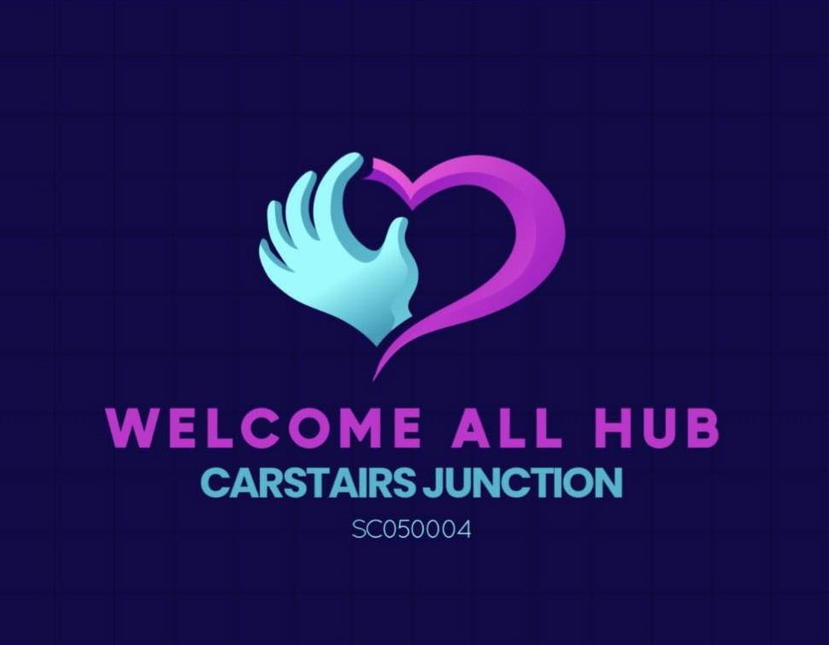

A Bit About Us
We are a Charity based in Carstairs Junction. We provide a warm, safe space for people of all ages to hold various groups/activities. We have a well-stocked food bank that provides emergency food parcels to those in need. We hold events throughout the year for all ages and have a community garden where we grow our own produce.

Job Title

JOB TITLE | Community Development Coordinator
LOCATION | 39 Coronation Street  Carstairs Junction  Lanark  ML11 8RB
RESPONSIBLE TO | Board of Trustees
SALARY | £27,645.51 per annum (Pro-rata)
HOURS OF WORK | 28 hours per week
LENGTH OF CONTRACT | 12 months. May be extended
FUNDED BY | The National Lottery Community Fund

Purpose of the Role
The role of the Community Development Coordinator is to take on the management of the charity. The role is to ensure that activities are planned, monitored and evaluated, that staff on those specific projects are lead and managed appropriately and that appropriate funding is sought for these projects.
The postholder will act as a link between the Welcome All Hub, the local community, Local Authority partners and other Third Sector parties.

Duties and Responsibilities
Smooth running of projects
. Provide long-term planning, in association with the Board of Trustees, for the relevant projects
. Source and apply to appropriate funders
. Along with the team, ensure that sessions are planned appropriately and that the relevant resources are ready and available
. Actively participate in the running of the activities
. To work directly with the community to develop projects that meet their needs
. To attend and participate in regular team and planning meetings with regards to all programmes developed within the organisation
. To meet the outcomes outlined by the funders
. To identify new group work opportunities and create a development plan which will provide participants with a wide range of various of skills and abilities
. To be professional in all dealings with young people, adults and organisations yet approachable and welcoming
. To ensure all relevant administration is carried out with high standards including all monitoring and evaluation reports, Provide regular and accurate reports to the Board of Trustees and where appropriate to the funding bodies
. Ensure that all policies (e.g safeguarding and health and safety) are adhered to appropriately
. Financial management and recording of limited budgets

Management of staff
. Support the Board of Trustees in the recruitment and induction of appropriate staff and volunteers
. Implement appropriate performance management measures such as setting targets, regular catch-ups and appraisals with staff and volunteers
. Seek out appropriate opportunities for continuing professional development of staff and volunteers
This Job Description is not an exhaustive list of required activity, but an indication of the duties and responsibilities required to remit in a satisfactory manner.

Person Specification
Position: Community Development Coordinator
 | ESSENTIAL | DESIRABLE
QUALIFICATIONS |  | Qualified Community Development Coordinator
EXPERIENCE | . Experience working in a Community Development role  . Proven ability to plan and manage activities  . Recruitment and management of staff/volunteers  . Successful submission of funding bids  . Great understanding of Microsoft Word and Excel | Strategic planning experience
SKILLS/ABILITIES | . Good communication skills, including report writing  . Ability to inspire and motivate others  . Good networking skills  . Ability to engage with people from a range of backgrounds  . Creative and innovative thinking  . Willingness and ability to work within the organisational guidelines and to corporate objectives  . Ability to work as part of a team  . Ability to work with other partner organisations  . Good organisational and problem-solving skills
PERSONAL QUALITIES | . Team player  . Flexible  . Warm personality  . Commitment to inclusion and empowerment  . Results driven  . Self-starter  . Willing to work anti-social hours as required  . Good sense of humour  . Confident and self-motivated | . A driving licence is welcome, but not essential

PLEASE APPLY IN WRITING AND INCLUDE CV TO welcomeallhub@outlook.com

