Dementia Service Coordinator
Job Description

Role: Dementia Service Coordinator | Department: Caring Services
Reports to: Carer Support and Development Officer | Salary: £25,974 per annum (pro rata) = £20,779 per annum
Location: The Eric Liddell Community | Type of contract: 12 months Fixed Term Contract (initially)
Working hours and pattern: 30 hours per week.

About The Eric Liddell Community
The Eric Liddell Community (Scottish Charity Number SC003147) is a local care charity and community hub founded in 1980 in memory of the 1924 Olympic 400m gold medallist, Eric Liddell.
We are on a mission to bring people together in their local community, to enhance health and well-being and ultimately bring us closer to our vision of a world where no one feels lonely or isolated. We are doing this by: providing a Day Service for people living with dementia; a programme of wellbeing activities, courses and classes for unpaid carers, and developing our vibrant community hub at the heart of Edinburgh.
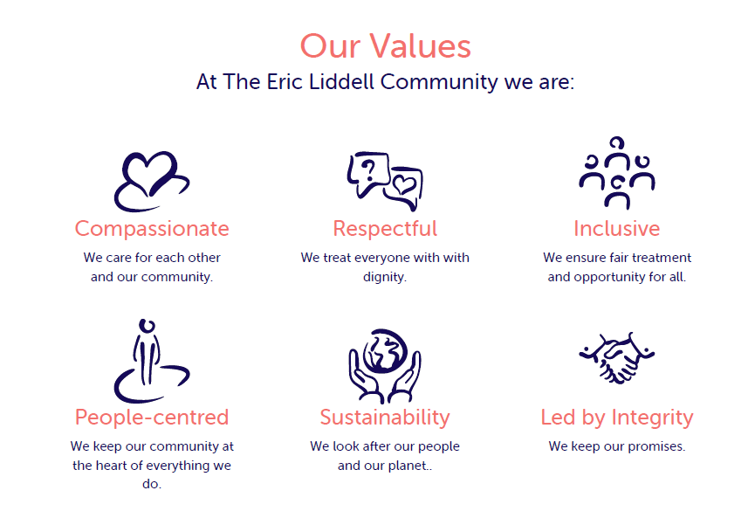
Job Purpose:
The Eric Liddell Community has been undergoing a period of growth and development with a new vision for the delivery of Caring Services. We have an exciting opportunity for a Dementia Service Coordinator to join our growing team. If you would like to work for a local care charity in a rewarding role where you will make a difference, then join us here at The Eric Liddell Community.
Our Service Coordinators lead on the delivery of a number of our programmes within our Caring Services as well as supporting each other to identify and develop new initiatives. This particular role will lead on the Dementia project within The Eric Liddell Community, as well as having the opportunity to get involved in other areas of our Caring Services.
Currently our Caring Services team deliver free Health and Well-being classes to unpaid Carers, Befriending to Carers and people living with dementia, and an extensive Dementia support programme which includes a meeting centre, lunch groups, community outings, dementia-friendly workshops etc.
We have ambitious plans to grow the range of services we provide to move us closer to our vision to live in a community where no one feels lonely or isolated. The Dementia Service Coordinator will spend a significant part of their week leading our Dementia Projects and Volunteers but they will also work closely with our Fundraising Team and other Service coordinators, to identify, shape and lead the delivery of new projects and services.
Key responsibilities and accountabilities:
The Dementia Service Coordinator role is a varied and rewarding one as described below:
- To lead on the delivery of key dementia services and activities such as the, Liddell Lions, Lunch Breaks and other relevant dementia inclusive services and activities.
- To be aware of key Dementia//Carers strategies and policy developments at both local and national level to ensure that programmes offered are responsive and provide contemporary outcomes.
- To promote our activities and services to service users and work with the Volunteer Coordinator to recruit, train and manage volunteers to support our service delivery
- To develop and sustain links with individuals, agencies and professional bodies in the statutory, voluntary and private sector.
- To promote our services activities and services to service users and the wider community
- To identify, support and complete relevant funding applications in conjunction with The Eric Liddell Community’s Fundraising Team.
- To provide monitoring, evaluation and statistical reports to our funders, management team and Board.
- To ensure that Health & Safety and appropriate Risk Management actions are undertaken and reported upon as required.
- To ensure that all service delivery activities and related use of personal data, comply with the charity’s GDPR policies and procedures.
- The targets and outcomes set out in The Eric Liddell Community Strategic Business Plan, Action Plan and funding agreements are delivered/ achieved.
- Monitor budget spend, file and code invoices for records and pass on to Finance Team for payments
- Any other reasonable duties as requested by the Carer Support & Development Officer or the wider Senior Management team

Person specification:
The successful candidate will be someone who is passionate about making a difference to the most vulnerable groups in our community. They will see new opportunities to improve the services we offer, identify new services and will be driven to pursue these. They will recognise our values as being aligned to their own.
Essential Criteria:
- Educated to degree level or demonstrable experience
- Knowledge and understanding of dementia or working with other vulnerable adults.
- Experience of gathering data to monitor the effectiveness of the different initiatives
- Ability to work in partnership with other professional staff and organisations
- Proactive, self-motivated and organised – ability to work as part of a team as well as work independently
- Knowledge of voluntary and/or statutory sectors
- Excellent communication skills, both oral and written
- Proficient computer skills for record keeping, producing documentation, emails and working with partners virtually
- Problem assessment and solving skills
Desirable Criteria:
- Knowledge and understanding of local and national strategies in relation to people living with dementia and their carers
- Knowledge of befriending and working with volunteers
- Ability to assist in setting, managing and monitoring budgets
- Experience of providing a range of written materials for marketing and reporting purpose
- Knowledge of Self-Directed Support
The Eric Liddell Community will complete a PVG certificate application for the successful candidate.
TERMS AND CONDITIONS
- Salary: £25,974 (pro rata)
- Working Hours: 30 hours per week
- Annual leave entitlement: 6 weeks (annual – pro-rata) inclusive of public holidays
- Notice period: 1 month

Other benefits:
Company contributory pension scheme
Death in service cover
Detailed induction and training support
Café Discount
Edinburgh Leisure Card

