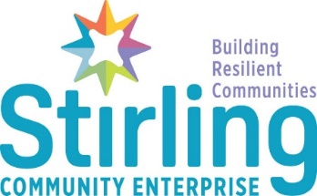

Job Description and Person Specification

Peer Mentor

About the Role

This is an exciting new partnership pilot scheme to reduce harm inducing behaviors such as substance misuse, violence and anti-social behavior through early intervention and prevention. Using this approach, you will support young people to become more resilient, confident and capable of fulfilling their potential.

The post is initially funded for a 1-year period but as the project is part of Stirling Community Enterprise’s wider resilient communities’ strategy, there will be an opportunity to extend this subject to funding.

As a peer mentor, you will have ‘lived’ experience of the complex barriers facing many people today. This includes, justice system, mental health issues, experience of the care system and (or) substance misuse. Drawing upon these experiences, you will work alongside colleagues from Police Scotland, Stirling’s Business Improvement District and a range of stakeholders to identify and co-ordinate the diversionary support of young people involved in anti-social behavior or at risk of not engaging in employment, education, or training. Working with key partners in education, employability, and statutory services, you will provide young people with the support necessary to make positive life choices for themselves, their families, and the wider community.

The role will include outreach work, supporting the SCE’s ASB Peer Mentor, local Community Police, and partner organisations. The primary aim is to identify, embed and provide alternative pathways for young people to access positive destinations, who may be involved in harmful behaviors.

About You

As an individual with lived experience, you will have a good working knowledge of the complex barriers faced by disadvantaged groups and the services needed to wrap around them. You will be able to use your own experiences and knowledge to support, guide and mentor individuals to access services that will improve their life chances and build resilience You will be non-judgmental in your approach yet be able to challenge behaviors in an empathetic and progressive way to support the development of safe and appropriate boundaries. Relationships and getting to know young people is critical therefore you will need to be able to engage, listen and build a rapport that will support the development of relationships built upon Stirling Community Enterprise’s values of honesty, trust and respect.

You will be focused, well organised and detail orientated. As a strong communicator you will have the ability to think innovatively, solve problems and keep calm under pressure. You will be passionate about changing lives and an advocate for developing fairer, sustainable and resilient communities.

Job Description
This job description may be amended from time to time dependent on job requirements and Service provision.
Section B
Organisational relationship and employee responsibility
This section describes the reporting relationships of the job within the immediate organisation and if appropriate has detail of the organisation a tier above and below the job. Also described is responsibility for employees, (if any).

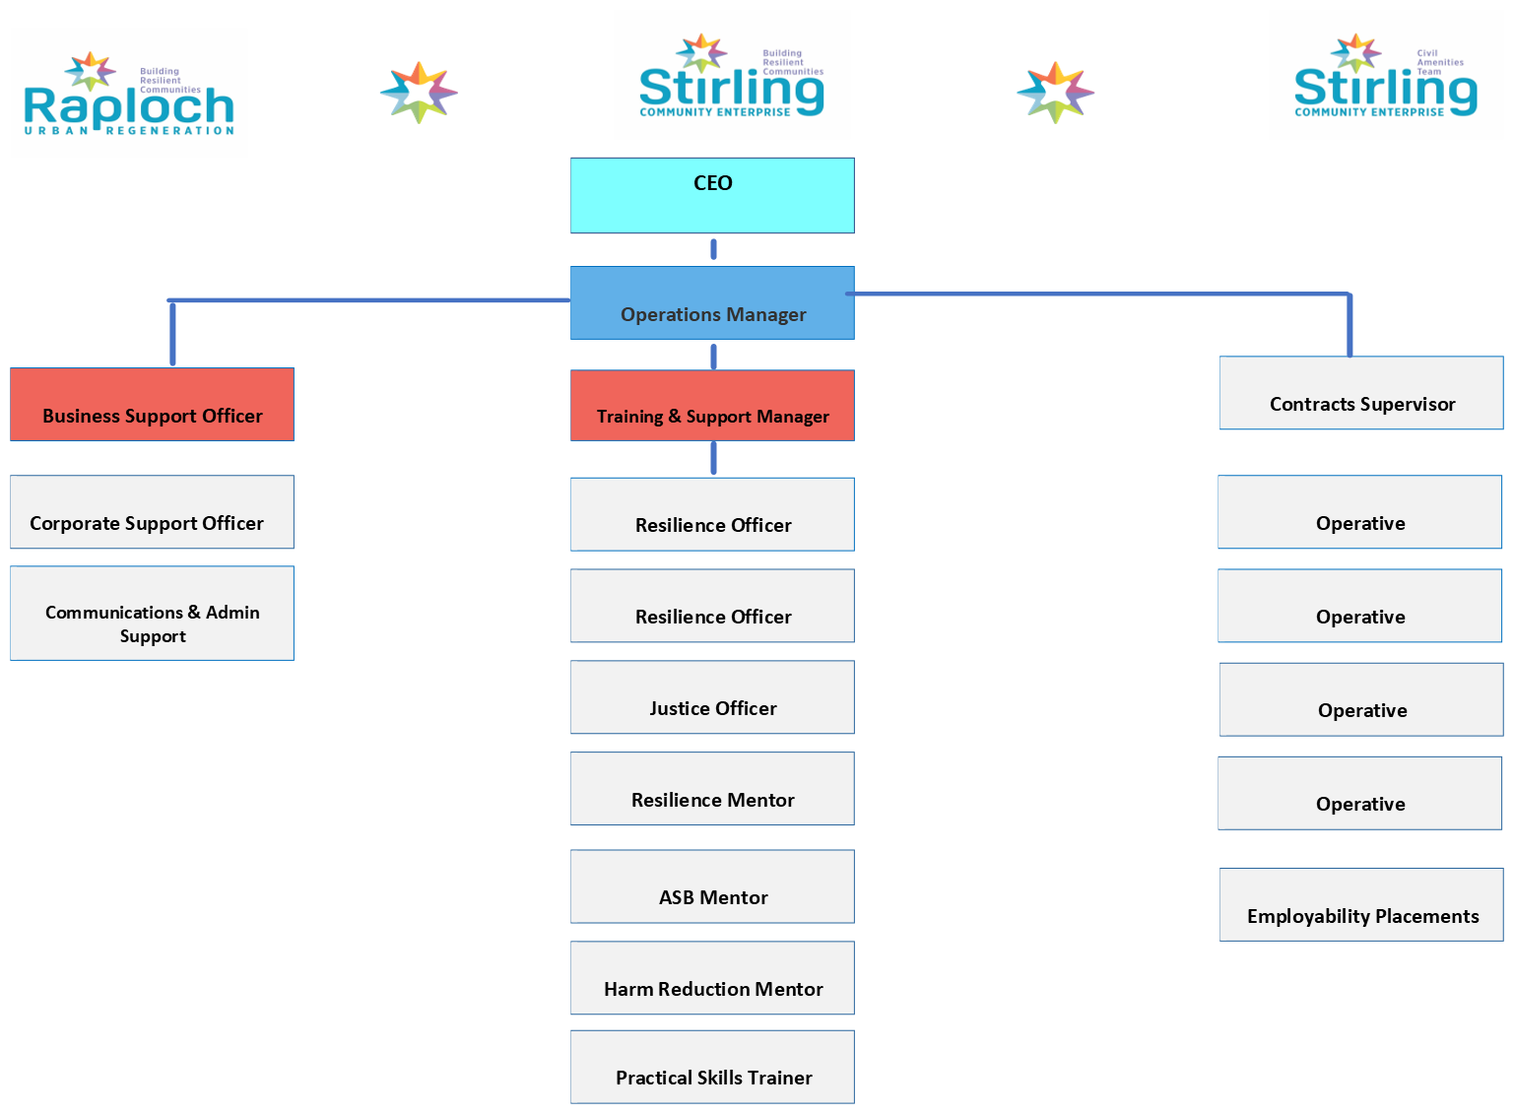

Principal purpose and objectives
This section lists the main (headline) responsibilities / accountabilities of the job.

The principal purpose and aim of this role is identify and develop alternative pathways for young people to make positive life choices, while contributing to safer, welcoming and more resilient communities. You will provide support for individuals identified as at risk of involvement with statutory services by signposting them to a range of education, training and employability services, while also liaising with a range of wrap around support services. Working in partnership and collaboration with Police Scotland, The NHS, Local Authority Housing, Social Work, Education and Third Sector organisations, you will support, guide, signpost, and mentor individuals to become more resilient and progress towards a positive future and out of poverty. You will provide the ‘stickability’ that young people need to navigate the range of services and supports that will potentially help them change their life trajectory.

Primarily the work will support a model of early intervention and prevention. The role will involve working alongside young people from involved with statutory services or with individuals currently in, or on the periphery of the justice system, at risk of homelessness or in temporary accommodation, individuals with problematic substance use, individuals with mental or physical health support needs, young people not engaging in education or individuals who are either long term unemployed or economically inactive.

The Peer Mentor will use their own experiences and knowledge along with SCE’s range of training, education, and employability services as a vehicle to access areas of support that will improve life skills, promote resilience, improve financial awareness, enhance employment prospects, increase health and wellbeing, create more life options, and reduce poverty.

In addition to providing a safe, empathetic, and non-judgmental first point of contact, the Peer Mentor will support the delivery of bespoke training and education interventions, both in person and through a wider network of partner agencies that support people away from a chaotic lifestyle and towards safer, healthier, and more productive lives. The Peer Mentor will nurture and develop relationships built upon mutual trust and respect to empower young people to make positive choices. The Peer Mentor will foster a ‘No Wrong Door’ approach ensuring that support is available for as long as the young person requires it.

The post holder will liaise with key partners in a targeted outreach approach, supporting local business owners, residents, commuters and visitors to experience a vibrant, welcoming a safer Stirling.

Main duties and responsibilities
This section provides details of the main responsibilities / accountabilities. Individual tasks may be included. Note, these are illustrative only and are not exhaustive.
The post holder will be responsible for:

  - Relationships:

- Building rapport and establishing trust and relationships with individuals who can at times have very challenging circumstances. This might include individuals currently in the justice system or identified as at risk of involvement within it, people with alcohol or drug issues, individuals with chaotic lives, school pupils identified as not engaging in employment, education or training, those experiencing homelessness or individuals with experience of the care system.

- Use lived experience to develop relationships with mentees, partner organisations and statutory bodies to provide a safe environment to provide identified support.

- Build rapport and establish trust with local business owners by understanding their concerns and developing demonstrable interventions to reduce anti-social behavior.

- Liaise with local business owners to maintain a visible presence within the City Centre at key times.

- Work alongside SCE’s dedicated Anti-Social Behavior Peer Mentor, City Centre Ambassadorial Team, Stirling Council Youth Participation Officers and Community Police Officers to establish a safe, welcoming and thriving City Centre.

  - Support

- Identify and support individuals to access pathways of support that include diversionary activity, training, education, volunteering or employment.

- Promote and develop a culture of accountability and restorative activity that supports the local business community and the wider Stirling community.

- Undertaking individual assessments to identify specific needs and develop an appropriate plan of support with associated person-centered interventions.

- Liaise with SCE colleagues to support interventions agreed in individualized action plans and review on a regular basis.

- Ensure individuals are supported and protected to achieve the goals identified within their specific actions plan. This may include 1-1 support or engaging partners to deliver tailored wrap around support to achieve sustainable, positive change.

- Provide 1-1 mentoring support for individuals who have been released from custody or are subject to statutory court orders and those who are not being case managed by justice staff and have a history of offending that may be preventing them from securing employment or accessing a positive destination.

- Provide 1-1 mentoring support and guidance for individuals who are require support in the areas of housing, health, addiction, low income and personal development that may be preventing them from securing employment or accessing a positive destination.

- Meet with clients within the SCE HUB and outreach support in the local community, including home visits.

- Provide tailored employability support including creation of disclosure letters, create and update CVs, create cover letters, job search, access additional advice services, access additional training opportunities

- Support and promote warm, caring, and nurturing relationships and environments in which everyone feels secure, respected and valued.

- Link with the wider SCE Team and external provision, including Health and Wellbeing support to meet the requirements of the individual.

  - Partnerships

- Establish and maintain positive and purposeful working relationships with a range of statutory and non-statutory agencies, as well as the general public as a representative of Stirling Community Enterprise.

- Establish strong professional relationships with the local community and services to identify individuals who may benefit from the service.

  - Reporting
- Prepare and report relevant information as required for regular internal or external partner agency case management meetings.

- Ensure administrative systems such as client forms, databases and contact files are kept fully up to date and secure, in line with data protection legislation and our confidentiality policy.

- Maintain all relevant records to meet company, funding, accrediting body, audit and other requirements, including SQA and SDS.

- The post holder will work to standards and procedures, demonstrating confidentiality, initiative, commitment, and flexibility and manage competing priorities.

- Regularly monitor objectives and report against performance targets set by the Training and Support Team Manager.

  - Other

- Work on own initiative and as an effective team member.

- To undertake appropriate training as identified by the service and participate in staff development opportunities, training and PRD.

- Keep abreast of national and local initiatives and requirements

- Any other duties that may be considered appropriate for this post.

Responsibility for physical assets, data and finance
This section details responsibility for physical assets, e.g., vehicles, buildings, stock control
/ Procurement, data, e.g. computers, record keeping, finance e.g. budget holding / monitoring / cash handling.
- Maintain all relevant records to meet company, funding, accrediting body, audit and other requirements, including, Scottish Qualifications Authority, Skills Development Scotland and Robertson Trust.
- Keyholder for the SCE building.

Communications skills
This section notes examples of the individuals or organisations with whom the post holder will come into regular contact and explains the nature of the communication and level of skill required by the postholder.
This role requires a high level of communication skills including verbal, written and digital literacy. It also requires the ability to develop partnership working with the following contacts.

Internal: SCE Training and Support Team, Senior Management Team, and other SCE staff and partners within the HUB. Providing support and guidance to individuals from the local community who may come from challenging social backgrounds.
External: Including but not limited to - Stirling Council, Community Planning Partners, Go Forth Stirling, Forth Valley College, Skills Development Scotland, Scottish Qualification Authority, Scottish Prison Services, Police Scotland, Local employers, Forth Valley Developing Young Work Force Team, Stirling Voluntary Enterprise, Community Groups, Department of Work and Pensions (DWP), Robertson Trust, Cora Foundation and related organisations.

Planning, collaboration and analysis
This section details the level of problem solving, analysis, creativity, forward planning/scheduling required.
- Excellent partnership, negotiation, and confident decision-making skills.
- Able to develop strong interpersonal relationships, build trust and develop role as an advocate for individual(s)
- Ability to work in partnership/engage with other services to manage and address risk/needs and support individuals reintegration into the community following periods of imprisonment.
- Ability to work as a team member while still delivering individual outcomes.

- Can effectively coordinate the individual work of multiple organisations to contribute positively to a multi-agency approach.

- Practice the principles of confidentiality, equal opportunities and non-discriminatory practice at all times.

Person Specification
Knowledge and skills
This section details the knowledge and skills including any qualifications, specific training or experience required.

Essential criteria:
- Direct ‘lived’ experience of the justice or care systems, experience of substance misuse or recovery pathways or experience within the issues relating directly to mental health.
- Understanding of the employability, justice, social work, housing, health and or education systems.
- Understanding of the complex nature of underlying issues that can have an impact on offending behavior, non-engagement in education, risk of homelessness or long term unemployment.
- An understanding of the issues faced by people impacted by trauma, poverty and adverse childhood experiences.
- An understanding of the court system and the wider justice process.
- Ability to balance multiple priorities.
- Ability to build and sustain relationships in a professional context.

- Ability to communicate politely, articulately, and confidently both verbally and in writing with a wide range of people from the most senior person in an organisation to individuals from challenging social backgrounds.

- Solutions focused with good organisational, administration and problem-solving skills.

Desired criteria:
- Experience of working and developing relationships with local employability, training and support providers.
- Evidence of a proven track record of working with people impacted by trauma and experiencing multiple barriers, including anti social behavior, alcohol and drugs, mental health and homelessness
- SQA Assessor/Internal Verifier
- An understanding of homelessness and accommodation processes.

Summary of main terms and conditions

Type of contract | 1 year fixed term.
Grade and salary | Starting Salary: £25,000 (pro-rata)
Hours of work | Full-time hours 25 hours per week. Will include weekends and evenings.  We also offer flexible working opportunities.
Pension scheme | All employees are automatically enrolled in the Peoples Pension scheme.  Contributions are made by both the employee (4%) and employer (3%).
Annual leave | Leave entitlements start at 29 days per annum and increase in line with length of service.  In addition to this, we also have 7 fixed public holidays when our offices close.
Business travel | Mileage rates are £0.45 per mile up to 10,000 miles and  £0.25 per mile thereafter in a rolling year from 1 April to 31 March.  Public transport for business will be reimbursed through expenses.
Other benefits | - Staff development and training provision  - Cycle to work scheme  - Occupational health services  - Employee Assistance Programme

