

Recruitment Pack

NHS Charities Together
Pure Offices (Suite 68,) Lake View House, Wilton Drive, Warwick CV34 6RG
info@anhsc.org.uk www.nhscharitiestogether.co.uk
T: 0300 303 5748
Royal Patrons TRH The Prince and Princess of Wales | Patron Lord Nigel Crisp

NHS Charities Together is the trading name of the Association of NHS Charities
Charity number: 1186569 (England & Wales) and SC050716 (Scotland) Company number: 12325259.

Message from the CEO of NHS Charities Together

Dear Applicant,

Thank you so much for your interest in working at NHS Charities Together as our Grants Officer. This is an exciting time to join our team and our charity is on an incredible journey.

Thanks to phenomenal public support during the pandemic, our national Covid-19 Appeal raised more than £160 million to help NHS staff, volunteers, and patients through the immediate and long-term effects of coronavirus. Now, after a transformational two years, we have recently reviewed our strategy and are working towards exciting new goals to support the NHS and the nation’s health.

The recruitment of this post is part of an ambitious revisited strategy and commitment to grow our support and build on the success of our Covid Appeal. With a network of over 230 NHS charities around the UK, together we ensure extra support goes where it is most needed in our health service and help the NHS go further for patients, staff and communities.

We are very proud of what we achieve as a small but growing staff team. The post of Grants Officer will have an important role to play as we work hard to raise the profile of NHS charities, demonstrate our collective impact, and inspire continued support from the public.
If you are passionate about the helping the NHS tackle today’s challenges and tomorrow’s opportunities, and believe that through supporting NHS charities we can significantly increase the vital support given to our hospitals, community, mental health, and ambulance services, we would love to hear from you.

Best wishes



Ellie Orton OBE
CEO, NHS Charities Together

NHS CHARITIES TOGETHER

Background

NHS charities

NHS Charities Together is the national charity for everyone who uses, cares about and works in the NHS. We have a unique relationship with the NHS and a unique role as the membership organisation for over 230 NHS charities across the UK.
Collectively NHS charities give over £1million every day to the NHS, so that people can stay well for longer and get better faster. In recent years NHS charities have funded major capital projects, pioneering research, and medical equipment at our hospitals, helping patients access the best possible care when they need it most.
Our vision is a future with a thriving NHS, and we mobilise the collective power of the NHS charity sector to create the best possible healthcare for everyone. Together we help the NHS go further for patients, the workforce and communities.
Thanks to the heartfelt generosity of the public, NHS Charities Together’s 2020 Covid-19 Urgent Appeal raised over £160 million. We have now allocated £148 million to reach every NHS Trust around the UK, supporting the NHS during and beyond its immediate recovery from the pandemic. Donations have funded thousands of projects providing extra support for the NHS, including mental health support for the workforce, training and equipment for community first responder volunteers, and initiatives to prevent ill health.

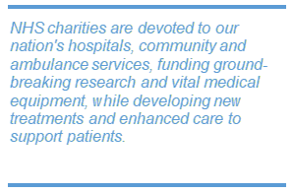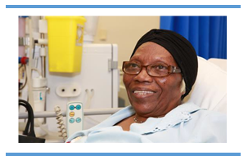

NHS charities also play a key role in mobilising volunteers to support NHS staff, brightening wards and waiting areas with colourful and engaging art and building an important link between our hospitals and our communities. Other NHS charities support mental health trusts, community health trusts and ambulance trusts.

These vital funds and services are above and beyond what the NHS alone can provide, touching lives and making a huge difference to millions of people when they are at their most vulnerable.

To read real life stories of the difference NHS charities make, visit the NHS Charities Together website.

The Association of NHS Charities & NHS Charities Together
Founded in 2000, the Association of NHS Charities started as an informal group of the largest NHS charities, which came together to provide mutual support and a forum for discussion. Since then, we have changed our name to NHS Charities Together (to better reflect what we do and who we support) and grown steadily, welcoming charities both large and small from across England, Wales, Scotland and Northern Ireland. Today NHS Charities Together represents 100% of the NHS charity sector in the UK as members.

NHS Charities Together provides a forum for nationwide fundraising and advocacy campaigns, provides advice and guidance to its members, bespoke conferences and training days covering issues and development opportunities for NHS Charities, as well as access to online resources and support through exclusive member pages on the website.

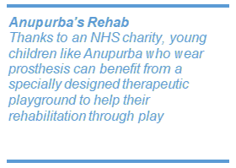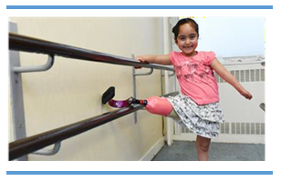
Vision, Mission and values

Our Vision: A future with a thriving NHS and the best possible healthcare for everyone.

Our Mission: We mobilise the collective power of NHS charities and the nation to help the NHS go further for patients, staff and communities – ensuring extra support goes where it’s most needed and enabling the NHS to advance in a rapidly changing world.

Our Impact Values

How we work:

- Actively listen - we seek first to understand before we are understood
- Collaborate - together we are more than the sum of our parts
- Every life counts - we champion diversity, equity and inclusion in all that we do

Equality and Diversity:

Strategic Objectives:

Over the next five years we will work together with members to enhance the impact of our network with a focus on three areas of change. This focus harnesses the areas that matter most to all of us across the breadth of the network of NHS charities and provides the framework around which we can all coalesce. They also highlight the distinct position we have as NHS Charities Together both to facilitate change and to connect our impact into strategic conversations at a national level, supporting adoption, spread and scale.

JOB DESCRIPTION
Job Title: Grants Officer

Reporting to: Grants Manager

Hours: Full Time (35 hours per week)

Tenure: 12-month fixed term contract

Key Relationships: NHS Charities Together Staff Team, Member Charities, External Grant Assessors. Other key stakeholders and organisations as required.
Location: Both posts will be working remotely. One post to be based in Scotland/near the Scottish borders. The other post to be based in England (Regions to be confirmed). You will be expected to make available a suitable office space for business use at home/in your region with equipment provided by the Charity. Regular travel to NHS Charities in your Region and at least once each month to attend face to face team meetings at our Head Office in Warwick and across the UK.

Reward package: £25,000 - £30,000 plus 10% pension contributions, 28 days annual leave
Non-Financial Reward Package
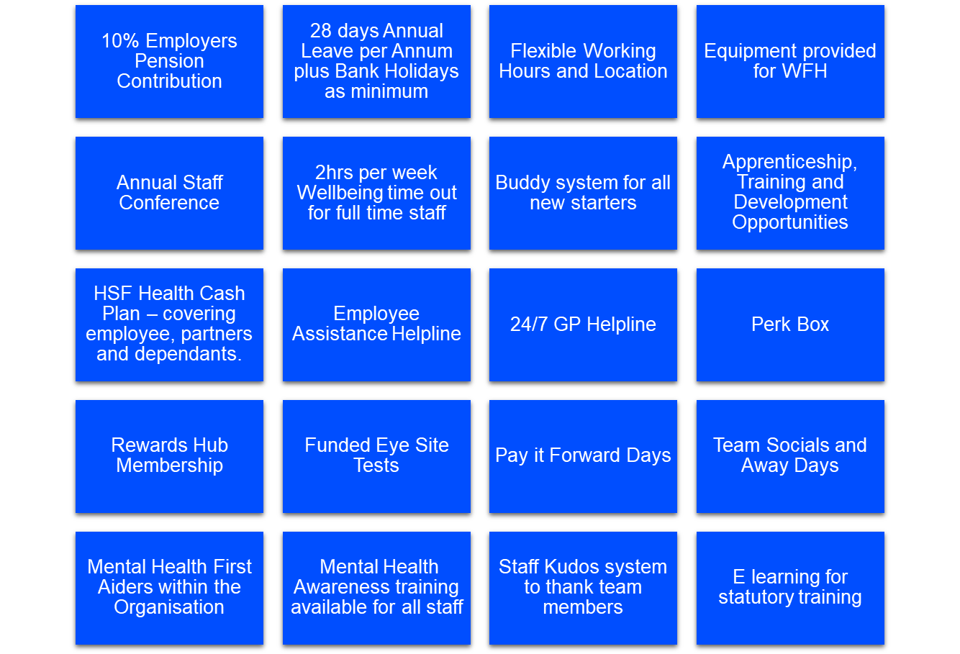

Overall Purpose
The Grants Officer supports the delivery of the local/regional grant making and grant management process, awarding funding to NHS Member Charities. The post will manage a geographical portfolio of grants, taking a relational approach to grant making and acting as a key contact point for internal and external stakeholders. By reviewing and assessing grant applications and through relational grant management, the postholder will enhance our offer to member NHS Charities and support the development of future grant programmes.
The role is an integral part of the Grants Team at NHS Charities Together which collectively delivers the grants programmes of the Charity to further the organisational impact strategy.
Overall objectives
- To support NHS Charities Together grant making and impact function to deliver positive outcomes for the NHS in line with NHS Charities Together Impact strategy.

- To ensure funding is distributed through robust grant making systems and processes.

- To provide a relational approach to grant making within a membership environment, liaising with NHS Charities with regards the application, review/assessment process, reporting and evaluation.

KEY RESPONSIBILITIES
The main duties and responsibilities of the role holder are as outlined below:
Grant Making
- To ensure that our relationship and interface is of the highest standard with all stakeholders engaging with the grants team, including potential applicants, applicants, and grant holders within member NHS Charities.

- To provide effective grant programme guidance and application/project development support to potential grant applicants.

- To review and assess grant applications, for across the UK against programme criteria and quality standards.

- To produce assessment reports and present recommendations in support of fundable applications to decision making panels within NHS Charities Together grant making governance structure.

- To advise on enquiries from member applicants/recipients and ensure appropriate feedback to unsuccessful applicants.

- Support the analysis of application and grant portfolio for trends, quality, and scope, and providing feedback on findings to colleagues, assessors, and committee as appropriate.

- Contribute to NHS Charities Together’s learning and evaluation activities to develop knowledge of grant programme outcomes and wider impact.

- Support Senior Grants Officer and Grants Manager where appropriate, with the recruitment, induction, training, retention and support of freelance assessors and peer reviewers to maintain a skilled, well-informed, and diverse team.

Grant management

- Demonstrate a relational approach in grant management within a defined geographical portfolio, which resonates within a membership environment. This includes proving support and signposting to member charities to enable effective outcomes for the NHS in line with NHS Charities Together grant & impact strategy.

- Develop deeper relationships with member NHS Charities, including through project visits and monitoring calls to contribute to grant monitoring, assessing, progress updates and sharing of learning.

- Ensuring that grants are reported on in a timely manner and providing staff review and commentary on reports.

- To actively support the grant management of allocated grant portfolio, including proving support and mitigation of grant issues or areas of risk within an agreed delegated framework, including investigating issues and referring up as required.

- To work in alignment with the Grants Administrative Team to ensure accurate filing and recording of information and data relating to the grant applicant journey within the Grants Data Management System.

- Support the development and delivery of Grants+ activities to enhance the impact of grant making via targeted support for NHS Charities.

- Where appropriate represent NHS Charities Together grant making function through the attendance of regional meetings of NHS Member Charities.

Other
- Work with NHS Charities Together’s Membership, Learning & Evaluation, Fundraising, Communication and Finance Teams ensuring strong cross organisational team work and clear communication.

- Hold and nurture appropriate local relationships with key stakeholders within the geographical remit of the post.

- Visibly live NHS Charities Together’s values, including our commitment to equality, diversity and inclusion, particularly by ensuring that our grant making reflects the diversity of the communities we serve.

- Act as an advocate for the work of NHS Charites, promoting and supporting the impact of our membership.

- Work flexibly, prioritising workload, and working effectively as part of a team.

- Carry out the duties of the post in accordance with NHS Charities Together’s values, policies, and procedures, including on Health and Safety, and take responsibility for ensuring personal health and safety.

- Comply with relevant legislation, best practice, policies, and processes including, but not limited to, charity law, the charity commission, fundraising regulator, GDPR and professional codes and standards.

This is not meant to be an exhaustive list of duties. The need for flexibility is required. We are currently a small team, and the post holder is expected to carry out any other related duties that are within the employee’s skills and abilities whenever reasonably instructed.

Competencies
Teamwork – ‘One charity’, working within and across teams | Ability to build and maintain effective working relationships with a range of internal and external stakeholders.  Works collaboratively and effectively with others as part of a cross organisational team.
Building trust and respect – listen, feedback, and learn | Ability to instil confidence and respect; demonstrated through active listening, and presenting sound and well-reasoned opinions, whilst being open to challenge and learning.
Responsibility – owning your part in our success | Excellent attention to detail; ensuring that information presented is accurate and clearly communicated both written and verbal  Self starter with ability to consider and plan to establish an efficient and appropriate course of action for self and others.
Professionalism – creating an environment to achieve success | To communicate in professional manner, and in line with our ACE philosophy at all times with staff, stakeholders, and external providers.  Excellent time management with an ability to plan and organise a large workload to meet both internal and external deadlines.  Maintains virtual and face to face presence across NHSCT and with key supporters and third-party agencies.
Stakeholder focus – understanding the needs of our key stakeholders and audiences | Able to focus on the needs of member NHS charities, wider stakeholders and supporters, our donors and NHS staff, volunteers, and patients.
Acumen – Sound decision-making | Demonstrates analytical thinking with the ability to simplify complex information and data to explore and evaluate systematically.  Ability to work within a framework to assess information against core criteria to enable transparent, effective, and robust decisions.  Awareness of and ability to manage unconscious bias and it’s potential impact in decision making.  Able to present sound and well-reasoned arguments, drawing from a range of strategies to persuade and convince others based on evidence.

PERSON SPECIFICATION

 | ESSENTIAL | DESIRABLE
Qualifications/Education:
Maths and English GCSE Grade C or Level 4 or above, and/or  demonstrable written, numerical and verbal communication skills | ✓
Relevant qualifications, education, training or development |  | ✓
Knowledge, Skills & Experience:
Knowledge and experience of grants programmes, either from a funder or grant recipient point of view | ✓
Knowledge of grant making processes and systems | ✓
Experience of relational grant management |  | ✓
An understanding of the landscape of grant making, ideally within the voluntary sector, health sector or NHS |  | ✓
Experience of grant management systems, e.g. salesforce |  | ✓
Good understanding of charities and charity governance |  | ✓
Clear understanding of monitoring, evaluation, and impact measurement |  | ✓
Excellent time management skills and an ability to consistently meet deadlines | ✓
Reporting and analytical skills. Evidence of creative thinking and problem-solving skills. |  | ✓
Excellent interpersonal skills and a track record for collaborative working and building sustainable relationships at all levels | ✓
Excellent written and verbal communication skills. Able to assimilate information clearly and prepare appropriate, clear, and concise content. | ✓
Good presentation skills, confidence to deliver presentations, training, or grants + support |  | ✓
Knowledge of co-production, collaboration and partnership working |  | ✓
Interest in the shared values and culture of organisations supporting the NHS | ✓
Self starter with ability to work remotely with a UK wide team | ✓
Experience of working in a team to support the delivery of team objectives | ✓
Personal Qualities:
Articulate, confident communicator | ✓
Collaborative and open approach | ✓
Passionate, driven and committed to delivery | ✓
Well organised and structured with an eye for detail | ✓
Flexible and responsive | ✓
A team player who is also a self-starter and happy to work independently to develop and deliver objectives | ✓

Working Hours | Full time - 35 hours per week (negotiable)
Pension | 10% employer contribution
Annual Leave | 28 days per annum (pro rata) plus bank holidays.
Probation Period | 6 months (for external appointments)
Notice Period | 1 week during probation & 2 months thereafter

How to Apply
Please apply via our recruitment consultants, Not-for-Profit People. Grants Officer - Remote - England, London - (1673) (nfp-people.co.uk) The recruitment site can be found at: https://www.nfp-people.co.uk/

Please upload your CV and a covering letter outlining which vacancy you are interested in (Scotland or England based GO position), your interest in the role, how you meet the job description and person specification. The covering letter should be no more than 2 sides of A4.
The closing date for applications is Monday 6th November 9am
1st interview: 28 and 29 November 2023 (online)
2nd interview: 4 and 5 December 2023

Appointments to commence early 2024.

If you have any queries or would like more information regarding this document, please email hazel@anhsc.org.uk or paula@anhsc.org.uk.

For detailed information on how we process your personal data, please review our privacy policy on our website https://www.nhscharitiestogether.co.uk/privacypolicy

In line with GDPR, we ask that you do NOT send us any information that can identify children or any of your Sensitive Personal Data (racial or ethnic origin, political opinions, religious or philosophical beliefs, trade union membership, data concerning health or sex life and sexual orientation, genetic and / or biometric data) in your CV and application documentation. Following this notice, any inclusion of your Sensitive Personal Data in your CV/application documentation will be understood by us as your express consent to process this information going forward. Please also remember to not mention anyone’s information or details (e.g. referees) who have not previously agreed to their inclusion.

