Job Description: Project Officer St Conan’s Kirk Development Phase
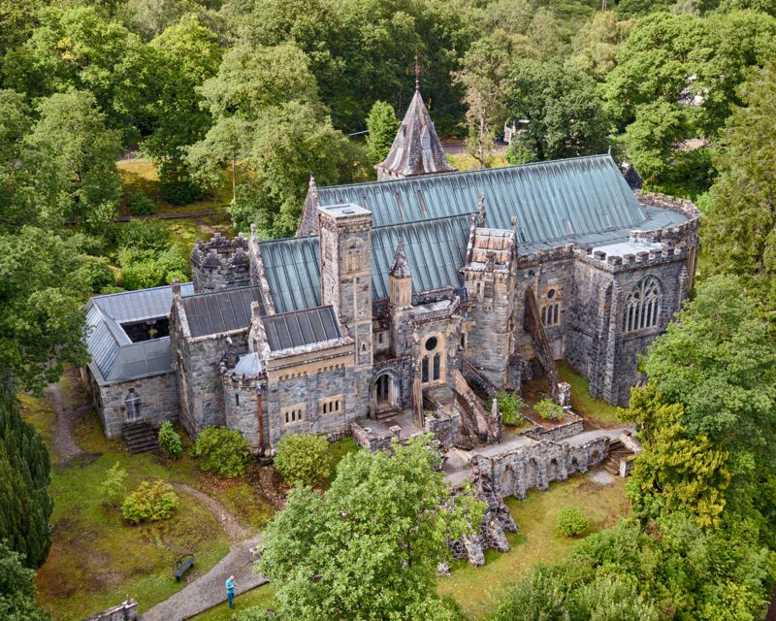

About St Conan’s Kirk and the 2023-2025 Project Development Phase
St Conan’s Kirk is a Grade A listed historic building in Lochawe, Argyll and a truly special place. It is run by an independent Trust and since 2014 has been supported by a Friends organisation. This role covers the Development Phase of a major project to aiming to grow the role of St Conan’s Kirk in its local community, its local area and supporting the wellbeing of residents and visitors. As well as preparations for a longer delivery phase, during the Development phase a range of community engagement activities, pilot programmes, co-creation and volunteering activities shall be carried out to help shape future community activities.

Overview
The employment of a project officer to support the activity elements of the Development stage of delivery of the proposed project is essential to support the volunteer team who will undertake the majority of the project. The project-officer will provide a day-to-day contact with specific accountabilities and a key role coordinating and planning events, organising people and supporting ongoing communications with the public and event attendees at the kirk. They will also have a key role formalising and supporting relationships with other groups and organisations.
Our website can be found at https://www.stconanskirk.org.uk/
From 2014 to 2022 significant conservation and restoration have taken place and a number of small adjustments to make the building more suitable for community activities and programmes. Following on from these works this project aims to transform the use of the kirk to appeal to a wider range of users.

Principal duties and responsibilities
- Manage the delivery of all the required activities of the Development Phase of the Heritage project, ensuring the project outcomes as agreed with the National Lottery Heritage Fund are achieved as planned and within budget, making decisions in consultation with the Steering Committee and Chairperson, and informing them of any deviations from the plan and making corrective actions as appropriate.
- Collaborate with the project staff (Evaluation Consultant, Conservation Architect) to enable delivery of the Activity Plan.
- Develop administrative and ICT systems to facilitate the sharing of information across the project team, including the electronic management of filing, and storing of project documentation.
- Ensure the Steering Committee and Chairperson are fully and regularly informed of progress and the key decisions that they need to make. Provide regular reports on the delivery of activity, including the financials.
- Ensure that all contractual obligations and conditions of external funding bodies are met, including reporting requirements.
- Working with the Chairperson arrange and co-ordinate meetings involving the Steering Committee, the project team, and key stakeholders as required, including agendas and minutes.
- Oversee the Community Engagement Lead (Volunteer post) developing a communications plan, a volunteer policy and ensuring volunteers receive appropriate training and are managed in order that they work effectively.
- Working with the Community Engagement Officer (voluntary role) and Chairperson -
- develop and maintain excellent relationships with partners and stakeholders in the local North Lochaweside and Argyll community.
- develop and oversee effective communications with key stakeholders, potential user groups and the general public through website, newsletters, site meetings and email groups.
- oversee the promotion of the Heritage project and ensure it has a positive profile in the media.
- Advise on possible new actions as ideas and issues emerge through implementing the project.
- Explore opportunities to develop new partnerships, and new funding opportunities, that can further the projects ambitions, working with and through appropriate team members.
- Working with evaluation consultant ensure evaluation processes are in place and appropriate supporting data is collected.
- Ensure the project (activities) are compliant with Health & Safety and any other legal requirements.
- Support the project team to prepare the community elements within the Delivery Phase NLHF submission and other Delivery Phase grant applications working with appropriate team members.
- Undertake any other duties that may be reasonably required.

Outputs/Deliverables
The main outputs shall be:
- Programme of events in line with activity plan.
- Partnership mapping and relationship building with key contacts.
- Development Phases
  - communications plan including social media posts.
  - Lead site contact for programme of events, visitor tours etc
- Delivery phase preparations (to support the preparation of the Stage 2 Grant submission )
  - Supporting the volunteer team with preparations, specification and costings of the activity plan for the delivery phase (i.e. events, education visits, temporary and permanent exhibits).
Note: The majority of work relates to the “activities” in the activity plan with Capital Works and Capital Works development led by the Architectural Services team.
Terms and conditions of employment
Following interview and appointment the successful individual shall be awarded a 12-month fixed term contract as an employee of the Friends of St Conan’s Kirk but via the auspices of the Scottish Government funded Argyll and Bute Third Sector Interface as they have the HR and financial infrastructure in place. Other arrangements can be discussed by mutual agreement (i.e. self-employment as a contractor or via a limited company).
A suitable individual with line-management experience will be delegated as the line manager for the Project Officer.
Duration: Initially appointment is for the Development Phase of our NLHF Project (2023/24). It is envisaged that a role will be available during the delivery phase and post-delivery but the Delivery Phase appointment shall need to be advertised in a competitive process.
The role therefore is in two stages (a) an initial fixed term of 12 months covering the project Development Phase and (b) a subsequent second term which will be for a minimum of a year subject to the National Lottery Heritage Fund Delivery Phase application being successful.
Reporting To: Nominated Board Representative, Friends of St Conan’s Kirk SCIO
Hours: 16 hours per week.
Pay: £30,500pa for an employee (full-time equivalent)

Relationships - Responsibility for People
The Project Officer (Activities) will collaborate with, the Exhibition Consultant, Evaluation Consultant, and Conservation Architect. The Project Officer shall coordinate a range of volunteers.

Relationships - Nature of Contacts
The Project Officer (activities) will be liaising with the FoStCK leadership, the project team and contractors, project partners, a wide range of key stakeholders, and community groups within Argyll. The contact is largely operational in nature and will require frequent contact through all available communication channels.

Person Specification:
Essential
- Appropriate qualifications relating to project management (i.e., PRINCE2) or equivalent work experience.
- Understanding and experience of managing the community engagement and activity elements of significant scale heritage, community and/or development projects.
- Experience of working with NLHF or Lottery Funded projects or similar.
- High degree of interpersonal, communication and numeracy skills, written and verbal, able to digest and synthesise complex information.
- Experienced in business and financial planning, including cash flow and work progress reporting.
- Experience in managing staff and volunteers.
- Leadership and negotiating skills.
- Ability to work collaboratively and facilitate partnerships.
- Able to work on own initiative, self-motivated, with strong time management skills.
- Proficiency in working with standard office IT applications.
- Empathy with the project’s objectives.

Desirable
- Experience of working in the cultural and/or heritage sectors.
- Experience of procurement processes and managing work of consultants/contractors.
- Experience of fundraising and grant applications.
- Understanding of social media and websites.

Working Environment
Whilst some of the work can be conducted flexibly much of the community engagement and planning activity is going to require a presence at the Kirk. Generally, the role will be normal office hours with the occasional need for evenings and weekends for specific meetings. A project office at the Kirk is currently being established.

It is envisaged that there will be at least 1 day a week on-site / visiting local organisations/individuals.
How to apply – 5pm, 26th October 2023
Application is via covering letter which must address as many of the essential and desirable criteria as possible as well as a comprehensive CV. For the covering letter you may find it useful to group your experience and provide examples under the desirable and essential criteria headings.

Please send your tailored CV and covering letter to takkisulaiman@argylltsi.org.uk by 5pm, 26th October 2023.

For further information
For further information and an informal conversation please contact Takki Sulaiman, Secretary, Friends of St Conan’s Kirk, on 07778 419218 or takkisulaiman@argylltsi.org.uk.

Thanks to the National Lottery players.

