
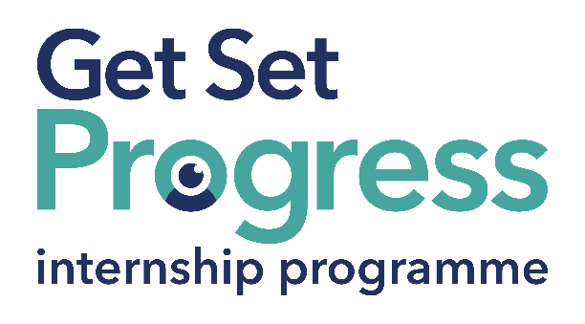

Assistive Technology (AT) Intern

Join us at Sight Scotland Veterans
Thomas Pocklington Trust (TPT) and RNIB are collaborating with charities in the sight loss sector to create new opportunities for blind and partially sighted people to find employment through the Get Set Progress Internship programme. Sight Scotland Veterans is delighted to be offering an internship as part of the Get Set Progress scheme.

For 230 years, Sight Scotland and Sight Scotland Veterans has been supporting people impacted by vision loss. We believe we play an important role in continually shifting the conversation around sight loss, and contributing to achieving a fair, equitable society. Over the years, we’ve seen a positive shift in expectations, with individuals and communities increasingly empowered to live lives the way they choose, free of discrimination.

We work with charities across our sector to make sure people with sight loss have access to the right resources when they need them. But what makes us unique is:
• Together, Sight Scotland and Sight Scotland Veterans is the largest Scottish charitable organisation that supports people impacted by vision impairment
• We’re the only Scottish vision impairment charities that fund medical research into eye health
• We’re the only Scottish vision impairment charities that have a dedicated policy and campaign team
• Our services span all age groups, including people born with a vision impairment, and those that acquire a vision impairment

These unique attributes of our organisation allow us to become something more than we have been up until this point.
It’s an exciting time to join us as we continue to change, grow, and develop to ensure that we remain relevant and innovative – and, most importantly, provide support which responds to the needs of people with vision loss today. You could play a major role in making that happen.

Our Values
The charities have a set of Values & Our Ways of Working Framework, we ask you to work within, and these apply to everybody in the organisation irrespective of their role or job. You can find out more about our values on the website.
This means we want you to have:
- The ability and willingness to understand others’ perspectives and to consider the impact of your actions on them and to adapt your actions as necessary.
- The ability and willingness to learn and try new things, to be flexible and step outside of your comfort zone.
- An open and honest way of communicating, ready to ask others for their ideas and to be open to hear and consider different points of view.
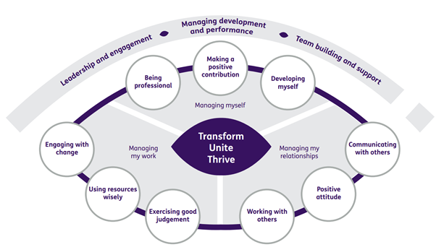
- A pro-active approach to taking initiative and to driving forward ideas and projects designed to improve daily operations and deliver an exceptional visitor experience.

Leadership and engagement, managing development and performance, team building and support

At the centre of the values:
- Transform
- Unite
- Thrive

Value area: Managing myself
- Being professional
- Making a positive contribution
- Developing myself

Value area: Managing my relationships
- Communicating with others
- Positive attitude
- Working with others

Value area: Managing my work
- Exercising good judgement
- Using resources wisely
- Engaging with change

What are the benefits of a Get Set Progress internship for me?
As part of your 9-month internship, you will gain the following:
- Obtain valuable work experience within the charity sector
- Technology support and upskilling opportunities
- Online and in-person Training and development opportunities
- Opportunities to work with fellow interns on a group project
- A personal mentor offering support, advice and guidance throughout your internship
- Help deliver positive changes for people with sight loss


As part of the GSP Internship programme, you will also be enrolled on the TPT Works For Me Employment Program, where you will gain bespoke employment support, guidance and advice from the TPT Employment Team, some of the skills that you will receive support and guidance around include:
- CV writing
- Job searching
- Cover letter and speculative letter writing
- Application form writing
- Interview techniques

The Works For Me team will also support you once your time on the GSP comes to a close in securing further employment. This support is bespoke and highly valuable with the team working to suit all your employment needs.

Job description

Role: Assistive Technology (AT) Intern
Department: Independent Living, Sight Scotland Veterans
Reporting to: Assistive Technology Lead
Location: Hybrid
Salary: Based on Living Wage Foundation rates,
Contract type: Fixed Term 9 months, full time 35 hours per week

Job Specification Information

Job purpose: Overview of the role:
The job will support making Assistive Technology part of the everyday set of tools and helpers that our visually impaired clients and colleagues use to make their lives easier and increase their independence.
The job will often be ‘hands on’ with activities such as demonstrating AT options that might be of use for clients and providing them with support and guidance on making best use of the technology they already use.
There will be opportunities to help train clients and staff on AT and offer expert advice to them.
This job will also have a role to play in helping us identify new technology and tools that can be brought forward for testing, and if they pass, become part of the AT Hub Knowledge Base of recommended solutions. We can offer those solutions to those we support and ensure they are always getting the most useful and reliable options that can help maximise their independence and remove barriers to everyday activities.
You will also work closely with the AT Lead and other teams to support the rollout of the new AT Strategy, and input to its continuous improvement.
An important strand of this job will also be to help develop and support our AT offering to colleagues (including volunteers) to ensure inclusivity is at the forefront of what we do.

Key areas of responsibility:
• You will support and provide advice to colleagues and clients to ensure they are getting the best possible options and solutions to help them be as independent as possible
• You will provide advice and expertise to help us ensure we are actively inclusive in our support for colleagues who use AT in the workplace
• You will help develop the AT Hub Knowledge Base as a library of our recommended options and solutions we can offer to clients
• You will regularly write articles on AT topics that will be published in the AT Hub Blog, which is read by frontline staff to help build their knowledge and awareness and keep them up to date with the best solutions and news
• You will assist with identifying and testing suitable new technology with staff and clients to determine if it will be suitable to be part of our Knowledge Base
• You will build relationships with our different teams, including travel to our Activity Hubs if required
• You will work with the AT Lead to support the implementation of the Assistive Technology strategy and input to its continuous improvement, including gathering feedback and views from our clients and colleagues
• You will assist the AT Lead to promote our services both locally and nationally, helping to build awareness of our work in AT

Personal specification - Essential criteria:
• Lived experience of sight loss
- IT literacy and experience with Microsoft Word, Outlook, and Teams
- Excellent written and verbal communication skills
- A strong motivation to learn new technology
- A friendly and approachable manner with clients and colleagues
- Experience with delivering support for clients
- A broad knowledge of IT and technologies that support AT, such as iOS, Android, Windows and MacOS
- Knowledge of WCAG Accessibility Standards and best practices
- Experience of design and delivery of a variety of training materials

Desirable criteria:

- A broad knowledge of the application of technological aids in the AT field

What to do next
Apply at Sight Scotland website: https://sightscotland.org.uk/vacancies

This post has a Genuine Occupational Requirement that the successful applicant be a person who is blind or partially sighted, in line with The Equality Act 2010

Closing date:
17:00 on 06/11/2023

About Sight Scotland Veterans

We're one of Scotland's oldest charities - for more than two centuries, we've been supporting and empowering people with sight loss to live fulfilling lives. We're proud of all we've achieved in the past - but we have our sights set firmly on the future.
We're determined that no-one should face sight loss alone. We're committed to improving, diversifying and growing our services to make sure we can reach many more people with sight loss - when and where they need us.
We have been accredited with the Disability Confident Employer status in recognition of our commitment to good practice in employing and retaining disabled people. The core actions we take, as required under the scheme, are as follows:

- Actively looking to attract and recruit disabled people.
We have been accredited with the Disability Confident Employer status in recognition of our commitment to good practice in employing and retaining disabled people. The core actions we take, as required under the scheme, are as follows:
- Actively looking to attract and recruit disabled people.
- Providing a fully inclusive and accessible recruitment process.
- Offering an interview to disabled people who meet the minimum criteria.
- Being flexible when assessing people so disabled job applicants have the best opportunity to demonstrate that they can do the job.
- Making reasonable adjustments as required.
- Encouraging our suppliers and partner firms to be Disability Confident.
- Ensuring colleagues have sufficient disability equality awareness.
- Providing work experience.
- Providing work trials.
- Promoting a culture of being Disability Confident.
- Supporting colleagues to manage their disabilities or health conditions.

