Application Pack

Greenmyres Business and Operations Manager

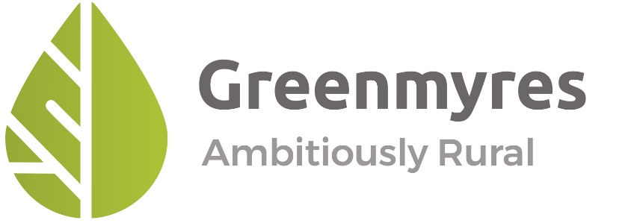

October 2023

Contents

1. Introduction 3
2. The Application Process 3
2.1 Overview 3
2.2. How to Apply 3
3. An Introduction to Huntly Development Trust 4
4. An Introduction to Huntly and District 5
5. Greenmyres 6
6. Job Description 8

Introduction
Huntly Development Trust (HDT) is an ambitious, active community-led company and charity working to make Huntly and District a better place to live, work and visit.

One of our key projects since 2014 has been the development of a former 63-acre (25 hectare) farm, Greenmyres, into a vibrant community asset providing all kinds of benefit to locals and visitors alike.

With support from the UK Shared Prosperity Fund and Smarter Choices, Smarter Places, HDT is seeking to recruit a full time (37.5 hours per week) Greenmyres Business and Operations Manager (GBOM). The purpose of the post is to work with a range of stakeholders to maximise the opportunities that the Greenmyres site offers and ensure that it runs in a safe and welcoming manner. The post-holder will promote and manage all aspects of the Greenmyres site, including the new adventure tourism project and support work to provide volunteer, biodiversity and wide community benefits. The post is permanent. The accompanying starting salary is £34,000 - 36,000 depending on experience, plus a contributory pension scheme.

This application pack introduces you to the application process, HDT, Huntly, Greenmyres and the role. If you have any queries, please contact: jobs@huntlydt.org.

The Application Process

Overview
The timetable for the application process is as follows:

Sunday 19th November | Deadline for receipt of applications by e-mail to jobs@huntlydt.org.
Monday 27th November | Applicants informed whether they have been short- listed for interview and about the interview format.
w/c Monday 4th December | Interviews in Huntly/at Greenmyres
w/c Monday 11th December | Interviewees informed of the outcome
As soon as possible thereafter | Successful candidate takes up their post

HDT reserves the right to amend this timetable without notice.

How to Apply
By midnight on Sunday 19th November, applicants should send to: jobs@huntlydt.org
    - A letter of application explaining your interest in the post (2 pages of A4 max)
    - Your CV, including your contact details.
    - The names and contact details of two referees, one of which should be your current or most recent employer. These referees may be contacted by HDT prior to your interview. If you do not wish your referees to be contacted unless you are offered the job, please indicate this clearly in your letter of application.

Thank you for your interest in the vacancy and in Huntly Development Trust.

An Introduction to Huntly Development Trust

Huntly Development Trust (HDT) is a company limited by guarantee with charitable status formed by and for the community of Huntly and surrounding district.

HDT’s aim is to build a resilient, inclusive, enterprising community capable of dealing with ongoing change.

Our main objectives are:
- maintenance, regeneration and improvement of the community’s physical, economic, social and cultural infrastructure, and assisting people who are at a disadvantage because of their social and economic circumstances.
- advancement of education and training, arts, culture, heritage, sports, recreation and environmental improvement.

Our main activities are development and management of projects to make Huntly and District a better place to live work and visit.

HDT has defined its ‘community of benefit’ as the AB54 postcode sector, which covers the town of Huntly itself and its catchment, including Aberchirder, Forgue, Gartly, Glass, Largue, Lumsden, Rhynie, Rothiemay & Ythanwells.

Since our establishment in 2009, we have undertaken a wide variety of projects of increasing scale and complexity and with a wide range of partners. These include:
- Construction of several foot and cycle paths
- Co-ordination of a skills development and exchange project with 3 communities in Finland
- Installation of gateway signage for Huntly
- Acquisition and redevelopment of 3 town centre buildings as part of a wider community regeneration strategy
- Acquisition and ongoing development of Greenmyres Farm as a community resource
- Establishment and operation of the Huntly Travel Hub, including car, e-bike and community minibus hire.

To ensure we can continue to deliver projects to benefit our community in the long term we seek to generate our own income streams wherever possible so that we reduce our dependency on grant funding. To that end, we have developed several renewable energy initiatives, including commissioning our own community wind turbine.

HDT plays a key role in the Huntly Town Team (HTT), a multi-stakeholder group made up of a range of community organisations in Huntly and the public sector.

We are a member-owned and led organisation, steered by a volunteer board of Trustees/Directors and employ 4.2 FTE staff.

More information on HDT can be found at www.huntlydt.org.

An Introduction to Huntly and District

Huntly is a small rural market town approximately 35 miles North-West of Aberdeen in the North- East of Scotland. The town lies close to the Aberdeen to Inverness trunk road, has a station on the Aberdeen to Inverness railway line and is about an hour from the international airports of both cities. The current population of the town of Huntly is ca 4,500, with an additional 7,100 in the surrounding district.

Huntly is the rural service centre for the wider hinterland. The entire town centre, including the attractive central market Square, is a conservation area and contains 62 listed buildings. A short walk from The Square is Huntly Castle. formerly the seat of the Gordon Clan. The Gordons raised the Gordon Highlanders, now merged into the Royal Regiment of Scotland. Besides agriculture, other important local industries have been textiles, brewing, engineering and a flourishing retail sector.

Nowadays, Huntly has a significant industrial estate. Major employers are Deans (shortbread manufacturers), Rizza’s (ice cream) and R&M Engineering. The public sector is also a major employer in Huntly, with Aberdeenshire Council, the National Health Service and Scottish Forestry/Forestry and Land Scotland all having a strong presence.

In 2006, two supermarkets opened on the edge of town presenting a significant challenge to businesses in the town centre. As a response, local farmers established a popular monthly farmer and producers’ market in the town Square on the first Saturday of every month. The town centre has, however, continued to decline in recent years and actions to tackle its state were identified as a priority through a recent wide-ranging community consultation process, Room to Thrive. (https://www.huntly.town/). HDT has been an active participant in realising the actions identified in the strategy and, as a result of collective actions, a palpable sense of belief is returning to the town.

Huntly is home to a large number of active community groups with interests ranging from contemporary arts to traditional fiddling, and from rugby to bridge. Huntly Nordic and Outdoor Centre continues to produce representatives for the Great Britain Cross Country Junior Development Squad, several of whom have competed at Winter Olympics. Local shooter Sheena Sharp was a double Gold Medal Winner at the Commonwealth Games in 2006.

Huntly is also very proud of the seemingly endless stream of talented individuals in the traditional Scottish performing arts. The town produces World Highland Dance Champions and has thriving Dance Schools which have sent performers as far afield as China. Huntly & District Pipe Band perform by invitation at many Scottish Highland Games and abroad. Shona Donaldson is a top traditional Scottish singer from Huntly who has toured internationally. Both she and her husband, champion Scottish fiddle player and composer Paul Anderson, have separately completed ‘artist-in-residence’ projects in the town commissioned by local socially engaged arts group Deveron Arts. Iona Fyfe hails from Huntly. In 2013, Huntly was named Scotland’s most Creative Places in its (size) category.

More information about our vibrant community can be found at: www.experiencehuntly.com.

Greenmyres

In 2014, with the help of the Scottish Land Fund, HDT acquired Greenmyres Farm some 4.5 miles South-East of Huntly close to the A96 Aberdeen-Inverness trunk road and bordering Forestry and Land Scotland's Gartly Moor Forest. The aim of the purchase was twofold:
- Develop a community wind turbine to generate green electricity and a significant revenue stream to support HDT and its investment in community projects over the long-term
- Provide a venue for a range of outdoors activities for the health and wellbeing, economic development of our community.

On purchase, the farm comprised a deteriorating 1.5 storey farmhouse, various outbuildings, a large pond, and 63 acres of upland grazing. To date our work has resulted in:
- Successfully commissioning the community wind turbine
- Conversion of the deteriorating Greenmyres farmhouse into an Ecobothy, an exemplar environmental community venue capable of hosting groups of varying sizes.
- Creation of a car park capable of hosting ca 20-25 vehicles
- Construction of a cycle workshop/equipment store and installation of two e-bike lockers
- Completion of the missing links in a pre-existing foot/cycle path from Huntly to Greenmyres allowing access to the farm on 7 km of almost entirely traffic free paths/roads
- Construction of a 1.2 km foot/cycle path into Gartly Moor providing access to ca 30 km of forest tracks
- Planting of over 6,000 native trees, a wildlife pond and wildflower areas to increase biodiversity.
- Creation of a dog run.

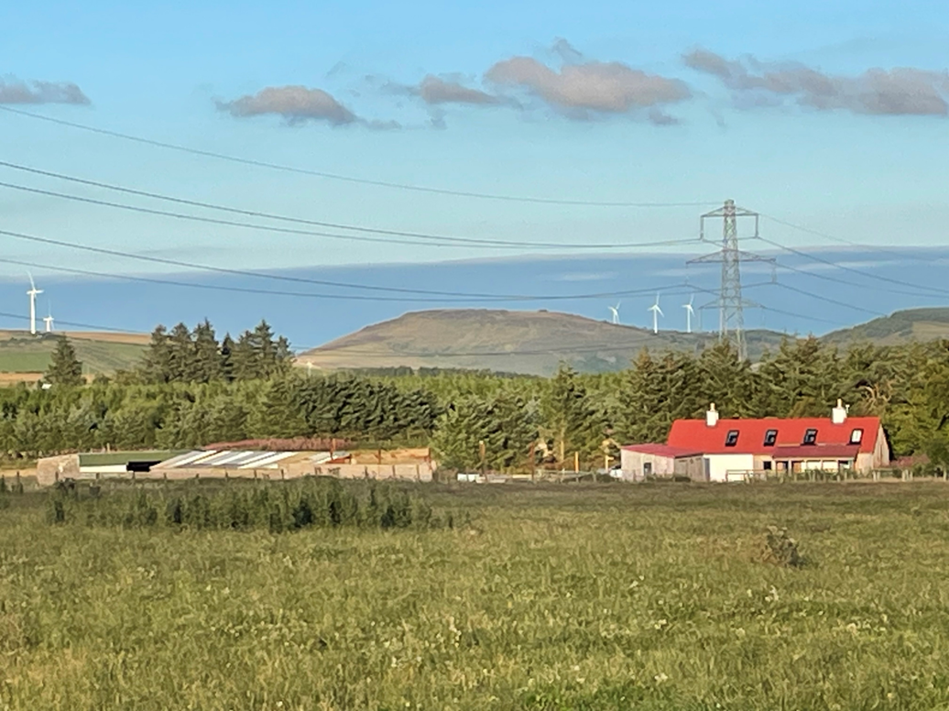

From the above, it can be seen that Greenmyres packs a lot into its 63 acres, some areas lending themselves to “high energy” activities, while others are better suited to more tranquil activities, such as simply enjoying nature.

The site is now richer in biodiversity than when we bought it, and home to several endangered species. It is increasingly used by dog-walkers, runners and cyclists. The Ecobothy is also being booked more often and by a wider range of groups. In short, the site is coming alive on several fronts.

In an exciting new development, HDT has secured funding from the Scottish Government’s Just Transition Fund through Opportunity North East’s North East Adventure Tourism arm (NEAT) to develop adventure tourism facilities at Greenmyres. This will enable us over the next 3-5 years to create a high-quality family-friendly adventure tourism venue for visitors and our community. Initial plans for 2023-24 are to create a cycle pump track and changing facilities. We aim to follow this in 2024-25 with development of a watersports pavilion. All will be accessible by active travel, as well as the private car and the community minibus which HDT runs. Over time, we aim to add mountain bike trails, children’s play area and potentially further supporting infrastructure on site, such as accommodation and a café.

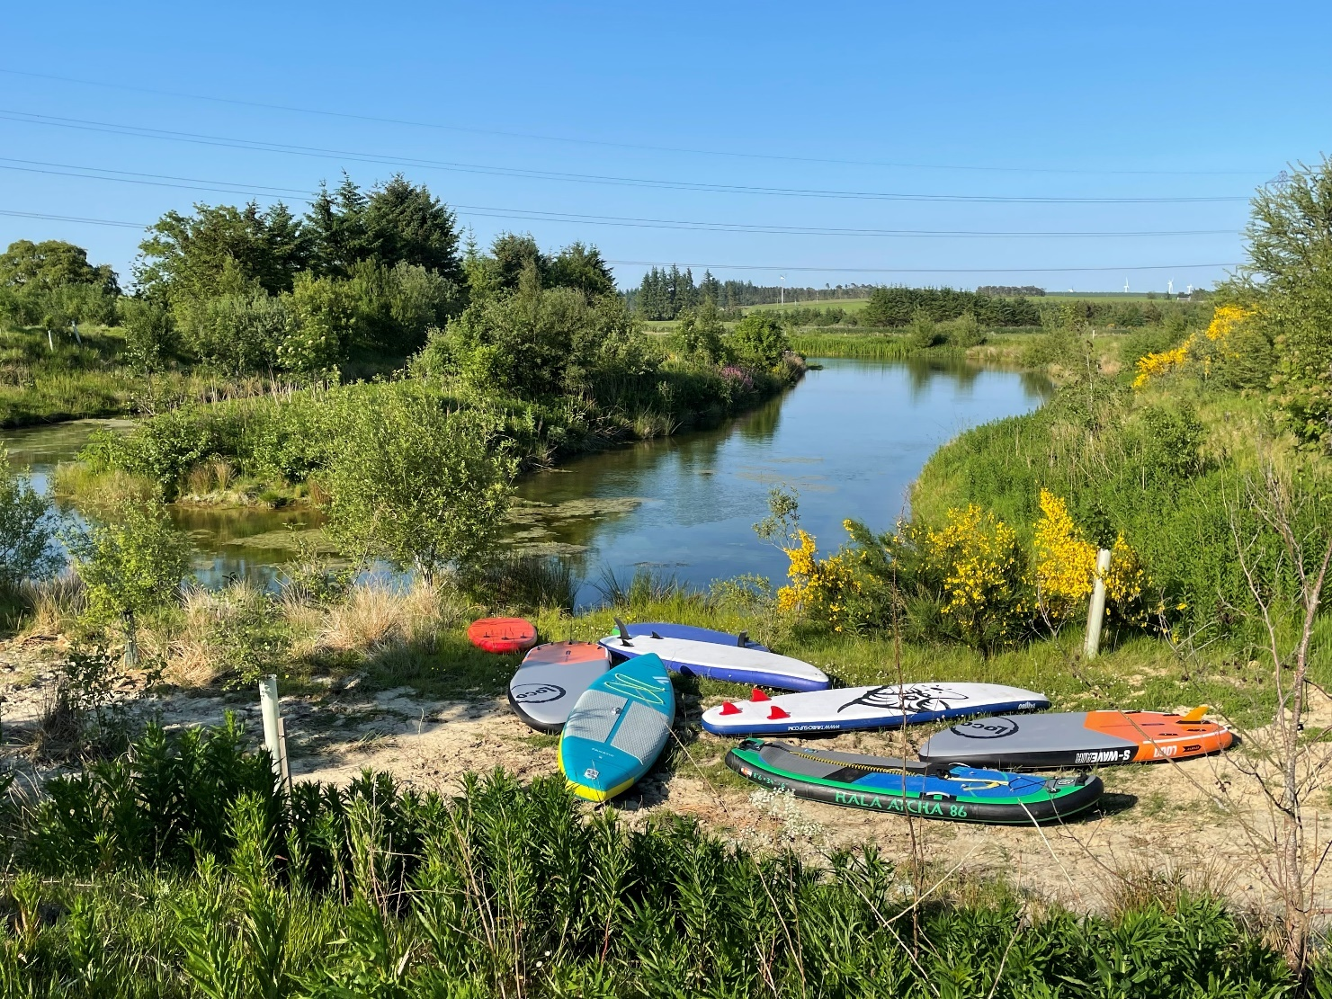

To help us manage what Greenmyres already offers and develop the next phase of activity, we are now seeking an ambitious, conscientious, enterprising team player to fulfil the role of our Greenmyres Business and Operations Manager.

Job Description

JOB DESCRIPTION | HDT/019
POST TITLE | Greenmyres Business and Operations Manager
DURATION | Permanent (37.5 hrs/wk.)
REMUNERATION | £34,000 - £36,000 depending on experience, per annum, plus pension contribution
REPORTS TO | HDT Joint General Managers

Background and Job Purpose
Huntly Development Trust (HDT) is an ambitious, active community anchor organisation serving the town of Huntly, Aberdeenshire and its wider rural catchment. We undertake a range of initiatives to make our community a better place to live, work and visit, both for now and the future.

One of our key projects since 2014 has been the development of a former 63-acre (25 hectare) farm, Greenmyres, into a vibrant community asset providing all kinds of benefit to locals and visitors alike. In an exciting new development, HDT has secured funding from the Scottish Government’s Just Transition Fund through Opportunity North East’s North East Adventure Tourism arm (NEAT) to develop adventure tourism facilities at Greenmyres.

HDT has secured support from The UK Shared Prosperity Fund and Smarter Choices, Smarter Places, to employ a Greenmyres Business and Operations Manager who will help us make the most of what this unique site has to offer. The successful candidate will be responsible for marketing and operating the existing site facilities, as well as leading the planning and delivery of future developments. This will ensure that the site delivers maximum benefit for a range of users, offers opportunities for (social) enterprise of all kinds and that it becomes financially self-sustaining.

Key Tasks
- Actively promoting the site and its opportunities, managing enquiries and securing bookings
- Liaising with users before, during and after their visit, ensuring that all equipment is ready for them to ensure a positive experience and that HDT obtains feedback to aid further development.
- Keeping the booking calendar updated and responding promptly to booking/information requests.
- Acting as operations manager for the site, completing regular maintenance checks, identifying and mitigating risks and organising repairs where needed
- Communicating with users of the site generally and managing potentially conflicting interests
- Designing and delivering a programme of appropriate on-site events to promote usage, especially related to cycling, watersports and active lifestyles, as well as land management for biodiversity, environmental education, rural skills and community growing.
- Developing and coordinating a programme of appropriate volunteer opportunities and managing volunteers
- Developing educational events and training courses
- Engaging, collaborating and communicating with the Greenmyres subgroup, HDT staff, Board, members, partners, the wider community and the project’s major funders
- Establishing and developing partnerships with others, e.g., Networks of Wellbeing and Developing Mountain Biking in Scotland around a Trail Therapy and social prescribing to make Greenmyres a base for wellbeing in the North East
- Working with Huntly Travel Hub and other local cycling organisations to provide cycling confidence sessions to encourage more people to start travelling more actively around the town and district.
- Engaging with schools and youth organisations to offer cycling practice facilities to young people to promote and encourage cycling or travelling actively to school.
- Identifying possibilities to utilise the site as a sustainable travel outlet by introducing green electric vehicle charging.
- Collaborating with others on preparation of a holistic future site development plan and robust site business plan to ensure financial sustainability of the site.
- Identifying funding sources for future projects proposed on the site and helping prepare funding applications to make them happen.

Required Skills

A. Essential
- Self-motivated with the ability to work under own initiative. Can work well as part of a small dynamic team and has the good judgement on when to bring in others.
- Knowledge and understanding of operating a rural (community) facility, with an affinity for the outdoors, active travel and an enthusiasm to share that affinity with others.
- Experience and interest in adventure tourism e.g., water sports/cycling/active travel
- Ability to form partnerships and work with others in a constructive way.
- Marketing and promotion skills/commercial experience
- Project management skills and experience (including financial management) with the ability to juggle competing demands and priorities.
- Attention to detail.
- Ability to proactively identify and mitigate risks and examine/compile robust risk assessments.
- Good communication and presentation skills
- Fluent in the use of Microsoft Office applications, e.g., Word, Excel, Powerpoint and Outlook, and competent in the use of social media
- The ability/willingness to work flexible hours, including evenings and weekends, to reflect the nature of the post.
- Driving licence and access to own transport, although a Co-wheels vehicle and e-bike can be accessed through HDT’s Huntly Travel Hub.

B. Desirable
- Practical knowledge and experience of working in the rural/adventure tourism sector with an ability and willingness to undertake hands-on jobs, if necessary
- Experience of or an interest in all or any of the following: land management for biodiversity, environmental education, rural skills, community growing
- Qualifications in outdoors-related activities, especially leading group sessions and/or volunteer management
- Experience of and ability to make high-quality funding bids.

Reporting Relationships (This job is indicated by *)

HDT Members

HDT Board of Directors

HDT Joint General Managers

HDT Greenmyres Business and Operations Manager (*)

Other
- The postholder will be based at Greenmyres.
- The post suits a positive, outgoing, down to earth person who can deliver real and tangible results.
- The post-holder is entitled to 31 days paid holiday per year, including public holidays rising to 34 days after 5 years of continuous employment and 36 days after 10 years of continuous employment.
- HDT offers a contributory pension scheme from which the post-holder may opt out if they wish.

Please note, the purpose of a Job Description is to indicate the general level of duties and responsibilities, not to form an exhaustive or compulsory list of detailed activities.

