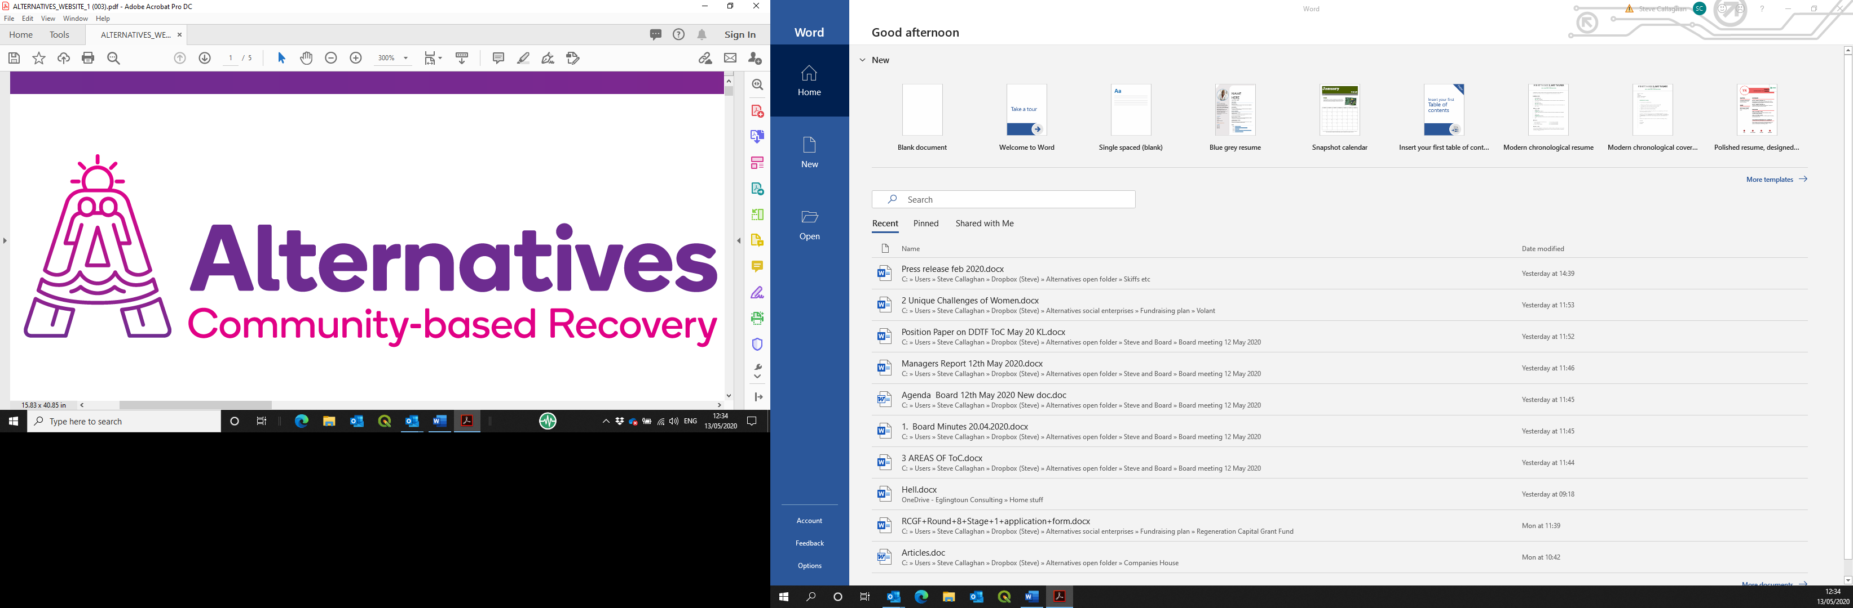

Post of Recovery House Project Worker
Information pack

Contents
Introduction and background information 3
Applying for the post on offer 3
Alternatives West Dunbartonshire Community Drug Services (Alternatives) 3
History and achievements 3
Social enterprises 3
Job description 3
Person specification 6

Introduction and background information

Applying for the post on offer
Please read this pack in its entirety, then apply by sending your CV. This should be returned by 12.00p.m. on 7th November 2023, by email to mhairi@alternativeswd.org .
Interviews are expected to take place week commencing 13th November 2023.
LATE APPLICATIONS WILL NOT BE ACCEPTED.

Alternatives West Dunbartonshire Community Drug Services (Alternatives)

History and achievements
Alternatives has been established since 1996 as a charitable company, with premises across West Dunbartonshire. Its operation base currently consists of:
- A main office in Quay Street, Dumbarton;
- A secondary office in Alexander Street, Clydebank;
- A 16-bed ‘Safe House’ in Jean Armour Drive, Clydebank;
- 4 x 2-bedroom ‘scatter flats’ in Drumry; and
- A catering operation within the Concord Community Centre, Dumbarton.

Alternatives’ core theme and purpose is to facilitate the personal journey from chaos to wholeness for individuals who have a substance dependency, by normalising a lifestyle without such a dependency.
Much of Alternatives’ core work is through its Service Level Agreement (SLA) with West Dunbartonshire Council for the delivery of community-based group work with service users in recovery from dependency on substances. Some of these service users are housed in the Safe House and associated scatter flats as part of their recovery journey, out with the SLA. The Care Inspectorate has recently awarded Alternatives a score of 6s across the board for its core work, the highest mark available and 5s for the rest, still an excellent accolade. This was the subject of a Private Member’s Motion in the Scottish Parliament during January 2020, where Alternatives and its team were praised and endorsed.

Social enterprises
We run social enterprises as safe, therapeutic work placement opportunities, these are being developed within the operational structure, to take in a horticulture operation and an expansion of the piloted catering operation as well as a heritage based operation.

Job description

To support the day to day running of the Recovery House Programme including supporting the main house project and scatter flat operation, aimed at promoting positive alternatives to drug use and stability in the community.

This will involve working with individuals and families affected by drug misuse, collaboration with partner organisations and assisting in the implementation of the Safe as Houses Recovery Programmes and links to the community.

This role may be suitable for an internal or external secondment, as part of the candidate’s continuing professional development.
PVG Scheme Membership is required for this post.
Alternatives operates an Equal Opportunities Policy.

Job title: Recovery House Project
Place of work: Safe As Houses Project, Clydebank
Employer: Alternatives West Dunbartonshire Community Drug Services (Alternatives)
Reporting to: Recovery House Co-ordinator, Alternatives
Salary: £27,000 per annum dependant on level of qualifications and experience. There is a contributory Pension of up to 6%.
Hours: Rotating shift pattern averaging out at 36 hours per week covering over 7 days.

Job purpose/main scope of post:

To support the day to day running of the Recovery House Programme including supporting the main house project and scatter flat operation, aimed at promoting positive alternatives to drug use and stability in the community.
This will involve working with individuals and families affected by drug misuse, collaboration with partner organisations and assisting in the implementation of the Safe as Houses Recovery Programmes and links to the community.

- Under the direction of the service co-ordinator assist with the development and implementation of the structured Groupwork Programme.

- To assist with the day to day running of the Recovery House services.

- To provide support in the afternoons, evenings and weekends within the Recovery House and accompany residents to outdoor activities using company vehicles. .
- To be directly involved in the planning and supporting of residents care plans alongside partner agencies.
- To provide support to recovering participants in a non-judgemental manner

- To work jointly with all partner agencies towards meeting the needs of service users.

- To record work undertaken in a suitable form as designated by the Line Manager and to gather data and maintain data gathering systems.

- To actively promote the services provided by Alternatives in line with policy guidelines, protocol and service philosophy.

- To work as part of a team towards the aims of service users in line with agreed working practice and strategies.

- To undertake such training programmes as may assist this agency and personal development.

- To participate in formal consultation and supervision of as required.

- To undertake the development and support of volunteers/peers workers in the delivery of the Community Recovery Programme.

- To undertake such other duties, appropriate to the grade, as may be delegated by the service co-ordinator.

Person specification
Specification | Essential | Desirable | How demonstrated
Qualifications |  | Relevant social care qualification minimum of SVQ3 or equivalent | CV or application form as appropriate
Knowledge and Experience |  | Knowledge of Recovery Orientated Systems of Care. | CV or application form as appropriate  Detailed in interview and references
Competencies | Clean driving licence for minimum of 2 years and a willingness to drive company vehicles as required is essential.  Awareness of social, educational, emotional issues facing drug users and their families.  Knowledge of social services.  Knowledge relating to record keeping and planning workloads.  Commitment to teamwork and user involvement in the planning and delivery of services.  Ability to work on own and as part of a team.  Knowledge of local resources.  A person-centred approach to working with people experiencing drug problems.  Ability to recognise and report concerns about the well-being of children and vulnerable service users.  Ability to work within appropriate legislation processes and procedures. | An understanding of vulnerable adults and trauma  An appreciation of lived experiences  Technical skills (simple IT)  Attention to detail | CV or application form as appropriate;  Competency based interview; references

