

Job Description

Role Title: | Community Activity Assistant
Department: | Family Wellbeing Service
Reports to: | Senior Community Worker
Pay Grade: | Pts. 10 - 14
Normal place of work: | North or South Lanarkshire
Line Manager? | No
Budget Holder? | No
Criminal Record Check/PVG required? | Yes – PVG for work with Vulnerable Adults
Driving license for UK driving required? | Yes, and access to a car

Who we are

The Family Wellbeing service provides support to individuals affected by sight loss and to families impacted by a loved one with sight loss ensuring they are fully equipped to adapt to the changing world around them and reach their full potential regardless of age. As a service we adopt a person-centred approach ensuring that interventions and support respond to individual family circumstances.

You will provide community-based support to people with sight loss by practicing a person-centred approach to ensure that support responds to individual family circumstances.

What this job is about

We are looking for caring, creative, innovative and dedicated people to join our family wellbeing service within the Community Services team at Sight Scotland to provide community-based support to people with sight loss.

We aim to reduce the isolation and anxiety often felt by those with sight loss, while improving confidence to live well with visual impairment now and in the future.

As part of our aim to help those with impacted with sight loss to live well, you will create and facilitate group support to individuals to improve social inclusion for people living with sight loss.

What we want you to be responsible and accountable for

- Provide advice, information and guidance within communities from referrals from our Community Support Team including our telephone and online helpline.
- Create and facilitate group support and activities to improve social inclusion for people with sight loss and to enable people with sight loss to identify and work towards personal goals.
- Along with the Community Workers, work with people with sight loss in identifying existing and new opportunities within local communities and signposting for clients to specialist resources, such as employment, education, life skills training and leisure.
- Liaise with a range of organisations to ensure the needs of families are prioritised and met in conjunction with the Community Support Team.
- Ensure that all records are maintained and are up to date.
- Liaise with the Volunteer Champion to refer families and service users to our Volunteering Befrienders.
- Refer any child and/or adult protection concerns and issues to the senior community worker.
- Maintain positive and effective relationships with colleagues across Sight Scotland.

The current duties of the role require a criminal record check or membership of the PVG scheme through Disclosure Scotland.

How we would like you to achieve this

- Be able to demonstrate an understanding of the support needs of people with visual impairment and their families.
- The ability to facilitate groups and/or activities for those living with sight loss and their families.
- Be able to build positive relationships with service users and colleagues.
- Excellent time management skills to plan, prioritise and manage workload.
- You will have Good IT skills with a good knowledge of Microsoft office packages.
- An understanding of and ability to maintain confidentiality.
- You will undertake organisational training as required and be committed to continuous personal learning and development, including developing and maintaining skills in relation to sight loss and family support work.
- You will support and work closely with the Senior Community worker and Head of Community Services.

Who you will be working with

- Community Support team
- Senior Community worker
- Head of Community Services
- Senior Managers
- Other Sight Scotland and Sight Scotland Veterans Services
- Colleagues
- Service Users and their families
- External Agencies

The budget you will hold

- N/A

The experience and skills you need to have to do this job

Essential:

- Experience of facilitating community groups and/or activities.
- Be able to demonstrate an understanding of the support needs of people with visual impairment and their families.
- You will have the ability to build positive relationships with service users and colleagues.
- You will be able to demonstrate excellent communication skills.
- Ability to work on own initiative.
- Have knowledge of outcome focussed assessment and the principles of person-centred support.
- You will have the ability to work calmly under pressure.
- You will have the ability to adapt to change and respond positively to non-routine situations.
- You will have a flexible approach to working hours which is expected to reflect business needs.
- You will have a full driving license and access to own car and willingness to undertake travel to support families as required.

Desirable:

- Have a relevant Health and Social Care or Community Care qualification or another equivalent professional qualification.
- Have experience and expertise of working in the health and social care environment.
- Have experience of service development.
- Be able to demonstrate excellent time management skills to plan, prioritise and manage workload.

Just so you know…

- The Charities have a set of Values & Our Ways of Working Framework, we ask you to work within, and these apply to everybody in the organisation irrespective of their role or job. You can find out more here: Our values. This means we want you to have:
  - The ability and willingness to understand others’ perspectives and to consider the impact of your actions on them and to adapt your actions as necessary;
  - The ability and willingness to learn and try new things, to be flexible and step outside of your comfort zone;
  - An open and honest way of communicating, ready to ask others for their ideas and to be open to hear and consider different points of view;
  - A pro-active approach to taking initiative and to driving forward ideas and projects designed to improve daily operations and deliver an exceptional visitor experience.

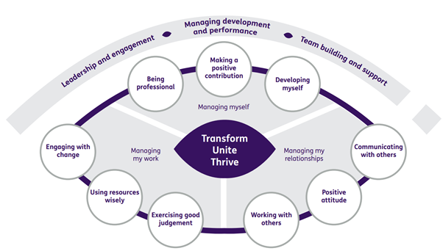

Department structure (this role outlined in red)

