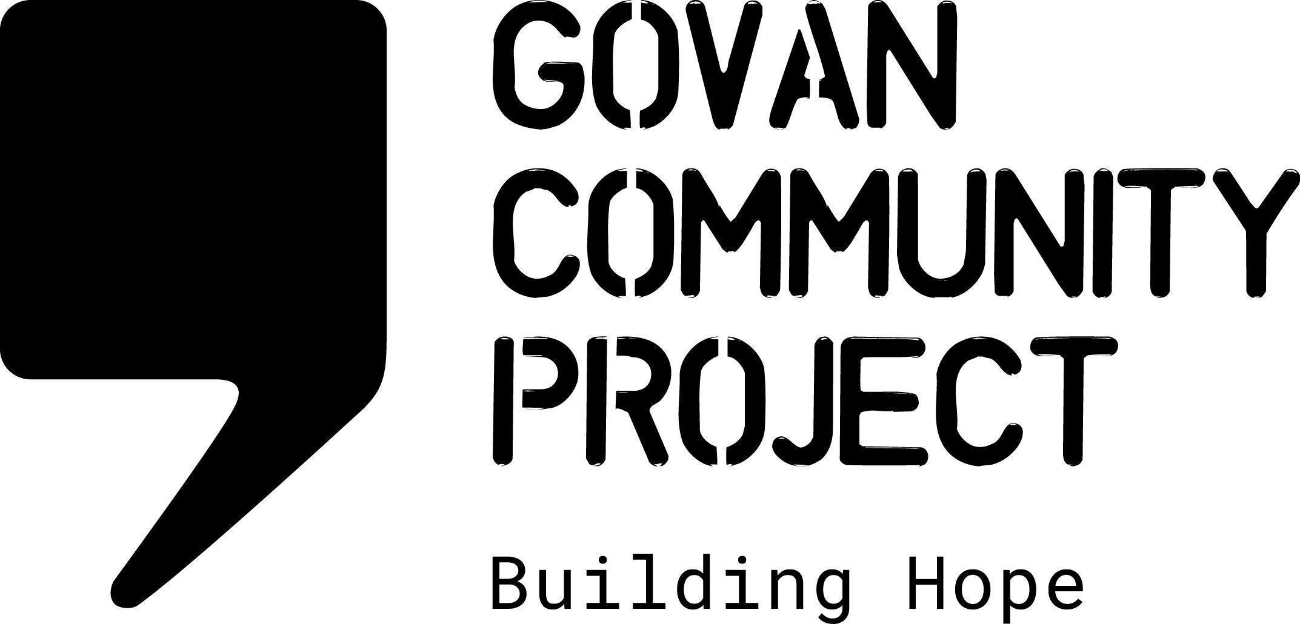
JOB DESCRIPTION

Job Title: | Wellbeing Group Coordinator
Location: | GCP Office
Hours Per Week: | 17.5 hours per week
Salary Scale: | £23,634 per annum (pro-rata’d)
Duration of Post | 1 year fixed term
Reporting To: | Head of Charity
Responsible For: | Supporting volunteer facilitators/group members

ABOUT THE ORGANISATION

Govan Community Project works with individuals and families in the asylum and refugee community, providing a range of holistic activities to support New Scots settling in Glasgow. Our range of support provides both practical supports to help mitigate the impact of destitution, combined with a range of community learning and development activities which empower individuals and families to rebuild their lives and make connections in their local community.

ABOUT THE PROJECT

This is a new project, which was developed in response to needs identified by community members in relation to challenges in accessing support to manage mental health. Our community members identified that navigating the hostile environment of the UK immigration system has a detrimental impact on mental health, and that it would be helpful to community members to be able to access some support which would enable individuals to better understand and self manage their mental health/wellbeing and know where to access support.

OVERALL PURPOSE OF THE ROLE
The group coordinator will develop and deliver a trauma informed groupwork programme which supports New Scots to understand and manage mental health symptoms. The groupwork programme will be co-designed with community members.
MAIN DUTIES AND RESPONSIBILITIES

Groupwork Programme

- Work with GCP community members, to co-create a trauma informed 6 – 8 session mental health self management support group programme
- Work with group members to identify mental health themes for additional awareness sessions
- Build connections with health partners to provide additional input to sessions
- Co-facilitate groupwork sessions
- Recruit and train volunteers to co-facilitate sessions

Awareness Sessions

- Deliver 5 one-off awareness raising sessions on topics identified by group members to support good mental health
- Work with partner organisations to deliver inputs which increase awareness and accessibility of external support services to community members

Evaluation and Reporting

- Develop a project delivery plan including a monitoring and evaluation plan for the project
- Collate monitoring and evaluation evidence in line with the evaluation plan
- Provide quarterly updates to the Head of Charity on quantitative and qualitative data on engagement levels
- Work with community members to develop a case study evidencing the impact of the activities
- Coordinate 6 monthly focus groups with participants for more indepth feedback
- Work with the fundraising officer to produce an end of project report

Other Organisational Duties And Responsibilities

- Work as part of the staff team to maintain and promote the values and ethos of Govan Community Project.
- Adhere to all organisational policies and procedures.
- Work with the staff team to contribute towards providing a safe, welcoming, clean and tidy environment for staff and visitors.
- Attend team meetings and contribute to strategic development.
- Perform any other tasks or duties deemed necessary.
- Occasional Weekend or Evening Work may be necessary in this post

PERSON SPECIFICATION

Essential Skills And Experience

- Experience working or volunteering in providing mental health/wellbeing support
- Knowledge and understanding of human rights, equalities and social justice issues
- Knowledge of the impact of the UK asylum system on mental health
- Experience facilitating diverse groups of vulnerable individuals
- Experience in identifying and responding to adult safeguarding concerns
- Ability to work unsupervised and as part of a team
- Ability to manage a varied workload
- A flexible working approach and excellent time management skills

Desirable Skills And Experience

- Experience working with people in the asylum/refugee community
- Lived experience of forced migration/displacement
- Experience working with interpreters in a group setting
- 2nd language such as Arabic/Farsi

