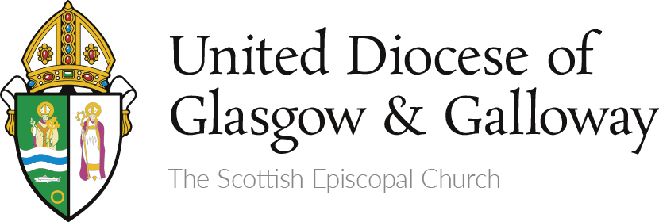
JOB DESCRIPTION DEC 2023

Job Title: | Diocesan Administrator
Responsible to: | Bishop
Responsible for: | 1) Finance Administrator, Digital Engagement Officer, External IT consultant report directly to the Diocesan Administrator.
 | 2) Property Administrator, Net Zero Officer, Senior Administrator and Mission Development Officer report indirectly (for the purposes of personnel matters/team planning etc).

Key relationships: Dean, members of Bishop’s Core Group, Diocesan Secretary, Diocesan Treasurer

Purpose of post:

• Working closely with the Bishop and the Dean, have oversight of Diocesan finances and support the effective operations of the Diocese and the Diocesan office staff team to ensure a standard of excellence in the support given to local charges.

Operational Development

- To work with the Bishop and Diocesan staff team to ensure that the vision of the Diocese is delivered, statutory and regulatory duties are met and that strategic and operational objectives are timely, clear, relevant and implemented.

- To foster a positive working environment for all staff, and ensure that effective support, supervision and staff development is implemented.

- To work with the Finance Administrator to prepare the annual budget and annual accounts for audit, ensure that monthly financial management information is available, monitor performance against budget at least monthly and take any necessary corrective action.

- Monitor annual congregational Finance Schedules and annual reports and accounts. Calculate annual quota for congregations and supervise assessment schedules both issue and receipt of payments.

- Liaise closely with the Diocesan Treasurer in the performance of all financial matters as required, in particular when preparing for Council and Synod meetings.

- To ensure compliance with Health and Safety, employment and equality legislation and accepted good practice.

Governance

- To ensure that the Bishop and Diocesan Council have at their disposal sufficient resources, guidance and professional advice in order that the Diocesan Trustees can carry out their roles effectively, ensuring compliance with Canon Law of the Scottish Episcopal Church, relevant legislation and good practice in charity governance.
- To liaise with the Bishop’s Core Group in particular.
- In consultation with the Bishop and Dean to prepare meeting Agendas for relevant meetings and draw the attention of Diocesan leaders to matters that need discussion and/or decision.
- To take responsibility for providing minutes of Core Group, Council, Synod and other formal meetings as required.
- To ensure that a risk management policy is in place and that the risk register is maintained and reviewed.
- Liaise closely with the Diocesan Secretary in the performance of these duties, in particular when preparing for Council and Synod meetings.

This document does not form part of your contract of employment.

Person Specification

Experience and Qualifications | Essential | Desirable
At least five years’ experience of senior organisational leadership within the faith/community/charitable sector | X
Prior project development and management experience. | X
Experience of managing and monitoring large budgets | X
Skills and Knowledge | Essential | Desirable
Strong and inclusive leadership skills. | X
Knowledge and understanding of charity accounting and audit procedures |  | X
Excellent inter-personal skills | X
Excellent verbal and written communication skills. | X
IT literate. | X
Attitudes and Values | Essential | Desirable
Understanding of and commitment to the vision and mission of the Diocese and the Scottish Episcopal Church | X
Ability to build positive relationships with people from diverse backgrounds | X
Ability to act and think strategically. | X
Ability to work on own initiative and with multiple stakeholders in a complex environment. | X

This document does not form part of your contract of employment.

