Dear Applicant

Wellbeing Group Worker

Thank you for your interest in the above vacancy with Govan Community Project.
Enclosed with this letter is a copy of the job description, and a copy of our application form. The application form can be completed electronically, however we are also happy to receive paper applications.
We want our recruitment processes to be as inclusive as possible so if you require any support to submit your application , please do get in touch. Any enquiries regarding the role or the application process should be directed to Traci Kirkland, Head of Charity, traci@govancommunityproject.org.uk
The closing date for applications is midnight on Thursday 4th January 2024. No late applications will be considered.
To enable us to monitor diversity within our recruitment processes, we would be grateful if you could complete our anonymous diversity survey which can be accessed here: http://bit.ly/GCPHReqmonitoring, however this is not mandatory and opting out of this will have no impact on your application.
Completed applications being submitted by email should be sent to recruitment@govancommunityproject.org.uk. Paper applications should be sent to:
Traci Kirkland, Head of Charity
Govan Community Project
31 Garmouth Street
Glasgow
G51 3PR

Please note that as a small organisation we do not have the capacity to respond to every applicant individually. If you have not heard from us within 14 days of the closing date, you should consider your application to have been unsuccessful.
We look forward to receiving your application.
Kind Regards
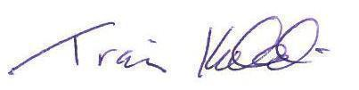
Traci Kirkland
Head of Charity

