

Job Description

Role Title: | Personal Assistant to the Chief Executive
Department: | Executive Support Team
Reports to: | Executive Support Manager
Pay Grade: | TBC
Type of Contract: | Permanent
Normal place of work: | Head Office but with flexibility to include some working at home under our Hybrid Working arrangements
Line Manager? | No
Budget Holder? | No
Criminal Record Check/PVG required? | NA

Who we are

The impact of vision loss is huge. Too often, it leads to people lacking or losing confidence and independence. People with vision loss are at higher risk of unemployment, isolation, mental health problems, and financial challenges. It can have an enormous emotional toll. But with the right support, people with vision loss can gain the skills to remain independent and active in their communities – to thrive.

That’s why we’re here.

For 230 years, Sight Scotland and Sight Scotland Veterans has been supporting people im-pacted by vision loss.

We believe we play an important role in continually shifting the conversation around sight loss, and contributing to achieving a fair, equitable society. Over the years, we’ve seen a positive shift in expectations, with individuals and communities increasingly empowered to live lives the way they choose, free of discrimination.

And we’ve had to transform too, so that our services reflect the times we live in and meet the changing needs of the people we support. We’re now looking at how we continue to evolve, considering how we contribute now and what we could do differently in the future.
We work with charities across our sector to make sure people with sight loss have access to the right resources, when they need them. But what makes us unique is:

• Together, Sight Scotland and Sight Scotland Veterans is the largest Scottish charitable organisation that supports people impacted by vision impairment
• We’re the only Scottish vision impairment charities that fund medical research into eye health
April 2023
• We’re the only Scottish vision impairment charities that have a dedicated policy and campaign team
• Our services span all age groups, including people born with a vision impairment, and those that acquire a vision impairment throughout their lives

These unique attributes of our organisation allow us to become something more than we have been up until this point.

It’s an exciting time to join us as we continue to change, grow and develop to ensure that we remain relevant and innovative – and, most importantly, provide support which responds to the needs of people with vision loss today. You could play a major role in making that happen.

What this job is about

This job exists in order to provide high level confidential support to the Chief Executive by providing a full secretarial and administrative service and ensuring that effective diary planning and administrative systems are in place and maintained efficiently and effectively.

What we want you to be responsible and accountable for

- Assisting the Chief Executive in preparation for meetings and appointments
- Managing the Chief Executive’s diary
- Assisting the Chief Executive in the preparation of documents, reports, applications and presentations.
- Sending / receiving correspondence on behalf of the Chief Executive. This may include phone calls, emails and letters.
- As required organising appropriate travel arrangements for the Chief Executive for external meetings and events.
- Maintain effective and confidential filling and data storage including emails and retrieval systems ensuring the needs of the Chief Executive are met.
- Planning conferences, workshops, seminars and other events
- Working independently but also work closely with the Executive Support Team and contribute to the Charities’ purpose.
- As required support the Executive Support Team with minute taking and administration of Board, Committee and Executive Team meetings.

The current duties of the role do not require a PVG or Standard Police Act Disclosure check.

How we would like you to achieve this

- We want you to work in a way that is wholly consistent with our stated organisational values and Corporate Strategy.
- We would like you to build particularly close relationships with colleagues across the Charities as well as external stakeholders
- We would like you to work in partnership with the Executive Support Manager to ensure consistent high quality administrative support to the Chief Executive.

Who you will be working with

- Chief Executive
- Members of the Executive Team
- Trustees
- Executive Support Team
- Colleagues across Sight Scotland and Sight Scotland Veterans

The budget you will hold

NA

The experience and skills you need to have to do this job

Essential:

- Substantial previous experience in providing PA support to a Chief Executive or Director
- Demonstrable experience across a range of administrative tasks
- Experience of diary management, minute taking and agenda preparation
- Highly competent across a range of IT skills (Word, Excel, PowerPoint, Access, Outlook and Teams)
- Be able to demonstrate a professional manner when dealing with both internal and external stakeholders
- An ability to cope with prioritising a changing and complex workload, including tight deadlines.
- Knowledge of Data Protection principles and GDPR
- Experience of developing and maintaining systems for information storage and retrieval
- Excellent verbal and written communication skills
- Able to work independently but also effectively as part of a team
- Strong attention to detail

Just so you know…

- The Charities have a set of Values & Our Ways of Working Framework, we ask you to work within, and these apply to everybody in the organisation irrespective of their role or job. You can find out more here: Our values. This means we want you to have:
  - The ability and willingness to understand others’ perspectives and to consider the impact of your actions on them and to adapt your actions as necessary;
  - The ability and willingness to learn and try new things, to be flexible and step outside of your comfort zone;
  - An open and honest way of communicating, ready to ask others for their ideas and to be open to hear and consider different points of view;
  - A pro-active approach to taking initiative and to driving forward ideas and projects designed to improve daily operations and deliver an exceptional visitor experience.

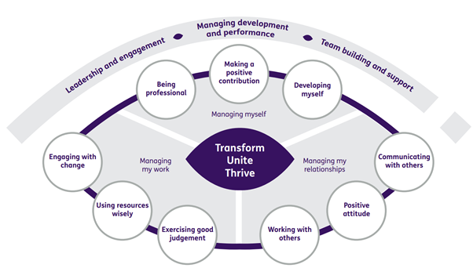

Department structure (this role outlined in red)
