Title of Post

Youth and Community Worker (FT)

Main Purpose

The Kirk Session of Barrhead St Andrew’s have identified a need for improved mission and outreach with the young people and the wider community of Barrhead to take forward our new Vision and Mission Strategy (see page 4). The Kirk Session seeks an enthusiastic and experienced individual specifically to develop and drive forward missional initiatives, making use of current church and community networks, links with local schools and building connections with young people and the wider community. Ideally, we are looking for a candidate with a suitable qualification (Community Learning Development or equivalent) and some years post-qualification experience.

Management & Support

The post holder will be line-managed by the Minister and report back to the Leadership Team and the Kirk Session, with support from an experienced and knowledgeable steering group. A dedicated budget will be available for professional development, operational costs and to resource projects and activities. The church has well-furnished and equipped premises to support initiatives. This post is pivotal as part of our new vision for mission in Barrhead for which we see a continuing and increasing need. The post holder will be offered an initial 3-year fixed term contract with the possibility of extension following a review of ministry and mission across the parish, and the ongoing review of Clyde Presbytery’s Approved Mission Plan.

Main Duties

Community
- Engage creatively with secondary aged young people in a range of community settings, seeking to explore how the church and expressions of faith can better meet their needs.
- Network and develop links with other external youth and community organisations to explore opportunities for joint working.
- Develop existing links with schools, in particular Barrhead High School, and work towards establishing a Team Chaplaincy approach.
- Work with the Minister and Comms team to develop the public face of the church, both digitally and through traditional media.
- Explore the option of providing some form of supported accommodation within the town, either through Green Pastures or other appropriate community initiatives.

Church
- Develop and build on existing relationships with Bourock and Neilston Parish Churches, seeking opportunities to work in partnership and to develop joint models of work.
- Oversee delivery and development of youth and children’s work & volunteer team within the church.
- Develop programmes to deepen the faith of young people connected with the congregation and to enable them to take a greater role in the life of the church.
- Develop and build on links with existing youthwork organisations connected with the Church: Boys Brigade, Scouting and Guiding.
- Work with the Minister and Kirk Session to make traditional church more accessible for young people and members of the community.
- Seek to develop new forms and fresh expressions of church life, in particular intergenerational approaches to and participation in forms of worship.
- Co-ordinate and expand our programme of community outreach events from our premises, in particular our new Community Hall, i.e. Christmas Market, family films, holiday provision, etc.
- Work with young people and the congregation to explore the impact of our church on the local environment and seek ways to address this, i.e. Eco-Congregation Scotland.
- Attend Leadership Team and Mission and Outreach meetings and report regularly to the Session.

General

- Assist with identifying and applying for suitable funds to support the work.
- Plan, deliver, review and evaluate the impact of all work undertaken with young people.
- Any other duties as required.

Terms and conditions

- Normal hours of work will be 35 hours a week as agreed locally. The nature of the work will require a degree of flexible working including regular evening and weekend work. Regular attendance at Sunday services is expected as a key aspect of the role.
- The starting salary is £28,815 – scale point 1 on the Church of Scotland MDS scale. The post will include an employer’s pension contribution of 3%.
- There are 6 weeks annual paid leave in each full holiday year, running 1st January to 31st December. Entitlement is based on full weeks worked.

How to apply

Application is by CV and covering letter to tmineard@churchofscotland.org.uk. For more information and an informal conversation, please contact our Minister Tim Mineard via 07935 768530.

Closing date is Monday 5th February 2024 at 12pm.
Interviews will take place on Tuesday 13th February.

This appointment will be subject to PVG Membership and satisfactory scheme checks.

A total of 3 references will be requested for the successful candidate: 2 professional references including the most recent employer, and 1 character reference able to comment on the candidate’s faith and Christian commitment.

https://barrhead-standrewschurch.org.uk/
https://www.facebook.com/BarrheadStAndrews

Person Specification:
Skills, abilities and knowledge | Essential | Desirable
Christian commitment (this is a genuine occupational requirement in terms of the Equalities Act 2012)
Qualification in CLD to Degree level or equivalent experience (or commitment to work towards)
Ability to engage with youth and families in the community who have little or no church connection
Experience in identifying, recruiting and motivating volunteer teams
Experience building working relationships and liaising with other organisations to support joint working
Good organisational and IT skills
Ability to use a range of media (including social media tools)
Ability to collect information, keep records and evidence progress through regular reporting
Effective use of monitoring and evaluation systems
Ability to reflect and evaluate on professional practice
Track record of applying for, securing and reporting on funding
Experience of assessing risks and ensuring a safe environment

Person Specification (continued):
Personal Qualities | Essential | Desirable
Enthusiastic, friendly and approachable
Enjoys working under own initiative and is self-reliant
Relational in outlook and approach
Comfortable in a team environment
Flexible, reliable, adaptable and good problem solver
Communicates effectively in different contexts, both to groups and individuals
Manages difficult situations sensitively and effectively
Additionally, you would need to be flexible, open to learning, have a positive attitude, love working with people (both young and not-so-young!) and know how to have fun, laugh and enjoy life.

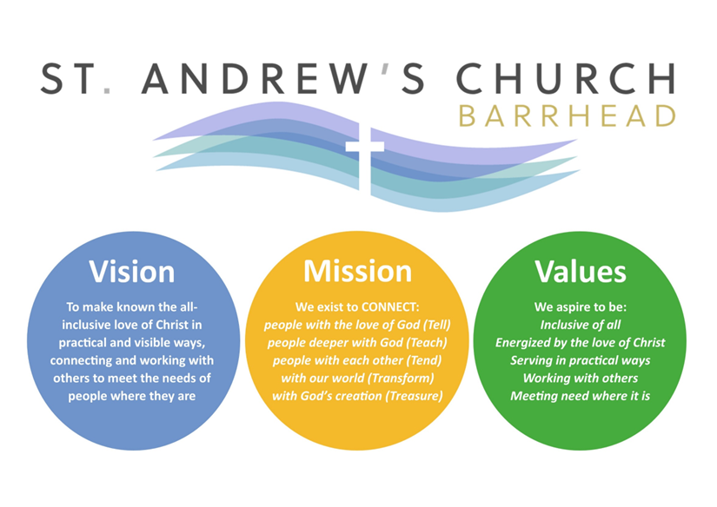
OUR KEY VALUES
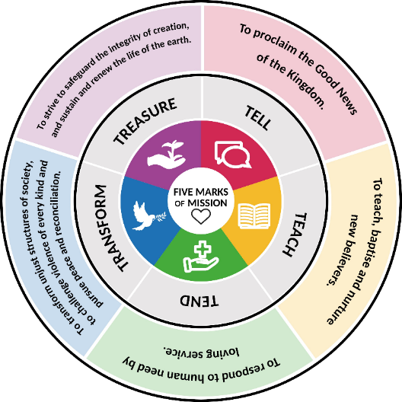
- Inclusive of all (whole community) Galatians 3:28
There is neither Jew nor Gentile, neither slave nor free, nor is there male and female, for you are all one in Christ Jesus.
- Energized by the love of Christ: 2 Corinthians 5:14
For Christ’s love compels us, because we are convinced that one died for all, and therefore all died.
- Serving in practical ways: James 1:27
Religion that God our Father accepts as pure and faultless is this: to look after orphans and widows in their distress and to keep oneself from being polluted by the world.
- Working with others: Ecclesiastes 4:9
Two are better than one, because they have a good return for their labour.
- Meeting need where it is: John 4:1-42
The woman from Samaria.

