

Job Description

Role Title: | Administrator
Department: | Facilities
Reports to: | Facilities Manager
Pay Grade: | £23,088 - £24,042 per annum (from 1 April) Pts. 16 - 18
Type of Contract: | Permanent
Normal place of work: | Head Office
Line Manager? | No
Budget Holder? | No
Criminal Record Check/PVG required? | No
Driving license for UK driving required? | Yes / No – if yes outline why e.g. attends meetings in locations away from normal place of work, many of which are not readily accessible by public transport.

Who we are

The impact of vision loss is huge. Too often, it leads to people lacking or losing confidence and independence. People with vision loss are at higher risk of unemployment, isolation, mental health problems, and financial challenges. It can have an enormous emotional toll. But with the right support, people with vision loss can gain the skills to remain independent and active in their communities – to thrive. That’s why we’re here.

For 230 years, Sight Scotland and Sight Scotland Veterans have been supporting people impacted by vision loss. We believe we play an important role in continually shifting the conversation around sight loss, and contributing to achieving a fair, equitable society. Over the years, we’ve seen a positive shift in expectations, with individuals and communities increasingly empowered to live lives the way they choose, free of discrimination.

And we’ve had to transform too, so that our services reflect the times we live in and meet the changing needs of the people we support. We’re now looking at how we continue to evolve, considering how we contribute now and what we could do differently in the future.

We work with charities across our sector to make sure people with sight loss have access to the right resources, when they need them. But what makes us unique is:

- Together, Sight Scotland and Sight Scotland Veterans is the largest Scottish charitable organisation that supports people impacted by vision impairment
- We’re the only Scottish vision impairment charities that fund medical research into eye health
- We’re the only Scottish vision impairment charities that have a dedicated policy and campaign team
- Our services span all age groups, including people born with a vision impairment, and those that acquire a vision impairment throughout their lives .

What this job is about

You will be responsible for ensuring the smooth running of our joint Head Office and Scottish Braille Press reception at Robertson Avenue, and providing an excellent level of customer service to colleagues, visitors and external contractors who visit or work within the building as well as those contacting Sight Scotland by post, email or telephone. As well as coordinating front desk activities you will also be responsible for general office administration and facilities management tasks. You will also act as lead Fire Marshall and a nominated First Aider for the building.

What we want you to be responsible and accountable for

- Ensuring reception cover for the Sight Scotland / Sight Scotland Veterans Head Office and Scottish Braille Press joint reception
- Ensuring all guests are received in a positive friendly manner and our culture and values are presented every day
- Dealing with colleagues, clients and contractors, monitoring their access arrangements and conducting safety briefs
- Answering telephone, email, post and website enquiries professionally and accurately, working with colleagues across the organisation to source the answer to the enquiry / ensure follow up by the service. Tracking topics and numbers of enquiries for reporting purposes
- To make sure the front of house and meeting rooms are efficiently managed to the standard expected by Sight Scotland / Sight Scotland Veterans
- To be the Lead Fire Marshall for the building
- To be a nominated trained first aider for the building. Training will be provided
- As well as coordinating front of house tasks undertake a range of administrative tasks to support services, colleagues in the building and facilities management, including:

- Processing incoming / outgoing mail for Head Office teams
- Recording fundraising income (cash / cheques) received by post and ensuring it is securely transferred to the fundraising team, including the scanning of any relevant documents as required
- Dealing with deliveries to the building
- General filing, scanning, photocopying and administration support for staff as required
- Record keeping for facilities management as required
- Signing in/out of access keys and equipment to staff/external contractors
- Monitoring fire alarm system and conducting system tests
- Ensuring fire log book is up-to-date
- Issue staff access fobs
- Preparing meeting rooms, arrange tea, coffees and buffet lunches when required. Clear rooms after use ready for next booking.
- Manage meeting room bookings
- Manage pool car bookings
- Responsibility for stationery supplies and ordering for Head Office
- Ordering general supplies for the building as required
- Sourcing other resources as required by colleagues / services.
- Any other duties as may reasonably be required

The current duties of the role do not require a criminal records check or membership of the PVG scheme through Disclosure Scotland.

How we would like you to achieve this

- We want you to work in a way that is wholly consistent with our stated organisational values and our Corporate Strategy.
- We want you to be customer-focused and to always keep in mind how your activities impact on our colleagues across the Charities, but without losing the integrity and efficiency of processes, and technical standards.
- We would like you to build particularly close relationship with your colleagues across the organisation.

Who you will be working with

- Colleagues based at Robertson Avenue
- Other Sight Scotland and Sight Scotland Veterans services
- Senior Staff
- External visitors and contractors
- Members of the public

The budget you will hold

NA

The experience and skills you need to have to do this job/

Essential:

- Have previous experience of working in a busy reception
- Have previous experience of office and / or facilities administration
- Have excellent customer service skills
- Have good time management skills
- Be able to multitask
- Be able to evidence excellent MS Office skills
- Have strong organisational skills
- Be able to communicate effectively (verbal and written) including having an excellent telephone manner
- Have experience of working effectively as part of a team

Desirable:

- Recognised qualification in keyboard associated skills and office management techniques
- Previous experience as a nominated first aider and / or fire marshall

Just so you know…

- The Charites have a set of Values & Our Ways of Working Framework, we ask you to work within, and these apply to everybody in the organisation irrespective of their role or job. You can find out more here: Our values. This means we want you to have:
  - The ability and willingness to understand others’ perspectives and to consider the impact of your actions on them and to adapt your actions as necessary;
  - The ability and willingness to learn and try new things, to be flexible and step outside of your comfort zone;
  - An open and honest way of communicating, ready to ask others for their ideas and to be open to hear and consider different points of view;
  - A pro-active approach to taking initiative and to driving forward ideas and projects designed to improve daily operations and deliver an exceptional visitor experience.

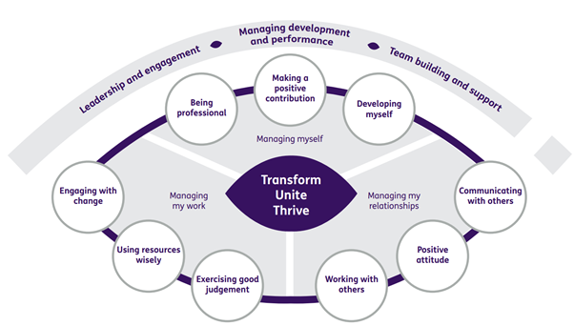

Department structure (this role outlined in red)

