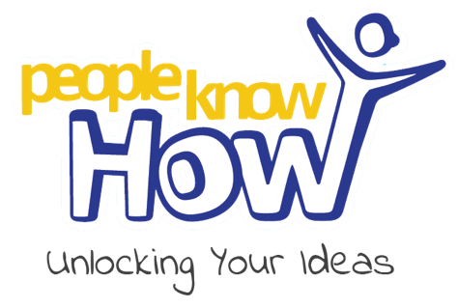 | People Know How  Straits Meadow  61-63 London Road  EH7 6AA  0131 569 0525  contactus@peopleknowhow.org  www.peopleknowhow.org  Registered charity No. SC043871
Applicant information
Please submit this form to us alongside your CV and cover letter. We also encourage you to complete our Equality & Diversity Monitoring Form. If you need this form in a different format, please don't hesitate to email us at recruitment@peopleknowhow.org.
Role applied for

Full name
Known as (if applicable)
Address & postcode
Phone number
Email address
Are you eligible to work in the UK?
Please let us know about any accessibility requirements for interview
Declaration & Data Protection Statement
People Know How will hold your details on file but will not release them to any third party. Some further details may be shared with staff/trustees relevant to your application.

I confirm that, to the best of my knowledge and belief, the information I have given on this form and any additional sheets is correct. I understand that any misleading statement or deliberate omission may result in my dismissal. I hereby consent to the processing of sensitive personal data, as defined in the Data Protection Act 2018, involved in the consideration of this application.
Signature: | Date:

Where did you see this advert?

