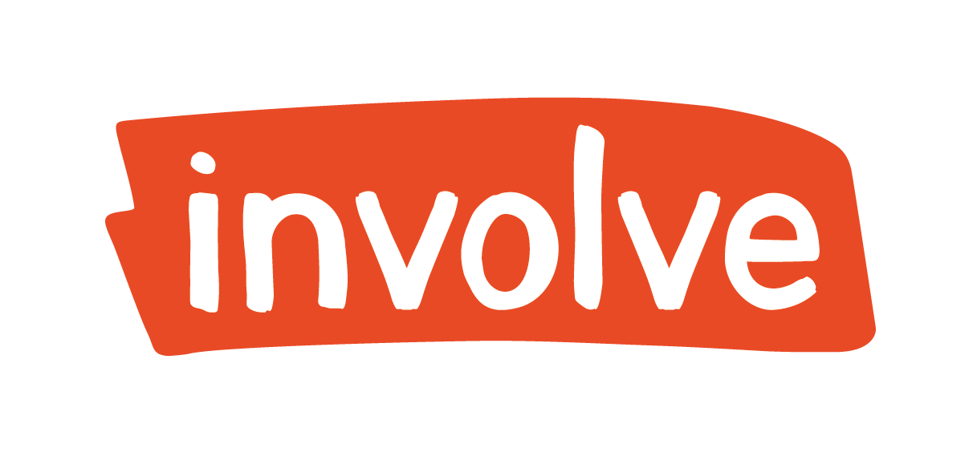

SENIOR PROJECT OFFICER

Job Description

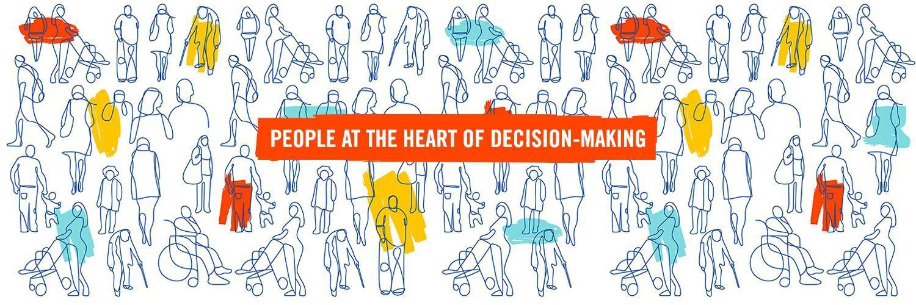

Key information about the role
SALARY BAND: £38,975 - £43,584
LOCATION: Flexible. Must be comfortable with committing to regular travel both for project work and Involve team activities. Must be able to travel across the UK.
HOURS: Full time

01. Who we are
We’re the UK’s leading public participation charity, and we want to build a more vibrant democracy, where everyone can have a say in a society that works for all of us.
Since 2003, we have been working with governments, parliaments, civil society, academics and members of the public to create and deliver new forms of public participation that re-vitalise democracy, improve decision-making, and enable people to shape the decisions that affect their lives.
We are realistic about the challenges faced by democracy, but optimistic about how to overcome them. We are committed to ensuring our democracies are vibrant and fit for the future by putting people at the heart of decision-making.
We work across the UK and internationally, with offices in Belfast and London. Many of our staff work from home across the UK or in a hybrid pattern, rather than being based at one of our offices, though we meet up regularly as a team.

02. What we do
Our mission is to lead the UK in making participation and deliberation an everyday part of democracy, to help meet the challenges of the 21st century.
We need to make important choices as a society, but our democracy isn’t working as it should. Decision-makers are struggling to get things done. The public are frustrated the system isn’t working for them. And everywhere people are feeling divided, distrustful and powerless.
Our work is focused in three areas:
- Making the case – demonstrating why participation and deliberation are essential features for a healthy modern democracy, and ensuring that those in positions of power and influence understand and support their use in addressing some of the UK’s most intractable issues. Check out our latest thinking.
- Embedding change – building the capacity of public servants and practitioners, and developing the body of evidence, principles and standards that support participatory and deliberative practice. Check out our resources.
- Pioneering practice – encouraging widespread uptake of participatory and deliberative processes, and promoting continuous learning and innovation to improve democracy and deliver lasting solutions in key policy areas. Check out our practical projects.
All our work builds towards delivering the following six outcomes for our democracy, which we believe will lead to the vibrant, participatory society we want to see.
- Democratic norms – Participation and deliberation are recognised as essential features for a healthy equitable democracy by the public, society and decision-makers;
- Political support – People in positions of power and influence across society and the political spectrum understand and actively support the use of participatory and deliberative decision-making;
- Frequent use – There is frequent use of participatory and deliberative processes supported by the right resources (people and budgets) both inside and outside of political institutions;
- Evidence and practice – There is an accessible and well-communicated body of evidence and practice that demonstrates the impact of our vision and how to achieve it;
- Clear standards – There are clear principles and standards that support good practice in delivering and embedding participatory and deliberative processes, which are widely understood and followed;
- Democratic innovations – There is continuous learning and innovation to improve democracy and work against entrenched inequalities.
Find out more about our work: www.involve.org.uk/our-work/

Our values
- Collaboration – because change comes when broad coalitions of people work towards a common vision;

- Equity – because everyone in society has an equal right to be listened to and participate in decisions that affect their lives. No one should be held back by societal divisions or prejudice;

- Independence - because we are committed to the integrity and impartiality of participatory and deliberative processes;

- Purpose – because participation must have an impact. We reject tokenistic or ineffectual engagement;
- Quality - because effective participation requires time, attention and commitment.

03. About the role
This role will sit primarily within our Innovation and Practice (I&P) function but will work closely with our Capacity Building and Standards (CB&S) and Advocacy and Communications (A&C) functions and Involve’s overall approach to project management.
The Innovation and Practice function’s daily work includes setting up, managing, designing, delivering and reporting on a wide range of participatory and deliberative processes, ranging from small scale, hyper-local community engagements to large, national, multi-event Citizens’ Assemblies and longer term projects. Our processes can be face to face, hybrid, or online, and often involve bringing together different groups from within the public with interested parties and experts from across government, business, academia and civil society. We are one of the UK’s leaders in high quality participatory approaches and that centres around our practical delivery in this team.
You will be a core member of the team, with a particular focus on project and programme management. This includes:-
- Project management and delivery - core project management and logistics, running onboarding for participants, event management, analysis and reporting and facilitation, as appropriate
- Building our project management approach further - supporting Involve to build our project management capacity and resources that are appropriate for our creative, inclusive processes and culture
- Project design - designing processes which use deliberative, qualitative and participatory methods
- Project impact - recording and monitoring how our projects work, the kinds of impacts they have, and the ways they contribute to Involve’s mission.
- Business development - fundraising for grants and projects, responding to tenders and writing proposals, shaping programmes, building relationships with our funders, collaborators and clients
In addition, you would work closely with our Capacity Building and Standards team to support their work helping others to deliver these approaches and contribute to our communications and advocacy work.
We are committed to offering our team complete support for personal growth at work. This includes in house and external training on all aspects of participation, deliberation, systems thinking around democracy and relevant issues such as how we tackle inequities of power and privilege in society; technical skills development such as design, facilitation and presentation skills; along with relevant professional development such as line management and leadership, communications and public speaking.

04. Key responsibilities

Project managing, designing, and leading on projects from small to large

- Coordinating and delivering small, medium, and large projects (for example, a series of events or workshops with the public and stakeholders); leading on delivery and project management for smaller projects and with support for larger engagements.
- Managing whole programmes of work as the lead contact (for example our Thriving Places programme focusing on net zero visions in local authorities) and proactively holding the overall programme plan
- Liaising and being first point of contact for clients and partners, dealing confidently with senior level clients and liaising with, briefing and supporting our associates and freelancers.
- Liaising with recruitment agencies and with general public participants to “onboard” people into our processes, troubleshooting the things that might make their participation difficult, working effectively with participants on the day, particularly ensuring that individual needs are met.
- Using strong writing, analysis and qualitative research skills to deliver high quality reports for a policy making and practice audience. Drafting different kinds of reports and communications outputs.
- Supporting the design of deliberative processes, facilitation plans, and wider engagement plans, leading on designing sessions within a plan.
- Facilitating confidently and calmly at tables in workshops or in focus group-size events.
- Writing impact reports before and after projects and identifying key learning and best practice; writing externally-facing blogs to communicate our work.

- Leading project management development
- Developing Involves systems and capacity for project management excellence in a way that is adaptive, flexible and fits with the needs of deliberative processes and Involve’s culture
- Supporting and managing project officers, as appropriate

- Project development
- Contributing to proposal writing, both tender responses and grant applications to attract funding, in line with Involve’s vision, mission, and strategy.

- Managing self and others

- Manages simultaneous projects by careful diary and task time management, proactive diary management, and seeking out help and support where needed.
- Developing and reading around areas of personal interest in deliberative democracy and adaptive project delivery to help boost Involve’s thought leadership in a particular sector of interest.
- Where applicable, line manages junior staff, ensuring that all line management admin is completed well and on time, especially appraisals, and that the person managed is supported and developed.

- Contributing to all-team activities

- Contributing to organisational development projects.
- Supporting our communications and advocacy work through effective communications
- Participating in team meetings, strategy and away-days. Complying with core Involve procedures and policies, such as time recording and leave records.
- Other relevant duties may be undertaken as agreed with the line manager.

05. Key competencies
Essential competencies
Applicants must demonstrate the following competencies:

- Excellent project manager, able to manage fairly large projects, with high levels of uncertainty, and task manage others at all levels to ensure smooth delivery. Able to prioritise a diverse workload; be adaptive and agile; deliver key project elements on time, on budget and to a high standard and support others to do so; and manage project finances, budgets, and reporting;
- Open to being flexible, creative and innovative in the way we manage our work - ensuring that our project management approach fits our work and culture
- Great at managing relationships at all levels and working with others to get things done
- Public participation and facilitation skills, or relevant or transferable expertise; able to contribute to discussions advising public servants on designing and delivering effective engagement and deliberation.
- Shrewd communicator, able to make reliable judgements about which messages should have priority, what level of detail is appropriate, and how to adapt communications for specific audiences;
- Committed team player, embodying our values of collaboration, equality, independence, purpose and quality, and passionate about furthering our mission. A commitment to addressing power and privilege in our work..

Desirable competencies
The following competencies are desirable:

- Experience of building project management capacity in a team or organisation, in a way that is flexible, inclusive and deals with uncertainty
- Experience of working with public recruitment processes like sortition and other forms of citizen lottery.
- An understanding of how you ‘onboard’ participants to participate in events and dialogues
- Some understanding of policymaking processes and knowledge of how government and related systems work.
- Experience, and interest in, supporting staff to be their best, coaching and managing junior staff on projects and as a line manager
- Fundraising and proposal writing; ability to communicate the value of public participation, in ways which help secure funding for projects which advance Involve’s vision.
- Systems thinking; ability to look at operational and project work and see how they might be improved to better achieve our mission
- Strong communications skills, a good presenter and/or public speaker and able to communicate key learnings effectively online in blogs and social media.

06. Pay, location and benefits
Job Title: Senior Project Officer
Pay band: £38,975 - £43,584
Hours: Full time preferred (but we will consider part time)
Start date: As soon as possible
Location: Flexible, but within easy reach of either London, Edinburgh or Belfast and able to travel regularly to one of our offices
Reporting to: Engagement Lead within the Innovation and Practice Function.
We’re actively building a diverse team and welcome applications from everyone. But simply having a diverse workforce is not enough. We aim to build an inclusive environment, where everyone can contribute their best work and develop to their full potential. We celebrate our differences, and recognise the importance of teams reflecting the communities they work with.
We can make reasonable adjustments to our interview process, and to working arrangements, according to your needs. And we offer flexible working arrangements.
The following benefits are available to all staff:
- 25 days annual leave + bank holidays + the period between Christmas Day and New Year’s Day
- Workplace pension with employer contribution of 5%
- Childcare vouchers
- Phone/data allowance of £13.50 per month
- Enhanced maternity and paternity leave packages for qualifying employees.

