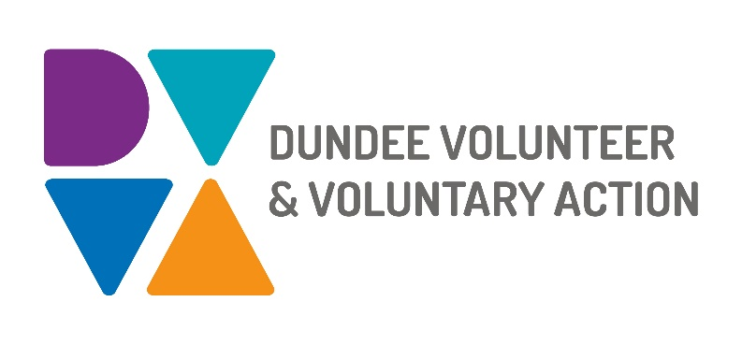
Job Description and
Person Specification

POST TITLE: Volunteer Manager

DURATION: Fixed Term to 31st March 2026 in first instance

HOURS OF WORK: 35 hours per week, to be worked in accordance with DVVA Conditions of Service. Occasional evening and weekend work will be required.

SALARY: Grade 5 (£30,363 - £33,737)

CONTEXT OF POST: The post holder will be employed by DVVA and work on behalf of the Dundee Alliance. The Dundee Alliance is a collaborative, cross-sector partnership deeply committed to fostering creativity, innovation and collaborative practices while actively pursuing the realisation of The Promise and Whole Family Support Principles. The Alliance operates under the guidance and accountability of the Children’s Services Planning Partnership (Dundee Children and Families Executive Board) and the City Plan. Together these entities are dedicated to enhancing the wellbeing of children and families in Dundee within their local communities whenever possible.

PURPOSE OF POST: To lead on the delivery of the Dundee Alliance Volunteer Strategy, collaborating closely with a wide array of partners and stakeholders to evaluate, refine and enact the Strategy.

MAIN DUTIES:

To lead on collaborative efforts across the statutory, voluntary and private sectors in Dundee to develop a sustainable model of volunteering.

To develop an integrated volunteering strategy that delivers high quality volunteer support to children, young people and families based on identified needs.

To foster strong and enduring relationships between professionals and families, enabling them to navigate and access services while tapping into the existing strengths within the family to improve outcomes.

To adopt a holistic whole family support model, which engages with families facing complex needs and deeply entrenched social issues.

To ensure that work is undertaken from an asset-based, co-production perspective

To support organisations with training and guidance to ensure the effective implementation of organisational policies and best practice in relation to volunteering

To engage with organisations interested in corporate volunteering and support them to develop sustainable models which meet the needs of third sector organisations

To monitor and evaluate the services provided to organisations

To line manage the Volunteer Engagement Worker, providing support and supervision regularly.

To manage volunteers, providing support and supervision regularly

Exploring strategic partnerships and develop links with services to meet the needs of communities.

Drawing the Senior Management Team’s attention to any matters that require their input.

Producing reports, research and strategies to inform Senior Management, the Board, funders and external stakeholders as requested.

OTHER DUTIES
The job description is a broad picture of the post at the date of preparation. It is not an exhaustive list of all possible duties as it is recognised that jobs change over time. Should the duties change radically then the post and grading will be reviewed.

CONDITIONS OF SERVICE
- These are set out in the organisation’s staff handbook.
- All staff meeting the qualifying criteria may join a defined contribution pension scheme provided by TPT Retirement Solutions.
- The organisation has an equal opportunities policy and seeks to be an equal opportunities employer.

ANNUAL LEAVE: 21 days per annum on appointment increasing each year by 1 day to a maximum of 25 days, plus 6 public holidays, plus 5 days Christmas closedown. Pro-rata for part-time staff.

LOCATION: Our main office is based in Dundee city centre and we also have community hubs in Lochee and Whitfield. There may be the opportunity for hybrid working depending on role and duties.

TRAINING: Staff may make application to pursue appropriate training.

Person Specification

Volunteer Manager

 | Essential | Desirable

Professional/Educational Qualifications
Relevant professional qualification and/or relevant experience | Yes
Leadership/management qualification |  | Yes
Knowledge and Experience
Experience of managing staff and volunteers | Yes
Experience of work within the Voluntary Sector | Yes
Establishing and maintaining effective working relationships. | Yes
Successful track record in community development | Yes
Understanding of workforce development | Yes
Knowledge of health and social care related legislation and policy at national, regional and local level | Yes
A sound knowledge of how the voluntary, statutory and community sectors work and a proven ability to build productive networks | Yes
Proven experience of managing staff to deliver objectives | Yes
A good understanding of how to work in an outcomes focused way | Yes
A good understanding of equality and diversity issues and a commitment to supporting people from marginalised groups | Yes
Experience of managing and co-ordinating volunteers | Yes

Skills and abilities
Excellent communication skills, both oral and written | Yes
Demonstrable strong time management skills and ability to effectively manage workload, including that of others | Yes
Excellent organisational skills with the ability to handle multiple tasks simultaneously | Yes
Collaborative leadership | Yes
Strong interpersonal skills, with the ability to manage internal and external relationships effectively | Yes
Imaginative and creative approach to problem solving | Yes
Advanced IT skills, including in the use of Microsoft Office | Yes
Project management skills including planning, delivery, monitoring and evaluation | Yes
Ability to manage budgets | Yes
Ability to write high quality reports for funders and stakeholders | Yes
Ability to maintain an objective and professional perspective at all times | Yes
Ability to motivate and develop others and manage quality and performance | Yes

Personal Qualities
Self-motivated, enthusiastic and committed | Yes
Good decision maker | Yes
Resilient, resourceful and flexible | Yes
Flexible approach with an ability to meet deadlines | Yes

Additional Job-Related requirements
Satisfactory PVG check | Yes
Flexible working which may include evening and occasional weekend work | Yes
Driving license |  | Yes

EMPLOYEE BENEFITS AT DVVA

Work/Life Balance

Generous annual leave and public holidays, including 2 week shutdown over Christmas/New Year

Increased annual leave entitlement based on length of employment

Most roles are eligible to work flexibly, including hybrid options

Right to request flexible working from day 1

You/Your Family

Enhanced sick pay entitlement

Increased sick pay entitlement based on length of employment

Free access to a confidential 24 hours a day/7 days a week helpline service for you and your family with a specialist range of support and information, including access to coaching and counselling

Discounted membership fees with Leisure and Culture Dundee for you and your family

Finances

Generous pension contributions

Access to voucher and discount schemes via Perks at Work

Opportunity to join Discovery Credit Union and benefit from loans and savings at fair rates

Opportunities at Work

Opportunities to undertake training relevant to your role and professional/personal development

A lively and active Staff Consultation Group providing opportunities to influence how we work

Recognition agreement with UNITE giving you legal support and much more

Support for Wellbeing, including access to Wellbeing Champions

