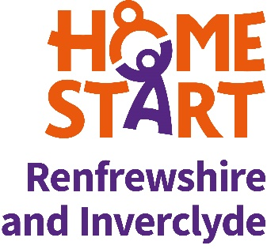
Diversity monitoring form

Please complete and return this form together with your application. Home-Start Renfrewshire and Inverclyde is committed to promoting inclusion. The information on this form is strictly confidential and will be used for monitoring purposes and so that we can work to create a team who represent the diverse communities across Renfrewshire and Inverclyde.

Ethnicity

White
- English / Welsh / Scottish / Northern Irish / British
- Irish
- Gypsy or Irish Traveller
- Any other White background, please describe
Mixed / Multiple ethnic groups
- White and Black Caribbean
- White and Black African
- White and Asian
- Any other Mixed/Multiple ethnic background, please describe
Asian / Asian British
- Indian
- Pakistani
- Bangladeshi
- Chinese
- Any other Asian background, please describe
Black/African/Caribbean/Black British
- African
- Caribbean
- Any other Black/African/Caribbean background, please describe
Other ethnic group
- Arab
- Any other ethnic group, please describe

Gender

Woman |  | Man |  | Non-binary |  | Prefer not to describe |  | Prefer not to say

Disability

Do you consider yourself to have a disability? | Yes |  | No

Sexual orientation

Straight |  | Gay Man |  | Gay Woman / Lesbian |  | Bisexual |  | Pansexual
I prefer to use another term

Age

Up to 16 |  | 17-25 |  | 26-39 |  | 40-64 |  | 65+

Thank you for completing this form.

