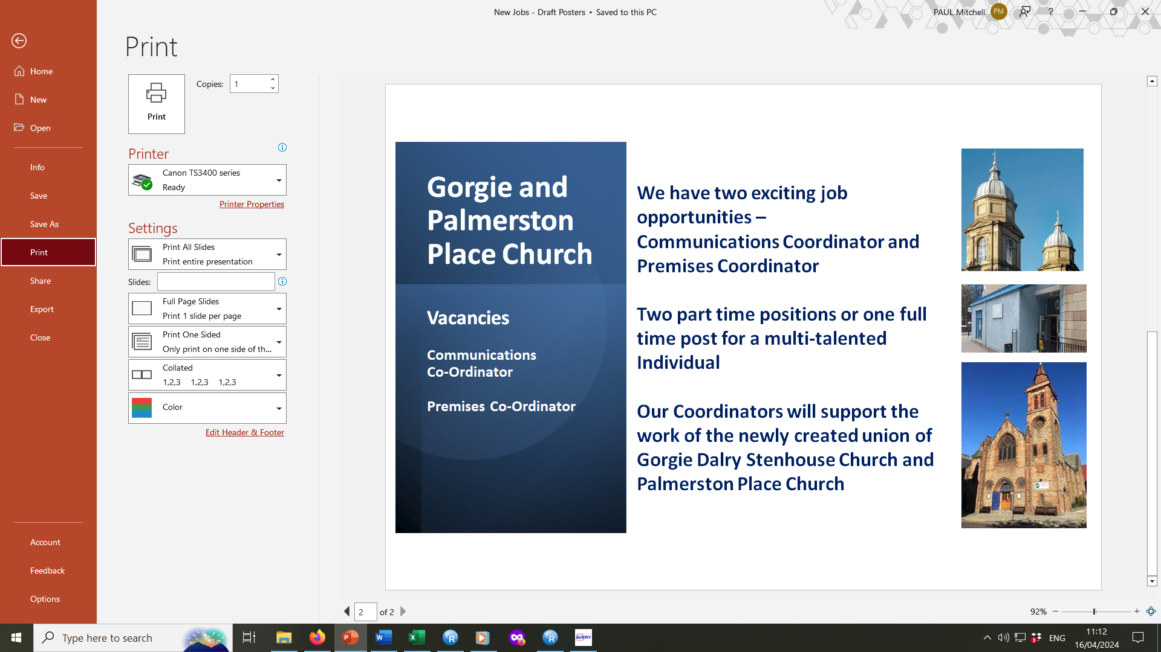

Communications Coordinator and Premises Coordinator
at
Gorgie and Palmerston Place Church
(GaPPC)

Thank you for your interest in these positions which come about following the union of our two churches and the vacancies created following our Administrator and Church Facilitator moving on to pastures new.
About Us
GaPPC is a new charge formed by the union of two thriving congregations in the west of Edinburgh. The united parish is one of the largest in the city, in terms of both geographical extent and population. Both existing church buildings, on Gorgie Road and on Palmerston Place, have been retained as active worship centres for the new parish. We also have a community café and outreach centre at Saltyard on Dalry Road.
The united parish extends from Queensferry Road in the north as far as Stenhouse in the south and west, embracing the bustling transport hub of Haymarket and the full length of Dalry Road and Gorgie Road, a distance of some 4 miles.
Apart from Haymarket Station, it encompasses a number of notable public buildings, including Tynecastle Stadium, the home of Heart of Midlothian FC, HM Prison Edinburgh, and several primary and secondary schools. Around 24,000 people live in the parish, which represents nearly 5% of the city’s population. There is a considerable student population, with a number of dedicated halls of residence and more under construction.
Our two church buildings, on Palmerston Place and Gorgie Road, are approximately one mile apart, and conveniently linked by several bus routes. Half-way between them on Dalry Road the Church runs Saltyard, a community café and hub, which is invaluable as a mission and outreach base, and is also used for various less formal worship services.
We are in a Parish Grouping with two neighbouring congregations, Murrayfield and St Stephen’s Comely Bank, with whom we co-operate closely and run various joint activities. We have a close relationship with St Mary’s Episcopal Cathedral and again run several joint activities with them.

We have just begun the process of appointing a new minister willing to accept the challenge of leading us at this exciting and testing time in our history and hope to have someone in place before the end of the year. The minister will be working as part of our recently constituted Ministry Team: Reuben, our Ordained Local Minister (OLM); Lisa and Jessica, our Ministerial Assistants responsible for Pastoral and Outreach and Children and Families work; Simon, our Organist. We also benefit from the input of our three evening and weekend Caretakers, Piotr, Lauren and Rory and our three Catering staff at Saltyard, Norda, Alex and Ruaraidh as well as numerous willing volunteers. We look forward to our Coordinators joining this growing staff team.
About the vacancies
Ideally, we are looking to appoint two part time coordinators, each working for five half days each week so that we have someone in our offices throughout the working week. We would expect both Coordinators to spend time in the offices at Gorgie Church and Palmerston Place Church each week and sometimes in the office at Saltyard Café too.
Our Coordinators will often be the first point of contact with our church and must therefore be fully aligned to our Christian ethos and values so we are looking for special people with a strong and lively Christian faith. [This is a Genuine Occupational Requirement in terms of the Equality Act 2010]
Since our Union, we have been working to develop our vision for the future of the Parish. To this end, we have held two “Vision 2030” days at which the whole congregation has been invited to think prayerfully about our priorities for the years ahead and we have identified and agreed on:
· Mission through service
· Young people and families
· Discipleship and equipping
· Caring and nurturing
In all these areas we will work with other churches and organisations in our parish and in the wider church.

Role descriptions
Title of the Post:
Communications Coordinator
Responsible to:
Parish Minister once appointed, interim line manager as appointed by the HR Team
Purpose of the post:
Along with the Premises Coordinator to be part of our Staff Team, providing administrative support to the Minister and Ministry Team, Session Clerks and volunteers involved in our Mission so that we can fulfil our Vision priorities. To provide a creative input to our publications and social media communications. Both Coordinators will share responsibility for dealing with callers at the door and handling incoming post, email and phone calls.
Main Duties:
- To prepare, publish and distribute our weekly news bulletins, (bi)monthly magazine and regular social media posts
- To prepare materials for Sunday Worship services – printed Order of Service sheets, slides for the overhead screens using Easyworship and Powerpoint and other visual aids as required
- To ensure that our websites are kept up to date on a weekly basis
- To create and distribute publicity materials, greetings cards, tickets, posters for events and rota sheets as requested
- To keep ALL Church noticeboards lively and up to date
- To ensure that the Church Roll, Baptismal Register and other membership lists are accurate and up to date and to prepare the annual statistics as required
- To ensure efficient use of our digital subscriptions and take responsibility for back ups and archiving of documents and records alongside annual returns to the Copyright Agency
Additional duties:
- To ensure compliance with Church of Scotland GDPR policies and procedures
- To ensure OSCR requirements are met
- To keep up to date with the Church of Scotland Safeguarding Policy and support the Church Safeguarding Officer.
- To participate in the annual appraisal process.

Person specification:
We are looking for someone with excellent inter-personal and communication skills which align with our Christian ethos along with the ability to maintain confidentiality
We need someone able to work on their own initiative and also to work in a team.
We would like someone with creative flair and an eye for detail
Proficiency in the use of Microsoft Office is essential
Expertise in the use social media is expected
Having experience of working in a church environment and/or with volunteers would be an advantage

Title of the Post:
Premises Coordinator
Responsible to:
Parish Minister once appointed, interim line manager as appointed by the HR Team
Purpose of the post:
Along with our Communications Coordinator to be part of our Staff Team, providing administrative support to the Minister, Property Conveners, Treasurers, Session Clerks and volunteers involved in our Mission so that we can fulfil our Vision priorities. To oversee the use of all of our buildings and assist in the maintenance and upkeep. Both Coordinators will share responsibility for dealing with callers at the door and handling incoming post, email and phone calls.
Main Duties:
- To ensure rooms are set up and cleared up for internal and external adhoc lets and to be first point of contact for our tenants
- To be responsible for Catering and Caretaking staff and liaise with contract cleaners
- To draw up daily and weekly cleaning schedules and for ensuring an adequate supply of cleaning materials and stationery stock
- To administer the marketing, rental agreements, letting hire contracts for short and long term use of our premises by outside agencies
- To oversee the master church diary, including use of Saltyard
- To act as Health and Safety and Fire Officer, maintaining the Premises Log Books, Fire Risk assessments and annual maintenance spreadsheets, scheduling inspections as required
- To maintain the keyholders registers and ensure the security of our buildings
Additional duties:
- To ensure compliance with Church of Scotland Health and Safety guidance
- To update the Inventories and prepare for the Presbytery annual inspection of records
- To provide regular reports to the Property and Finance Team
- To participate in the annual appraisal process.

Person specification:
We are looking for someone with excellent inter-personal and communication skills which align with our Christian ethos along with the ability to maintain confidentiality
We need someone able to work on their own initiative and also to work as part of a team
Proven leadership of staff and volunteers would be welcomed
We would like someone with creative flair and an eye for detail
Proficiency in the use of Microsoft Office is essential
Having experience of working in a church environment and/or in facilities management would be an advantage

Terms and Conditions:

The working hours are 37.5 per week for a full-time position.
Start date – June 2024 or as soon as possible thereafter
Salary from £27.5k per annum (pro rata). The posts are permanent but probationary and mutually reviewable for a period of six months.
There is provision for five weeks holiday plus nine statutory days each year, with the holiday year running from 1st January to 31st December.
A pension scheme is in place.

How to apply:

Interested candidates should submit a CV including the names and contact details of two referees (only to be contacted if the job is offered and accepted) and a letter of application explaining their interest in and suitability for the position. Interviews for short listed applicants are planned for w/c 13th May. Applications should be emailed to Norma Rolls our HR Team Leader at
norma@palmerstonplacechurch.com
by the closing date: 12 noon on Monday 6th May 2024

