Deputy Cinema Manager, Glasgow
Band 2

Reports to: Glasgow Cinema Manager
Location: Royal Hospital for Children, Glasgow G51
Terms: Part-time – 2-3 days per week, plus holiday and emergency cover
Salary: £30,115 annual – actual salary pro-rated to reflect working hours
Benefits: 27 days annual leave pro-rata to reflect working hours + 5% employer pension contribution

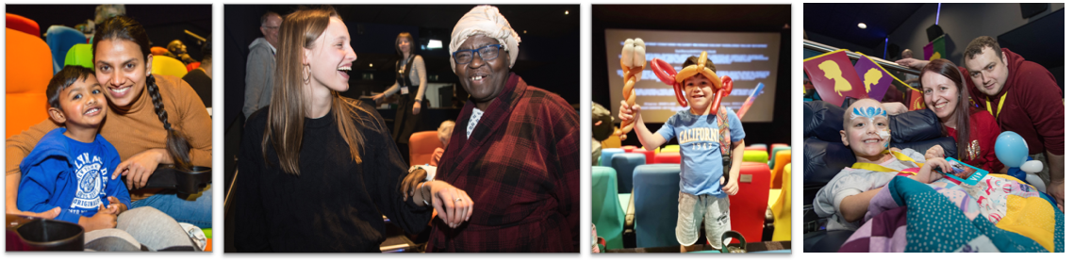

About MediCinema
MediCinema is a unique national, UK registered charity that improves the wellbeing and enriches the quality of life of NHS patients, their families and carers through the power of the shared cinema experience and the magic of film. We achieve this by building and running cinemas in hospitals and places of care equipped with space for beds, wheelchairs and medical equipment, and providing free films and activities at bedsides for patients of all ages. Our services help to improve emotional, mental and physical health, reducing isolation, anxiety and stress, and increasing patient resilience to help them cope with what they’re going through.

Our purpose-built in-hospital cinemas are designed to accommodate patients in hospital beds and wheelchairs, on drips or with monitors. Patients are looked after by trained volunteers who accompany them to and from the cinemas, and by two nurses who are present at each inpatient screening. In addition to our regular inpatient screenings, in 2023 we introduced new Tailored Screenings for specific patient communities, working closely with the patients and clinical teams to co-design experiences that meet the specific needs of each group. We also routinely hold personal screenings for patients who are unable to mix with other patients, are receiving palliative care or are in other sensitive situations. Through our long-standing strategic partnership with Disney, we also design and provide activities on wards and in the MediCinemas as part of our ‘Moments that Matter’ (MTM) programme.
Our cinema-based health programmes make a real impact during challenging times, shown by our regular feedback surveys from attendees.
- 99% agree MediCinema makes a positive difference to their hospital experience
- 93% agree MediCinema reduces stress and anxiety
- 90% agree MediCinema supports mental health and helps people cope
- 88% agree MediCinema helps support recovery
- 55% agree MediCinema helps to reduce pain

Our MediCinema in the Royal Hospital for Children in Glasgow has been supporting patients and their loved ones since the hospital opened in 2015, building on our previous 8 years at Yorkhill Children’s Hospital. We offer free, fully-accessible film screenings of the latest film releases in our bespoke cinema auditorium for both adult and paediatric patients, with our paediatric screenings being run in partnership with Glasgow Children’s Hospital Charity.

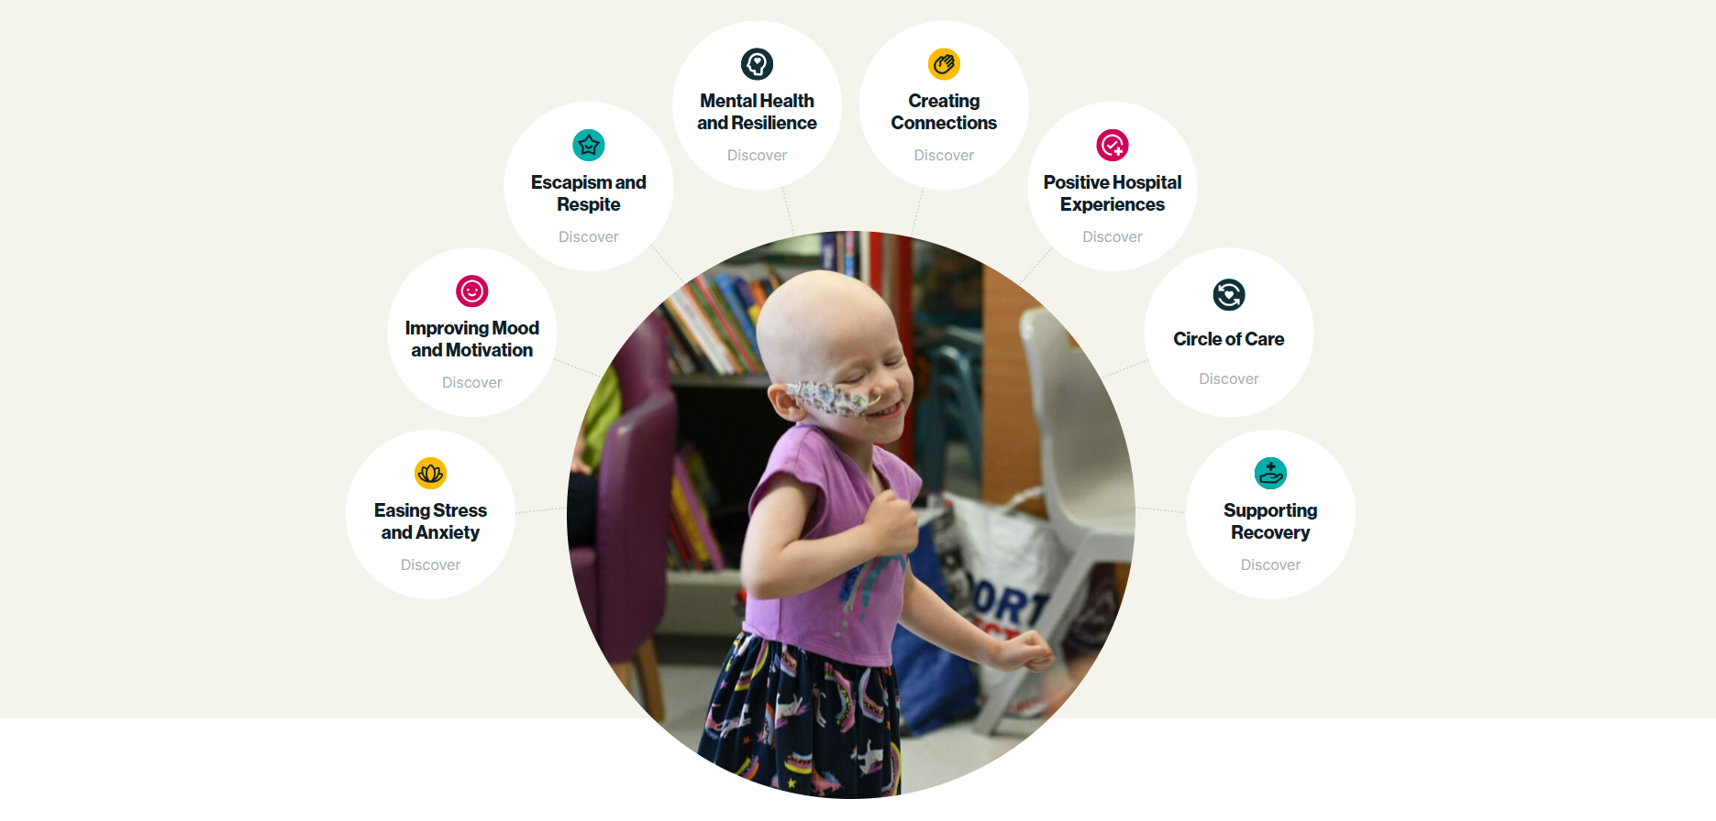
MediCinema provides a warm, welcoming and safe place that enables patients to escape the ward and have much needed breathing space - to have quality time together with loved ones, connect with the wider world, and forget their pain. From all our impact evaluation and with over 24 years’ experience, we know this equips people with the tools to navigate the stress and difficulties that come with illness, to create positive memories, positive healthcare experiences, and to help build resilience.
The Role
The post-holder will work closely with the Glasgow MediCinema Manager, nurses, volunteers and central office operations team to prepare for and run successful film screenings each week.

We currently run four regular screenings each week - every Monday & Wednesday for the children’s hospital and Tuesday & Thursday for the adult hospital. Each shift is 8 hours, and the days will be worked flexibly and be agreed on a rota-basis with the Cinema Manager. There will also be additional Applied and Personal screenings on top of these 4 regular screenings.

The role offers a unique, exciting and extremely rewarding opportunity for someone interested in a service delivery role at the heart of our charity, involving direct contact with the patients and families we support.

Main Tasks and Responsibilities

Service Delivery
- Support the Cinema Manager in delivering a programme of screenings each week as agreed according to MediCinema’s Operating Procedures, including running and managing screenings on your own. Most screenings are held in the evenings, so the role requires regular evening working.
- On screening days be responsible for:
  - Marketing the service through the hospital’s wards, organising the safe collection and the return of patients, and for safety and care in the cinema itself.
  - Taking responsibility for the health and safety of patients coming to the cinema, and the safety and appearance of the cinema space.
  - Preparing and operating the digital projection equipment for the screening, ensuring that films are rehearsed in advance and screened to the highest technical standards. Training and ongoing technical support will be provided for this.
  - Ensuring that all operational, welfare and safeguarding policies set out by MediCinema are followed accordingly and that, where appropriate, consent forms are obtained for photographic or filmed records.
  - Ensuring that all aspects of the service comply with relevant health and safety legislation, and that areas where MediCinema might be in breach of such are dealt with immediately or brought to the attention of the appropriate authorities for rectification.
  - Keeping accurate monitoring and operational records, including contacts and database updating as required.
  - Logging and reporting any incidents immediately to the National Cinema Manager as per our Incident Reporting Procedure.
- Help the Cinema Manager collate, analyse and report back on agreed metrics and KPI’s.
- Assist with arranging and running any special events and special screenings.
- When required, arrange and run additional personal screenings for patients unable to attend regular screenings, plus special tailored screenings in partnership with particular hospital departments and patient groups.
- Support the development and roll out of any new type of screenings we embark on, such as our Tailored Screening initiative for 2024.
- Support the delivery of our complementary bedside services, such as our Disney ‘Moments that Matter’ work.

Nurse & Volunteer Management
- Help the Cinema Manager build, manage and support the team of nurses and volunteers to assist in the duties outlined above and to ensure that screenings run safely and smoothly – this will include assisting with recruitment and creating monthly rotas.

Marketing and Relationship Management
- Be proactive in marketing the service within the hospital, building key relationships with hospital staff and members of Glasgow Children’s Hospital Charity.
- Help develop and manage effective partnerships throughout the hospital and community.
- Representing the organisation effectively and compellingly at all times.
- Support the programming and development of the MediCinema as a centre for entertainment, being pro-active in developing a creative programme of sustainable events at each site. This could include fundraising events, live performance and other relevant activities.
- Work with the MediCinema Comms team on local publicity initiatives, sometimes alongside GCHC and the hospital.

Administration and other duties
- Deputise for the Glasgow Cinema Manager as and when required.
- Provide holiday or emergency screening cover when required.
- Help manage the collection, loading and returning of films.
- Champion the work of MediCinema within the hospital and cinema environment, as well as confidently and positively representing MediCinema in all interactions and at any meetings and events.
- Contribute to the strategic development of the Glasgow MediCinema, operations and MediCinema as a wider organisation.
- Communicate effectively with all team members, ensuring an inclusive and whole organisation approach.
- Undertake other tasks, projects and duties as reasonably required.

MediCinema is a small team and staff members are expected to support each other and share cross-organisational work in addition to fulfilling individual responsibilities.

The Person

We are looking for a high energy, enthusiastic, self-motivated individual who is passionate about helping people and delivering impactful and effective services. They should be a warm, welcoming and positive person who can demonstrate the following skills and qualities:

- Strong organisational skills with a good attention to detail.
- A proactive, resourceful, problem-solving approach.
- An ability to work both on their own and as part of a team.
- Experience in using IT and an ability to quickly learn and understand new systems and technology. Please note full training on ingesting films and running the projection equipment will be provided so direct projection experience, while beneficial, is not required.
- Excellent communication skills and an ability to caringly and openly relate to and build relationships with a wide variety of people, from children, family members, volunteers and hospital staff.
- Flexibility and adaptability, and enjoyment of a working environment where no two days are the same.
- Demonstrate tact and sensitivity when dealing with people with a variety of needs and be aware of issues relating to confidentiality and safeguarding.
- Interest in healthcare, wellbeing and/or film & cinema.
- A sense of humour and congenial demeanour to help patients and families feel at ease and enjoy their MediCinema experience.

Please note the role will require an Enhanced Disclosure Scotland check, which we will arrange.

How to Apply

If you have a passion for health, wellbeing, film and the arts, and are a driven, highly-organised, compassionate and enthusiastic individual, we would love to hear from you.

Please send your CV and a supporting statement telling us what appeals to you about this role and what makes you a strong candidate (no longer than one side of A4) to jennyageorge32@gmail.com

Please note applications will be anonymised as part of the selection process.

Closing date for applications: Noon on 15th May 2024
We are looking to hold interviews on 22nd and 23rd May 2024.

MediCinema are an equal opportunities employer and an accredited Living Wage Foundation employer.

