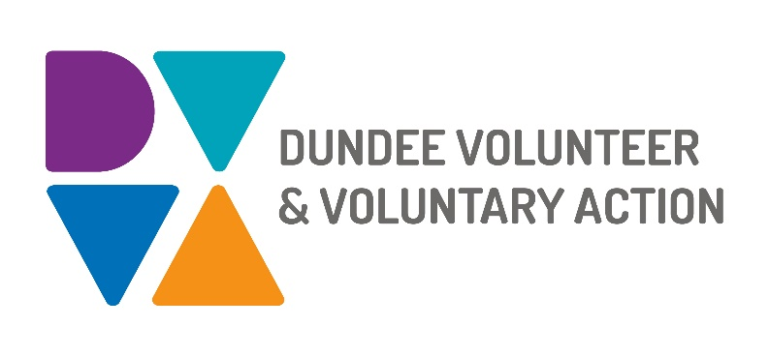

Job Description and
Person Specification

POST TITLE: Mental Health Engagement Worker

DURATION: Permanent

HOURS OF WORK: 30 hours per week, to be worked in accordance with DVVA Conditions of Service. Occasional evening and weekend work will be required.

SALARY: Grade 3 (£22,844 - £25,383 pro rata)

PURPOSE OF POST:

You will be highly motivated with a passion for involving people in shaping issues that affect their lives. You will promote the active involvement of people who have lived experience of mental health challenges in the planning, development and evaluation of services that are important to them.

MAIN DUTIES:

Engagement Delivery

- Use a strength-based approach which values people and the assets of lived experience.

- Encourage and support individuals and volunteer involvement in the design and delivery of mental health services using co-production approaches and techniques.

- Negotiate, prepare, and deliver your own work plan to achieve agreed outcomes.

- Establish and sustain relationships with people with lived experience of mental health challenges.

- Develop and use accessible means of communication to engage target groups.

- Attract new people with lived experience, particularly targeting underrepresented groups.

Supporting Lived Experience Involvement in Decision-Making

- Support people to bring their lived experiences to decision-making within local and regional mental health plans and service delivery.

- Assist the Coordinator to promote, advocate for, and facilitate involvement of people with lived experience of mental health challenges in relevant decision-making arenas.

- Promote opportunities for people with lived experience to respond to emerging local issues and to influence matters important to them.

- Work effectively with key organisations and partnerships at a local level to promote involvement.

- Attend partnership groups as required by line manager.

- Keep up to date with legislation, policy changes and local publications that affect people.

- Actively pursue engagement and involvement by linking people with opportunities.

Programme/ Events

- Support the running and development of sessions/events following all start up and closing protocols.

- Be responsible for the procurement and maintenance of required resources for the running of sessions/ events.

- Be responsible for health and safety, risk assessment and vulnerable adult safeguarding procedures, reporting any concerns or incidents.

- Advertise and promote programmes, events and involvement opportunities through regular updates and newsletters.

Contributing to the development and delivery of DVVA’s Mental Health and Substance Use Engagement and Involvement Plan

- Use IT systems provided for recording, monitoring, and communication purposes.

- Maintain accurate records of attendances, outputs and outcomes to evidence work undertaken and its impacts.

- Actively and constructively participate in team meetings and activities.

- Contribute to shared team projects and developments.

- Work with others to ensure our plan and its delivery reflects the needs of individuals, organisations, and communities.

- Strive to maintain good practice in co-production.

Contributing to the development and delivery of DVVA’s Mental Health and Substance Use Engagement and Involvement Plan

- Use IT systems provided for recording, monitoring, and communication purposes.

- Maintain accurate records of attendances, outputs and outcomes to evidence work undertaken and its impacts.

- Actively and constructively participate in team meetings and activities.

- Contribute to shared team projects and developments.

- Work with others to ensure our plan and its delivery reflects the needs of individuals, organisations, and communities.

- Strive to maintain good practice in co-production.

OTHER DUTIES
The job description is a broad picture of the post at the date of preparation. It is not an exhaustive list of all possible duties as it is recognised that jobs change over time. Should the duties change radically then the post and grading will be reviewed.

CONDITIONS OF SERVICE
- These are set out in the organisation’s staff handbook.
- All staff meeting the qualifying criteria may join a defined contribution pension scheme provided by TPT Retirement Solutions.
- The organisation has an equal opportunities policy and seeks to be an equal opportunities employer.

ANNUAL LEAVE: 21 days per annum on appointment increasing each year by 1 day to a maximum of 25 days, plus 6 public holidays, plus 5 days Christmas closedown. Pro-rata for part-time staff.

LOCATION: Our main office is based in Dundee city centre and we also have a community hub in Lochee. There may be the opportunity for hybrid working depending on role and duties.

TRAINING: Staff may make application to pursue appropriate training.

Person Specification

Mental Health Engagement Worker

 | Essential | Desirable

Professional/Educational Qualifications
Relevant qualification such as Social Services, CLD or equivalent professional or volunteer experience and/or 2 years relevant experience. | Yes
Knowledge and Experience
Experience working with groups. | Yes
A good understanding of methods of engagement. | Yes
Experience in supporting individuals with lived experience. |  | Yes
A good understanding of how to work in an outcomes focused way. | Yes
Design, delivery and evaluation of information, training sessions/ workshops. | Yes
A good understanding of equality and diversity issues and a commitment to supporting people from marginalised groups. | Yes

Skills and abilities
Excellent organisational skills with the ability to handle multiple tasks simultaneously. | Yes
Ability to confidently build and maintain relationships with a diverse range of individuals and partner agencies. | Yes
Strong interpersonal skills, with the ability to manage internal and external relationships effectively. | Yes
Project management skills including planning, delivery, monitoring and evaluation. | Yes
Ability to identify individual and group needs. | Yes
Ability to maintain an objective and professional perspective at all times. | Yes
Ability to use Microsoft Office, E-mail, Teams and recording systems for monitoring and evaluating work. | Yes

Personal Qualities
Self-motivated, enthusiastic and committed. | Yes
Resilient, resourceful and flexible. | Yes
Flexible approach with an ability to meet deadlines. | Yes

Additional Job-Related requirements
Satisfactory PVG check. | Yes
Flexible working which may include evening and occasional weekend work. | Yes
Driving license. |  | Yes

EMPLOYEE BENEFITS AT DVVA

Work/Life Balance

Generous annual leave and public holidays, including 2 week shutdown over Christmas/New Year

Increased annual leave entitlement based on length of employment

Most roles are eligible to work flexibly, including hybrid options

Right to request flexible working from day 1

You/Your Family

Enhanced sick pay entitlement

Increased sick pay entitlement based on length of employment

Free access to a confidential 24 hours a day/7 days a week helpline service for you and your family with a specialist range of support and information, including access to coaching and counselling

Discounted membership fees with Leisure and Culture Dundee for you and your family

Finances

Generous pension contributions

Access to voucher and discount schemes via Perks at Work

Opportunity to join Discovery Credit Union and benefit from loans and savings at fair rates

Opportunities at Work

Opportunities to undertake training relevant to your role and professional/personal development

A lively and active Staff Consultation Group providing opportunities to influence how we work

Recognition agreement with UNITE giving you legal support and much more

Support for Wellbeing, including access to Wellbeing Champions

