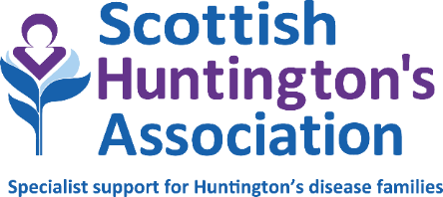

ADMINISTRATION / RESOURCE WORKER – LANARKSHIRE (PART TIME)

Job title: Administration / Resource Worker

Hours: 24 (Days and hours of working to be negotiated with successful applicant)
Base: Hybrid working model (weekly hours are split between East Kilbride office and home)

Salary: £18,938 to £20,259 pro rata

Reporting to: Senior Huntington’s Disease Specialist

Qualifications/skills: Experienced individual with excellent communication skills. Essential experience in Windows-based computer systems, including database and spreadsheets. Audio typing. NHS systems preferable.

ROLE SUMMARY

To provide administrative assistance to the Senior Huntington’s Disease Specialist (SHDS) including the production of reports and collation of information and resources as required by the service.

MAIN DUTIES AND RESPONSIBILITIES

To develop and maintain efficient administrative systems in support of the Lanarkshire service.

To assist Scottish Huntington’s Association to promote awareness of the needs and challenges faced by Huntington’s families through the provision of information as guided by the Senior Huntington’s Disease Specialist.

To assist the Senior Huntington’s Disease Specialist to maintain accurate records and statistical data as required by the service, using Windows-based computer systems including databases and spreadsheets.

To assist the Senior Huntington’s Disease Specialist to maintain accurate financial records as required by Scottish Huntington’s Association.

To assist with the update of clinical activity and the input of clinical information to the Scottish Huntington’s Association database as specified by the Senior Huntington’s Disease Specialist.

To assist in organisation of local and national study days and training sessions.

To assist with mailshots, audit and service satisfaction surveys.

In conjunction with the Senior Huntington’s Disease Specialist, to develop a resource library of relevant, updated material relating to the client group.

To communicate appropriately with clients, professional staff and other relevant agencies.

This job description may be subject to review following discussion with the post holder and management of Scottish Huntington’s Association.

Notes:

This job outline reflects the main tasks and responsibilities discharged by the post holder at the present time, however Scottish Huntington’s Association reserves the right to alter or amend the content of this job outline to reflect changes to the job or services provided, while maintaining the overall character and level of responsibility for the post.

Notwithstanding any information or statement described within this job outline, all duties must be carried out in a way that promotes equality of opportunity, dignity and respect for all individuals and which is consistent with Scottish Huntington’s Association’s stated policy on equal opportunities.

The successful candidate will be subject to an Enhanced Disclosure for Protecting Vulnerable Groups. Having previous convictions will not automatically disbar you from working at Scottish Huntington’s Association (with the exception of offences against children or other vulnerable groups) and every case is taken on an individual basis.

The duties and responsibilities of this post will be undertaken in accordance with the policies of Scottish Huntington’s Association.

June 2024

