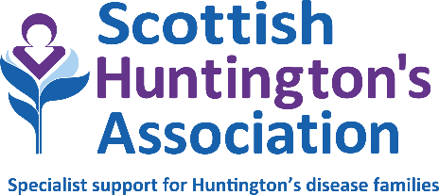

ADMIN/RESOURCE WORKER
PERSON SPECIFICATION

Job title: Admin/Resource Worker
Division: HD Specialist Service (Lanarkshire)
Based: Hybrid working model (office/home based). The successful applicant must be able to
travel to Hunter Health Centre, East Kilbride.
Reporting to: Senior HD Specialist
Hours: 24 hours per week (part-time). Days/times to be negotiated.
Duration: Permanent
Salary: £22,618 (pro rata)

EXPERIENCE AND KNOWLEDGE | ESSENTIAL | DESIRABLE
Experience of working in a busy office environment, fulfilling a range of admin duties | x
PC keyboard skills, including database and spreadsheet applications | x
Notetaking | x
Audio typing | x
Customer/client service experience |  | x
Experience of working with NHS IT systems |  | x
SKILLS | ESSENTIAL | DESIRABLE
Interpersonal:  Excellent verbal, telephone and written communication skills  Experience of working as part of a team | x  x
Planning and organising:  Ability to manage own time effectively and prioritise workloads  Ability to work on own initiative and as part of a team  Ability to work under pressure and to meet deadlines  Record and document management, diary management, meetings and appointments | x  x  x  x
Products:  Knowledge of standard layouts employed in preparing minutes, reports, general correspondence | x
Financial:  Basic bookkeeping, balance sheets and petty cash system management | x
Knowledge of data protection and confidentiality:  Across all areas of practice and in accordance with company policy | x
IT: Should have excellent IT skills and be very familiar with Microsoft Office, including Excel and PowerPoint, and other relevant software applications | x
Other: Commitment to undertake further training as necessary | x

June 2024

