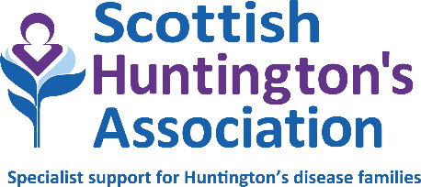

National Financial Wellbeing Service Lead
Job description
Division: Financial Wellbeing Service
Based: Hybrid working model (office/home) with travel throughout Scotland as required.
Reporting to: Deputy Chief Executive & Head of Services
Hours: 36 hours per week (full time)
Duration: Permanent
Salary: £33,537 – £36,077

Duties and responsibilities
- Provide line management to the Financial Wellbeing Team throughout Scotland.
- Deliver clear and adaptive leadership to the Financial Wellbeing Team.
- Supervision and support of individual team members.
- Develop and manage the Financial Wellbeing Service Plan in line with the needs of families affected by Huntington’s disease and the organisation’s five-year strategy.
- Operate as a member of the Extended Leadership Team, including participation at regular meetings.
- Contribute to budget discussions and work closely with the Finance Team.
- Work closely with the Income Generation Team to secure appropriate funding streams, complete applications and evidence the impact of funding through outcomes and reports.
- Produce reports on outcomes as required.
- Provide a range of information, advice, guidance with welfare benefits and debt issues.
- Maintain a high level of knowledge and expertise about welfare rights and debt issues.
- Provide effective representation to clients at appeals and tribunals.
- Develop and deliver training and education to colleagues and external agencies.
- Build relationships with partner services and external agencies.
- Help develop and maintain digital resources in relation to advice issues.
- Maintain accurate records of work undertaken with all clients.
- Meet, maintain and review compliance standards when managing conﬁdential information in respect of General Data Protection Regulation (GDPR).
- Deliver and manage service in accordance with the Scottish National Standards for Advice and Information Providers, the Financial Conduct Authority and all other relevant standards and legal requirements.
- Participate and contribute actively to team meetings, discussions and development of the service.
- Commit to ongoing learning and development in relation to your own work in addition to conducting reviews of others’ work as part of a peer-to-peer review system
- Comply with the charity’s policies and values framework.
- Achieve agreed outcomes and outputs, and personal appraisal targets, as agreed by line manager.
- Work occasional weekends and evenings as required.

NOTES
1. This job outline reflects the main tasks and responsibilities discharged by the post holder at the present time; however Scottish Huntington’s Association reserves the right to alter or amend the content of this job outline to reflect changes to the job or services provided, while maintaining the overall character and level of responsibility for the post.
2. Notwithstanding any information or statement described within this job outline, all duties must be carried out in a way that promotes equality of opportunity, dignity and respect for all individuals and which is consistent with the charity’s stated policy on equal opportunities.
3. The successful candidate will be subject to a Disclosure Scotland PVG Scheme check. Having previous convictions will not automatically disbar you from working at Scottish Huntington’s Association (with the exception of offences against children or other vulnerable groups) and every case is taken on an individual basis.
4. The duties and responsibilities of this post will be undertaken in accordance with the policies of Scottish Huntington’s Association.

