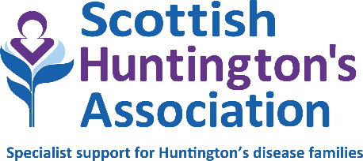

Title: National Financial Wellbeing Service Lead
Location: Hybrid Working with some travel, based at any location in Scotland
Salary: £33,537 – £36,077
Hours: 36 hours per week
Duration: Permanent
Reporting to: Deputy CEO & Head of Services
Accountable to: Board of Directors via CEO

PERSON SPECIFICATION

QUALIFICATIONS AND TRAINING | ESSENTIAL | DESIRABLE
A relevant qualification in welfare rights and money advice | x
Evidence of relevant training and qualifications such as Wiseradviser; CPAG training; City & Guilds Level 3 Energy Awareness; or equivalent. | x
KNOWLEDGE AND EXPERIENCE
Line management and development of a highly performing team | x
Significant, demonstrable experience delivering advice to the public in welfare rights, money advice or energy advice at Advice Type III. | x
Current knowledge of the benefit and tax credit system. | x
Knowledge and experience of budget management and financial record keeping. |  | x
Delivery of training and presentations. | x
Data gathering and report writing. |  | x
Management of appeals to tribunal level. | x
Working with people with long term health conditions. |  | x
Understanding of Huntington’s disease and other neurological conditions. |  | x
Ability to manage a busy caseload. | x
Working with carers. |  | x
Ability to work autonomously. | x
Computer literacy including MS 365 packages. | x
Excellent literacy and numeracy skills | x
Use of information systems such as AdviserNet, Rightnet, CPAG Handbook, Lisson Grove Benefit Programme. | x
Use of client database systems such as AdvicePro. | x
Excellent administrative skills and competent in the use of Microsoft Office 365. | x
SKILLS
Strong leadership and decision-making abilities. | x
Excellent speaking and listening skills. | x
Excellent attention to detail. | x
Effective networking and influencing skills and the confidence to deal with people of all levels of seniority. | x
Effective written and verbal reporting skills. | x
A good communicator (face-to-face, online, virtual etc) with ability to create and maintain relationships. | x
Competence to plan, organise and manage multiple priorities and the ability to successfully prioritise tasks for yourself and your team. | x
Effective time management skills and ability to meet deadlines. | x
ATTRIBUTES AND PERSONAL QUALITIES
Excellent communication and interpersonal skills. | x
Professional, diplomatic and able to maintain confidentiality. | x
Highly motivated and resilient with a ‘can-do’ attitude. | x
Keen to share knowledge while learning from others. | x
OTHER
A clean driving licence and access to a vehicle daily. | x
Commitment to, and promotion of, equal opportunities and anti discriminatory practices at work. | x
Awareness of personal responsibility in relation to health and safety. | x
Willingness to undertake, and support others to, participate in professional development. | x

June 2024

