

Job Description

Role Title: | Workshop Technician
Department: | Sight Scotland Veterans Linburn Centre
Reports to: | Jacqui Salter
Pay Grade: | Pt. 24 (currently £28,296 per annum pro rata)
Type of Contract: | Part time, permanent
Normal place of work: | Linburn Activity Centre – on site
Line Manager? | No
Budget Holder? | No
Criminal Record Check/PVG required? | Yes
Driving license for UK driving required? | No

Who we are

The impact of vision loss is huge. Too often, it leads to people lacking or losing confidence and independence. People with vision loss are at higher risk of unemployment, isolation, mental health problems, and financial challenges. It can have an enormous emotional toll. But with the right support, people with vision loss can gain the skills to remain independent and active in their communities – to thrive. That’s why we’re here.

For 230 years, Sight Scotland and Sight Scotland Veterans have been supporting people impacted by vision loss. We believe we play an important role in continually shifting the conversation around sight loss, and contributing to achieving a fair, equitable society. Over the years, we’ve seen a positive shift in expectations, with individuals and communities increasingly empowered to live lives the way they choose, free of discrimination.

And we’ve had to transform too, so that our services reflect the times we live in and meet the changing needs of the people we support. We’re now looking at how we continue to evolve, considering how we contribute now and what we could do differently in the future.

We work with charities across our sector to make sure people with sight loss have access to the right resources, when they need them. But what makes us unique is:

- Together, Sight Scotland and Sight Scotland Veterans is the largest Scottish charitable organisation that supports people impacted by vision impairment
- We’re the only Scottish vision impairment charities that fund medical research into eye health
- We’re the only Scottish vision impairment charities that have a dedicated policy and campaign team
- Our services span all age groups, including people born with a vision impairment, and those that acquire a vision impairment throughout their lives.

What this job is about

Our Activity Centre’s provide innovative and person-centred services and support to veterans struggling with sight loss. This job exists in order to provide tailored support to veterans carrying out woodworking projects. You will work alongside the veterans to identify abilities, share ideas and plan projects within the activity Centre. You will ensure that the support provided is person-centred, tailored to their needs and is the right support for them. You will support the leadership team to coordinate and manage the activities provided within and from the Activity Centre which will support the overall wellbeing of the veterans and their families. You will work closely with colleagues across the organisation and external stakeholders to ensure that veterans can access the relevant support.

What we want you to be responsible and accountable for

- Supporting veterans and their families/carers to maximise the benefit they gain from attending the Centre.
- Enabling veterans to maximise the benefit and enjoyment they gain from attending the Centre workshop where individuals can maximise their existing skills and abilities and develop new ones.
- Ensuring that all materials are available and well stocked for the workshop.
- Ordering raw materials and stock in conjunction with the leadership team.
- Encouraging maximum independence whilst providing a supportive environment where physical help is given if necessary.
- Developing and facilitating innovative and creative activities/events which are geared towards supporting veterans throughout their sight loss journey and beneficial in supporting the overall wellbeing of veterans
- Carrying out relevant risk assessments to ensure comprehensive risk management of workshop activities.
- Maintaining all necessary records/databases

The current duties of the role require membership of the PVG scheme through Disclosure Scotland.

How we would like you to achieve this

- By supporting person centred, asset based and outcome focused approaches to practice which are responsive to individual needs.
- By supporting a culture of co-production within the Activity Centre which ensures the veterans community have a large role in shaping service delivery.
- By supporting partnerships that positively support service impact
- By supporting the volunteering community which complements our staff teams.
- By acting as a positive role model for all staff and volunteers across Sight Scotland Veterans through coaching, mentoring and modelling of practice.
- Working with the leadership team to promote consistent approaches across both activity hubs.
- Encouraging and maintaining clear channels of communication between veterans, staff teams and the Sight Scotland Veterans management team.
- Developing and maintaining positive working relationships with colleagues across Sight Scotland Veterans and our sister charity Sight Scotland.
- Encouraging service users and their families to provide feedback and to share their stories about the impact of the service to help promote the service.
- Contributing to supervisions and staff meetings
- We want you to build positive relationships with service users, families, carers and other stakeholders
- We want you to work in a way that is wholly consistent with our stated organisational values and be committed to enabling visually impaired people to learn/maintain skills and access opportunities which support their independence and wellbeing and promotes social inclusion within local communities.
- We want you to be responsive to others in order to identify the needs of those who use the service
- We want you to have excellent time management skills to plan, prioritise and manage your workload
- We want you to have the ability to work calmly under pressure
- We want you to have the ability to adapt to change and respond positively to non-routine situations
- We like to be kept informed so it is important to us that you keep good records relating to all aspects of the workshop activity.

Who you will be working with
- Colleagues
- Other Sight Scotland services
- Senior Colleagues
- Volunteers
- Members
- Members families/carers
- External Agencies and relevant partners

The experience and skills you need to have to do this job

Essential:

- We require you to have experience of running a wood workshop or similar environment
- We require you to have experience of instructing others in woodworking techniques
- We require you to hold a NVQ Level 3 Diploma in Wood Occupations or similar qualification
- We need you to be able to demonstrate a knowledge of current health and safety regulations and requirements pertinent to a wood workshop
- We would like you to have an understanding of the support needs of people with a vision impairment
- We want you to able to demonstrate excellent communication skills

Desirable:

- Have additional relevant qualifications
- Have experience of working with service veterans
- Have experience of working with people with vision impairments
- Have experience in a rehabilitation setting
- Have evidence of continuous development and a willingness to undertake further training & development
- Have knowledge of statutory and voluntary sector provision in respect of people with a vision impairment
- Have knowledge of statutory and voluntary sector provision in respect of service veterans

Just so you know…

- The Charities have a set of Values & Our Ways of Working Framework, we ask you to work within, and these apply to everybody in the organisation irrespective of their role or job. You can find out more here: Our values. This means we want you to have:
  - The ability and willingness to understand others’ perspectives and to consider the impact of your actions on them and to adapt your actions as necessary;
  - The ability and willingness to learn and try new things, to be flexible and step outside of your comfort zone;
  - An open and honest way of communicating, ready to ask others for their ideas and to be open to hear and consider different points of view;
  - A pro-active approach to taking initiative and to driving forward ideas and projects designed to improve daily operations and deliver an exceptional visitor experience.

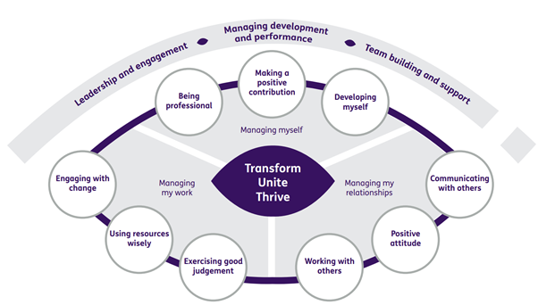

Department structure (this role outlined in red)

