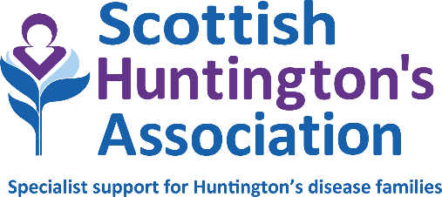

Title: Financial Wellbeing Officer
Location: Hybrid working with some travel, based in either southeast or southwest Scotland
Salary: £32,584
Hours: 36 hours per week (full time)
Duration: Permanent
Reporting to: Financial Wellbeing Service Lead
Accountable to: Board of Directors via CEO

JOB DESCRIPTION

The post holder will work as part of the Scottish Huntington’s Association Financial Wellbeing Service to significantly improve the financial outcomes of Huntington’s families.
The range of support provided to vulnerable groups will include advice about welfare rights and debt. As such, the post holder will be expected to have expertise in at least one of these areas and training will be offered where required.
The successful candidate should be able to work flexibly and autonomously using their own initiative. Good listening, communication and people skills are essential, as are excellent attention to detail, organisational and caseload management skills.
The post holder will also be expected help promote awareness of the issues affecting Huntington’s families as widely as possible and to contribute ideas to expand and develop the service.
- Key responsibilities
Delivery of a holistic advice service in south [west or east] Scotland by working directly with vulnerable Huntington’s families to improve the quality of life of people living with Huntington’s disease.
- Providing information, advice and guidance to all Huntington’s families referred to the service.
- Adopting an integrated working approach with colleagues across the organisation including HD Specialists, Specialist Youth Advisors and volunteers who could include professionals from a range of backgrounds.
- Providing education and training where appropriate and participating in the development of literature to meet the needs of the families.
- Management of busy caseload.
- Accurate record keeping and compliance with GDPR regulations and Scottish Huntington’s Association policies and procedures.
- Ensuring knowledge and awareness of benefits, debt and tax credit system remains up to date.
- Willingness to undergo professional development as required.
- Participate and contribute actively to team meetings, discussions and development of the service.
- Commit to ongoing learning and development in relation to your own work in addition to engaging in peer-to-peer review system
- Comply with the charity’s policies and values framework.
- Achieve agreed outcomes, outputs and personal appraisal targets, as agreed with line manager.

NOTES
1. This job outline reflects the main tasks and responsibilities discharged by the post holder at the present time; however Scottish Huntington’s Association reserves the right to alter or amend the content of this job outline to reflect changes to the job or services provided, while maintaining the overall character and level of responsibility for the post.
2. Notwithstanding any information or statement described within this job outline, all duties must be carried out in a way that promotes equality of opportunity, dignity and respect for all individuals and which is consistent with the charity’s stated policy on equal opportunities.
3. The successful candidate will be subject to a Disclosure Scotland PVG Scheme check. Having previous convictions will not automatically disbar you from working at Scottish Huntington’s Association (with the exception of offences against children or other vulnerable groups) and every case is taken on an individual basis.
4. The duties and responsibilities of this post will be undertaken in accordance with the policies of Scottish Huntington’s Association.

June 2024

