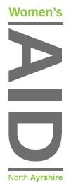
27/06/2024

Dear Applicant
Thank you for your interest in working with North Ayrshire Women’s Aid.
Please find enclosed /downloadable from website:
- An Application Form
- Job Description
- Person Specification
- Summary of Terms and Conditions

Please email (preferably) your application by the closing date of midnight on: Sunday 28th July 2024 to
admin@nawomensaid.co.uk
or post to arrive prior to closing date
‘FAO RECRUITMENT’ to
NAWA,
17 Vernon Street, Saltcoats, KA21 5HE

Please note that we are unable to acknowledge receipt of your application.

Interviews will be held Friday 9th August 2024

We will only contact those applicants who are to be invited to interview and thank you again for your interest in our work.

Yours Sincerely

Mary Beglan

Chief Officer

