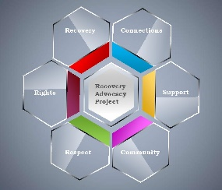
Additional Information
Recovery Advocacy Project
Isle of Bute
Permanent 16 hours per week

We are seeking an enthusiastic, highly motivated individual to join our friendly advocacy team.
This post is a chance to step into an existing well developed project, with opportunities to further improve the aims and objectives of the project.
If you are passionate about people, about ensuring people are empowered and treated with fairness and dignity then advocacy could be the role for you. This post will focus on assisting people impacted by problem substance use and alcohol dependency issues. You will support people with a range of issues, including access to Health and Social Care Services, support to meet with the GP, Housing and Welfare services. You will be connecting and signposting individuals and enabling them to feel empowered and respected, where often individuals can find accessing the recovery community challenging due to the stigma and shame.
Your core mission will be to offer people information about their rights and services and to assist them in seeking to have their voices heard and their wishes respected.
You will be working across the Isle of Bute, supporting people right across the Island.
This will be a hybrid post, the majority of the working hours will be spent working in the community with the people who seek your support, and working from your home to join meetings, type up notes and reports.

Please apply using the application form on our website.
For informal enquiries please phone 01546-606056 and ask for Ailsa McCrae in reference to the Bute Recovery Advocate post or email admin@laas.org.uk

